Assignment 18.3

DataSet is uploaded in as follows:-

* val baseRDD1 = sc.textFile("/home/acadgild/Assignment- 18/S18_Dataset_Holidays.txt")
* val baseRDD2 = sc.textFile("/home/acadgild/Assignment- 18/S18_Dataset_Transport.txt")
* val baseRDD3 = sc.textFile("/home/acadgild/Assignment- 18/S18_Dataset_User_details.txt")
* import org.apache.spark.storage.StorageLevel
* baseRDD1.persist(StorageLevel.MEMORY_ONLY)
* baseRDD2.persist(StorageLevel.MEMORY_ONLY)
* baseRDD3.persist(StorageLevel.MEMORY_ONLY)

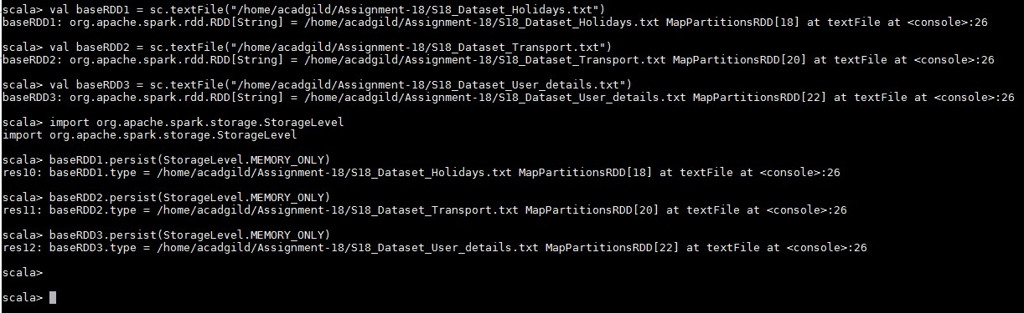

Problem Statement:-

1. Considering age groups of < 20 , 20-35, 35 > ,Which age group spends the most amount of money travelling.
2. What is the amount spent by each age-group, every year in travelling? Solution:-

# Considering age groups of < 20 , 20-35, 35 > ,Which age group spends the most amount of money travelling.

Below is the code used:-

* val travel = baseRDD1.map(x => (x.split(",")(0).toInt,x.split(",")(1),x.split(",")(2),x.split(",")(3),x.split(",")(4)

.toInt,x.split(",")(5).toInt))

* val transport = baseRDD2.map(x => (x.split(",")(0),x.split(",")(1).toInt))
* val user = baseRDD3.map(x => (x.split(",")(0).toInt,x.split(",")(1),x.split(",")(2).toInt))
* val AgeMap = user.map(x => x._1 -> {if(x._3<20) "20" else if(x._3>35) "35" else "20-35" })
* val userMap = travel.map(x => x._4 -> (x._1,x._5))
* val transportmap = transport.map(x=> x._1 -> x._2)
* val joinCost = userMap.join(transportmap)
* val calCost = joinCost.map(x => x._2._1._1 -> x._2._1._2 * x._2._2)
* val groupCost = calCost.groupByKey().map(x => x._1 -> x._2.sum)
* val groupAgeCost = AgeMap.join(groupCost).map(x => x._2._1 -> x._2._2)
* val finalCost = groupAgeCost.groupByKey().map(x => x._1 -> x._2.sum)
* val maxVal = finalCost.sortBy(x => -x._2).first()

Output:-

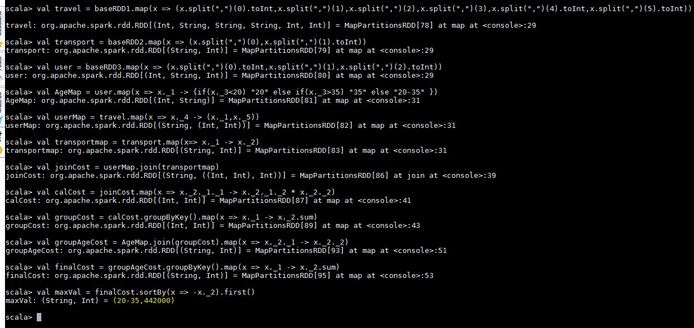

# What is the amount spent by each age-group, every year in travelling?

Below is the code used:-

* + val UserYearMap = travel.map(x => x._4 -> (x._1,x._5,x._6))
  + val transportmap = transport.map(x=> x._1 -> x._2)
  + val UserCost = UserYearMap.join(transportmap)
  + val CalcCost = UserCost.map(x => x._2._1._1 -> (x._2._1._3,x._2._1._2

* x._2._2))

* + val AgeMap = user.map(x => x._1 -> {if(x._3<20) "20" else if(x._3>35) "35" else "20-35" })
  + val CostMap = AgeMap.join(CalcCost).map(x => (x._2._1,x._2._2._1) -

> x._2._2._2)

* + val ExpPeryear = CostMap.groupByKey().map(x => x._1 -> x._2.sum)
  + ExpPeryear.foreach(println) Output:-

