1. **Create a dataframe with 1 to 100 and save as parquet file.**

In order to proceed first we need to create a RDD for numbers between 1 to 100.

Below screenshot shows the same-

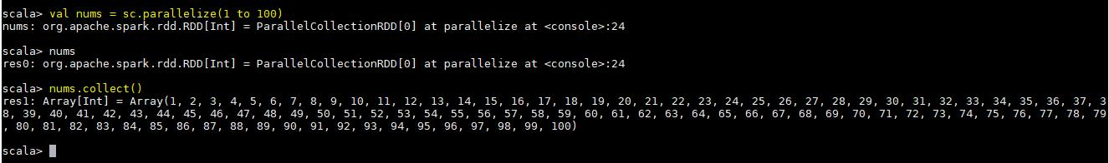

Now we will create the dataframe with above RDD as shown below-

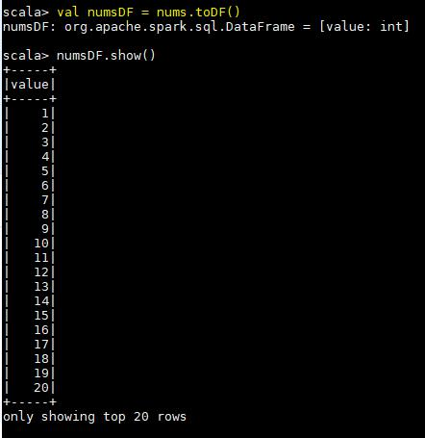

Now below is the final screenshot which shows that we are writing a parquet file from above defined datframe and then reading it-

