Assignment 21.1

Below is the tweets :-

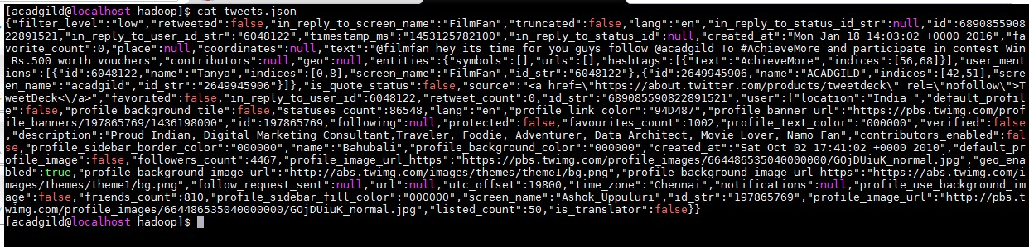

Source Code:-

* val tweets = spark.read.json("file:///home/acadgild/hadoop/tweets.json").registerTe mpTable("tweets")
* val hashtags = spark.sql("select id as id,entities.hashtags.text as words from tweets").registerTempTable("hashtags")
* val hashtag_word = spark.sql("select id as id,hashtag from hashtags LATERAL VIEW explode(words) w as hashtag").registerTempTable("hashtag_word")
* val popular_hashtags = spark.sql("select hashtag, count(hashtag) as cnt from hashtag_word group by hashtag order by cnt desc").show

Screenshots:-

