3D-printing a Shape Display

Introduction
A shape display is a 2.5D display which operates by manipulating the height of rods in a grid. Two notable applications are haptic interactions and displaying landscapes (e.g. DnD battle map).

Goals
Develop a shape display which can function as a landscape display device, with the following requirements:
- costs
  - material costs < 200 euro
  - construction time (excluding machine time) < 4 hours
- dimensions:
  - area 50 cm x 50 cm
  - resolution > 200 x 200
  - height < 5 cm
  - weight < 5 kg
- functionality
  - full screen refresh < 20 s
  - rod motion range > 5 cm
  - Should be able to support 10 grams / cm^2.

Existing projects

InFORM
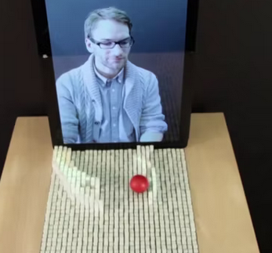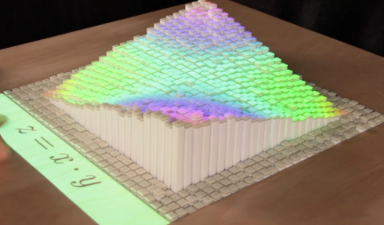
- Built with linear actuators (count = n^2).
- Rods individually and simultaneously addressable. Low actuation time.
- High cost.

Inform. (n.d.). Retrieved August 22, 2022, from https://tangible.media.mit.edu/project/inform

Shapeshift
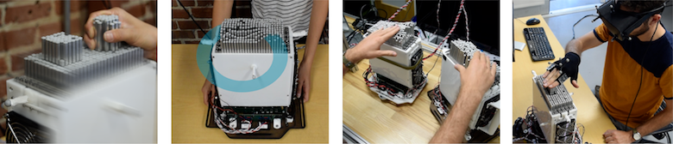
- Built with linear actuators (count = n^2).
- Rods individually and simultaneously addressable. Low actuation time.
- High cost.

Siu, A. F., Gonzalez, E. J., Yuan, S., Ginsberg, J., Zhao, A., & Follmer, S. (2017). Shapeshift: A mobile tabletop shape display for tangible and haptic interaction. Adjunct Publication of the 30th Annual ACM Symposium on User Interface Software and Technology, 77–79. https://doi.org/10.1145/3131785.3131792

3D LEGO Table
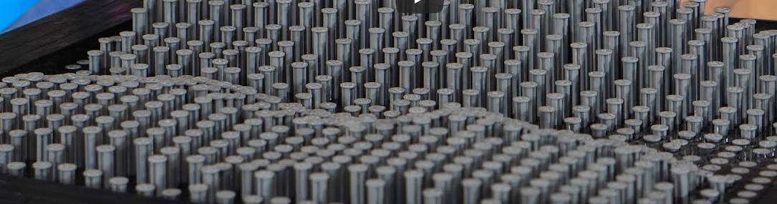
- Rods can not be individually addressed.

I Invented a 3D LEGO table that’s Oddly Satisfying... (n.d.). Retrieved August 22, 2022, from https://www.youtube.com/watch?v=wdBFroJC2-I

ESE350 Pin Art Display
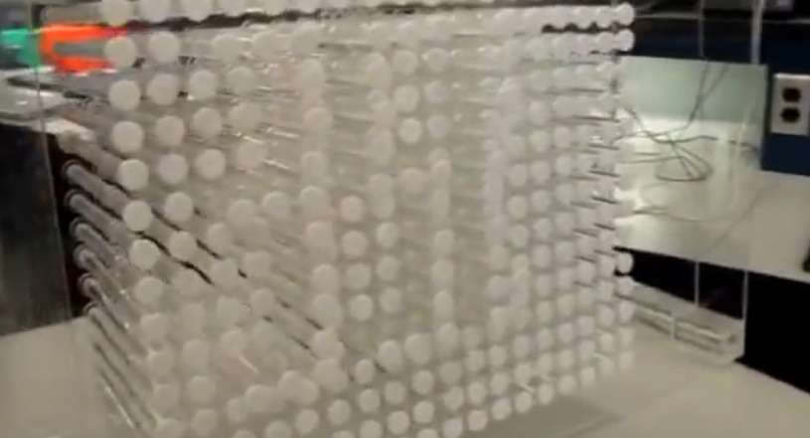
- Rods can be individually addressed, but not simultaneously due to XY-actuator design.
- Very high screen refresh time.
- Low cost.

Pin art. (n.d.). Retrieved August 22, 2022, from https://www.youtube.com/watch?v=KTXLUc_Hgh8

Augmented Reality Sandbox (Kinetic Sand)

- No actuation. Landscape must be designed by hand.
- Relief simulation through projection.

Augmented reality sandbox will blow your mind! (n.d.). Retrieved August 22, 2022, from https://www.youtube.com/watch?v=bA4uvkAStPc

Challenges
Existing projects are both expensive in terms of material costs and time investment, this is mainly due to the high number of linear actuators. While multiplexing can reduce this number, this increases the screen refresh time.
For a display with resolution r x r:
 | Actuator count | Screen refresh time
Direct addressing | r² | t
Row-column multiplexing | 2r | tr to tr²
XY-actuation | 3 | tr²

To achieve both low costs, low screen refresh time and low assembly complexity, the focus must be on (1) lowering the cost of actuators, (2) lowering the installation complexity of actuators and (3) increasing the responsiveness of multiplexing techniques.

Actuation and multiplexing technologies

Traveling nut linear actuator
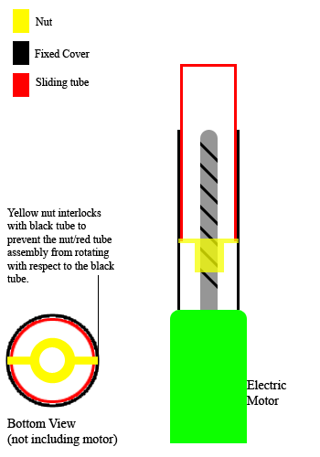
- Expensive and difficult to assembly.

Linear actuator. (2022). In Wikipedia. https://en.wikipedia.org/w/index.php?title=Linear_actuator&oldid=1101415559

Magnetic levitation linear actuator
- Difficult to manufacture and assembly.
- Difficult to support weight.

Piezoelectric linear actuator
- Low range of motion.
- Relatively expensive.

Heat based actuator
Materials that extend linearly when heat is applied (e.g. through resistor).

Wax motor
- Very high actuation time.
- Limited range of movement.
Wax motor. (2022). In Wikipedia. https://en.wikipedia.org/w/index.php?title=Wax_motor&oldid=1089345490

4D-printables and articial muscles
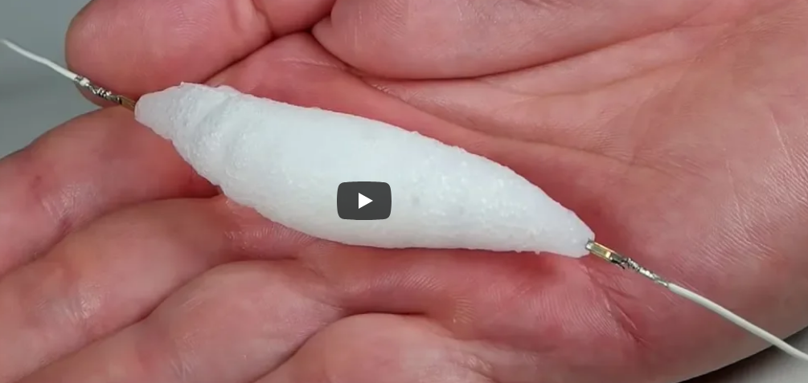
- Low availability.
- Limited range of motion.
Artificial muscles. (n.d.). Instructables. Retrieved August 22, 2022, from https://www.instructables.com/Artificial-Muscles/
4D printing. (2022). In Wikipedia. https://en.wikipedia.org/w/index.php?title=4D_printing&oldid=1102423782
Artificial muscle. (2022). In Wikipedia. https://en.wikipedia.org/w/index.php?title=Artificial_muscle&oldid=1094968233

Segmented spindle linear actuator
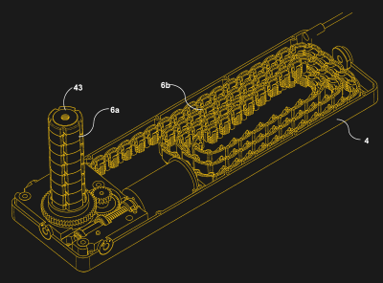
- High motion range.
- Bulky.

Segmented spindle. (n.d.). Hackaday. Retrieved August 22, 2022, from https://hackaday.com/tag/segmented-spindle/
Segmented spindle. (2022). In Wikipedia. https://en.wikipedia.org/w/index.php?title=Segmented_spindle&oldid=1098721206

Other smart materials
- Low range of motion.
Smart material. (2022). In Wikipedia. https://en.wikipedia.org/w/index.php?title=Smart_material&oldid=1084768294

Fluidics and pneumatic valves
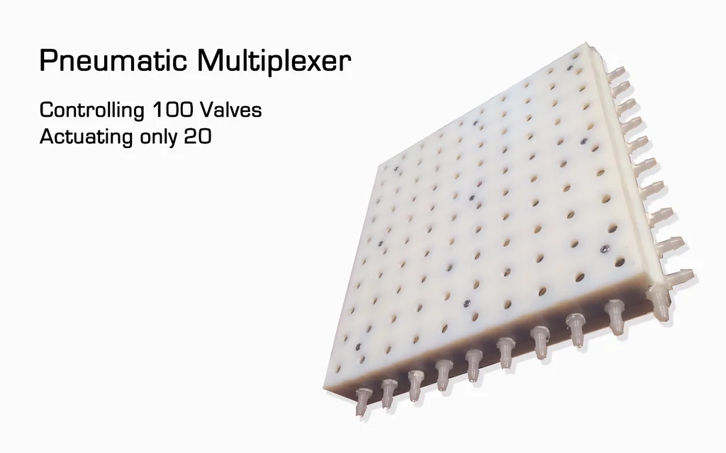
All about air logic valves. (n.d.). Retrieved August 22, 2022, from https://www.thomasnet.com/articles/pumps-valves-accessories/all-about-air-logic-valves/
dAcid. (n.d.-a). 3d printed pneumatic logic gates. Instructables. Retrieved August 22, 2022, from https://www.instructables.com/3D-Printed-Pneumatic-Logic-Gates/
dAcid. (n.d.-b). Pneumatic logic gates made with simple tools. Instructables. Retrieved August 22, 2022, from https://www.instructables.com/Pneumatic-Logic-Gates-Made-With-Simple-Tools/
Fadelli, I., & Xplore, T. (n.d.). LiftTiles: Actuator-based building blocks for shape-changing interfaces. Retrieved August 22, 2022, from https://techxplore.com/news/2020-01-lifttiles-actuator-based-blocks-shape-changing-interfaces.html
Fluidics. (2022). In Wikipedia. https://en.wikipedia.org/w/index.php?title=Fluidics&oldid=1094289794
Moralesinstagram, S. (n.d.). Pneumatic multiplexer- 3d printed. Instructables. Retrieved August 22, 2022, from https://www.instructables.com/Pneumatic-Multiplexer/
Valve Multiplexing. (n.d.). Megha Shah. https://openwetware.org/wiki/Valve_Multiplexing_-_Megha_Shah

Development
The shape display will be constructed out of multiple square modules that can be connected together to create a grid.

Module lay-out constraints
The following constraints are put on the lay-out of a single module.
(r = row count, c = column count, n = output count)
- r = c; as the module must be square
- √(n) ∈ ℕ; as the number of rows and columns must be an integer
- n = 2^x with x ∈ ℕ; as this makes binary multiplexing more easy
Thus, any configuration with 2^x outputs is possible as long as √(2^x) ∈ ℕ.
configuration | rows/columns | outputs
2 bit | 2 | 4
4 bit | 4 | 16
6 bit | 8 | 64
8 bit | 16 | 256
10 bit | 32 | 1024
12 bit | 64 | 4096
... | ... | ...

Module lay-out
The modules will have the following parameters:
- 8-bit, 16 x 16, 256 outputs
- rod: 5 mm x 5 mm
- module: 80 mm x 80 mm

Row-column configuration
For ease of development, the number of rows and columns should be equal. In addition, the number of outputs should be a power of 2 and its square root should be a natural number.

- 4 rows x 4 columns (16 outputs, 4 bit)

