CPE301 – SPRING 2019

Design Assignment 1

Student Name: Robert Sander

Student #: 5002102412

Student Email: sander1@unlv.nevada.edu

Primary Github address: https://github.com/sanderUNLV/submission_DA.git

Youtube link: https://youtu.be/KoeopwFGWXE

1. **DEVELOPED CODE OF TASK 1/A**

.include <m328pdef.inc>

.ORG 0 ;BEGIN AT THIS LOCATION

LDI R22, 0xFF ;LOAD IN MULTIPLICAND_8 'BOTTOM NUMBER'

LDI R24, 0xFF ;LOAD IN MULTIPLICAND_16_LOW 'TOP 'RIGHT PART' NUMBER'

LDI R25, 0xFF ;LOAD IN MULTIPLICAND_16_HIGH 'TOP 'LEFT PART' NUMBER'

LDI R26, 0 ;LOAD ZERO INTO REGISTER R26

CPI R22, 0 ;IF MULTIPLIER EQUALS 0

BREQ DONE ;IF MULTIPLIER EQUALS 0 GO TO DONE:

L1:

ADC R18, R24 ;ADD WITH CARRY THE VALUE OF R24 AND R18 AND STORE THE RESULT IN R18

ADC R19, R25 ;ADD WITH CARRY THE VALUE OF R25 AND R19 AND STORE THE RESULT IN R19

ADC R20, R26 ;ADD WITH CARRY THE VALUE OF R26 AND R20 AND STORE THE RESULT IN R20

DEC R22 ;DECREMENT R22, ITERATIVE ADDITION FOR MULTIPLICATION

CPI R22, 0 ;CHECK TO SEE IF REGISTER R22 IS ZERO

BRNE L1 ;IF REGISTER R22 DOES NOT EQUAL ZERO GO TO L1: OTHERWISE CONTINUE

DONE: ;GO HERE IF THE MULTIPLIER EQUALS ZERO

END: RJMP END ;FINISHED AND THE DESIRED RESULT SHOULD BE IN R18

1. **SCREENSHOTS OF EACH TASK OUTPUT (ATMEL STUDIO OUTPUT)**

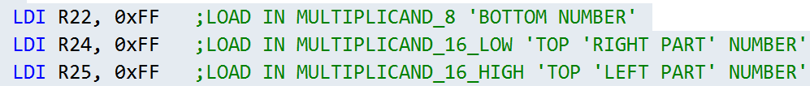

The test values are 255 in R22, 3840 in R24, and 61440 in R25.

Testing 255*65280.

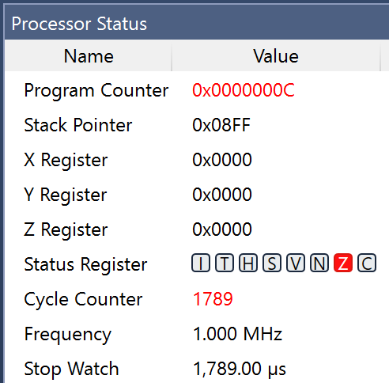

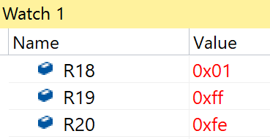

The result registers are R18, R19, and R20.

The maximum amount of clock cycles is 1789.

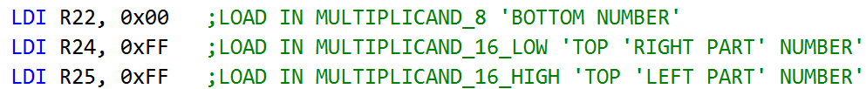

The test values are 0 in R22, 3840 in R24, and 61440 in R25.

Testing 0*65280.

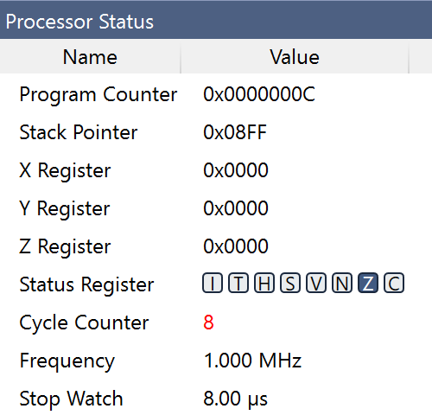

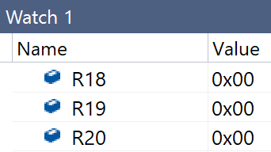

The result registers are R18, R19, and R20.

The minimum amount of clock cycles is 8.

This code has a maximum of 1789 cycles with 255*65535 and a minimum of 8 cycles with 0*anything.

1. **VIDEO LINKS OF EACH DEMO**

Youtube link: https://youtu.be/KoeopwFGWXE

1. **GITHUB LINK OF THIS DA**

Primary Github address: https://github.com/sanderUNLV/submission_DA.git

**Student Academic Misconduct Policy**

<http://studentconduct.unlv.edu/misconduct/policy.html>

“This assignment submission is my own, original work”.

-Robert Sander