CPE301 – SPRING 2019

Design Assignment 2A

Student Name: Robert Sander

Student #: 5002102412

Student Email: sander1@unlv.nevada.edu

Primary Github address: https://github.com/sanderUNLV/submission_DA.git

Youtube link:

T1: <https://youtu.be/xdysO13sV3g>

T2: <https://youtu.be/vJSh2bEIM3E>

1. **CONNECTION BLOCK DIAGRAM w/ PINS**

Block diagram with pins used in the Atmega328P

T1:

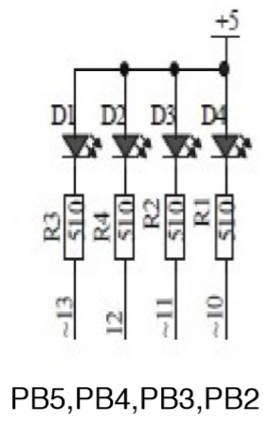

T2:

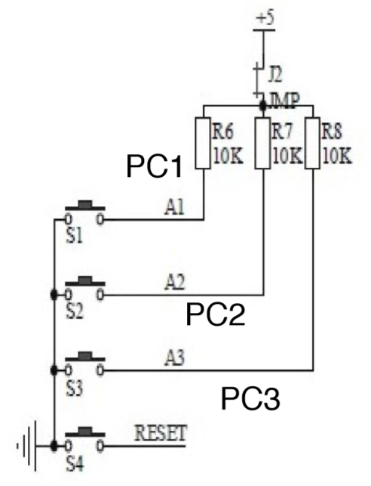

1. **INITIAL/MODIFIED/DEVELOPED CODE OF TASK 1**

**2.1.1.ASM**

// DA2A_T1_A

// Author : Robert Sander

.include<m328pdef.inc>

.INCLUDE "DELAY_OFF_ON.asm"

.ORG 0x00

LDI R16, 0x3C ;LOAD THE VALUE 0x02 0000 0010

OUT DDRB, R16 ;SETS PB.2-5 AS OUTPUTS

TOGGLE:

LDI R16, 0x38 ;LOAD THE VALUE 0x38 INTO R16

OUT PORTB, R16 ;'TURNS ON' PORTB HIGH STATE

RCALL DELAY_OFF ;CALL DELAY_OFF SUBROUTINE

LDI R16, 0x3C ;LOAD THE VALUE 0x3C INTO R16

OUT PORTB, R16 ;'TURNS OFF' PORTB LOW STATE

RCALL DELAY_ON ;CALL DELAY_ON SUBROUTINE

RJMP TOGGLE ;GO TO 'TOGGLE:'

**………………………**

.ORG 0x000100

DELAY_OFF:

; Delay 4 640 000 cycles

; 290ms at 16.0 MHz

ldi r18, 24

ldi r19, 138

ldi r20, 232

L2: dec r20

brne L1

dec r19

brne L1

dec r18

brne L2

ret ; Return to the caller

DELAY_ON:

; Delay 6 960 000 cycles

; 435ms at 16.0 MHz

ldi r18, 36

ldi r19, 79

ldi r20, 221

L1: dec r20

brne L1

dec r19

brne L1

dec r18

brne L1

ret

**2.1.1.C**

// DA2A_T1_C

// Author : Robert Sander

#define *F_CPU* 16000000UL

#include <avr/io.h> //include this input output library

#include <util/delay.h> //include this delay library

int main (void)

{

DDRB |= 0x3C; //SETS PB.2-5 FOR OUTPUT

while (1) {

PORTB = ~(1<<2); //&= SET IT TO ZERO...TURNS THE LED ON...REVERSE LOGIC

*_delay_ms*(290); //0.725 x 0.4=0.290s

PORTB = 0x3C; // PUT 1'S IN ALL 8 BITS WHICH TURNS OFF THE LEDS 0011 1100 ONLY TURNS OFF PB.2-5

*_delay_ms*(435); //0.725 x 0.6=0.435s - 60% DUTY CYCLE ON

}

return 0;

}

1. **INITIAL/MODIFIED/DEVELOPED CODE OF TASK 2**

**3.1.1.ASM**

// DA2A_T2_A

// Author : Robert Sander

.include <m328pdef.inc>

.include "DELAY.asm"

.ORG 0x000000

LDI R16, 0x3C ;LOAD THE VALUE 0x3C INTO R16

OUT DDRB, R16 ;SETS PB.2-5 AS OUTPUTS, 00111100

CHECK:

SBIC PINC,2 ;skip next if PB2 is clear , IF BUTTON IS PUSHED GO TO "LDI R16, 0x38"

RJMP SKIP ;GO TO 'SKIP:'

LDI R16, 0x38 ;LOAD THE VALUE 0x38 INTO R16

OUT PORTB, R16 ;'TURNS ON' PORTB...REVERSE LOGIC

RCALL DELAY

SKIP:

LDI R16, 0x3C ;LOAD THE VALUE 0x3C INTO R16

OUT PORTB, R16 ;'TURNS OFF' PORTB...REVERSE LOGIC

RJMP CHECK ;GO TO 'CHECK:'

**………………………**

; Delay 20 000 000 cycles

; 1s 250ms at 16.0 MHz

.ORG 0x000100

DELAY:

ldi r18, 102

ldi r19, 118

ldi r20, 194

L1: dec r20

brne L1

dec r19

brne L1

dec r18

brne L1

RET

**3.1.2.C**

// DA2A_T2_C

// Author : Robert Sander

#define *F_CPU* 16000000UL

#include <avr/io.h>

#include <util/delay.h>

int main (void)

{

/* SET PORTB FOR OUTPUT*/

DDRB |= 0xFF; //ALL BITS AS INPUTS TO TURN OFF THE BITS IN PINB

PORTB |= 0x3C; // TURN OFF LED PB.2-5

/* SET PORTC FOR INPUT*/ //PC.0 IS CONNECTED TO POTENTIOMETER

DDRC |= (1<<2); //SETS PC.2 AS AN INPUT

PORTC |= (1 << 2); // ENABLES PULL-UP IN PC.2, PUTS SWITCH IN TO "OFF POSITION"

while (1) {

if (!(PINC & (1<<PINC2))) //CONSTANTLY POLL TO SEE CONDITION FOR PINC, CHECK TO SEE IF THE PIN IS HIGH, BUTTON IS PUSHED

{

PORTB &= ~(1<<2); // SET PB.2 TO 0 TO TURN THE LED ON, REVERSE LOGIC

*_delay_ms*(1250); //DELAY 1.25s

}

else

PORTB |= (1<<2); // SET PB.2 TO 1 TO TURN OFF THE LED

}

return 0;

}

1. **SCHEMATICS**

T1 T2

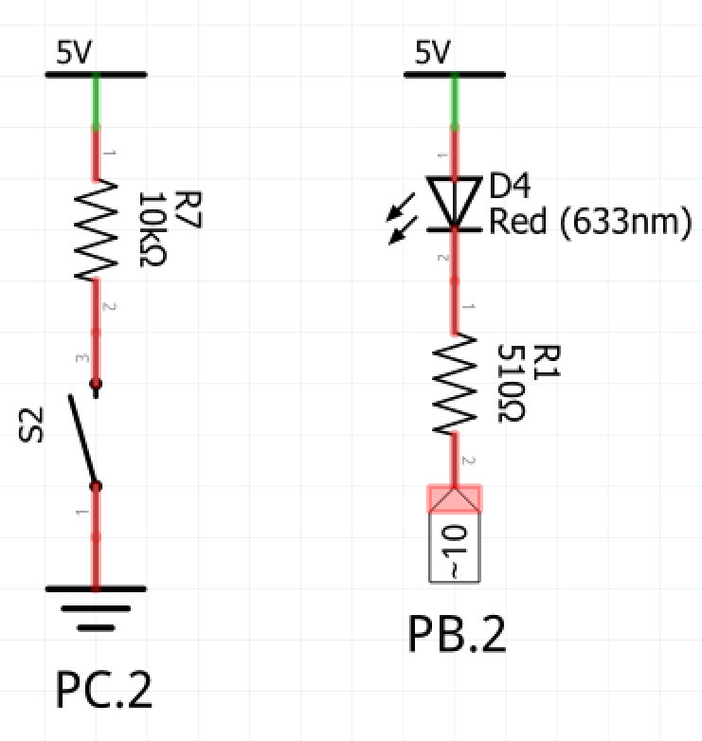

*Figure 2 – Task 2 schematic*

*Figure 1 – Task 1 schematic*

1. **SCREENSHOTS OF EACH TASK OUTPUT (ATMEL STUDIO OUTPUT)**

T1

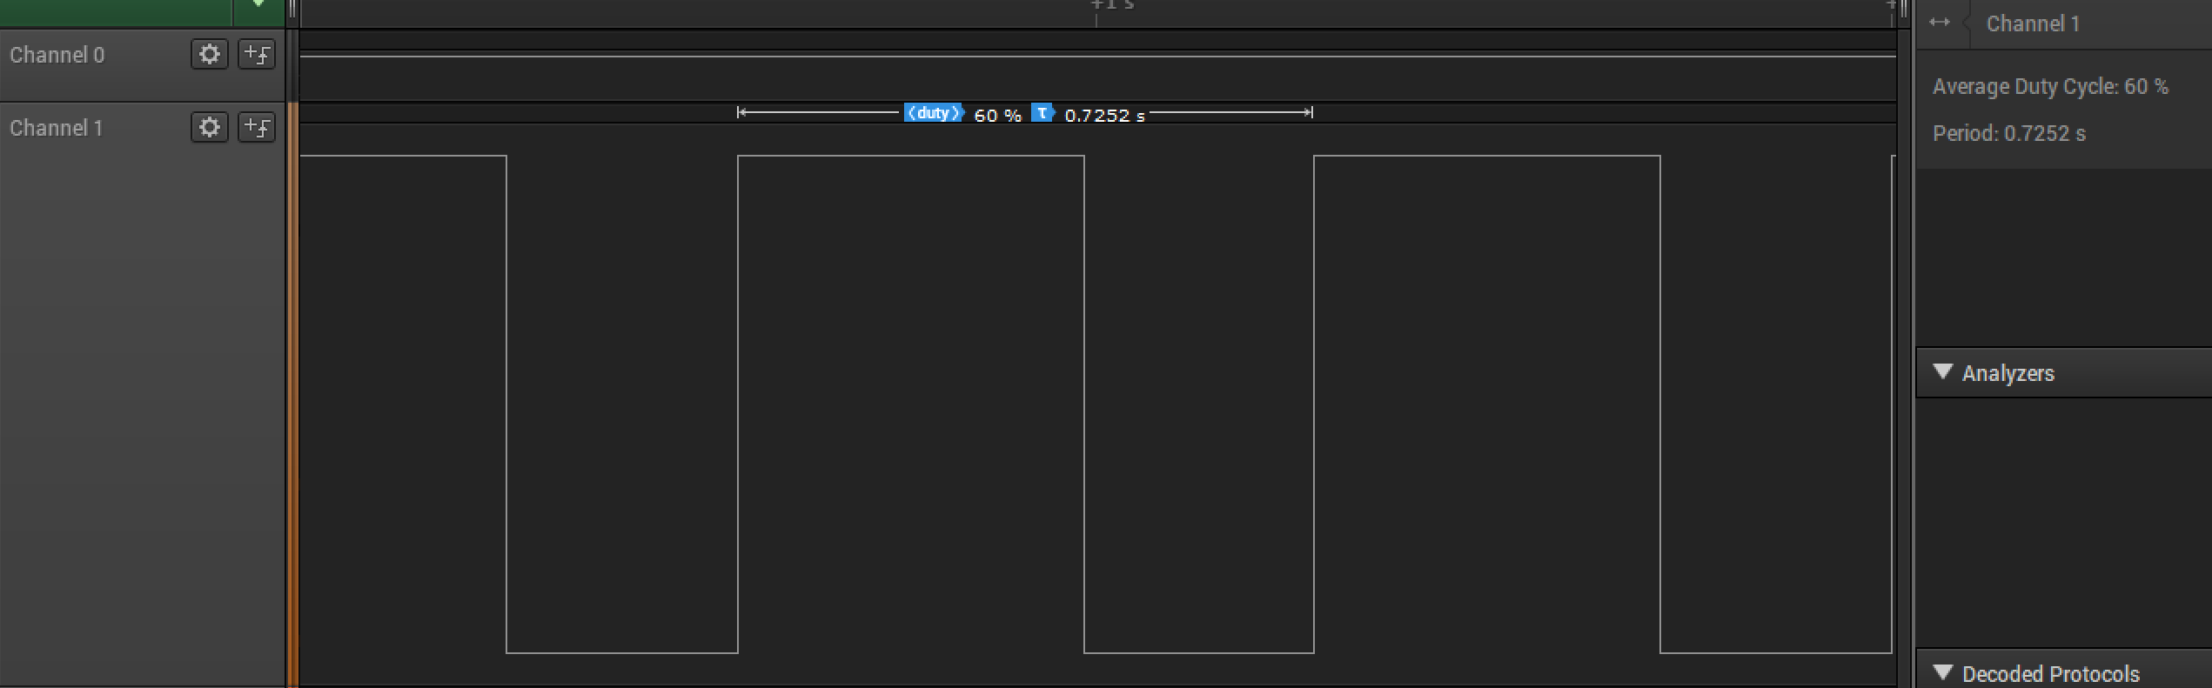

*Figure 3 – Duty Cycle and Period (Assembly)*

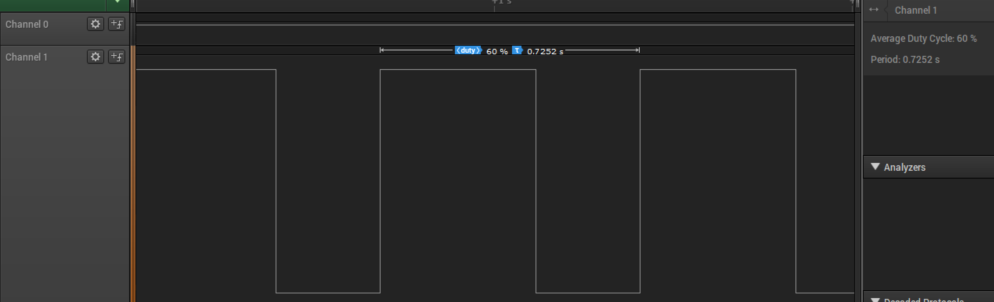

*Figure 4 – Duty Cycle and Period (C)*

T2

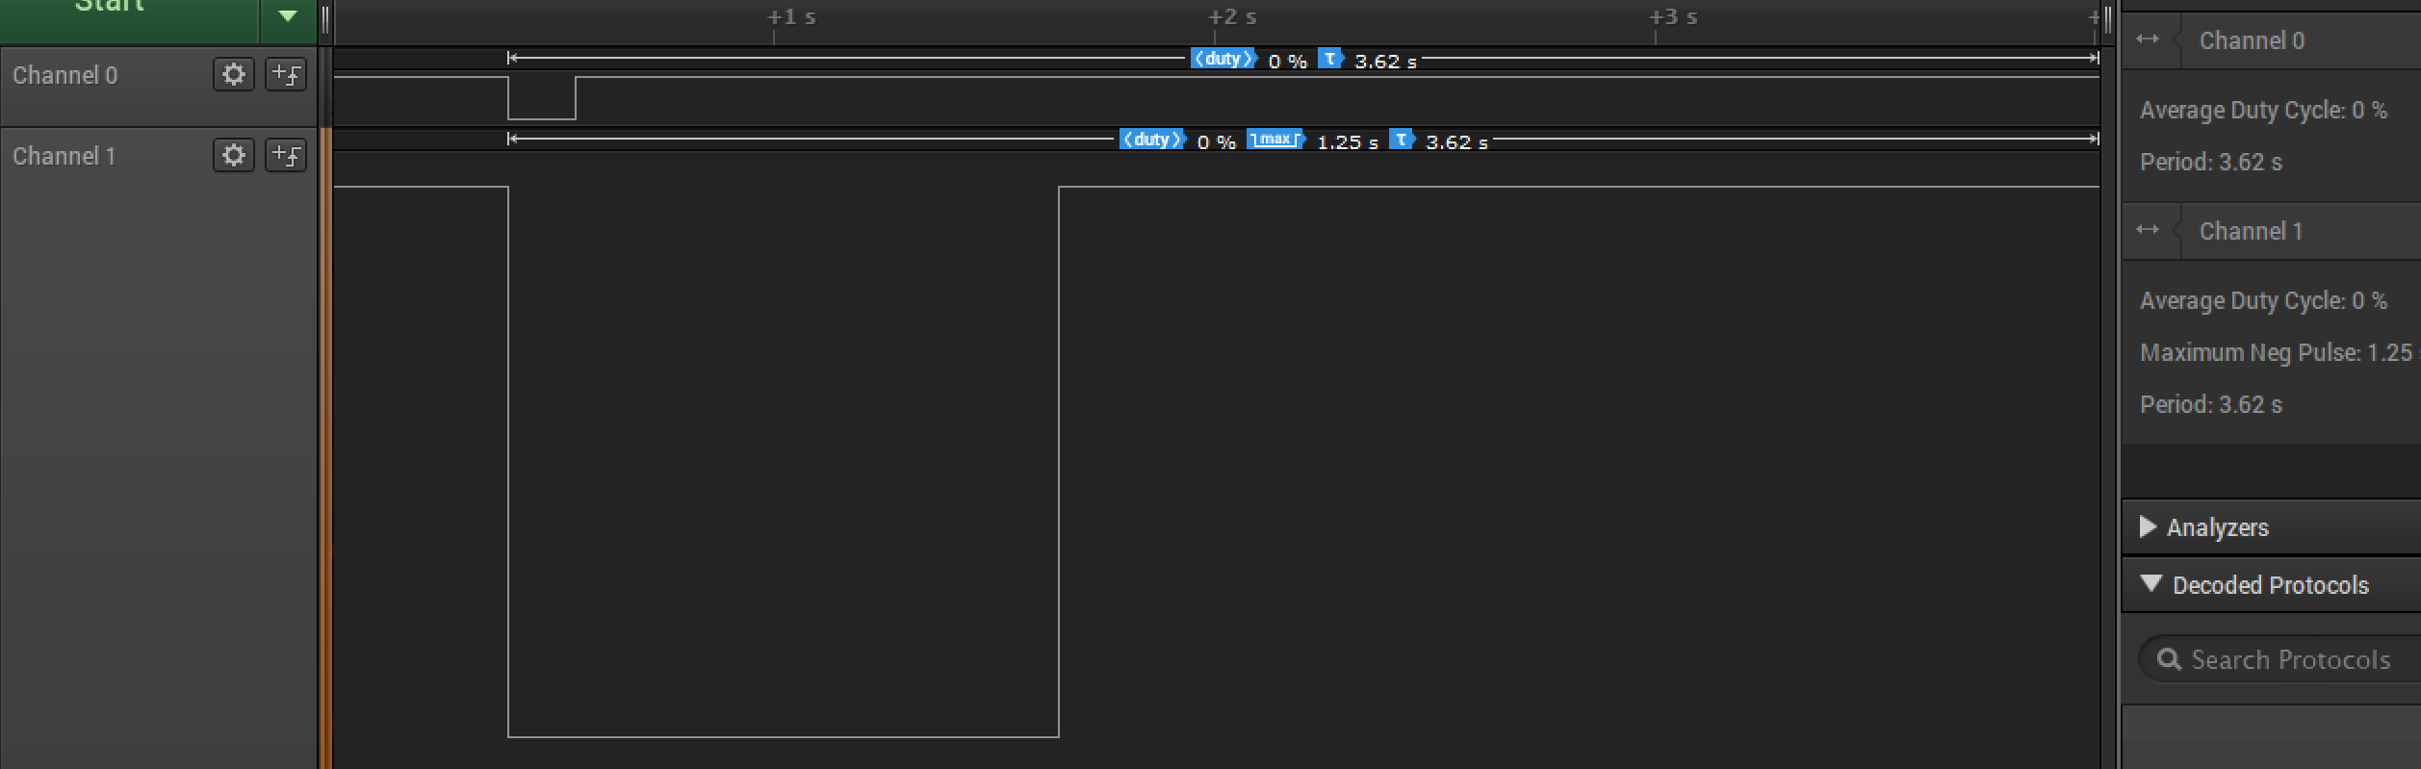

*Figure 5 – Duty Cycle, Period, and 1.250s delay (Assembly)*

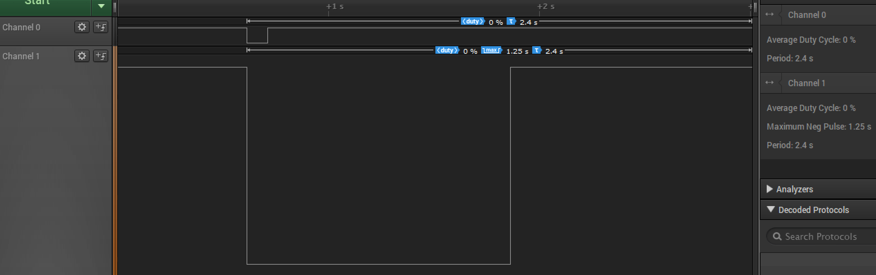

*Figure 6 – Duty Cycle, Period, and 1.250s delay (C)*

1. **SCREENSHOT OF EACH DEMO (BOARD SETUP)**

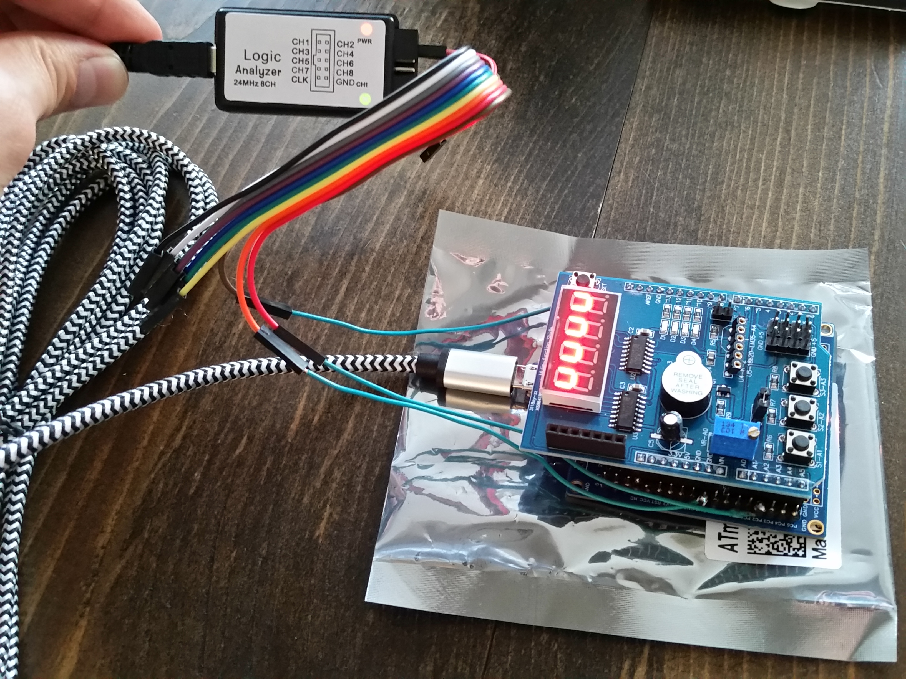

*Figure 7 – Xplained Mini w/ Multifunction Shield and Logic Analyzer*

1. **VIDEO LINKS OF EACH DEMO**

T1: <https://youtu.be/xdysO13sV3g>

T2: <https://youtu.be/vJSh2bEIM3E>

1. **GITHUB LINK OF THIS DA**

<https://github.com/sanderUNLV/submission_DA.git>

**Student Academic Misconduct Policy**

<http://studentconduct.unlv.edu/misconduct/policy.html>

“This assignment submission is my own, original work”.

-Robert Sander