CPE301 – SPRING 2019

Mid 2/ Final

Student Name: Robert Sander

Student #: 5002102412

Student Email: sander1@unlv.nevada.edu

Primary Github address: <https://github.com/sanderUNLV/submission_DA.git>

Youtube link: <https://youtu.be/9MAIOPtxEwQ>

1. **COMPONENTS LIST AND CONNECTION BLOCK DIAGRAM w/ PINS**

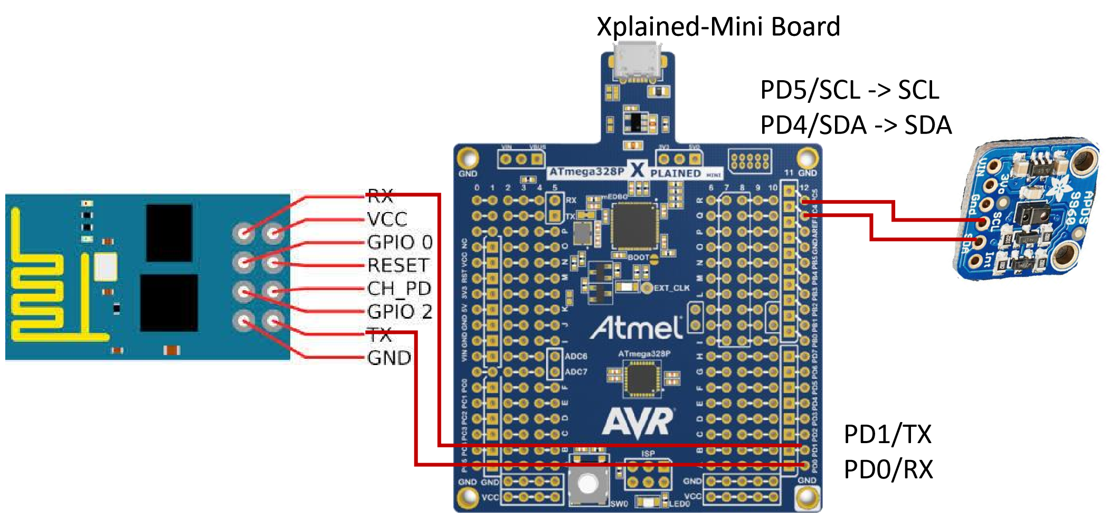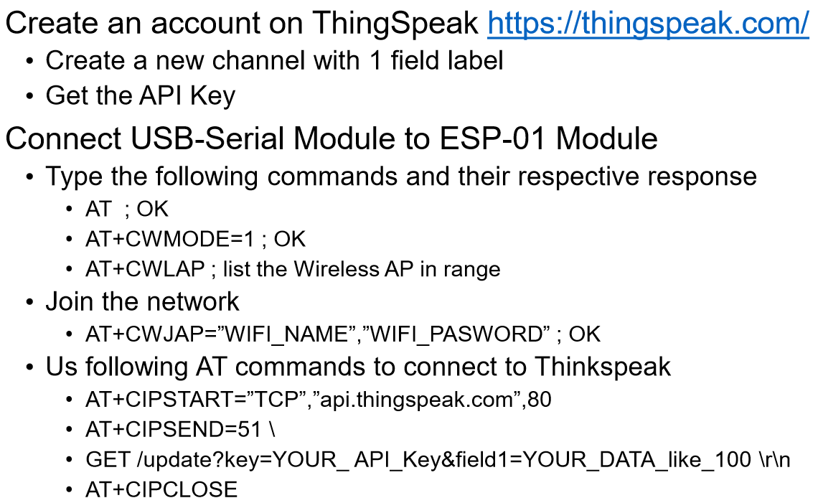

1. **INITIAL/MODIFIED/DEVELOPED CODE OF TASK 1**

// Assignment: Midterm 2/ Final

// Author : Robert Sander

/*

* ATmega16 Interface with MPU-6050

* http://www.electronicwings.com

*

*/

#define *F_CPU* 16000000UL /* Define CPU clock Frequency e.g. here its 8MHz */

#include <avr/io.h> /* Include AVR std. library file */

#include <util/delay.h> /* Include delay header file */

#include <inttypes.h> /* Include integer type header file */

#include <stdlib.h> /* Include standard library file */

#include <stdio.h> /* Include standard library file */

#include "APDS9960_def.h" /* Include MPU6050 register define file */

#include "I2C_Master_H_file.h" /* Include I2C Master header file */

#include "USART_RS232_H_file.h" /* Include USART header file */

#define APDS9960_WRITE 0x72

#define APDS9960_READ 0x73

float clear, red, blue, green;

void APDS9960_Init() /* Gyro initialization function */

{

*_delay_ms*(150); /* Power up time >100ms */

//I2C_Start_Wait(APDS9960_WRITE); /* Start with device write address */

//I2C_Write(APDS9960_ENABLE); /* Write to sample rate register */

//I2C_Write(0x00); /* 1KHz sample rate */

//I2C_Stop();

//I2C_Start_Wait(APDS9960_WRITE); /* Start with device write address */

//I2C_Write(APDS9960_ENABLE); /* Write to sample rate register */

//I2C_Write(0x01); /* 1KHz sample rate */

//I2C_Stop();

I2C_Start_Wait(APDS9960_WRITE);

I2C_Write(APDS9960_ATIME); /* Write to power management register */

I2C_Write(DEFAULT_ATIME); /* X axis gyroscope reference frequency */

I2C_Stop();

I2C_Start_Wait(APDS9960_WRITE);

I2C_Write(APDS9960_CONTROL); /* Write to Configuration register */

I2C_Write(DEFAULT_AGAIN); /* Fs = 8KHz */

I2C_Stop();

//I2C_Start_Wait(APDS9960_WRITE); /* Start with device write address */

//I2C_Write(APDS9960_ENABLE); /* Write to sample rate register */

//I2C_Write(1<<POWER|1<< AMBIENT_LIGHT); /* 1KHz sample rate */

//I2C_Stop();

I2C_Start_Wait(APDS9960_WRITE); /* Start with device write address */

I2C_Write(APDS9960_ENABLE); /* Write to sample rate register */

I2C_Write(0x02); /* 1KHz sample rate */

I2C_Stop();

}

void APDS_Start_Loc()

{

I2C_Start_Wait(APDS9960_WRITE); /* I2C start with device write address */

I2C_Write(APDS9960_RDATAH); /* Write start location address from where to read */

I2C_Repeated_Start(APDS9960_READ); /* I2C start with device read address */

}

void Read_RawValue()

{

APDS_Start_Loc(); /* Read ambient light value */

clear = (((int)I2C_Read_Ack()<<8) | (int)I2C_Read_Ack());

red = (((int)I2C_Read_Ack()<<8) | (int)I2C_Read_Ack());

blue = (((int)I2C_Read_Ack()<<8) | (int)I2C_Read_Ack());

green = (((int)I2C_Read_Ack()<<8) | (int)I2C_Read_Ack());

I2C_Stop();

}

int main()

{

char buffer[20], float_[10];

float C, R, G, B;

I2C_Init(); /* Initialize I2C */

APDS9960_Init(); /* Initialize MPU6050 */

USART_Init(9600); /* Initialize USART with 9600 baud rate */

while(1)

{

USART_SendString("cool");

Read_RawValue();

C = clear;

R = red;

G = green;

B = blue; /* Divide raw value by sensitivity scale factor to get real values */

*dtostrf*( C, 3, 2, float_ ); /* Take values in buffer to send all parameters over USART */

*sprintf*(buffer," CLEAR LIGHT = %s lumens ", float_);

USART_SendString(buffer);

*dtostrf*( R, 3, 2, float_ ); /* Take values in buffer to send all parameters over USART */

*sprintf*(buffer," RED LIGHT = %s lumens ", float_);

USART_SendString(buffer);

*dtostrf*( G, 3, 2, float_ ); /* Take values in buffer to send all parameters over USART */

*sprintf*(buffer," GREEN LIGHT = %s lumens ", float_);

USART_SendString(buffer);

*dtostrf*( B, 3, 2, float_ ); /* Take values in buffer to send all parameters over USART */

*sprintf*(buffer," BLUE LIGHT = %s lumens ", float_);

USART_SendString(buffer);

USART_SendString("beans!");

}

}

//USART_tx_string("AT+CWJAP=\"ssid\",\"password\"");

//USART_tx_string("AT+CIPSTART=\"TCP\",\"api.thingspeak.com\",80");

//USART_tx_string("AT+CIPSEND=51");

//USART_tx_string("GET /update?key=KEY&field1=100");

//USART_tx_string("GET /update?key=key&field1=100");

1. **SCREENSHOT OF EACH DEMO (BOARD SETUP)**

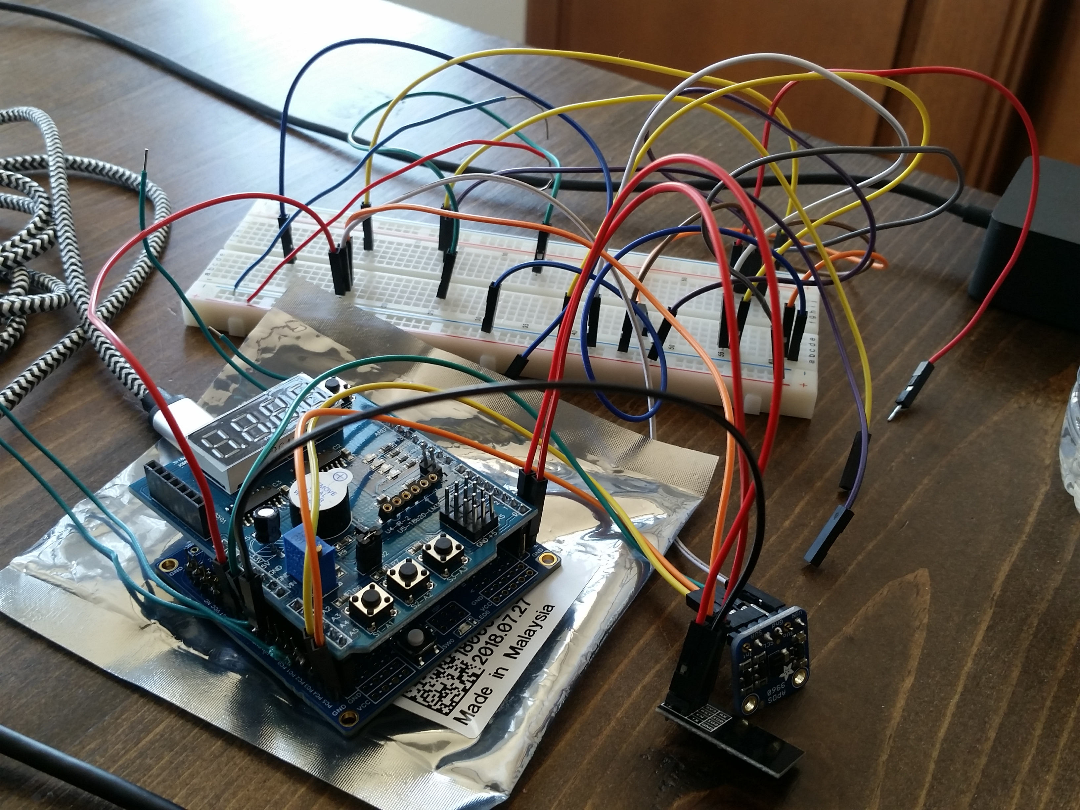

1. **VIDEO LINKS OF EACH DEMO**

<https://youtu.be/9MAIOPtxEwQ>

1. **GITHUB LINK OF THIS DA**

<https://github.com/sanderUNLV/submission_DA.git>

**Student Academic Misconduct Policy**

<http://studentconduct.unlv.edu/misconduct/policy.html>

“This assignment submission is my own, original work”.

-Robert Sander