MODELING SHORTNOSE STURGEON DEPARTURES FROM THE PENOBSCOT RIVER BY SEASON
Sander Elliott – SFR 605
Background
The shortnose sturgeon (Acipenser brevirostrum) inhabits large rivers along the North American coast from New Brunswick to Georgia (Dadswell, 1984). Shortnose sturgeon use rivers for spawning, foraging, and overwintering, but certain rivers are only utilized for a subset of these uses (Dionne et al., 2013). Male shortnose sturgeon usually spawn annually, while females can wait between two and five years to spawn (Kieffer & Kynard, 2012; Wippelhauser et al., 2015). Shortnose sturgeon in the Gulf of Maine move between the Penobscot and the Kennebec (Fernandes et al., 2010). Previous work has classified three different groups of coastal migrants based on timing, spring, summer, and fall (Dionne et al., 2013). Emerging data indicates that shortnose sturgeon also move between the Merrimack River and the Kennebec River (A. Heisey & M. Kieffer personal communication). However, all shortnose sturgeon in the Gulf of Maine spawn in the Kennebec (CITE). Similar coastal movement patterns have also been reported in Georgia (Nolan, 2025).
It is not known what drives shortnose to undertake coastal movements at certain times. Since 2006, the University of Maine, Maine DMR, and NOAA have tagged shortnose sturgeon with acoustic transmitters and maintained an acoustic array in Penobscot River, Penobscot Bay, and Kennebec River. We use these 20 years of telemetry data from these fish combined with environmental data from the Penobscot River to model the conditions under which shortnose sturgeon depart the Penobscot system for the Kennebec.
Methods
Acoustic telemetry transmitters (tags) produce coded, audible signals that can travel quite far in water. These signals are picked up by fixed hydrophones (receivers) and logged, giving a time and location to a tagged animal. Most acoustic telemetry studies are still descriptive, describing animal movements or animal use of an area, but the field is growing to include more complex modeling (Brownscombe et al., 2022). The initial acoustic telemetry dataset had a large number of raw detections for shortnose sturgeon across the three systems (n = 20,397). These raw detections were distilled into detection events using the GLATOS package in R Studio. Detection events groups of detections at a single receiver that are not interrupted by detections at another receiver or array (GLATOS). In this case, three arrays were created retrospectively, Kennebec River, Penobscot Bay, and Penobscot River (Figure 1). This reduced created 737 detection events across the three arrays. Departures were taken as the last detection in the Penobscot River before a subsequent detection in another system, that way tag failure could be ruled out.

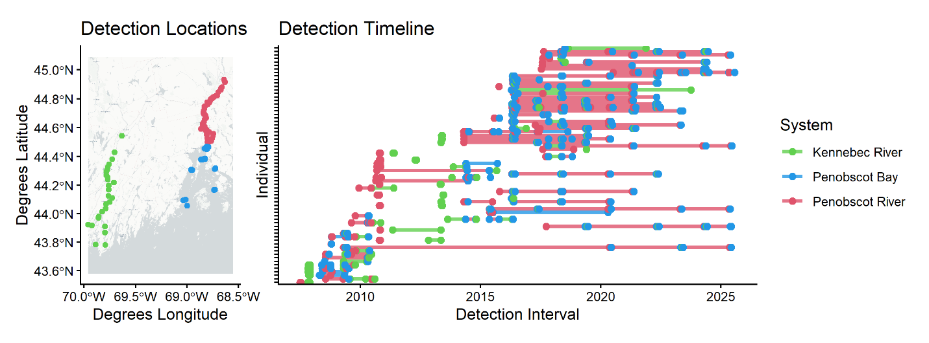
Figure 1.

