TTK4250 – Assignment 2

Task 2)

f)

x_bar_c = 

P_c = 

x_bar_r = 

P_r = 

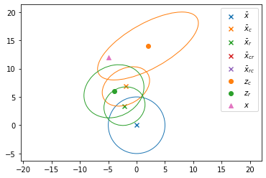

Observe: The conditional mean and covariance in the two cases (the two sensors standalone) both give improved results compared to the priori when looking at the means versus the true value for x (the triangle). It should be noted that the second state variable (along the y-axis) is significantly impacted by the very low priori estimate and that if the sensor data were to be combined, it would likely result in a estimate that is even closer to the true state for both the state variables.

Comment: Ignore x_bar_rc and x_bar_cr in the legend, they are not used yet and only relevant for the next subtask.