TTK4250 – Assignment 2

Task 2)

g)

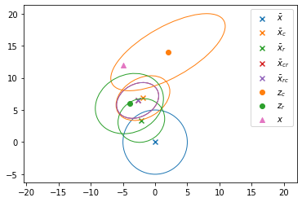

x_bar_cr = x_bar_rc = 

P_cr = P_rc = 

Here we have performed the update of the sensor for both the measurements in x_bar_cr and x_bar_rc. What we observe is that the distributions (which are gaussian and therefore characterized by the means x_bar_rc and x_bar_cr and the covariances P_rc and P_cr) are identical. This means that the order in which we condition does not matter.