Assignment 3: Brake Systems

NAME  [Name] | CLASS PERIOD  [Class period] | COURSE  Automotive Technology I (AUTO 110), Mr. Daniels

1. What is the job of a vehicle's brake system? Explain in your own words. (2 pts)
The brake system slows the car down and stops it when the driver pushes the pedal, and it keeps the car from rolling once it's parked. It works with friction. The pads or shoes rub against the rotors or drums and turn the car's motion into heat, which is why brakes get so hot after a long downhill.
2. Explain the difference between disc brakes and drum brakes. Give one advantage of each. (4 pts)
On a disc brake the rotor is a flat metal disc that spins with the wheel. A caliper sits over the edge of the rotor, and when you brake, hydraulic pressure pushes the caliper piston out and squeezes a brake pad against each side of the rotor.
A drum brake has a round drum that spins with the wheel, and everything else sits inside it. When you brake, the wheel cylinder pushes two curved brake shoes outward against the inside of the drum. Lots of cars use discs in the front and drums in the rear, because the front brakes do most of the stopping.
Advantage of disc brakes: the rotor is out in the open air, so it cools down much faster. That means less brake fade on hard or repeated stops.
Advantage of drum brakes: they are cheaper to make, and it is easy to build a parking brake into them because the shoes can be pushed out by a cable.
3. Why do most manufacturers recommend replacing brake fluid every 2 to 3 years? (2 pts)
Brake fluid is hygroscopic, which means it soaks up moisture from the air over time. Water lowers the boiling point of the fluid. For DOT 3 the minimum boiling point is 401 °F when the fluid is fresh and dry, but only 284 °F once it has water in it. If the fluid boils during hard braking it makes vapor bubbles and the pedal goes soft. The water also makes the lines, calipers and ABS unit rust from the inside.
4. Multiple choice: which brake fluid must NOT be mixed with DOT 4? (1 pt)
a) DOT 3, b) DOT 5, c) DOT 5.1, d) none, they can all be mixed
The answer is b) DOT 5. DOT 5 is silicone based, but DOT 3, DOT 4 and DOT 5.1 are all glycol based, so DOT 5 doesn't mix with the others.
5. Calculation (4 pts). A force of 150 lb acts on a master cylinder piston with a diameter of 1.0 in.
a) Calculate the hydraulic pressure in the system in psi.
Area of the master cylinder piston: A = (π / 4) × d² = 0.7854 × (1.0 in)² ≈ 0.785 in²
Pressure: P = F / A = 150 lb / 0.785 in² ≈ 191 psi
The hydraulic pressure in the system is about 191 psi.
b) The caliper piston has a diameter of 2.5 in. Calculate the clamping force on the brake pad.
Area of the caliper piston: A = (π / 4) × d² = 0.7854 × (2.5 in)² ≈ 4.91 in²
Clamping force: F = P × A = 191 psi × 4.91 in² ≈ 938 lb
The clamping force on the brake pad is about 938 lb. That's 6.25 times the 150 lb going in. The pressure is the same everywhere in the system, and the caliper piston has 6.25 times more area than the master cylinder piston, so it puts out 6.25 times more force.
6. Identify parts 1 through 6 in Figure 1. (3 pts)
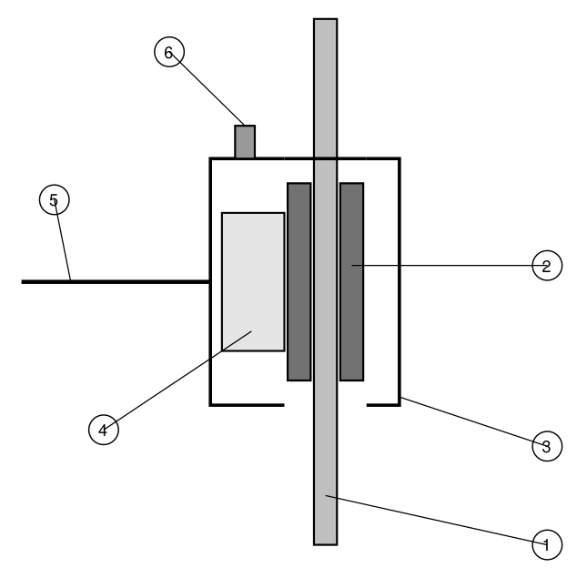
Figure 1: Disc brake (simplified cross-section)
1. Rotor (brake disc)
2. Brake pad
3. Caliper (caliper housing)
4. Caliper piston
5. Brake line (brake hose)
6. Bleeder screw
7. Complete the table. (4 pts)
Symptom | Possible cause
Brake pedal sinks to the floor | There is a fluid leak somewhere in the system, or the master cylinder seals are worn and fluid leaks past them inside.
Vehicle pulls to one side when braking | A caliper or its slide pins are sticking on one side, or the pads on one side have brake fluid or grease on them.
Squealing noise when braking | The pads are worn down and the metal wear indicator is rubbing on the rotor.
Steering wheel shakes when braking | The front rotors are warped (uneven thickness or too much runout).

8. What does ABS do, and how can a driver tell when ABS is working? (2 pts)
ABS (anti-lock braking system) keeps the wheels from locking up in a hard stop. The wheel speed sensors tell the ABS module when a wheel is about to lock, and the hydraulic unit lets off and reapplies the pressure to that wheel many times a second. So the tires keep their grip and the driver can still steer while braking hard. When ABS is working, the driver feels the brake pedal pulse or buzz under their foot and can hear a grinding or clicking noise from the ABS unit.
9. Describe step by step how to replace the front brake pads on a car. Include safety. (5 pts)
1. Put on safety glasses and gloves. Park the car on a level floor, put it in park with the parking brake on, and chock the rear wheels.
2. Check the fluid level in the master cylinder reservoir. If it's full, take some out with a clean suction gun, because pushing the pistons back later will raise the level.
3. Loosen the lug nuts a little while the tires are still on the ground.
4. Lift the car at the correct lift points and support it on jack stands or a lift. Never work under a car that is only held up by a floor jack.
5. Take off the front wheels and check the brakes before taking anything apart: pad thickness, leaks at the caliper and hose, and the condition of the rotor. Don't blow the brake dust off with compressed air. Use brake cleaner or a brake washer so you don't breathe it in.
6. Remove the caliper bolts and lift the caliper off. Hang it from the suspension with a wire hook so it is not hanging by the brake hose.
7. Take out the old pads and clips. Measure the rotor thickness with a micrometer and compare it to the minimum thickness stamped on the rotor. If it's under spec or badly scored, replace it or have it machined.
8. Push the caliper piston back with a C-clamp or a caliper piston tool, using the old pad to protect the piston. Watch the reservoir so it doesn't overflow, since brake fluid damages paint.
9. Clean the caliper bracket, put in the new clips, and put a thin layer of brake grease on the slide pins and where the pad ears sit. Keep grease off the pad material and the rotor.
10. Install the new pads, put the caliper back on, and torque the caliper bolts to the spec in the service manual. Do the other side the same way, since pads are always replaced in pairs on the same axle.
11. Put the wheels back on, lower the car and torque the lug nuts in a star pattern with a torque wrench (usually about 80 to 100 lb-ft on a car, but use the manufacturer's spec).
12. Pump the brake pedal until it's firm before moving the car. The first few pushes go almost to the floor because the pistons have to come back out to the pads. Then top off the fluid with the type listed on the reservoir cap.
13. Bed in the new pads with a few moderate stops and do a road test. Throw the old pads, rags and empty brake cleaner cans away the way the shop requires.

