3 - The Funeral on the Road of Graves
The eye of a specialist murderer squints, blinkless, from the dappled head of a painting of a horse. The eye is attached to a murderer’s body, in a black boarding-house room, on one side of a wall. It squints through the hole in the eye of the horse painting, into a candlelit room on the other side of the wall. The eye stares at two people - a knight in rusted plate mail, and his Lady of blue-black hair. The Lady is speaking, but the eye cannot hear what she says.
Another murderer, however, listens at the keyhole.
“My Cracked Cup Knight, I wish for us to walk under moon and cloak, through the Gate of Green Vines.
“I know your heart has just resumed its thudding.
“The assassins of Clan Wiege won’t smile alone for the slick crimson shine of my family on their short, sharp steel. Won’t laugh, but when all my house is burned, and I within it.
“Let us go. My heart misgives.”
````a````
Assassins!
You hear the crash - the thin driftwood door of your private room exploding inward, shuddering as it strikes the wall – and in an instant your hands are filled. A Pinecone Crest Shield. A Steel of an edge to wound the wind.
Three men in leather flood the room. In their hands are long knives. Good weapons for small spaces.
Your Lady shouts and backs towards the painting of the horse between the beds. You yourself are silent. Your limbs warm for the fight like stone under the steady pressure of a volcano.
To survive, you’ll need to withstand the assassins’ initial storm of blades. Keep your Pinecone Crest Shield raised as these first three killers stab and hack toward you. When there is an opening, after one of their swords deflects off your pauldron, retaliate with quick jabs of your Polished Steel Longsword.
With two men waxing the floor in shining blood the third charges. You bring your sword to bear, but too slow. An adult man’s weight falls against your breastplate. The impact sends you both shattering through the chamber’s window.
The ground catches you.
You land in the house’s inner court, breath stolen. A dead tree casts the skeleton of its shadow over brown grass.
You raise your shield to catch a crossbow quarrel. No time for gasping. You rise. You carve a second wave, half-a-dozen fresh knives in half-a-dozen bloodied hands. But the killers wear leather or common clothes. You have armor.
Razorshell
A scream - your Lady’s voice. You turn your visor, looking up. You see your Lady backing along an upper catwalk. Another assassin dogs her with his sword.
You must act swiftly and precisely from this point. Sever the jugular of the last killer in melee with you. On his belt you will find a razorshell, shaped like a fist-sized conch. Pick it up. Hurl it at the remaining assassin in the courtyard, the one with crossbow, his second bolt leveled already at your chest.
As the razorshell evaporates the crossbowman’s face into pink mist, run at him. Throw your shield and Steel aside. Dive to the crossbow with a crash of plates. Grab it, turn, and aim at the killer on the catwalk.
If you timed everything perfectly you will slay this final assassin, just as he raises his blade over your Lady’s blue-black hair. If you did not your Blue Lady will die.
````a````
Treading the Epitaphs
The smoke trails and bright terracotta towers of Ripe - largest of the towns on the mesa by the Lake of Tomatoes - have dwindled to fibrils against the slate-colored sky as you guide your Blue Lady’s palfrey along The Road of Graves. The Gate of Green Vines is a night’s distance behind you. The night passed slowly, and you met no travelers. A journey scored by the crickets and the owls, and the clopping of the palfrey’s shoes.
Dawn swings. As you round the bend in the next hill, you cast one look at Ripe.
Your Lady has not spoken all through the night. Now her voice comes softly from beneath the velvet of her cloak.
“Many miles... Still, killing eyes may see far.
“Every town on The Road of Graves encloses a Wiege Clan spy. At least, where it hugs the shore of the vast Lake of Tomatoes.
“My husband. My sons.
“My- my daughter.
“You and I, my faithful knight, will never find the warmth of a feather bed or the fireplace’s yellow shine, not here in our former castle.
“That castle’s windows are curtained, barred, and cold with frost.”
You consider what your Lady has said.
She’s right. Your poor Blue Lady. And poor Lord as well. He’s gone, and she has only your service left.
Serve well.
There are thin trails of smoke against the sky. You will stop at this next village. You know she needs rest - dreams, though they be ill. After, you must place more graves between yourselves and Ripe.
But to what end has she to go?
As you reach the next hill’s sun-bleached summit, a river-ribbon valley runs away below you. A mile further along The Road a small burg lies. Four score of homes and barns. Each home is shaped in the common style, like a sloping wedge of cheese. The homes are organized with their points facing each other as well, so that from your distance and height, each pair of homes is like a single hourglass, set on its side and sagging in the middle.
A woman stands beside The Road, a leather umbrella with holes mottling her white skin with sunlight swatches. She is pretending to count the blue needles on a spruce sprig, but looks up as you approach. She smiles. She wears a bright, short, yellow summer dress. On the inner crook of her left elbow is a paper lantern tattoo.
Magpie, the Pleasuress
“New faces, or repeat-comers?
“A knight and his mistress, my apologies.
“Sir knight, you come to The Cat in the Jar on the eve of seasonal disaster.
“When the harridan’s moon shines, as it does tonight, the town augurs that the shining orb will crash from the heavens. We pray through the night to the seven necromancer-gods. Pray that our souls will be inducted in their service.
“It makes the cats howl and stir.”
You may allow Magpie the Pleasuress to guide you into town.
There is not much happening at The Cat in the Jar. You can exchange your Lady’s palfrey for another horse at Brandt’s Carriage. At the center of the burg, where a bridge of mossy stones connects The Road of Graves on either side of the river, there is a fountain shaped like a hand. Set a bronze coin in the palm, and you will receive the blessing of Gallbladder.
Magpie eventually clasps your gauntlet, kisses it, and bids you and your Lady farewell. You wave behind her as she goes; your Lady does not.
Making your way around a throng of farmers as they chant around an effigy of the moon, your Lady’s voice reaches you.
“Though the sun is broad now, it is a lunar kind of shadow that seems to stretch under ever post and tree.
“We’ll keep to ourselves tonight.
“A place to shut our eyes from the world’s light, our ears from the world’s buzz. Then we must journey farther.
“Anyone in this hamlet may have the eyes of the Weige Family.”
The Cat in the Jar
Your search for lodging has not proven fruitful. You have been turned away from one homestead after another. Every person you speak with seems more concerned with impending impact of the moon.
The village is haunted with cats, both feral and tame. You’ll have to watch where you step; a sabaton on a tail will summon a pride-wide scream of wrath, and no villager will speak with you thereafter.
You may come across a small gulley on the western side of The Cat in the Jar. Here, the town has built several glass-bubble enclosures. In each enclosure is a single cat, each of a different color. If you cross the bridge, naming of the colors as you pass each, you will find a dove’s-egg stone on the opposite end.
As night approaches, you find a farmer who will lodge you in his barn.
Though you intended to set out again with haste, a vicious storm of sleet and rain rolls in that evening. The streets are a goulash of mud. The Road is firmer but slick, exposed to the frosted winds of early Spring. You will be forced to remain in town for several nights. The first is the most unpleasant; Sleep flees far from the chanting townsfolk and the screams of the alley cats.
Despite the poor weather there is a cheerful atmosphere throughout The Cat in the Jar (after the threat of this harridan’s moon has proven to be yet another false one). This cheer pierces through the drizzle and the frost.
On the second day of your visit, the waifish Magpie brings you and your Lady two crusts of rye bread, with some cheese from a black she-goat. It is not fine food, but your Lady doesn’t seem to mind. As she eats you step behind a horse stall. You remove your helmet, pauldrons, gauntlets. As you wipe the armor down, first with brick dust, then tallow, a pool of rainwater in the horse stall catches your eye. You stare for a moment at the reflection of your face in the silver water…
Later, you put your Polished Steel Longsword to use. In a burrow by the river bridge there lairs a small troll. You lure it out with some of the cheese that Magpie left, cut it down, and boil it’s skin for fat. The rest of the town is more welcoming afterwards.
````a````
The Melted Statue
An enormous pile of blue, rock-hard wax sits between the two halves of an hourglass-house pairing. This was once a wax golem, which defended The Cat in the Jar from levy men. It has seen better days.
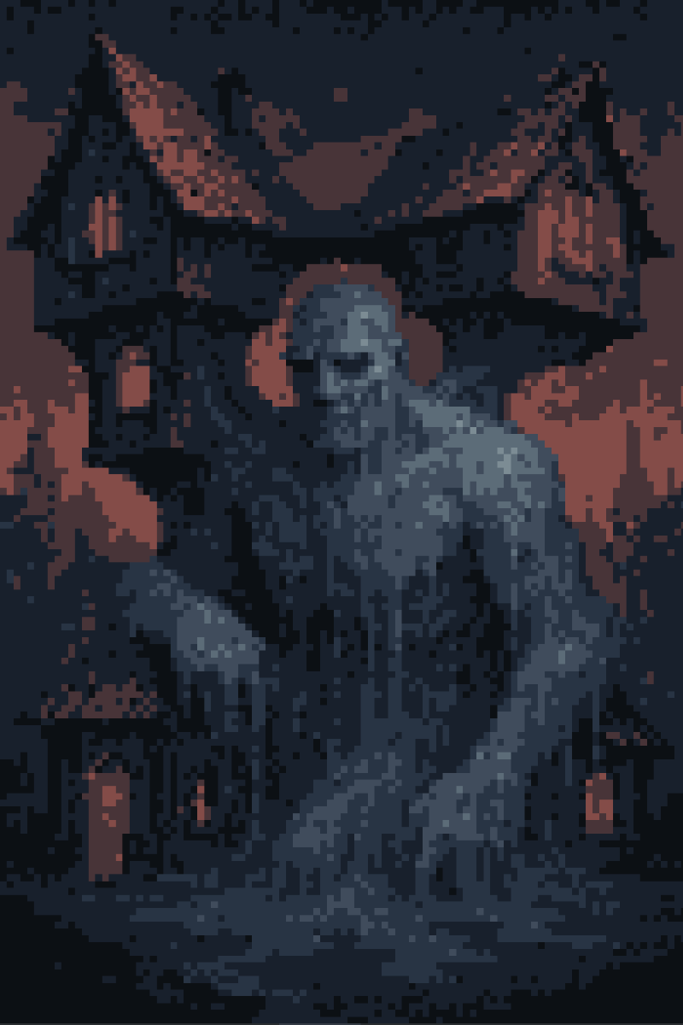
````a````
Magpie left your Lady a spare umbrella when she brought the bread and cheese. This one sports holes as well, but you hold it over your Lady’s blue-black hair as you stare at The Melted Statue. It gives some protection from the rain.
“When I sleep, it is my daughter I dream of most.
“She asked us once, when she was too little to see over the half-door of the kitchens, for a servant like this golem.
“When I see her, her face is white as any ghost’s, but there is a shadow under her skin. Like the inside of an eggshell before it is cracked.
“Why her face in my dreams? Why not my husband’s? My sons’?
“...
“Magpie - she is poor, but good also.”
The longer you remain the more you discover in and around The Cat in the Jar.
Farmer Skein’s Scarecrow  Farmer Skein will pay a fistful of square coins for the destruction of scarecrow, which has attained sentience. One strike will only make it cackle; only repeated blows will slay the thing. | The Snake Totem  Every knight with a sword, passing through The Cat in the Jar, leaves their slash in the wooden totem of the snake, beside the lavender-painted house on the east side of town. Many knights have come before... | Castiron Inn  A local cottage that rents rooms. Colloquially called the Castiron Inn, for the enameled iron pots that decorate its long fireplace mantle.
Initially, the owner of the Castiron Inn is quite reticent.
“The Inn opens after dark, sir.
“The Inn opens after dark, sir.
“The Inn opens after dark, sir.
“The Inn opens... Oh, you’re friends of Magpie. Need a bed and roof?”
Later, you and your Lady and Magpie sit before the cottage hearth. Your Blue Lady stares at the fire, a sadly serene light reflected in her eye. Magpie coughs, then says that she once dreamed of being a Lady herself, in The Court of the Leather Dragon.
Quiet hours slip away.
````a````
It is during your third evening at The Cat in the Jar when you recognize that Magpie’s tuberculosis is nearing its end.
You arrive at the young woman’s “home” just as the sun is burning dusky gold across the little crests of the river. It is a dark mossy hole in the side of the river wall. You can see that, when the water is high, it floods this small chamber where the woman lives and works.
Magpie lies within on a mat of straw. The bed provides an hour’s-worth of comfort for two, and not a moment more. Lice and mold wage an endless war in it.
Magpie is bloodless. She coughs almost continually, each cough rattling through her whole skeleton, so that you seem to see it vibrate under her taut skin. She holds a cloth that was once white to her mouth as she coughs. The cloth is now grey and crimson.
You try to press your Lady back towards the opening, the air feeling damp and sickly in your lungs, but she brushes past and kneels by the dying girl. You follow your Lady’s example. Magpie’s eyes shine as she sees the two of you, with luster that only a dying eye may shed.
“My greatest wish was once to be an elegant woman. Just as you, your Ladyship. COUGH COUGH COUGH.
“I am not ashamed. My means were ever small. I only wonder at how my dreams have humbled themselves. Once to be a Lady. Now only-
“COUGH COUGH. Your Ladyship, and you sir, are the first to visit my cave in three years, who have not left at the hour’s end.
“I am afraid. I am promised no spot on Those sacred labelled stones. I fear a mancer will steal my soul. I hope they don’t want the souls of whores.
“COUGH COUGH COUGH COUGH.”
Your Lady takes one of Magpie’s hands in her own before you can stop her. She takes her waterskin as well, and when Magpie pauses in her coughing, holds it to the girl’s lips.
You must throw that drinking skin away when your Lady isn’t looking. She is too proud and brave, she should not be here.
This girl will die soon. You’ve seen this before.
You might still give the girl the shield of after-life. You would need to carry her to a sanctum. And the nearest is fifteen miles, back the way you came, back in Ripe.
Swear to do it. You know it is the right thing. So do the right thing.
But how to protect your Lady also? She must stay here, hidden. And you must convince her - proud and brave - to stay.
Later, while Magpie sleeps more warmly under your woodgreen woolen cloak, your Lady whispers in the dark of the cave.
“My cracked cup knight, I implore you. Guide me back to that castle with the cold curtained windows.
“You and I must take the girl to the humming cathedral in the burg of Ripe.
“You thought the same? But you would leave me sleeping in a place safe and quiet. No, I will not stay.
“We will return to Ripe and claim this girl a stone upon The Road. Under an epitaph she may lie still.”
On the morning of your fifth Day at The Cat in the Jar, Magpie’s body lies cold and silent as earth beneath a glacier.
````a````
“Üres Cézék Metelnek Zéllel”
As you carry Magpie’s body across the fields of the common dead - over the bridges of the crisscross ditches - you hear the echo of deadspeech.
You spin in the direction of the voice. A man’s silhouette stands at a little distance, vague in the frosted mist. In the same moment you drop the body in your arms, and draw Steel.
Then your Lady cries. You glance and see a thousand shapes stretching in the ditches.
The Wiege Family has found you, and they’ve sent a mancer named Birchbark to finally end your Lady’s line. His spell has gone out to all the empty dead in this field. Now a monsoon of moldering cats rises from the quadrated, sogging ditches.
Begin the battle by cutting through the two-dozen cats that rise up from the four ditches enclosing your current square. Each raised cat takes a single swipe to destroy, but their numbers shamble beyond an eye’s count.
With the initial wave hewn, cross the bridge to the next square of field. Work your way toward the mancer. At each stage you will have to cut through another wave of the dead cat flood. Above all, be sure to chop any cats before they reach your Lady. Your shield and armor protect you from their pricking bones, but your Lady spathiphyllum skin may be torn to crimson strips.
As you reach the field adjacent to the mancer, Birchbark cackles like a giraffe. You cannot tell whether his laughter is mirth or madness. The mancer’s face is hidden by a mask.
Sorrowful Father Mask
One of twenty-three alabaster masks, which allow the wearer to assume a false identity. The Sorrowful Father grants leather skin, and a resistance to lesser cuts; but fire will burn the wearer to a crisp.
You hear your Lady scream. Glancing back, you see her grappling with a human cadaver - Magpie.
At the same moment the mancer whips a rope-glaive from his robe. The bridge between you and the mancer dances with the flying iron glaive.
To both defeat Birchbark and save your Blue Lady; first, block the two flying thrusts from the rope-glaive with your shield. When the glaive become tangled on the bridge, use the moment to turn and sever Magpie’s head. Her body will fall full-dead into the ditch. Block the next glaive-strike, leap across the ditch, and before Birchbark can utter a spell, cut his throat.
Be sure to retrieve the Sorrowful Father Mask from the mancer’s body. It will be useful at a later time.
On the next rise of the slate-colored sun you leave The Cat in the Jar. Using three pieces of blank vellum, you barter passage on The Witch Manth’s ‘Roadhugging Riverraft’.
The mill-paddle of the boat sends ripples in the wide ditch-river. A bullfrog croaks, and splashes to the banks. The village has disappeared behind a woody hill.
Standing at the rail of the barge, you watch the epitaphs of That Road familiar and strange slide beside you.
There are some who lie under those stones - old stones, the dead of older Times - who were less deserving of their place than Magpie, that Pleasuress.
Who are you though, to speak of ‘deserving’? An old knight in a cracked body.
These epitaphs here may be old as the necromancer-gods. But there will be fresher stones, the farther you go from Ripe.
The Blue Lady’s voice breaks your lapping-water reverie.
“You, my knight, were thinking of that wan girl.
“Many are those laid in the common fields. We cannot know on what wind her spirit will beat its feathers, but it may find a fine straw nest.
“She said she wished to be a Lady.
“She was fortunate. She died in ignorance of high station.”
````a````
The Gate of the Ten-Plates Ghost
A huge arch of stacked, mortared, sharp stones shadows both The Road and the ditch-rivers to either side.
The gateway was built two-hundred and thirty years ago. It was built to ward the Ten-Plates Ghost away from Ripe. The Ghost is dead, but the gate remains.
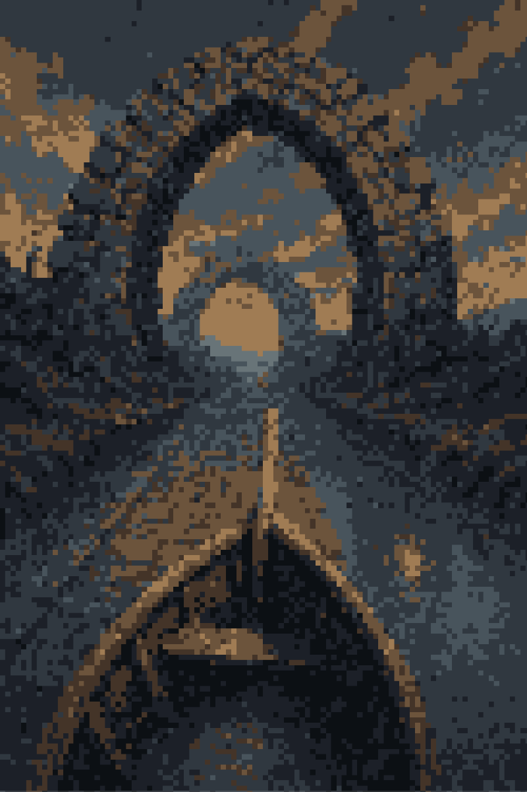
````a````
As you approach the Gate of the Ten-Plates Ghost, you recall that your Lady has never come this far from Ripe.
Two guards stand on The Road underneath the stone arch. One holds a spear, another a sling. Both stare at your raft without blinking. One speaks.
“You’re not traders from Ripe, I know that.
“Witch Manth doesn’t bring traders on her raft, do you, Witch? I know that.
“Oh.
“I see you’re just a knight and his sorrowful father.
“If you’re going to the western cities on the shore, make sure you carry a sword. The western cities are dangerous.
“I know that.”
You float under the bridge’s cold shadow.
You float out the other side.
The land changes little beyond the gate. At least at first. The same trees still cast their shadows over the terse brown field grass. In the far distance behind, The Lake of Tomatoes still shines red under the slate-colored sun. The redness of the lake is reflected in the wide eye of your Lady’s palfrey, where it stands nervously on the bucking raft deck.
In The Time of Dying lies a Road of Graves.

