2 - The Sewer Under Khoroduhn
In March the rain always falls heavily on Khoroduhn. For the rest of the year, the mountain town matches the cool, arid climate around The Lake of Tomatoes. But Khoroduhn lies under a special affliction – a necromancy for a forgotten storm, marshalled by one of the seven necromancer-gods to commence with Spring.
The whitewashed homes of Khoroduhn, and the guarded stone wall, glisten wetly in the shadow of the keep, which perches like a stone owl on the summit. Rolling along the descending hills, the rain slides continually down walls, over the cobblestones, in gutters, as if this rain scrubs at some city-wide stain.
Always the water runs. Deeper. Deeper. Always deeper down.
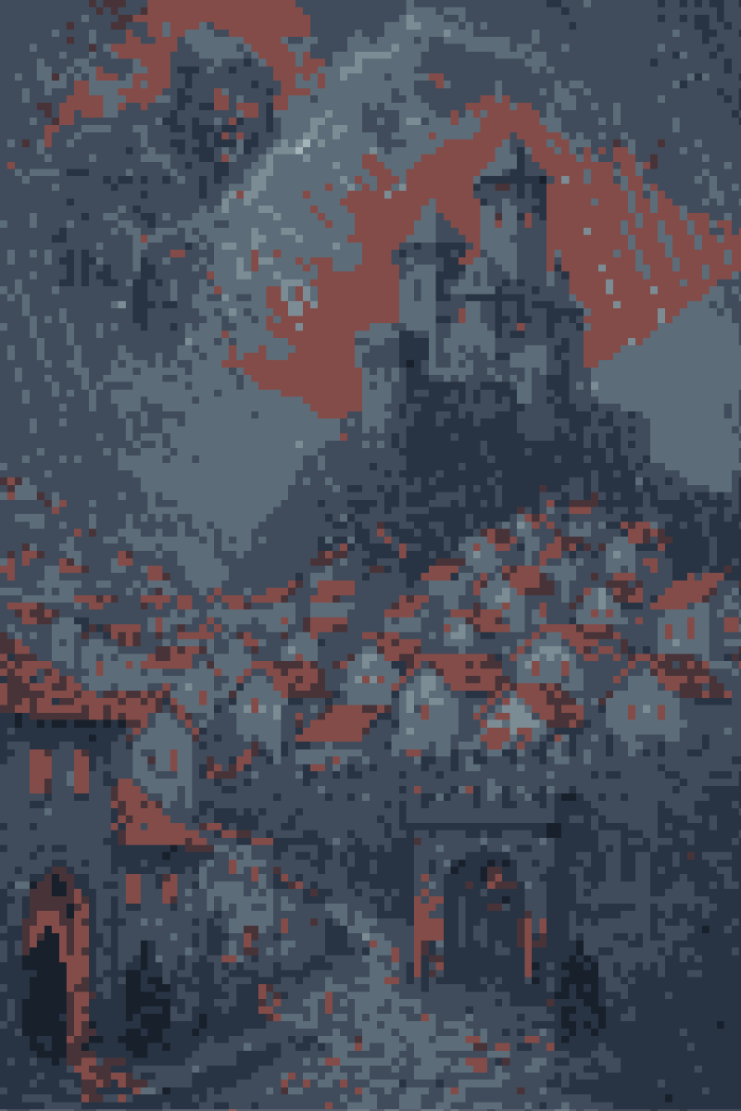
````a````
The Serpent Shelf
In a dry, stone-girt, dark central room of the keep at Khoroduhn, there is a library, with one long, spiral shelf. And at the top of that shelf is a book with yellow pages. And on the first page of that book a pale, sliding fungus has devoured the name of the man who laid the first stone of Khoroduhn. Whoever this man was, his family, and twelve families after, have won and lost Khoroduhn each in turn.
At the bottom of the spiral shelf are three books, spanning three hundred years. And every first name in those three books bears the family name of - Weige.
The Weiges of Khoroduhn are one of the strong families around The Lake of Tomatoes. Their Majordomo, Pigburne, has guiled the lawful assassination of thirteen children in rival families. The family are rumored cultists of The Red King, with black rites, and secrets in deep places.
As far as the wind-scarred stone of the keep rises on the mountain, still twice as far do the corridors run under it. In the larders live the wine and the rats. In the mausoleum, skull after skull stares blindly and thoughtlessly from black sockets, or sockets glinting with sapphire and ruby and onyx. And deeper still, under the bones, are the sewers.
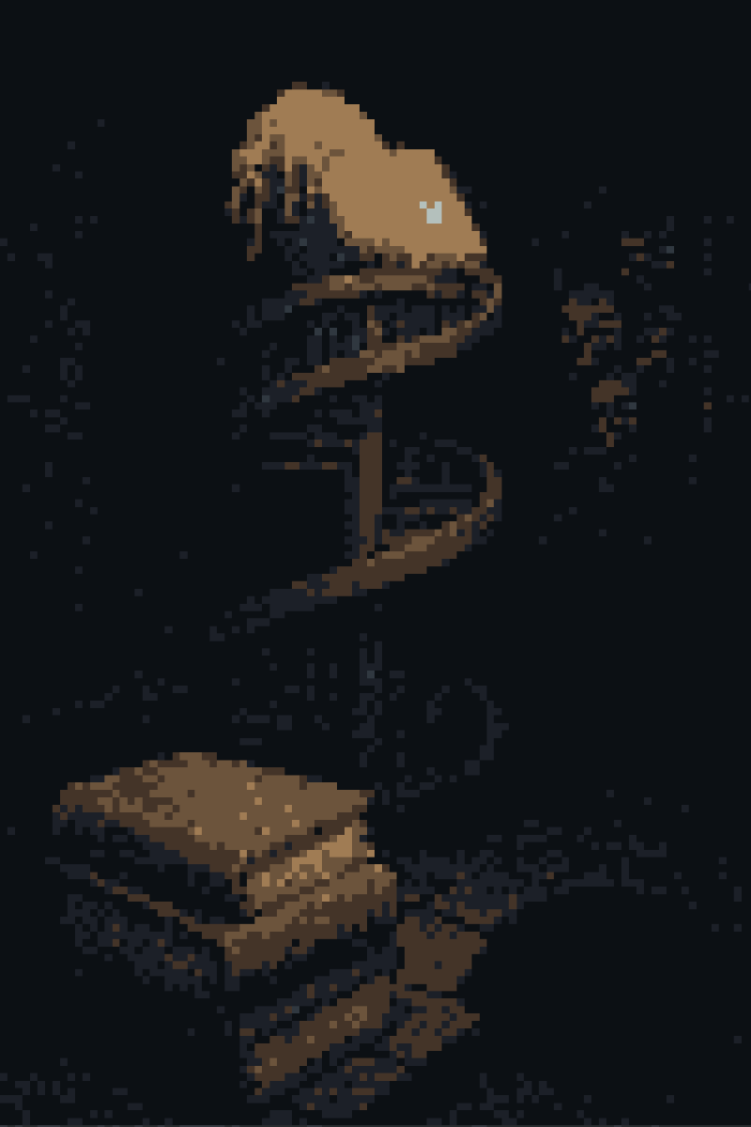
````a````
A woman cries the daily portents.
“His Grand Corpulency, Gallbladder, Lord of Lake, predicts for today.
“Mold shall grow on your first crust of bread.
“And the floodwaters rise unto the street of-
“Eh?”
The old crier stops. She holds a hand over her face. Water streams along her wrinkles.
A man stands backlit on a balcony, on the high eastern parapet of the keep. A Weige family retainer, thinks the old woman.
````a````
Pigburne
In a high chamber of the eastern wing of Khoroduhn, the shaved-headed, middle-aged, swarthy Majordomo of the Weige family leans over a desk crammed with jars.
“This one is a Trumpet.
“See it? Look as I hold the jar the near the candle.
“You can know this one by its brown color, and wavy edges - but not all mushrooms are as kind to the constitution as the Trumpet.
“Never have I given the incorrect mushroom for another to eat.
“Do you want to know why?”
Now that Pigburne has turned to look in your direction, the moment has come to perform your unpleasant task. You shut the balcony door. Without pause you then step to the soundproofed door to the hall. You throw the bolt shut.
Pigburne strokes his chin and begin to speak. You know you should finish your task, but wonder what might be learned from his words.
“Hmmm. Now let me see what this means. You are not a usual guard.
“To have reached my chamber and locked my door, you will know that this wing is barren. And I am trapped. You carry no visible weapon, and although I am not young, nor am I some cripple or nonagenarian.
“But where is it written that a family assassin must work with a knife? The right and bloody hands will do the job.
“Will you answer me which family are your masters?...
What if I told you, assassin, that though this room is proofed against sound and sight, yet still I -”
If you let him speak until he gets to the part about his secret alarm, it’s already too late. Nevertheless you’ll want to finish the job you came to do. Grab the majordomo around the neck with your pale, scarred hands. Pull him out of his chair - he has a knife hidden under the desk.
The strangling, if not honorable, is quick. In a minute Pigburne will cease to thrash.
You’ll want to keep the padded crimson armor and cloth mask disguise of a Weige retainer. It may aid your escape, and the mask hides your cracked face. You should also retrieve the knife strapped under the Majordomo’s desk. Use it to open his sternum and cut out his heart. It will prevent common necromancy from resurrecting this evil man.
As you rise from behind the desk, you can hear the rain hissing dully beyond the balcony door.
Then, farther off, a bell clangs.
````a````
Before you go, be sure to grab the following loot from Pigburne’s chamber.
Song-Singing Fungus  A mushroom with a hidden mouth under its cap. Sings in the presence of uncontrolled dead. | Constellation Chart  This chart, drawn on thick paper, shows in lines all the major constellations visible from The Lake of Tomatoes. One set of lines, the Amber Ox, has been circled in ink. | Jeweled Dagger  Ornamental, but worth a few coins at least.
When you hear fists hammering the chamber door, it’s time to run. Use the rope you stowed on the balcony to scale down the castle bricks and the cliffs below.
````a````
At last your feet touch cobbled stone. The bells roar from the keep that is now above you.
As you turn you see a guard in padded crimson. A real retainer. He stares at you. Fifteen paces. Too far. In his left hand he holds a signal horn. He raises it to his lips.
Instead of a reverberating peal, you hear one wet crunch. The man crumbles. Embedded in his spine is a Morning Star, covered in horn-like spines. Another man - lean and with a dark face - rips the star free by the handle.
R the Killer
“Escaping?
“Same. The name’s R the Killer. I’ve just bust out of their gibbets.
“I’m no sympathist, but two red hands are better than one.
“They’ll be locking the gate soon. What say you?
“Team?”
The streets of Khoroduhn can be a maze for strangers. To navigate the city, take the following course: a left at Larchroad, straight on for thirteen intersections, right down a long and crooked stair (watch out, the rain runs cataract-wise over the slick stones), right through Black Janus’s Tunnel, Left into Squallor’s Road, and finally up the wooden scaffold on your left after the third bystreet. By following this path, you also avoid most of the Weige Family retainers.
R the Killer complains when you turn away from the nearest exit, The Gate of Spears, but still follows.
Why does this extra shadow darken your step? For him, doubtless, tonight’s work is too usual.
Perhaps you should have driven him off before coming here. Pray to the seven necromancer-gods that he is no secret foe.
````a````
After climbing the scaffold of what was once an opera house, when all the houses lay under the shadow of older families, but under the Weige shadow has become a common inn, you arrive at your rented room.
You enter an eight-foot by ten-foot box. Rafters run grey with a century of dust. Something which glints in the open door’s light is stowed in the corner of one rafter. Sparse furniture occupies the floor of cracked wood boards: two straw mattresses, and a paper screen with holes. A plain but clean green wool cloak covers one mattress.
There are no windows, but someone has at some time painted two false ones in blue on the wall beside the door. The paint is flaking now, so that the windows are a calico of false sky and whitewashed stucco. An iron coal lamp, behind the screen, hisses and grants the room a small amber glow.
You have hardly stepped inside when, from behind the screen, you see movement.
Your Blue Lady.
The cloth of her dress rustles as she rushes the Killer behind you, a dagger in her fingers. She stops when she sees your raised palm.
“Two strangers stepped into my chambers, where I waited as a stranger also.
“My Cracked Cup Knight, this is no man with silver-trimmed doublet and dancing shoes, who slinks at your heels.
“Oh, but inform to me first about that older shadow whose footsteps haunted us at night.
“Has your hand freed us from the Weige family?
“May the ghosts of my husband and my sons and my daughter turn their faces fully to that other life which follows after?”
You pull down your equipment from the rafter - you will need it soon. Your armor, your helmet, your Pinecone Crest Shield, your Polished Steel Longsword; you take these behind the damaged screen, so that you may remove your disguise and equip yourself without revealing your face.
R the Killer meanwhile introduces himself to your Lady, with remorseless honesty. You hear your Lady’s distaste for the Killer in her monosyllabic replies. The sardonic nasal note in R’s voice makes you think the feeling is mutual.
You buckle your shield-strap tight, and check that your rusted right pauldron isn’t getting caught on your breastplate.
Soon enough you hear a distant but sharp banging. R the Killer goes to the door, opens in a creak’s-worth, and sneaks a glance at the street below.
“City militia. Driving people off the streets.
“Cursed luck. They’ll have shut the gates by now.
“Oh chivalrous assassin - we should’ve run out when we had the chance.
“This delicate damsel here has cost us our escape.
“Look at you now. A speechless, clanking tinman.”
R the Killer has cracked the door again, this time with his Horned Morning Star handy. He’ll wait in that position for two minutes, after which he will slink out alone.
You’ll want to make a choice before the Killer leaves - he’ll follow if you pick an escape route. His fear that the gates are closed is all-too-logical. Trying to escape through any guarded way will see you slain, your Lady captured.
Rumor, as it slips from cupped ear to cupped ear around The Lake of Tomatoes, speaks of a way in-to and out-of Khoroduhn, certainly hidden.
````a````
Six ways lead to the sewer.
The Haymarket Well  A railless hole in market square. | Deathless Catiph’s Mausoleum  You can find this marble sepulcher atop a gravel hill in Khoroduhn’s largest cemetery. Inside the sarcophagus with the scratched-out name there is a secret tunnel. | Greeg’s House  This way is closed to you at this time.
Abandoned Shack  Lies one street to the left of the Gate of Axes. Well-guarded by Khoroduhn’s black-market cabal, Ruddynails. | Khoroduhn Keep’s Wine Cellar  Your worst bet. | Hasodeki`s Crucible  This seemingly-innocuous clay kiln, in the Weige’s Family’s most esteemed mancer’s tower, serves as a portal to a hidden sewer chamber. The activation word is ‘Bindweed’.
````a````
Humming, crackling, your lamp and R the Killer’s torch usher you into the sewer. The twin sources shed a huge light in such a small space.
Having descended a manhole via a slick iron ladder, you enter into a tunnel which shines with thicker slickness still. Lumpy slime - some species of sepia-colored mold which blooms with drooping magenta petals - festoons the blackened brick walls like ivy on a manor.
You cannot hear the rain’s hiss. Instead, a river babbles; not only from farther down or up the tunnel, or from the little flow of greywater trickling over your sabatons, but through the slimy walls.
R the Killer raises his torch, peering upstream, then down.
“You’ve got the armor, tinman.
“You lead.
“What a cruddled gas we’re in. Wish I’d brought some sniffer snuffers.
“Hope that droopy bluebell of a Lady is willing to get her silk socks filthy.”
Finding your way through the tangled sewer veins will not be easy. The tunnels, all of differing sizes and grades and flows, merge or split in seemingly endless junctures. As you explore this greywater grotto, you’re likely to encounter some sentient flotsam.
The Ratwall  The sewer stream flows right under this living wall of ratskin and ratheads. Probably some mancer’s work. The gap is too narrow for you to squeeze through. If R the Killer still has his torch, you can hold it against the wall. The hair will burn for a moment, before the entire structure collapses with a loud, leathery, ripping sound. If R doesn’t have his torch, you’ll have to backtrack. Don’t try cutting a way through - the wall eats Steel, and any arm holding it... | Mermaid’s Lair  Best to avoid this bloated siren. If you do choose to fight her, try getting under her belly. Her fish eyes can’t look down.
The Penny Lizard  This enormous salamander collects all the treasures which slip through the grates in the city above. You run the risk of encountering it at any passage in the sewers. While it’s lair (and hoard) cannot be found, killing the monster and cutting open it’s stomach will net you the day’s catch of square copper coins. | Stitched Soul Men  This colony of grey-eyed men, with stitched-together flesh of variegated colors, live inside of eight stone lanterns, in a vast carved cave at the intersection of two main channels. At a single gong-note from one lantern, they’ll attack. You’re given no choice but to kill them.
Eventually your lamp and R’s torch will both burn out.
If you grabbed The Cat’s Eye Spear from The Hall of Diffusion when you retrieved Mool’s Spit, you should call upon its magic light now. Hold it aloft. Whisper the secret word carved on its haft. A glowing yellow cat’s eye will shine upon the tip of the spear. R has a free hand to hold the weapon.
Hours of wandering later you find a rough stone tunnel. It runs for a score of paces – with each the rush of the sewer water swells in your ears. The tunnel emerges quickly back into the slimy brickwork of the regular sewer.
One of the stitched soul fanatics crouches at the end. He holds a sharpened femur-bone. R emerges first from the tunnel - when he does, the wild man leaps.
R sees the movement just in time. Bringing the spear arcing sideways, deflecting the club, in the same motion he swings his Horned Morning Star in an uppercut. The horns burst up through the madman’s chin, into the mad matter of his brain.
R bends over the corpse. He points to a tattoo on the shoulder.
“Red King’s Brand.
“They are his devoted, wrathful dreamers.
“Regular cross-patches.
“A priest told me once-”
You stop. Listen. Three paths fuse this intersection, including the carved tunnel. Three streams trickle from it. Down the central egress you hear the sewer roaring slightly louder.
The tunnel slides higher overhead, and spreads apart, as you lead your Lady splashing through the merging rush of filth. The Cat’s-Eye spear in R’s hand shows trio after trio of lesser pipes spilling their runoff into your thoroughfare. Soon the water rubs over your knees.
As if passing through some mystic foggy threshold, the three of you materialize into an impracticably vast cistern. You stand upon a wide stone ledge which rings a pool of unknown depth. Twelve rivers of sewage splash over the ledge, into this pool. The water just below you gently whirls. Instead of grey, the water changes hues in an ever-shifting kaleidoscope of indigo and emerald and bright cherry-red.
At the whirlpool’s middle, a mound of sediment and rags forms an island over the reservoir drain. Sitting atop this mound is an oversized mahogany loom, actively rolling and clicking.
A giant figure, sitting in a rocking chair at the loom, notices your entry.
````a````
Gigan Othok
One of the Silk Giants, or ‘Gigan’, Othok was formerly a powerful weapon in the Weige family arsenal. He followed without fail the commands of Buster Weige, until that member of the house was slain in a bread riot. The death of his master drove Gigan Othok to madness - he turned upon the family. His sinewy flesh proved too tough for any blade to cut, but the Weiges managed to drive him into the sewers. The giant was thought to have starved to death decades ago, and was forgotten.
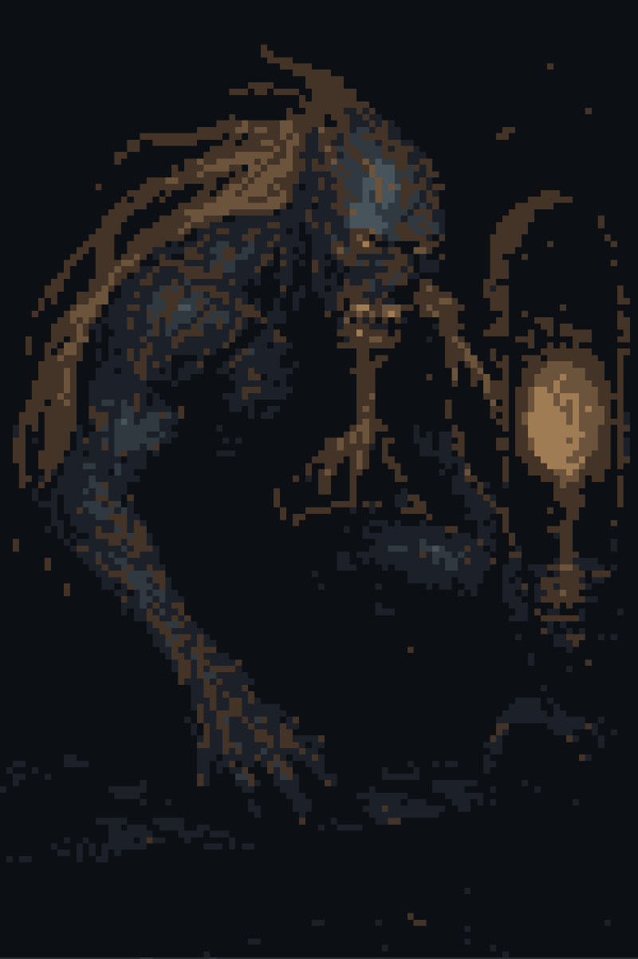
````a````
When the fight begins you won’t have time to do much else than draw your Steel. As a Silk Giant, Gigan Othok is incredibly nimble. He will spring from his island to your position on the ledge in a single bound. In doing so he’ll instantly knock either R or your Lady down, removing them for most of the fight. You’ll only be able to defend one of your allies with your Pinecone Crest Shield.
Your best option will be to block Othok from striking your Lady. R the Killer can’t inflict much damage to the hard-skinned giant with his Morning Star anyway. On the other hand, the vision of a beautiful woman will leave the silk giant hesitant while your Lady is still standing.
The first moments will be frustrating. Gigan Othok kicks with both feet or swings with his left arm to attack. These attacks are fast, and hit hard, but you can block them. Inflicting damage however is almost impossible. Every time you swipe at the giant he will leap backward or skitter up the wall like a spider. The most you can inflict are glancing blows, which are not enough to cut through the giants saddle-like skin.
The key to this fight is light. You’ll notice that Othok keeps his right arm in reserve. He uses it to hold his tunic of rope and sewer rags over his face. He keeps his head turned slightly away from the Cat’s-Eye.
To win, wait until Othok leaps away, then pick up the Cat’s-Eye spear. When he leaps back in, hold the light forth. The giant will scream and stop in place, swaying, stunned. Use this moment to ram your sword through his tough abdomen.
````a````
As the giant’s dying scream fades to a gurgle, then to nothing, the swirling sewer water refills the silence. The colors of the water merge, first into grey, then to a surprising silvery clarity. The distant mahogany loom on the island of sediment – which has been clicking, clicking, clicking all this time - stops.
R the Killer rises from where the giant tossed him. He is battered and dizzy, but otherwise unharmed. He will live to kill again, it seems.
You hear the light splash of your Lady’s footstep, then feel her hand upon your right pauldron.
“The breath heaves within you still, my Cracked Cup Knight.
“Be easy once more. Yours was the better arm.
“Look. Across the pool.
“Some slimy stones of the wall have crumpled like loose mountain snow. A false wall, a woven net of slimy silk.
“See that deeper umbra beyond?”
The Showering Gorge
The tunnel leads for a hundred - or perhaps ten thousand - paces. It seems an interminable length of darkness, broken only by your little light. The crash of the draining sewers seems to retreat behind you. You are left with only your trio’s splashing footsteps on the flat, carved rock.
Then, hissing again. It rises to meet you as you press along the tunnel.
A tiny mote of light appears in the expansive black. At first you do not trust it, but the light grows until it is the size of a walnut. Then an orange.
You emerge on a grassy ledge, leaning out over a small gorge. You hear splashing. Looking over the ledge, you can see the other sewer pipes emptying into a natural stream.
The rain sprinkles lightly about you. At the same time the slate-colored sun is shining, the sky dimly illumined in the dawn glow.
To the east lies Khoroduhn. You have travelled far underground. Of the bells in the distant keep upon the mountain, not even the faintest echo of a clamor can you hear.
Behind your visor your eyes glance upon your Lady.
Look how her face is raised to the sky. See how the rain washes the slime from her brow and her hands. Are you not ashamed, to have let her soil her person in the sewer of your enemy? No pride should you take in guiding her to this safety, in slaying the master of her tormenters. You have served. This time, the service was a foulness.
Still, perhaps you may be pleased with the way she looks now. She seems, having followed you through that darkness uncomplaining, to have cemented her nobility, though her house is ruined.
You may be honored to serve her.
The rain falls steadily - it always falls steadily, over Khoroduhn and its keep and its city and its mountain, in the month of March. The rain washes the slime from your armor. It cleanses your Blue Lady’s face and hands. It washes the gore even from the Killer’s Horned Morning Star.
The walk through the final tunnel seems to have broken R’s stupor. He stretches his arms, and wags his head like a dog. He turns his dark face toward you and your Lady.
“No ceremony. I’m done here.
“I’m too well-known a Killer around The Lake of Tomatoes. It’s off to Middlemoss for me.
“You think you’re safe here? No. That family’ll just find another master killer. Might be me, hahaha, if I weren’t cutting loose.
“Take my advice. Make the trip to Middlemoss.
“Alone though. I’ve mixed enough with tinmen and eggshell women.”
R the Killer leaves you and your Blue Lady alone in the rain.
In The Time of Dying lies a Road of Graves.

