4 - The Graveside Inn
“Of the means and motives of necromancy much is written.
“Of the ends, none discerns.”
- The Book of Winterdemon
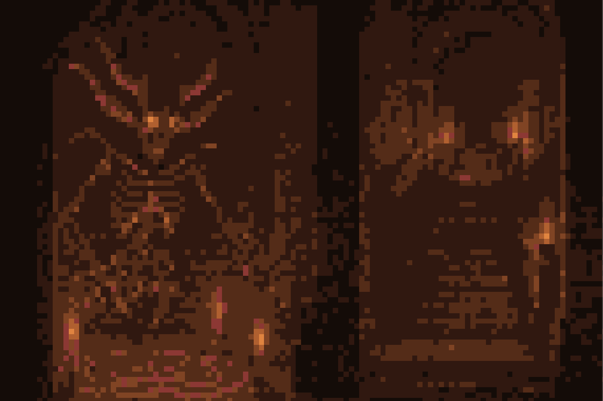
````a````
Your Blue Lady turns under the thin grey blanket of her bed, through the early night. You yourself hardly sleep these days. You watch her from the tall red armchair, sitting where its high back is lashed by cobwebs into the corner of your rented chamber. You notice your fingers tense around the hilt of your Polished Steel Longsword, sharp in its scabbard. You relax; your Steel can’t cut dreams.
At midnight your Lady wakes. She says nothing for many hours. But as dawn’s periwinkle creeps up the bottom panes of your window, she speaks in a quiet voice.
“My daughter...
“Oh my Cracked Cup Knight, I have seen my daughter tonight.
“Her ghost. Darkly white like the bottom of packed snow. But on her cheeks, a blush like skin left too near a candle flame.
“Why of all my family do I see my daughter in the corner of any chamber poorly-lit?
“Why her silence? Why her blush?”
Even if reply were possible the opportunity is denied you. Four heavy knocks rattle your room’s painted ash door. The walls, the floor - even the iron oil lamp on the bedside table - quiver.
Opening the door you behold a mass of body filling the entire frame.
The Steward
Serving as clerk, caretaker, cook, and all other menial and managerial roles at The Graveside Inn, this man seems too large for a human being. You cannot take his whole aspect in at once, no matter how far back you move. Without craning your neck, only his bristling grey mustache is visible. You suspect he was a soldier - a soldier’s cudgel hangs like a chopstick from his continental hipbone.
The Steward asks that you come downstairs. Something dreadful is in the dusty air.
Your room lies in a far corner on the highest floor of this ancient mansion-turned-inn. The descent is long, the stairs many. The boards make no sound under the massive Steward’s feet, but each of your own steel clad steps summons a communal groan from every surface. You pass by one window on the stair. Outside over the trees and grass, a late March frost is master.
The steward leads you in silence. He holds forth a four-pronged candlestick for light. There are many mirrors in the hallways; each time you pass a mirror, four ghost-candles flare to life, then die with your passing.
You enter the dining hall. Seven other guests at the Inn sit around a long, felt-topped table.
Timberwolfe  White hair. White beard. White bearskin cloak. Eyes: black. He breathes lugubriously. |  | The Late Poet  This troubadour is a Living Bones, a walking, conversant skeleton. Speaks often, usually in rhymes.
Miss Leatherworker  The woman wrings her hands constantly, like she is trying to squeeze all the blood from them - yet her face is wind worn and placid. |  | Six-Cats-Hiding  Wears a set of purple silk, many-folded, fraying robes. The pattern on the robes shows hundreds of orange cats.
Doctor Hoof  A short and bald doctor. He wears two normal-looking boots. | Frida  Female. Blonde hair, parted down the middle, and shaped like two huge golden cauldrons upon her head. Her body is disproportionately small. She looks anxious. |  | Melancholia  Every time you look at this girl you notice a faint smell of burnt sugar.
The steward clears his throat.
“Hrrrummm. You see that Madam Strock is absent.
“She is murdered.
“Hrummm.
“I went to give her - Hrrrum - tea. She did not stir.
“HrrrrRRRrrrruuuuuuMMMMmmmmm.”
You turn your visor to your Blue Lady.
This happening upsets her. You know that look of sorrow, where the lines of her face seem to darken.
You will protect her.
These others seem unconcerned. Even the steward, with his face so high, wears a brow more-worried by wrath than wonder.
The Late Poet speaks up.
“The doors are locked; the windows barred.
“The steward’s words surely sound true.
“Unless it be he, (and it’s surely not me!),
“Why, the killer must be one of you.”
At this point you can try a few options. Leaving seems like the obvious choice. When you reach for the front door’s iron handle, however, you find the enormous oak slab locked. The Steward refuses to let anyone out of the inn until the killer is found and punished. (A note: you are better off not picking a fight with The Steward. At least not while he’s fired up. He is too strong for you to beat at this juncture).
The other guests will proceed to take a breakfast of eggs and black bread with honey. Your Lady suggests that you and she search the scene of the murder for some clue.
Madam Strock’s room lies in the Yellow Wing. To reach it, search for a flight of stairs with a dead crow on its third step. This goes to the sixth floor of the inn. From there, take three left turns, until you pass through a room of furniture covered in dusty sheets. Do not lift any of the sheets. On the other side of the room is a stair which will take you back down to the third floor. From there, follow the yellow chalk marks on the walls, until you come to a mahogany door hanging loose on one hinge.
Madam Strock’s room presents a scene of pure catastrophe. The red velvet curtain hangs partially torn from its rod - slate-colored morning streams through the barred window. The cabinets are turned over, and one chest of drawers has been cleft completely in two, the splintered halves digging into the old wooden boards. Madam Strock lies atop her bedspread in a red pool.
If you perform a thorough search, you may find the following pieces of information.
Jasmine  There is a faint scent of jasmine perfume in the air, but it is overpowered by a damp, musty, earthy odor. | Loose Straw  Five long pieces can be found stuck in the threads of the rug. | Scroll Shreds  A pile of paper shredding, yellow with age, and bearing fragments of deadspeech, have been swept under a tall cabinet in the corner.
Your Lady walks to the bedspread, but does not touch Madam Strock’s body.
“Will her face ever stand lit on memory’s painted ceiling?
“Will she hang from the misty wall of some beloved child or grandchild’s thoughts?
“I am sorry for this sorrow, my Knight.
“Your faith is sweet honey.
“My daughter-dreams, however, remind me-”
A scream reverberates through the inn, drowning your Lady’s words, entering and swirling within every chamber like a breeze crossing through open windows.
You find the scream easy to follow. It’s echo leads you on, an echo rolling out for an impossible length of time. You chase this echo to the second floor.
Tenant Theater
Seven rows of small wooden chairs with leather cushions sit in circles around a stone stage. A path of broken legs and rent cushions leads from one of two spectator doors, through the rows of chairs, to the great slab. Atop the slab, Melancholia lies. She stares at the ceiling. There is a knife sticking up from the center of her chest, and you see it is the same knife which the steward used to slice the breakfast bacon.
Miss Leatherworker stands against the wall to the side of the stage. She wrings her hands. The echo of her scream still reverberates, though her mouth is now closed, her face placid.
But as the other guests filter in through the spectator doors, Miss Leatherworker raises another series of short, echoing shrieks.
“Strolling after breakfast!
“Me. The girl. Doctor Hoof.
“A trio. Safer.
Alas, separated! In the Room of Windows.”
The word ‘windows’ will still be quivering in the upturned legs of a few chairs when The Steward arrives. At the sight of the body, he clears his throat, then draws his chopstick club and swears to bludgeon whoever is the killer.
If you say that the knife is his, The Steward will stamp a chair into splinters, point a huge round finger down into your face, and say that the murderer could just as easily be you. Or, your Blue Lady. (You should resist the temptation to draw your Steel at this second comment - it will start a fight).
The only sure info you know at this stage is that neither you nor your Lady killed Melancholia or Madam Strock. By interviewing guests, you can learn the following clues as well.
Unless Three Share a Lie  Timberwolfe, The Late Poet, and Six-Cats-Hiding have all been together since breakfast. | Unless Two Share a Lie  Miss Leatherworker, Doctor Hoof, and the victim Melancholia were together until an hour ago. Miss Leatherworker and Doctor Hoof became separated only a quarter of an hour ago. | Unless Three Share a Lie  Frida and The Steward and The Late Poet all heard the chords of a crow-and-tincan throat singing from The Yellow Wing half-an-hour before the murder.
Frida, as she is staring at the body, wraps her long fingers around the two blonde cauldrons of her hair.
“I KNEW this would happen.
“A curse stalks this inn, these rooms, our poor skins.
“Once a man lived in these rooms. Kriecher of Graveside.
“Kriecher loved and lost the heart of a harridan, and she cursed him under her moon. Now he is a vampire, living but not, frozen far away.
“His house will kill any other who sleeps between its walls.”
````a````
A night passes. Morning wrings dew from the grass.
````a````
The next death will always be Timerwolfe. You cannot save him. You will find him in Madam Strock’s room, lying atop Madam Strock’s body. Their blood has dried together on the bedcover.
The Late Poet stands beside the bed when you enter. His skull wears no expression, but the bones of his thumb and index finger pinch his mandible in a pensive manner.
“Death’s not so bad, I’m well abreast.
“This troubadour is unimpressed,
“With fleshy stock. They’re overdressed,
“You must be very hot.
“This troubadour covets a star,
“A muse worthy his sad guitar,
“Someone befitting sung memoir.
“But you, sir knight, are not.
“This Lady here, though, rings my bell!
“Your blue complexion, mademoiselle,
“Another face- Ah, vain to tell,
“For a name, I haven’t got.”
Your Blue Lady turns her eyes away from The Late Poet. You lead her from the room.
It is while you are escorting your Lady back to the first floor, in search of the other guests - in the middle of a wide chamber of wooden colonnades thick with drapery of dense grey spider velvet - that something slams you. Your armor crashes against the floorboards. Unhuman fingers wrap your metal boot, and drag you away.
````a````
“…I will hold your hands…”
You jolt from the dream. No gentle sunrise of consciousness is yours, but a rushed return to your cracked cup body.
Your attempt to rise is checked by a rope wrapping your torso and arms and legs. You are bound, tied in your plate armor to an old but fine, cornflower-blue, velvet chair. Light, filtered through a marigold-tinted window, dances slantingly in the dust of the space. It is afternoon.
The prodigious Steward has been pacing before you. He stops when he sees you thrashing. He wears your sword on his hip like a kitchen knife.
“Did the - hrrrrruummm - thrill go to your head?
“I found you where you killed her, between the Shell Shelves, in the fossilarium.
“Hhhhhrrum. Why’d you cut her buns off?
“They shall be preserved. Hrum. In the museum. But once I find your false Lady -
“- hrrrrruuummm - the murderess, your comrade in slaughter - HHHHRRRRUMMMMMM-
“-I’ll roast you in that steel.”
Nothing you now say will convince The Steward to release you. He is convinced that you or your Blue Lady killed the other guests. Nor can you break your bonds; the rope he tied you with is woven from the silk of the Sewer Worm. Your binding is stronger than the iron on the window.
You will need to wait, tied to the velvet armchair, for at least one more death. When The Steward is told by The Late Poet about this fourth murder, point out to him that you couldn’t be the killer. He will untie you, but he withholds your Polished Steel.
The fourth victim, and the two after, occur in a random order. You can discover a clue to the killer near each of the bodies. The specific clue you receive depends on where that victim died in the order.
Miss Leatherworker  1st - A belt, perfectly stitched, hangs from the rafters beside her.  2nd - Written on the bottom of her shoe: “Corn crow. Corn crow. Corn crow.”  3rd - Found near the Closet of Masks, where every wall bears faces made of plaster. | Six-Cats-Hiding  1st - A bowl of curdled milk lies spilled at his feet.  2nd - Found nailed to the top of the dumbwaiter shaft.  3rd - More loose straw, and a wad is stuffed down his throat. | Doctor Hoof  1st - The last line in his diary is cut off: “I should have locked the window anyway, knowing-”  2nd - There is one empty, labeled vial in his satchel - ‘Ill Omen’s Heart’  3rd - A hole-riddled, sun-bleached top hat is locked between the death’s-vice of his fingers.
````a````
You march down a corridor of paintings. Every painting is a portrait, no two faces alike. One bald man with a bulbous nose and rosy, pox marked cheeks ogles you with two soft brown eyes. A woman, half her face behind a veil of mouse skins, glances sidelong in your direction. A dark-skinned boy of ten watches you behind painted lids.
You were separated from The Steward some hours ago, in the ballroom, where every moment the floors and walls change configuration. You wander without your Steel.
Dusk approaches.
The Sweetmeats Room
As the day reaches its close you step into this chamber, high on the thirty-third floor of the mansion. A dozen potato sacks hang from railroad spikes driven into the rafters. Each sack is swaying, as if there were a breeze, and drips some syrupy fluid. Additionally, there are two large, multi-level, silver displays. Each one is crammed with candles and bonbons.
You see The Late Poet. He is pointlessly masticating a bonbon beside one of the displays. The Steward lies dead - a sea of viscera - at The Poet’s bony feet. The Poet holds your Steel.
When he sees you enter The Late Poet flourishes the blade in your direction. Only once. Then he laughs. He tucks the weapon into its scabbard and offers the scabbard for you to take.
You must act fast to survive this next attack. As you reach for your weapon something rams into your pauldron. You’ll crash against the floor. Whatever it is continues its momentum. It hits the display where The Late Poet stands. There is a thunder crash of metal and chocolate. The silver dishes send reflections of the candles spinning around the chamber, dazzling your eyes.
Ignore the lights. Raise your shield in the direction where you last saw The Late Poet. You’ll feel another impact against the front of your guard - you still can’t see what’s attacking you. Whatever it is hurls you against the other display, but with your shield raised you will survive. Another crash and hail-like thudding, and the candles gutter out. The room goes dark.
In the aftermath, you hear the clucking sound of dry bones on floorboards. Then, a raspy, fading noise, like a broom sweeping slowly away.
After many minutes your striker finally conjures a small flame from a candle wick. You scan the room. Bonbons lie everywhere. Mixed with them are The Late Poet’s scattered bones.
By now you’ll have probably realized that this killer isn’t one of the guests - unless they be one of necromancy’s products, one of its ends. It isn’t your Lady.
Take your Polished Steel in hand, knight. Hunt it.
One thing you can try is going back to the scene of each murder. It may take many hours to navigate the creaking, silent halls. If you do, you’ll find that each body, and even the blood and other signals of killing, have vanished. The inn feels tenantless.
As you walk your ear may sometimes catch that sweeping broom. Rasp. Rasp. Rasp. You are never able to trace it. Each time you follow it into a room or corridor, the sound has ceased by the time you enter.
The final confrontation will always happen in one of three rooms.
The Belfrey  The heavy bronze bell has snapped from its line. It now lies embedded in the splintered, uneven floorboard. | Octopus Atrium  This central garden is full of brittle shrub wood and small but deep pools. | The Roaming Room  This room roams the halls on a hundred marble feet, like a centipede. It seems docile. You may enter through it’s ‘face’.
The specific room makes no difference. When you enter, you will see your Lady lying atop a table. She does not stir, but you see her breathing.
When you run toward her it will trigger the final battle.
````a````
Gallowspook
This tall and lank wight may only be summoned under the light of a harridan’s moon. It’s sackcloth skin bristles with the feathers of albino crows. It is heavy despite its skinny frame - the body is stuffed with hazelwood chips. The Gallowspook wears a huge cloak of woven straw, which swishes and sweeps the floor as it walks. In its left hand it carries a candelabra with six low-burning candles. There are always places for more.
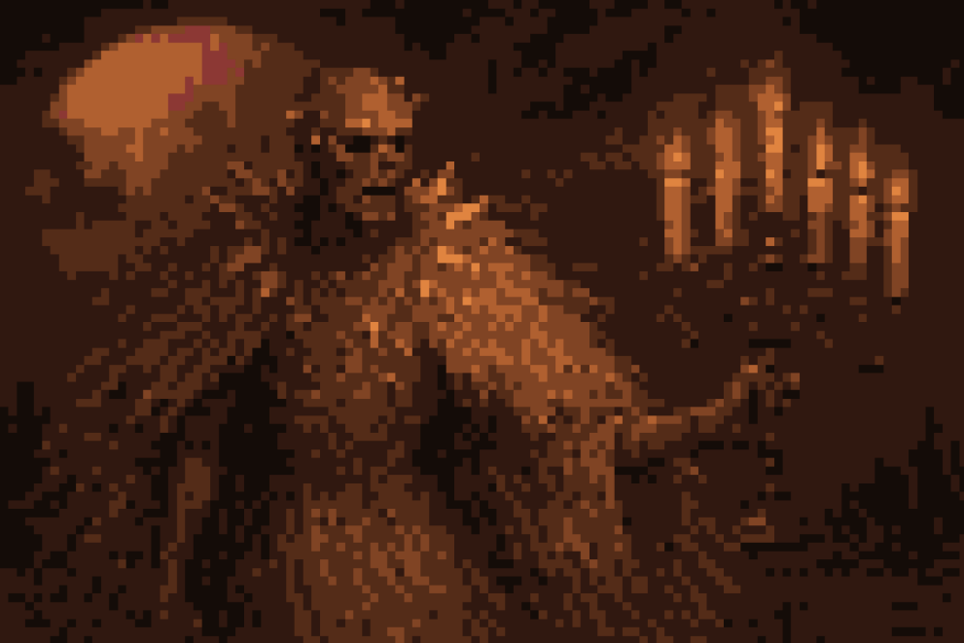
````a````
You don’t have to slay the Gallowspook to win this fight. You just need to survive until the candles in its candelabra burn out at dawn.
The Gallowspook moves fast. At the start it will try to envelop you in its straw cloak. If it succeeds in catching you, you’ll find the cloak to be airtight. You will suffocate. Don’t let it catch you. Whenever you find the fibrous garb closing around you, cut an exit with your Polished Steel. The Cloak sews itself back together, but at least you won’t be caught.
Occasionally the monster will try a more conventional punch with its free hand. Or a heavy kick. Keep your Pinecone Crest Shield up and ready. Even one of these blows, aimed right, will crack your bones.
You’ll also want to stay relatively close to your unconscious Lady. The Gallowspook will sometimes lose interest in you as a target, and rush to attack her. Be ready to intercede. Cut at the monster as often as possible. You probably won’t kill it, but you can slow it down with repeated blows.
Keep your breathing even, keep your Steel and shield ready, and you’ll triumph over this oversized scarecrow.
From some deep cellar, an ancient grandfather-clock booms with the morning hour. The Gallowspook vanishes in puff, it’s white feathers floating down, disintegrating as they touch the floor.
Your Lady stirs. As you rush to her side she sits up. She rubs her head, then blinks with remembrance. When she sees that you are unhurt, her face adopts its customary aged sorrow.
You hear voices from without. A moment later, you see a crowd bustle through the door into your room. It is the seven fleshy guests, led by The Steward. The latter looks at you. He asks who you are, and if you would like rooms for the night.
They are fleshy ghosts. Each week repeating their deaths.
A few minutes later The Late Poet wanders in, rubbing an olecranon. When he sees you he shrugs.
“Of the means and motives of necromancy much is written.
“Of the ends, none discerns.
“But to meet again this beautiful melancholy Lady is fitting,
“That memory I might upturn.
“You once cast out some offspring, that I’m certain.
“His face I crossed,
“In Middlemoss,
“But that is your concern.”
In The Time of Dying lies a Road of Graves.

