6 - The Three Guests
“I stepped out from a garden of tall roses, where the thorns cut my skin.
“I walked, my cracked cup knight, for I know not how long.
“Suns rolled like a spinning wheel.
“But when I reached where the path stopped, I found a different garden.
“It WAS different.
“Yet though the petals were pink not red, the thorns were already pranked with my blood.”
Your Blue Lady’s words seem muffled as she descends the creaking stairs into the common room of Cobweb’s Hotel. It is as if she spoke through a wool tarp. This is expected, given the space; the hotel and its owner seem accurately-named.
You lead your Lady through a network of fallen beams and opaque spiderweb curtains. Your Polished Steel Longsword would make short work of the dense drapery, but you keep it sheathed. The owner, Cobweb, has threatened “grievous wounds,” if you snap but a strand.
Cobweb follows you with two owl-wide eyes, as you take your Lady’s hand, guiding her under an angled piece of oak festooned in iron nails. You hear the flint-skinned man’s whistling breathing quite clearly. It is a sound small enough to pass through webbing which snares heavier voices.
Your rooms were not spacious, but you and Lady travel light. You slept soundly. Your Lady seats herself now in a plush, slightly-motheaten armchair before the hearth, a space mercifully free of webs. You station yourself behind her.
Her words give vent to hurt that is in her heart. Poor woman. You would say something to comfort her, were you not beholden to quiet. Besides that, what comfort can you offer? She has lost her home. Children. Her husband your lord.
What do you think she expects in these new miles of The Road of Graves? The same feuds and assassins that brought her house to ruin.
You must admit she may be right. Or is this a different country from The Lake?
The Middle of the Road...
You walked here, once. That was as a boy. Time and your cracked body have let leak much of your memories about this Middle.
Three others are already seated in the cushioned chairs which circle the hearth of Cobweb’s Hotel. The low blue flames behind the grate lend a glacial sheen to each of their faces.
R the Killer  Though he has never turned that Horned Morning Star against you or your Lady, yet you do not like this man without scruples. | Wrathmaige  Your newest and only friend. One of The Walkers, bitten during your journey across The Whiteeye Waste. His broad forehead sparkles in beads of sweat, and he shivers despite the warmth of the hearth. | The Mothy Widow  Says nothing. Stares at the blue veins on the backs of her olive hands.
A cup from the bar may offer your Lady some small comfort. If you navigate your way through the pale veils and the slanting forest of fallen beams, you can order wine at the bar from Cobweb.
Cobweb’s flint-colored skin makes his temper undecipherable. His voice when he speaks is like hearing several people talking at once, and you are only able to distinguish snippets of any given line.
To order any beverage from cobweb, you’ll have to piece together the exact name of a drink. This is no easy task - Cobweb lists several kinds of wine, but each has an elaborate, sentence-long name, and the names are broken up by his irregular speech pattern. Pick out as many of his words as you can. When he stops speaking, you may ask for one combination. If you give a combination which isn’t an actual beverage at the hotel, you’ll have to listen to the entire many-voiced, disjointed list again.
The actual drink names are: ‘My dazzled sight he oft deceives a brother of the dancing leaves’; ‘Hope and Despair meet in the porch of Death’; ‘The night that followed such a morn had worn a deeper shade’; and ‘Forests may fall but not the dusk they shield’.
No matter which drink you bring to your Lady - even if you return with no wine at all - R the Killer will suddenly laugh like a bag full of dry leaves.
“By my jiggling lungs. This knight has never lain so much as a finger on a woman’s skin.
“Have you, Steelclad?
“Your laced lady doesn’t want wine. She thinks she wants death.
“She ought to rub with some of The Road’s weird pleasures.”
Like the mothy widow your Lady holds silence. Unlike the widow your Lady stares not at her hands, but directly at R the Killer.
R takes out a long pipe (with someone else’s initials) from a front fold of his padded melee-coat. He places the stem to his thin lips. From another pocket he takes a pinch of some black leaf and stuffs it in the bowl. There is all of a sudden a lit match between the index and thumb of his left hand, like a miniscule reflection of the flame in the hearth, burning bright, violent indigo. He places this to bowl. He inhales. He exhales a spicy smoke.
“What? You want me to talk?
“You want a taste of the Weird. The Pleasant.
“Just a cold tongue-tip’s worth.
“Let me fill my belly with this smoke once more.
“Ah, that’s fine. Warm and scratchy.
“Lean in close then. Mine’s a doe story. Skittish. I’ll need a fur-soft voice.”
THE STORY OF R THE KILLER
You remember her.
Nilghiri.
Now she was a someone to fill a pipe’s worth of time.
One day in Autumn you walk along one of those thin dirt tails of The Road, and enter the two-score burg of Emily’s Gold. The old and young of the village quiver at your coming. Each of the men finds some form of stick tipped in iron.
When they discover that your killing is for gold, however, they lower their weapons.
They have work for a good killer.
An uncontrolled dead thing haunts a wooden castle, which sits in a glen a day’s march from the village. The villagers don’t trust this undead to stay in its home. They have seen it through the trees, when they chance to linger outside past the slate-colored sunset.
They have a man, half-priest half-mancer, who thinks he might exorcize the castle’s unliving host. But, the priest-mancer won’t go alone. Not without protection. They ask you to use your Horned Morning Star to protect the priest. The villagers will pay you, they say, in thirteen bronze arm-rings which they dug out of an old warrior’s grave.
You accept.
Hours before dawn you leave the warmth of your bug-rich mattress of barn straw. The village’s mancer-priest travels beside you, through the weave of oaks and spruce.
Your travelling companion is a short, squinting man of somewhere between thirty and eighty. His long widow’s-peak - like a stretched, fuzzy, grey finger pointing down his forehead toward his nose - seems to be a key component of his spellcasting. Throughout the journey, you catch him stroking it between the index and thumb of his left hand while muttering quietly in deadspeech.
You reach the wooden castle before dusk. Its walls are, in fact, nothing more than thick oak trees grown side-by-side. They are grown so closely together that you cannot see so much as a crack between the trunks. Their lowest branches are twenty feet above the ground, and short compared to the trees’ heights, like the branches of redwoods. Beyond the wall you see a chapel and a keep, each made of still-higher trees with woven limbs. The castle continually creaks and groans.
Your companion’s voice rises out of muttered deadspeech into plain language.
“Nippy nippy nippy. You’re the rough? Of course you are.
“You’re coarse and quiet.
“Name? Wait! Don’t say it. Better if my mind’s clean.
“Find the castle door. Or a castle window. Lead lead lead us in.
“I’ll sleepen any restless ones with a lullaby.”
You find the front door of Castle Celadust with little bother. It is a recessed tunnel, packed with the interlaced roots of two trees. A sign before the tunnel says: ‘This castle’s doors will never open’.
The sign is accurate. You won’t be able to get through the main entrance. If you search around the exterior though, you’ll find a hole in the trunks on the southern portion of the wall. Termites have bored through the wood. You are able to break away the infested, spongy wood to widen the opening, allowing you to pass through the exterior wall.
Once inside Castle Celadust, you can start your search in The Mother’s Chapel, the barracks, or the main keep. You may encounter Vigorous Blood or Skinrights in any of these places.
No matter where you start your path eventually descends into the dungeons. You’ll have to fight the Rolling Walrus Bones that occupies this floor. From a distance the Bones will launch beams of Walrus Fire, which you’ll have to dodge. In melee, the Bones will engulf you and tear you to pieces; keep your distance... Dodge the fire beams, and use a thrown hammer or other blunt object to slowly chip away at the skeletal tumbleweed. If the Bones does get in close, you can still destroy it by getting in one good swing with your Horned Morning Star.
In the blink of an eye her breath is on your neck. Nilghiri. She manifests out of a portal in the stone on your right which wasn’t there when last you looked. As you spin, raising your Morning Star, her eye catches your eye.
You hear the mancer-priest shout, stammer. But his voice is muffled.
Nilghiri’s eyes are like two enormous plates of faceted onyx. The sere, loose, decaying gauze which wraps the rest of her body is nothing to you. Her hair is uncannily vital, lustrous gold curtains peeking through her wraps, and her lips are full and red. It is those bottomless onyx pits, however, which cause your Morning Star to dip, your jaw to hang slack.
You do not hear the priest’s body when it strikes the floor.
“Invader.
“Not full of hubris, though. Not as was that jabbering voice of the mancer.
“More handsome, as well.
“Sink into my eyes. Breathe the music of my voice.
“You’ve slain my guardians. Now, be guardian yourself.”
Your service to Nilghiri the mummy is largely spent patrolling the root made floors and ringed wall that form her castle of trees. You kill foxes and minks that slip through the wall with a stone slingshot, and keep the population of rats down by setting out piles of yellow powder. You tend the garden. You bring cold water up from a deep well.
Sleep is an old habit now - you no longer need sleep. Your nights are spent standing over the limestone sarcophagus of your mistress. She leaves the stone lid open. While the moon and stars wheel you stare at her body. She is beautiful, though you cannot see her skin.
When did you break from this hypnosis? When did your service change from forced to willing?
She was lovely to see, and never a cruel woman. Not in death.
You remember her eyes, even to this day. Ah, how the seasons have rubbed indistinct her voice, her hair, her red lips. Everything. But not her eyes. You still have those.
Your pipe is burning low. There isn’t much smoke left to tickle your lungs. You should come to the end while your throat’s still warm.
How many days, years, pass for you in Celadust, you don’t know. It cannot be more than half a decade. When it is over your face has no new wrinkles.
Over your time in the castle you occasionally fight with other mercenaries hired by the village. Most of these are young blades. You either scare them off or kill them.
After seven lesser fights, you meet a fellow professional.
King Ikno
Before you can defeat King Ikno you’ll have to kill his two henchmen. The brambles will slow down the warriors, so stick to the tangled rooms of the castle. Once you have them thoroughly caught up in the roots and vines, close quickly. Open their skin with your knife. (Your Morning Star needs too much room for this kind of blood work.)
After his henchmen are dead, King Ikno will attack you. His great axe is better at cleaving through the tangled plants, but Nilghiri will arrive just after he breaks loose. With her stare instilling a chill into his body, Ikno’s hands will turn numb. He’ll drop his axe.
Give this ‘king’ the same end you gave his subjects.
Each dawn as Nilghiri wakes those gemstone eyes seem softer. Smoother. After some time they look less like gems, more like wet globes; two ink-filled jellyfish.
One day, you catch the mummy as she sings The Elegy of the Equinox. The song allows her to see in the cold when the stars shine over her linen covering. She catches you watching her, your face reflecting in the corner of her obsidian eyes. She sings on. Her voice rings like the residual echo of hunting-cat’s purr.
An evening later you and Nilghiri sit together on a bough, in the high canopy of the tallest tower of Celadust Castle. You watch the owls swoop for mice against the velvet sky.
“A too-willing servant you are. You wear no resentment in your face when you guard my sarcophagus.
“No resentment, but worse.
“To feel warmth within my breast again - that would cast me down to ash as no blade yet has.
“I release you from my spell. Leave this castle, handsome invader.”
The spell was broken already. You stay.
The next dawn as she awakes and finds you in her wooded grand hall, Nilghiri threatens to melt you with her necromancy. You drop your Horned Morning Star to the roots with a hollow thunk. You hold your arms wide with fingers splayed.
That evening, you lay down. Together.
Did any ever sleep more soundly than you slept in that grave? In that grave of Nilghiri’s? That night?
Imagine that a seed falls from its ash tree in autumn. Before it can find the soil, a man takes it, and places it in a wooden box. All through the winter it lays in the box, while the snows fall. Then, when Spring brings its birds and rain, the man buries the seed in the soil at last. To return finally to that warm earth for which it was destined from birth. That is how you felt. It was a warmth you never knew before. That night.
In the morning you wake next to a pile of ash-covered linen. Nilghiri is gone.
When the hunters arrive later that afternoon you pretend you fought and exorcized the un-living beast of Celadust Castle. They take you at your word. They offer to guide you back to the village.
Before you leave you make sure to collect a few of the valuable items which the mummy collected over the years.
Feral Pickled Farie  A tiny fairie suspended in a jar of lime-colored brine. Dead, yet there is some magic left in its body. | Glass Merigold  Orange. | Coldsoil  This pot of special soil can keep undead worms alive... Dead? Alive-dead?
You return to the village. You are paid. You leave.
The castle made of trees has begun to rot in the succeeding years. It is a ruin now.
And the village? Two summers ago, you heard that a priest of The Scratcher came, and sewed a miasma over the crops. Those villagers who survived left for other dwellings.
You walked on. You spent your thirteen bronze arm-rings. You made more square coins. That is living on The Road of Graves.
````a````
R the Killer exhales the last smoke that is in his lungs.
In the chair nearest to the fire Wrathmaige stirs. The pallid Walker breathes deep with a shiver.
“This man said about a seed buried in warm earth. His seed was caught in Early Spring Frost, I am thinking.
“But some seeds live to be tall, tall trees.
“COUGH COUGH.
“Wonderful things are on this Road.
“The Mystery in a handful of dust. The songs of whip-poor-wills. The things that live in a very old wood.”
````a````
The Story of Wrathmaige
A bootlace-shaped loop, of a knobby-skinned root, of a spruce that uphold the sky, in The Old Soulwood – this catches your foot. You stifle a shout as you trip. You land on your shoulder at the top of a wooden slope.
Your fall ends when you have rolled to the bottom.
Your body, battered by the trunks and turf, stings, yet you stifle complaint. You catch your wind in silent gasps; the smell of moss and rain and old forest earth fills your lungs. You listen, but hear no bird’s call. No other fearful animal howl. The only noise is a single cricket that seems to follow you through the woods, repeating continuously a high, squeaking, rusty-wheel chirp.
Your companions are dead, and you’ve lost your way back to The Road of Graves. The Old Soulwood’s writhing junipers roll up and down the shaded earth in all direction.
You listen longer, but there is still only the cricket. Having caught your breath you swallow and wet your throat.
“Anybody is there? Help. Please.
“I have seen a gigantic monster. A lynx, but as big as a bear, and wide like a salamander.
“A Periwinkle Forest Cat.
“Help me to be not lost. I promise I’ll serve you.”
````a````
The Periwinkle Forest Cats
The Periwinkle Forest Cats patrol The Old Soulwood. Any traveler who strays from The Road, where it passes through the woods, may catch the slit yellow eye of a cat. Periwinkle Forest Cats are not always aggressive, mostly they attack only when cornered. They sometimes befriend children and women.
It is said by certain among the oldest ghosts that these cats are the spirits of the Bouldsatr, the giants who took up residence in The Old Soulwood, when the widowed mistress of a demon king first made the forest garden. While their bodies were hunted to extinction, the giants refused to die. They possessed the bodies of the native wild cats, to become the forest’s eternal guards.
So the oldest ghosts say.
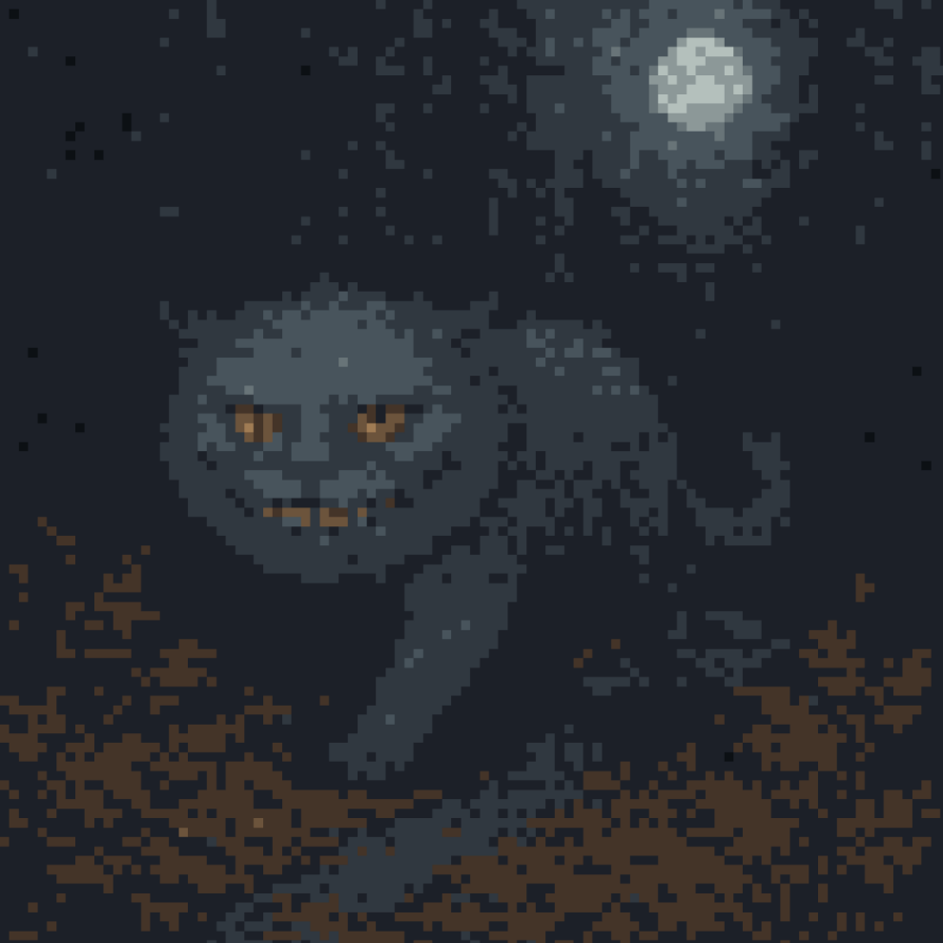
````a````
Strange Light
The semitranslucent light emerges from the branches above you like a line of fuchsia drool. This wisp’s glow is so soft that you only notice it when it has coagulated to a ball inches from your ear, and sheds a faint warmth against your cheek.
You can leap to your feet and draw your spear, but you’ll scare the wisp away. The stalking cats will probably track you down before you find your own way out. Instead, keep your body movements slow and your breathing steady. You should hold out your hand slowly to the glowing ball, as if to a horse. Don’t mind the tingling sensation - that is the wisp tasting your emotions.
If you have any Speech Cheese, eat it now. You’ll be able to understand and speak in the tinny voice of the wisp. By speaking tenderly to it, you can convince the wisp to reveal secret underground entrances to the five major temples in Middlemoss.
You think - COUGH COUGH COUGH - think the glow light is not a usually friendly one. Some trees will leak off the souls they’ve ensnared, like sap, to lure others. When you taste the sap, it will shrink you, until you are small enough for the tree’s digestion.
COUGH COUGH COUGH.
But you think that the stalking Periwinkle will rip your bones apart if you stay lost. And the night is darkening the canopy. Following a stranger-light: it may be worse than following the cuckoo in the woods. But, may be good.
What else can you do? Follow - COUGH - follow mushrooms?
Through the branches there rises the terrible, titanic hunting cry of a Periwinkle Forest Cat. It is a deep yowl. The sound is to the call of a lynx as the bellow of a bull is to the squeal of a piglet.
You fall into step behind the fuchsia ball. It floats over the root and needle and epitaph carpet. Unpathed tracts of The Old Soulwood roll under your feet.
At one point you spy four children in deer masks. They dance and skip around a bush of bright-red strawberries. As soon as they notice you, they evaporate like dew in the sun.
The Eye of the Woods
A glade opens up to the sky. Spanning it, you see a wide pond of eggshell-colored water.
You recognize that this is a Blind Eye of The Old Soulwood. Its water is waist-high across its bed; except that there is one hole just large enough for a man to fall into, which leads to an ocean in another place.
“Be pleased not to lead me in there, light orb.
“I’m afraid of drowning.
“I want my bones to be buried on The Road.
“Not lost.
“Take me out, and I will find you a blue potion to make your color more purple.”
Another Yowl. Like thunder.
You follow the wisp into the pool.
As you cross, you produce no ripples in the water. There are several faces which you might see in the eggshell surface.
Old Mancer  You stare down at a face of folds, wrinkle upon wrinkle. The white eyebrows stretch to each cheek until they interweave with the white hair, into the white beard. | Bluechild  This pudgy baby’s face is blue, as if starved of air, but the mouth is open in a smile. | Inn Hound’s Head  A tired dog stares at you with drooping eyes.
When you reach the other side you glance back.
Across the water, between two trees, a hulking feline shadow creeps.
COUGH COUGH.
No. You won’t settle back into the chair cushion. You will tell these other guests - COUGH COUGH COUGH - tell these guests how you escaped that old soul-filled forest.
COUGH COUGH COUGH.
The Blue Lady should attend her ear. This story has a good end.
When you turn back the fuchsia glow will be fading into the hollow tunnel of a tree. With the Periwinkle Forest cat already stepping out into the water, you’ll want to follow the wisp.
The hollow is guarded by a pair of scorpion stoats. You need to kill them in order to pass farther in. Their long bodies are covered in thick plates of chitin, but their heads and tails are weak.
Once you’ve killed the guardians, you’ll find the wisp has vanished. You’ll have to find it. You can be sure your path through the winding hollows is right by only walking down tunnels that run with the rings of the tree. If you go through more than three layers at once, you’ve taken a wrong turn, and the cat will catch up.
After you’ve climbed a hundred steps, you’ll come out onto a branch overlooking-
COUGH COUGH COUGH COUGH.
Nooo. Hunted by the cat is not how the story ends - COUGH COUGH - ends...
````a````
The sweat has ceased to bead upon the long pale forehead of Wrathmaige. His eyes reflect glassily the blue fire under the grate.
It is The Aged Widow’s voice that breaks the silence.
“Sir knight, Ladyship, are you pleased with that end?
“No?
“The sun is rising. And my aching bones have far to travel.
“Still, I will give you a better story to take through The Middle of the Road.”
The Story of The Aged Widow
You and your husband have stepped across the Athidal in Middlemoss - over the sulfurous gorge that splits this cemetery of the living - and entered the town’s House of Maze. You’ve come to beg a mystery from The Master of the Puzzle Mask.
After you’ve ascended the Stairs of Falling Echoes and given a gift of pure water to one of the attendants, you and your husband are led to separate rooms. The Master enters your room just behind you. He gives you your mystery: ‘two men were seen marching onto the eastern end of the dry river wharf yesterday, yet only a little blonde girl came out of the western side.’
When you meet your husband again in his anteroom, already you feel something is different. There is something incorrect in the shape of his body.
You cast your eyes down, however, and with this man, depart.
There is little value in the mystery you received from The House of Maze. You’ll have to find some other way to earn black bread for your supper.
Tailor’s Tester  Yarnstitchweave the Tailor wants someone to try on his latest graveclothes, checking them for lice, or mold, or skin disease. | Squeaker  The town butcher needs more squeakers; trappers who go into the woods and kill the giant rats. He’ll pay five copper chits for a female rat, one bronze for a male.
Leechee  The College of Leeches is in need of good, strong blood. If you sign a contract in leather with any of the leeches, they will cover you in the animal for which their profession is named, and draw a few pints. You’ll make no money, but they will offer you supper, and you can take some home. | Pet Cemetery  The keeper of the town petting zoo needs someone to look after his four species of animal: goats, pigs, chickens, and his special praying mantis.
That night over supper your husband’s words are wrong.
“Aged Wife, how young your skin is tonight.
“What? Why do you stare at me?
“A husband should remind his Wife of her beauty.
“You disagree? Remember that all of this is made up. Nothing is real.”
In the evening, as you are unbuttoning your husband’s shoulder-cloak for him, your hand touches his collar. The bone feels wrong. You ask the man if the cloak was enough to keep him warm today, when he went out on the moor over town. Your husband looks at your eyes directly. He says he didn’t go onto the moor.
It is not until the following morning that you know for certain the man on your straw mattress is not the one you wed.
Every morning, your husband gives you a rhyme dependent on the circumstances of the day. “Warm rain on the windowpane,” on a drizzly summer morning. “My toes have gone numb and the birds are all mum, and your dress is the color of gum,” if he sees you wearing your pink wool shirt and it is snowing.
This morning, he says nothing.
You wrack your brain, and after several hours you remember one likely imposter.
````a````
Doppelganger Skeletons
These immortal masters-of-disguise are the everlasting remains of cunning mancers. They cannot endure outside of flesh. When their body grows old, their skeleton rips its way out. It finds a new host, tears the host’s bones out by the spine, then climbs into the vacant body. Several of these undead are said to work in The House of Maze.
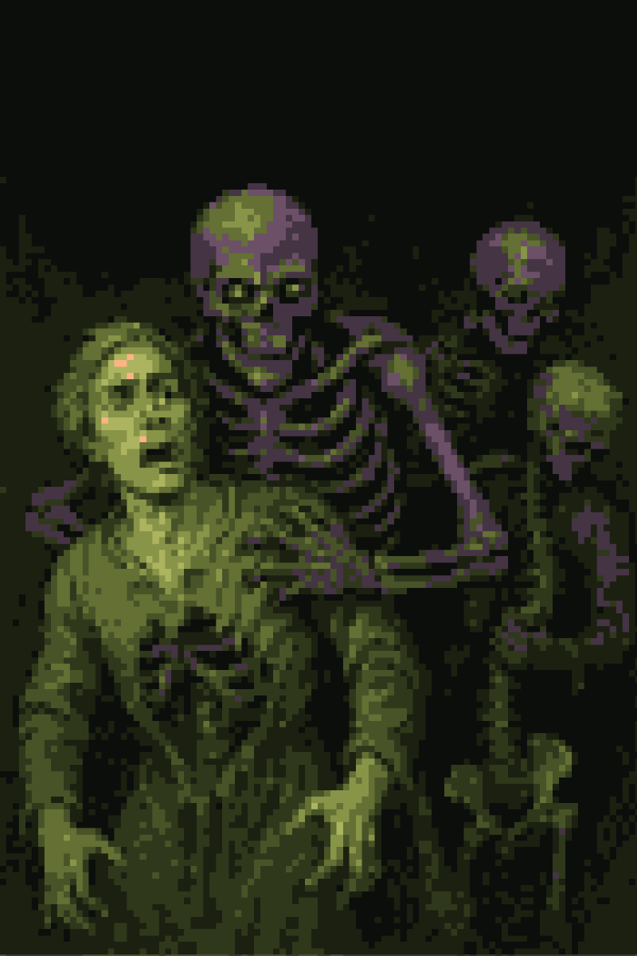
````a````
You know of some possible ways to test for a fake skeleton in your husband’s body. Any Inside-seeing Statue of a woman would be able to look through his skin as through a window. You might also purchase an enchanted bloodstone. Bloodstones turn pale and shiver when a body near them is made from multiple people.
Both such tests are beyond your means.
You know that the man in your home is no longer your husband. You are certain.
Will you live with the changed man?
Later that day, you tell the doppelganger skeleton disguised as your husband that tonight is the night when you two must deliver black bread and tomatoes, out to the harridan which lives out on The Wounded Hills.
The man does not protest.
You feel some remorse, but little fear, that evening as you cross the moonlit moor. You yourself took a dram of Lemon Cider in secret before you left home. You are protected.
The black heather rustles. It is not the wind.
Your husband screams as the grey skinned dead emerge. Spittle gleamingly streams from the teeth and long tongues.
Ghouls.
You shudder as the dead swarm. Yet they run past you. The doppelganger turns, tries to run, but the ghouls are on all his sides. You drop your bread and tomatoes. Look away. Higher screams. There is a ripping noise.
You hurry back the way you came. You cannot see the pulp and gore spattering the heather behind you, but you hear that leathery tearing, and the cracking of the false bones.
You never went back. You never checked the body.
But you know you were right. That man was not your husband, even if it was his flesh. Even if- if it was his soul.
Which bones are yours?
Which, a stranger’s?
The Aged Widow falls silent.
R the Killer smokes another pipe.
You stand stock-still behind your Blue Lady.
The living - and one dead man - stare into the fire at Cobweb’s Hotel.
In The Time of Dying lies a Road of Graves.

