Assignment 16.5
S. Keerthi
2303A51635
Batch-23

Task 1 – Employee Management Database
Task:
Create a database schema for managing employee records in an organization.
Instructions:
• Tables: Employees, Departments, Salaries.
• Use AI to define constraints such as NOT NULL and UNIQUE.
• Generate queries:
o List all employees in a specific department.
o Retrieve salary details of an employee.
o Find the highest-paid employee in each department.
Expected Output:
• Schema and SQL queries demonstrating joins and constraints.

Code:
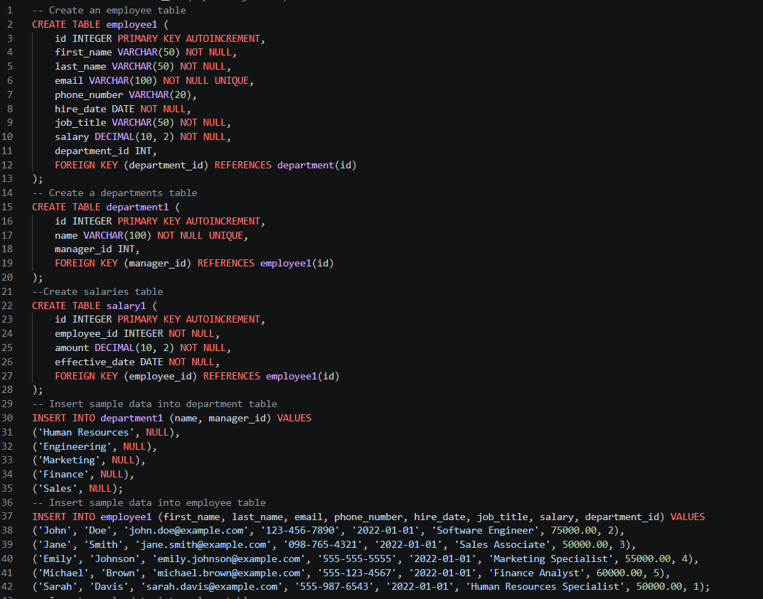
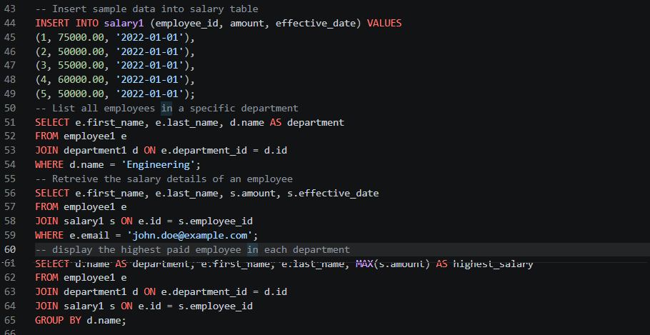

Output:
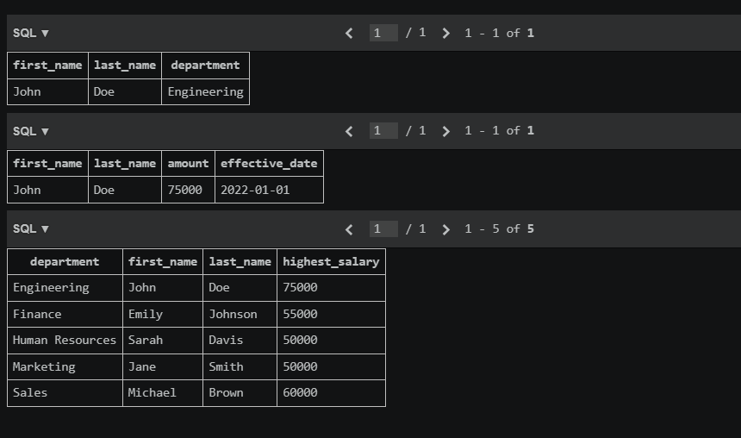
Task 2 – Online Course Platform Database
Task:
Design a database for an online learning platform.
Instructions:
• Tables: Users, Courses, Lessons, Enrollments.
• Define relationships between users and courses.
• Generate queries:
o List all courses enrolled by a user.
o Count number of learners per course.
o Retrieve lesson details for a course.
Expected Output:
• Relational schema with SQL queries using joins.

Code:
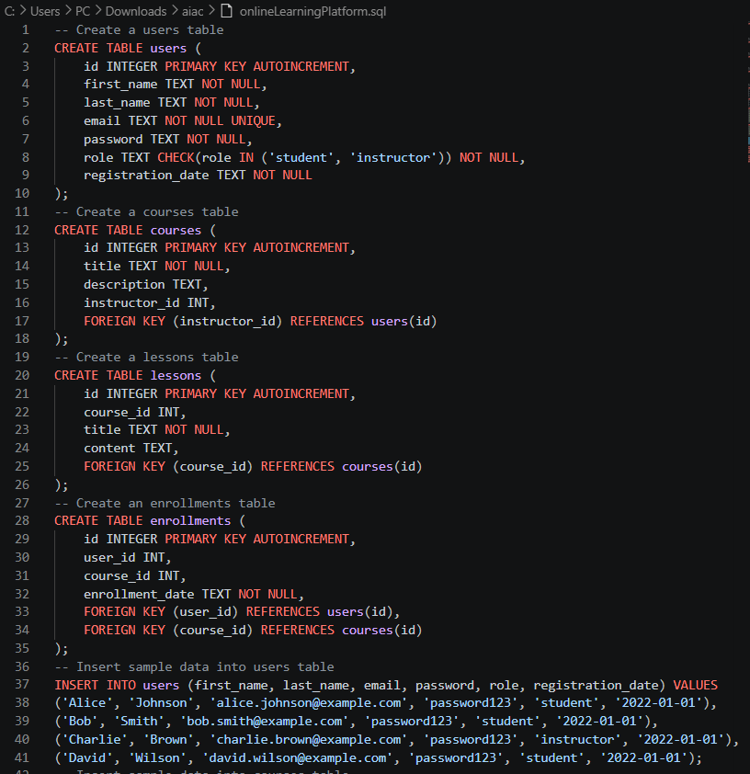
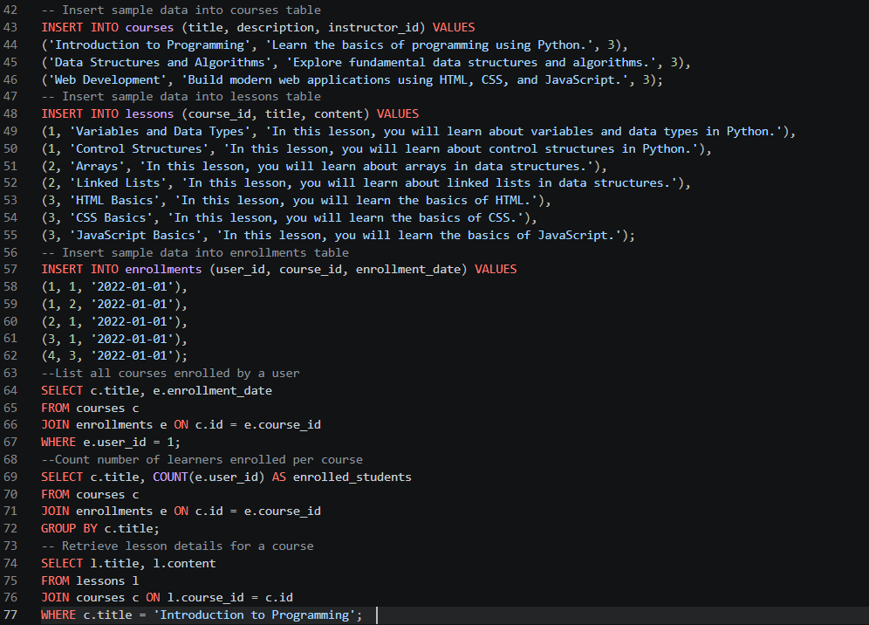

Output:

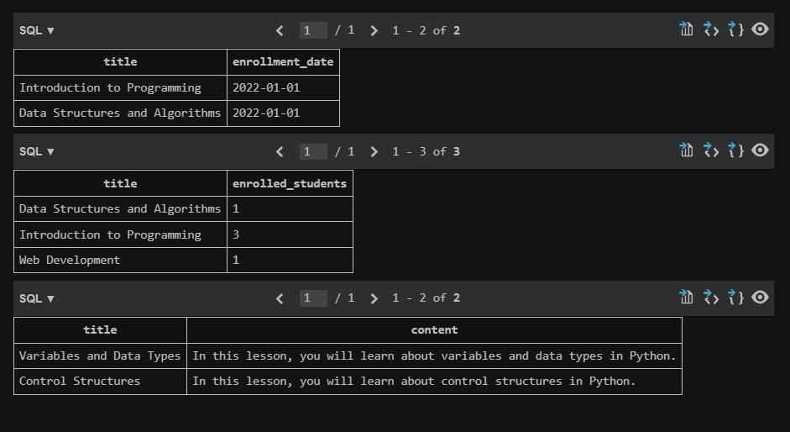

Task 3 – Banking Transaction Database
Task:
Create a schema for a banking transaction management system.
Instructions:
• Tables: Customers, Accounts, Transactions.
• Use AI to suggest constraints for transaction validity.
• Generate queries:
o Retrieve transaction history for an account.
o Calculate total deposits and withdrawals.
o Find accounts with balance below a threshold.
Expected Output:
• Secure database schema and analytical SQL queries.
Code:
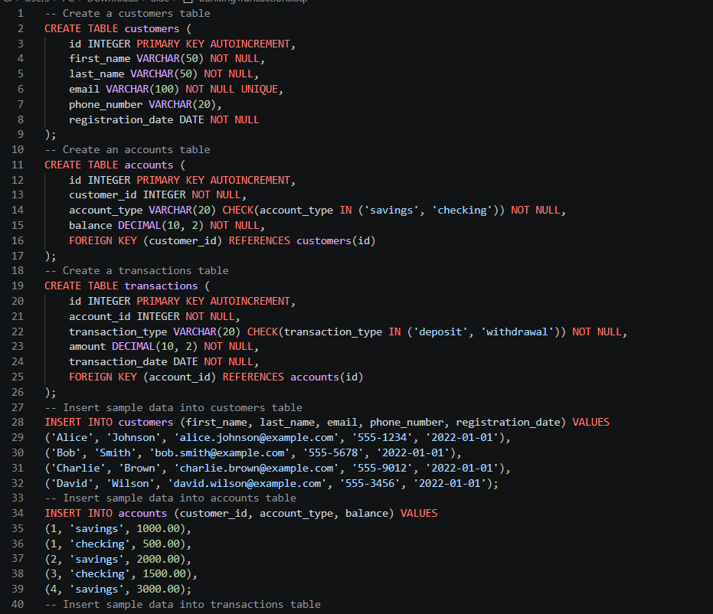
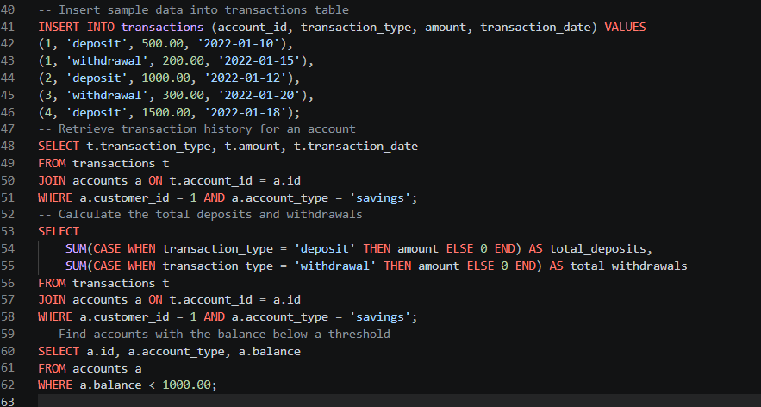
Output:
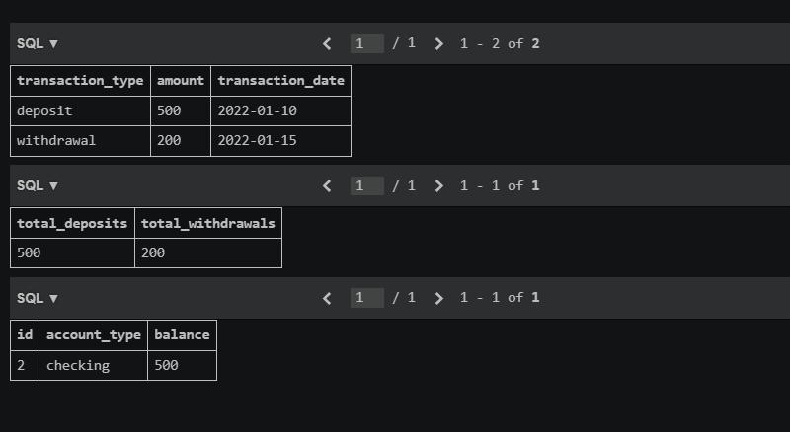
Task 4 – Airline Reservation Database
Task:
Design a database for an airline reservation system.
Instructions:
• Tables: Flights, Passengers, Tickets, Bookings.
• Define relationships and seat allocation logic.
• Generate queries:
o List all passengers on a specific flight.
o Find available seats for a flight.
o Count total bookings per flight.
Expected Output:
• Schema with SQL queries using joins and counts.
Code :
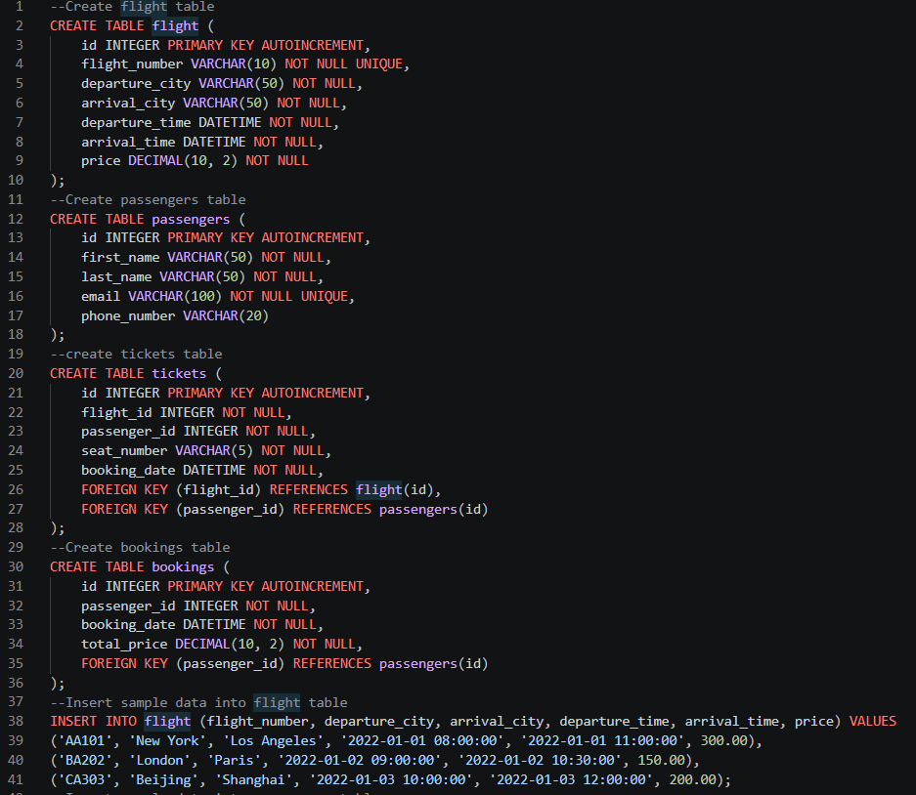
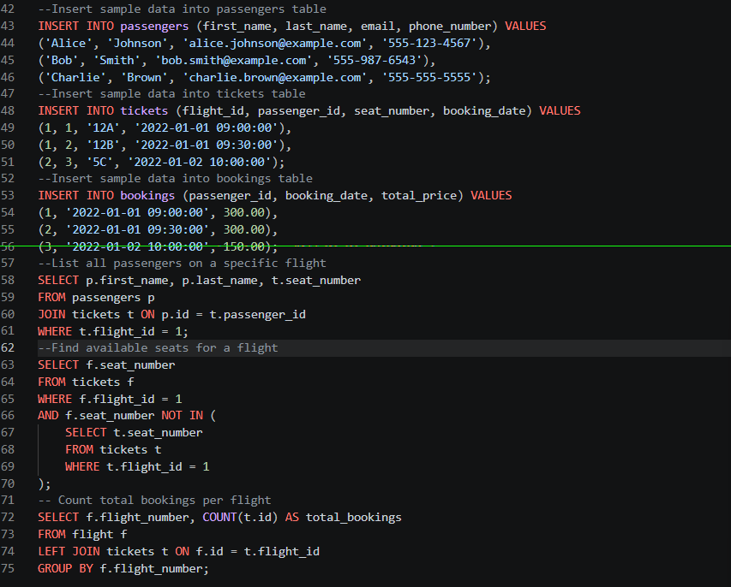
Output:
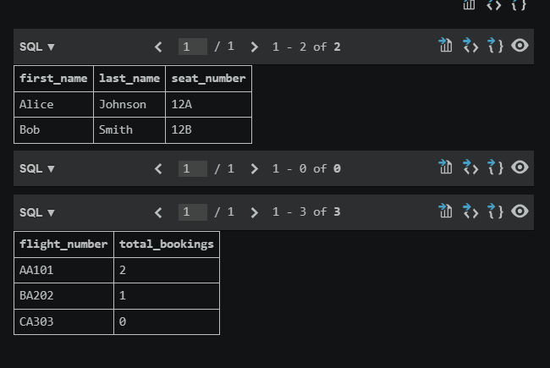

Task 5 – Transport Management Database
Task:
Design a database for transport route management.
Instructions:
• Tables: Vehicles, Routes, Drivers, Assignments.
• Use AI to suggest indexing strategies.
• Generate queries:
o List vehicles assigned to a route.
o Retrieve driver details for a vehicle.
o Count trips per route.
Expected Output:
• Schema and optimized SQL queries.
Code:
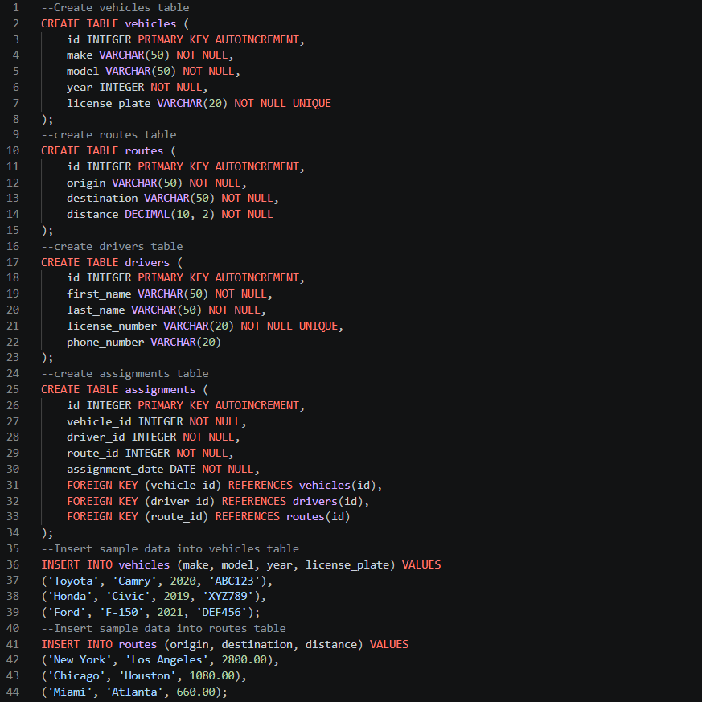
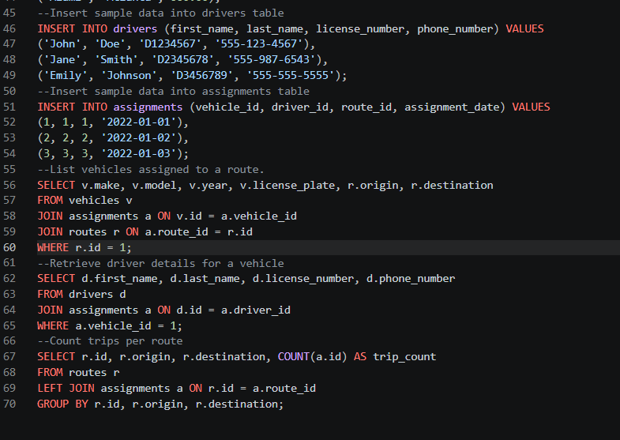
Output:
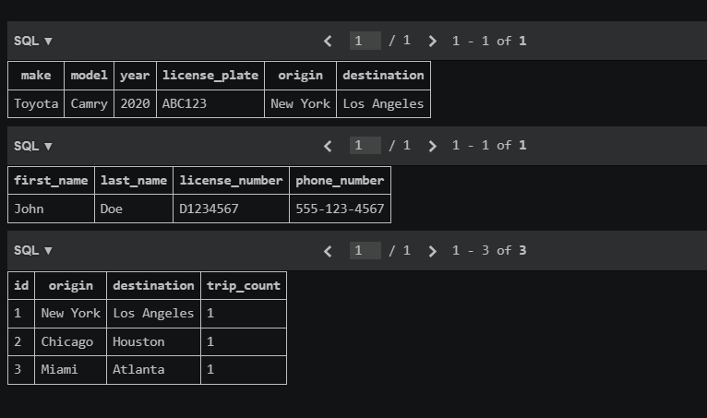

Task 6 – Hotel Reservation Database
Task:
Create a database schema for hotel reservations.
Instructions:
• Tables: Hotels, Rooms, Guests, Reservations.
• Define date constraints and relationships.
• Generate queries:
o List all reservations for a guest.
o Find available rooms for a date range.
o Calculate occupancy rate per hotel.
Expected Output:
• Relational schema and SQL queries for booking analysis.
Code:
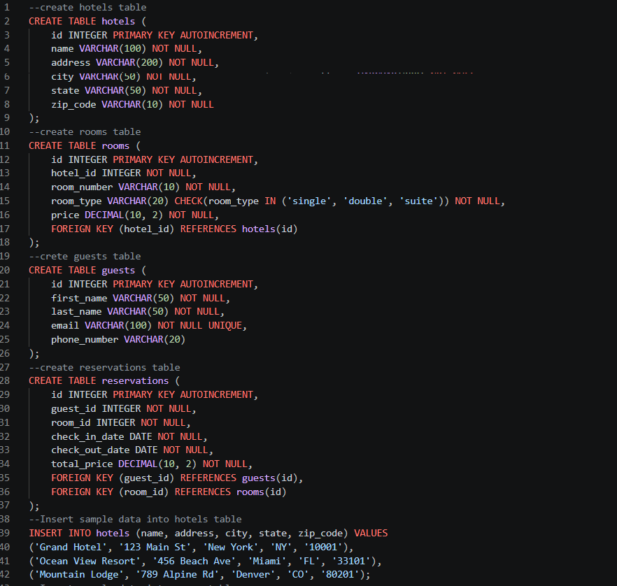
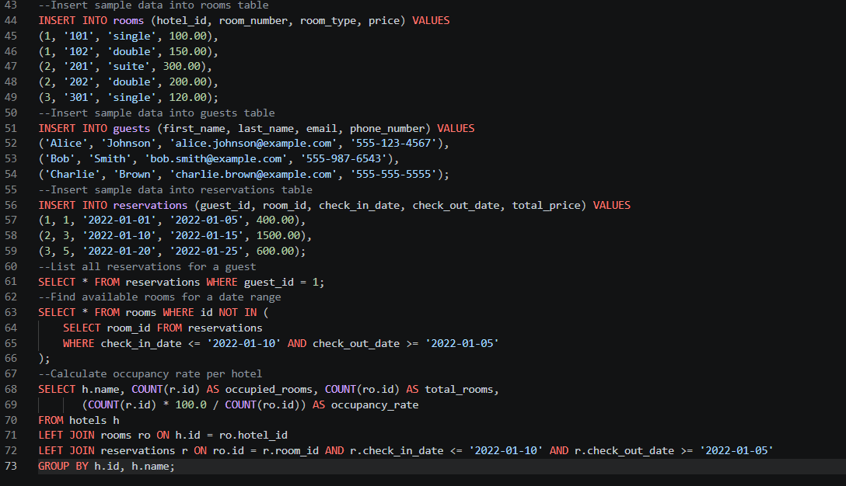
Output:
