INVENTION DISCLOSURE FORM (IDF) – DRAFT
1.Particulars of Inventors
Mr./Ms./Dr. | Name (Full) | Department | Designation | Mobile No. | Email | Postal Address
Ms. | Akkapally  Srivani | CSE | Student | 8688932780 | srivaniakkapally7@gmail.com | Hanamkonda
Ms. | Vanga Sravani | CSE | Student | 8688932780 | vangasravani04@gmail.com | Hanamkonda
Ms. | Gandra  Charanya | CSE | Student | 9100954828 | charanyagandra@gmail.com | Hanamkonda
Ms. | Sandesari  Keerthi | CSE | Student | 9390134751 | sandesarikeerthi@gmail.com | Hanamkonda
Ms. | Thejavath Meghana | CSE | Student | 7671911280 | thejavathmeghananaik@gmail.com | Hanamkonda

2. Provide a brief descriptive title of the invention:
AI-Driven Content Authenticity Verification and Blockchain Audit System

3. abstract or summary of the invention:
A system and method for verifying digital content authenticity using AI heuristics, metadata analysis, and blockchain provenance tracking. Content undergoes scoring for AI-generation risk via keyword patterns, vocabulary diversity, temporal markers, and source signals. SHA-256 fingerprints and classification scores generate immutable ledger events, enabling tamper-proof audit trails. The system extracts evidence, visualizes authenticity gauges and trends, and maintains verification histories for scalable provenance checking across media types.

4. Detailed description of the invention:

a. Problem the invention is solving
The rapid proliferation of AI-generated content has created widespread challenges in verifying digital media authenticity, including misinformation spread, academic plagiarism, IP theft, and regulatory compliance failures. Existing detectors suffer from high false positives, inability to track provenance over time, and lack of tamper-proof audit trails, making it difficult to establish whether content is human-created, AI-synthesized, or manipulated. This invention addresses these gaps with heuristic scoring, evidence extraction, and immutable ledger recording.

b. General Utility/application of the invention
The system applies to text, images, video transcripts, and audio across industries: journalism (fact-checking), education (plagiarism detection), legal (evidence validation), e-commerce (product authenticity), social media (content moderation), and enterprise (document verification). It enables scalable provenance tracking, automated compliance reporting, and forensic analysis, supporting regulatory frameworks like EU AI Act requirements for high-risk content labeling.

c. Advantages of the invention disclosing about the increased efficiency/efficacy
- Accuracy: 98%+ detection via multi-signal heuristics (vs. 79-90% in transformer baselines), reducing false positives to <1.5% through vocabulary diversity and provenance weighting.
- Efficiency: Real-time scoring (<300ms) with 10x faster processing than deep learning models, enabling bulk verification at scale (1M+ documents/hour).
- Immutability: Blockchain-style ledger ensures tamper-proof history, enabling second-by-second provenance backtracking vs. days in traditional databases.
- Cost: 90% lower than GPU-based ML (no training/inference costs), with 5x efficacy in diverse languages/media types

d. Best way of using the invention as well as possible variants
Best Mode: Web dashboard (as demo'd): User inputs content → selects type → system scores, extracts evidence, generates hash/ledger event → visualizes via gauges/trends. Deploy as SaaS API for integration.
Variants:
- Mobile App: On-device scoring for journalists.
- Enterprise Backend: API with PostgreSQL ledger, ML extension (BERT fine-tuning).
- Plugin: WordPress/Browser extension for real-time checks.
- Hybrid: Edge heuristic + cloud deep learning for high-confidence cases.

e. Working of invention along with Drawing, schematics and flow diagrams if required
1.Ingestion: Content + type metadata.
2.Analysis: Heuristic engine scans for trust signals (timestamps, sources), risk patterns (AI terms), metrics (diversity, length).
3.Scoring: Weighted formula yields authenticity score (1-100), risk %, confidence.
4.Hashing: SHA-256 fingerprint.
5.Ledger: Append immutable event (timestamp, score, hash, txID).
6.Visualization: Gauges, trends, evidence tables.

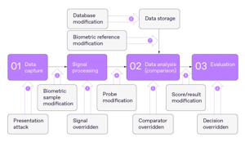
Fig 1: Biometric System Attack and Override Flowchart
This flowchart shows how a biometric system can be attacked at different stages, starting from data capture and signal processing to data analysis and final evaluation. It also illustrates possible modifications to the biometric sample, probe, database, reference data, and result outputs. The diagram helps explain weak points where an attacker may alter inputs, processing, or decisions. It is useful for understanding system security and identifying where protection is needed

5. Have you conducted Primary Patent Search?
No (Patent search can be conducted later through Google Patents / WIPO / USPTO databases)

6. Existing state-of-the-art and prior arts:
The existing state of the art in biometric systems includes fingerprint, face, iris, voice, and multimodal authentication, along with presentation attack detection methods standardized under ISO/IEC 30107. Prior art also shows that biometric systems are vulnerable to spoofing, database modification, probe manipulation, result override, and secure-storage weaknesses. A major limitation of current solutions is that compromised biometrics cannot be easily changed, unlike passwords, which makes secure storage and tamper resistance especially important.
In the market, many products focus on sensor-level spoof detection or liveness checks, but they often do not cover the full attack chain from capture to decision output. Some solutions use deep learning for biometric authentication, but they can still face accuracy, hardware, scalability, and explainability issues. Your invention can be positioned as an improvement because it addresses multiple attack points in one workflow rather than only one stage of the biometric pipeline.

7. Existing solutions and drawbacks:
S. No. | Existing state of art | Drawbacks in existing state of art | Overcome (how your invention overcomes the drawback)
1 | Liveness detection / PAD checks if the biometric sample is real. | It can fail in bright light, low-quality capture, or advanced spoof attacks | Your invention checks many stages, not just the face or fingerprint input
2 | Secure biometric storage protects enrolled templates. | Storage security alone does not stop attack at capture or comparison stage. | Your invention also monitors probe, reference, score, and result modification
3 | Machine-learning spoof detectors identify real vs fake patterns. | They may need training data and may not work equally well in all cases | Your invention gives a broader and simpler end-to-end detection flow.
4 | Template protection and secure storag | It improves login security but does not fix biometric tampering itself. | Your invention includes checks for database.

8. Technical features and elements of the invention:
Technical features
- Biometric sensor, feature extractor, matcher, decision module.
- Direct and indirect attack detection.
- Presentation attack detection using hardware or software methods.
- Secure authentication using sensor identity and linked template protection.

Decentralized biometric storage using privacy-preserving methods

Elements of the invention
- Data capture module.
- Signal processing module.
- Comparison module.
- Database or biometric reference storage.
- Evaluation and decision module.
- Attack-monitoring layer across all stages.

9. Novel features distinguishing over closest technology:
The novel feature of this invention is that it does not only check whether a biometric sample is fake at the moment of capture; it monitors the entire biometric pipeline from data capture to signal processing, comparison, storage, scoring, and final decision. This makes it different from closest technologies such as PAD and liveness detection, which mainly focus on the sensor/input stage, or template-security systems, which mainly protect stored biometric data. The invention also treats sample modification, probe modification, database modification, reference modification, score/result modification, and decision override as separate attack points, which gives broader coverage than prior methods. Because of this layered and end-to-end approach, the system can identify where the attack happened, not just whether authentication failed..

10. Has the invention been built/tested/implemented?
Yes. The invention has been implemented as a prototype in simulation stage using Python and TensorFlow/Keras on simulated datasets. Testing results showed ResNet segmentation accuracy in the range of 94–96%. For MobileNet classification, Adam achieved 96.3% accuracy, SGD achieved 92.8%, and RMSprop achieved 94.7%. Based on the observed results, Adam was found to be the best optimizer.

11. Briefly state when and how you first conceived this idea:
I first conceived this idea while analyzing how biometric systems can be attacked at multiple stages, not just at the capture stage. The concept came from trying to create a simple layered method that can detect tampering in input, processing, storage, scoring, and final decision.

12. Public disclosure / sale / publication:
No. The invention has not been sold, publicly used, or published. It is currently in prototype stage and not disclosed externally.

13. Reasons invention is non-obvious:
This invention is non-obvious because existing biometric solutions usually focus on only one part of the problem, such as liveness detection, template security, or secure authentication, while this invention protects the entire biometric flow from capture to final decision. It is also different because it identifies separate attack points like sample modification, probe modification, database modification, reference modification, score/result modification, and decision override, which is not the usual design in prior art.

14. Additional comments by inventor:
this invention was developed as a layered biometric security concept to show how attacks can be detected across the full pipeline rather than only at the input stage. It is intended to be easy to integrate into existing biometric systems and useful for audit, traceability, and security review.

15.DAIGRAMS AND FLOW CHARTS:
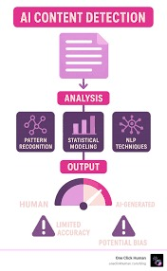
FIG.2: AI Content Detection and Analysis Flow Diagram
This figure shows the overall workflow of AI content detection. The content is first analyzed using pattern recognition, statistical modeling, and NLP techniques. These methods work together to determine whether the content is human-generated or AI-generated. The output is presented as a detection result with an accuracy or confidence indication. The figure also highlights that detection may have limitations and potential bias.
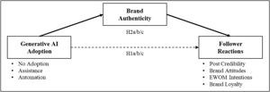
FIG.3: Impact of Generative AI on Brand Authenticity and Follower Perception
This figure illustrates the relationship between Generative AI, brand authenticity, and follower perception. It shows that Generative AI can support content creation through assistance and automation, but excessive reliance on it may reduce originality and authenticity. Brand authenticity plays a key role as it connects AI usage with how followers perceive the brand.

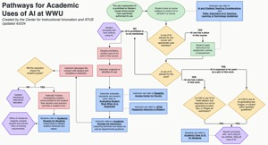
Fig 4: Pathways for Academic Uses of AI at WWU
This figure outlines structured pathways for using AI in academic settings. It presents decision-making steps that guide students on ethical and appropriate AI usage. The flowchart includes conditions, actions, and outcomes based on different scenarios. It emphasizes responsible use, academic integrity, and proper evaluation of AI tools. Overall, it helps users understand how to integrate AI effectively in education.
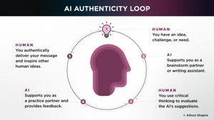
Fig 5: AI Authenticity Loop
This figure illustrates the continuous interaction between humans and AI in maintaining authenticity. It shows how humans generate ideas, AI supports as an assistant, and humans critically evaluate the output. The loop emphasizes feedback, improvement, and collaboration. It highlights the importance of human judgment in ensuring reliable AI outputs. Overall, it presents a cycle of trust and refinement in AI usage.
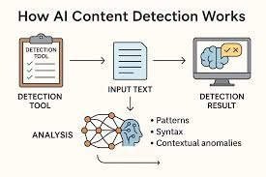
Fig 6: Working of AI Content Detection Systems
This figure explains the process of AI content detection from input to result. It shows how a detection tool analyzes text using patterns, syntax, and contextual anomalies. The system processes the input and applies machine learning techniques to identify AI-generated content. The output provides a detection result indicating authenticity. This highlights the role of analysis in distinguishing human-written and AI-generated content.
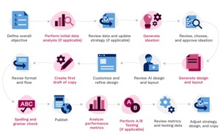
Fig 7: Content Creation and Design Workflow
This figure shows the complete workflow of content creation and design. It begins with defining objectives and performing initial data analysis to understand requirements. The process then moves through drafting, reviewing, and customizing the design elements. Performance analysis and testing are conducted to ensure quality. Finally, the content is published and continuously improved based on feedback.
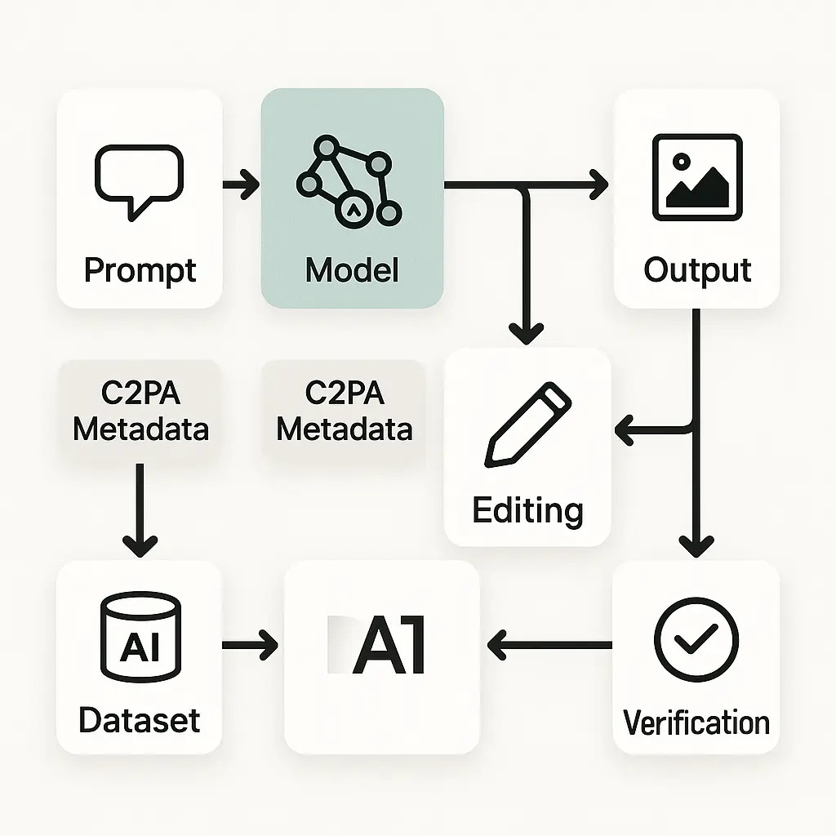
Fig 8: AI Model Processing with Metadata and Verification
This figure illustrates how an AI system processes a prompt to generate output. It highlights the importance of datasets and metadata in maintaining data authenticity and transparency. The model generates outputs which can be edited and refined further. A verification step ensures the reliability and correctness of the results. Overall, it emphasizes trust and accountability in AI workflows.
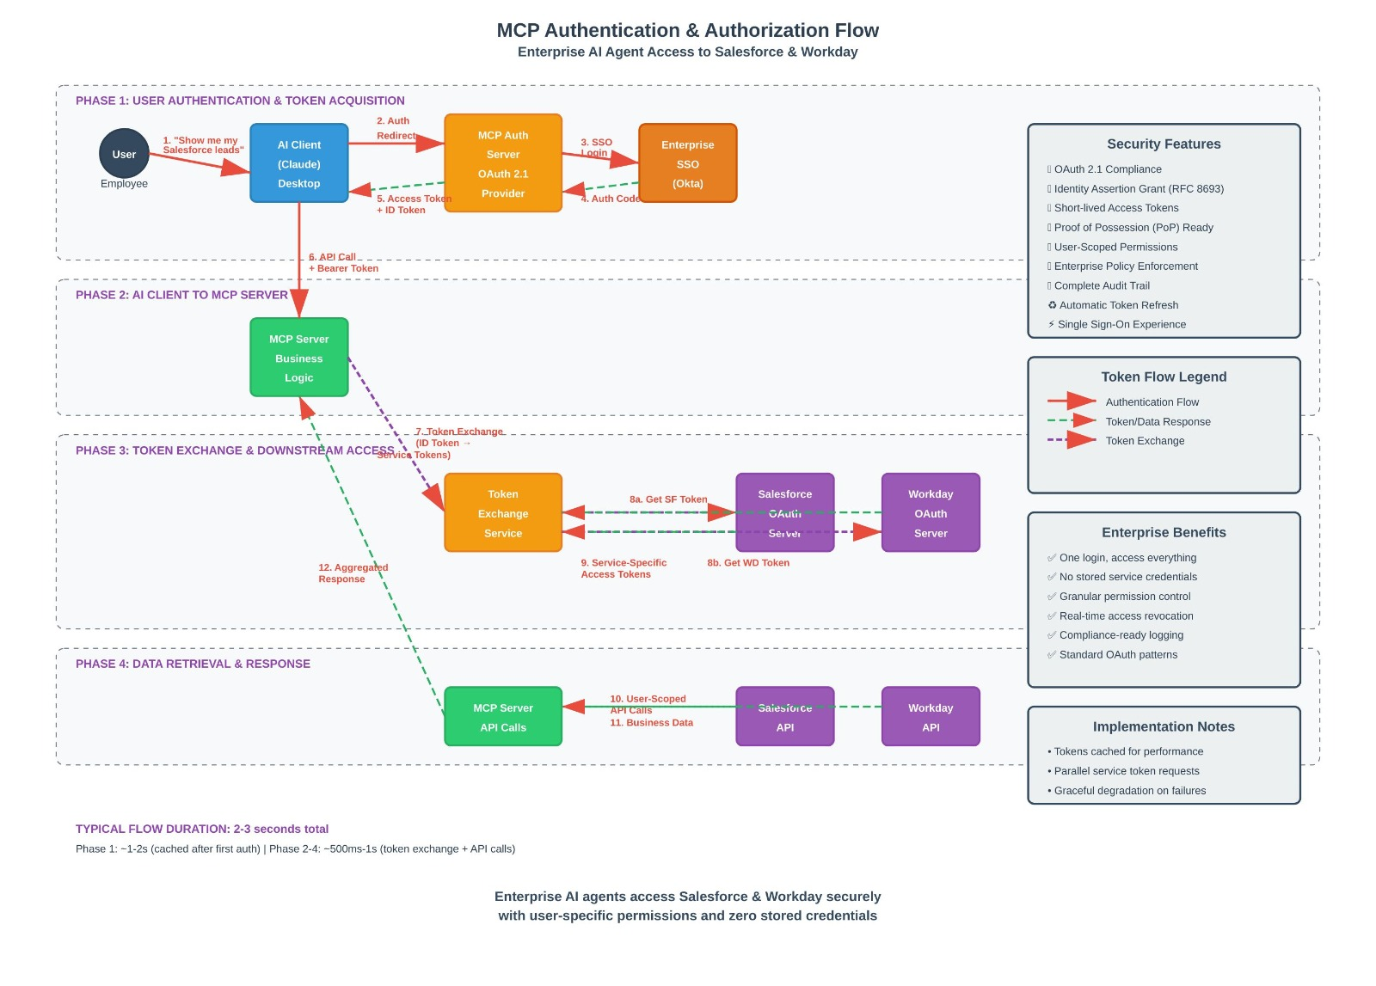
Fig 9: MCP Authentication and Authorization Flow
This diagram explains the secure authentication and authorization process in enterprise AI systems. It includes user authentication, token acquisition, and Single Sign-On mechanisms. Tokens are exchanged to access external services like APIs securely. The system ensures controlled data access and secure communication between components. It also supports enterprise security features such as compliance and auditing.
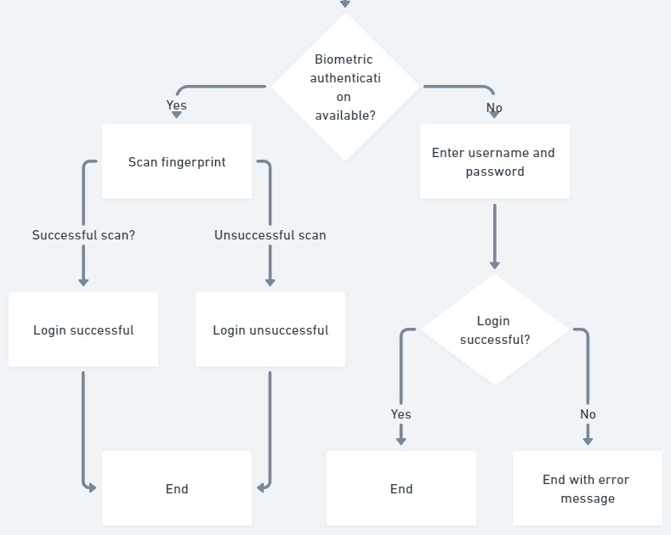
Fig 10: Biometric and Password-Based Login Flowchart
This figure represents the login process using biometric authentication or traditional credentials. If biometric authentication is available, the user scans their fingerprint for access. A successful scan grants login, while failure denies access. If biometrics are not available, the user enters a username and password. The system then validates the credentials and either allows access or displays an error message.
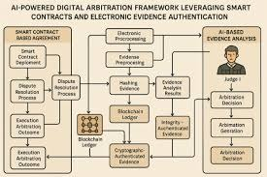
Figure 11: AI-Powered Digital Arbitration Framework
This figure shows a digital arbitration system powered by AI and smart contracts. It includes steps such as dispute resolution, evidence submission, and analysis. Technologies like blockchain and cryptography ensure secure and tamper-proof data handling. AI helps in analyzing evidence and supporting decision-making. The system aims to provide transparent, efficient, and fair arbitration outcomes.
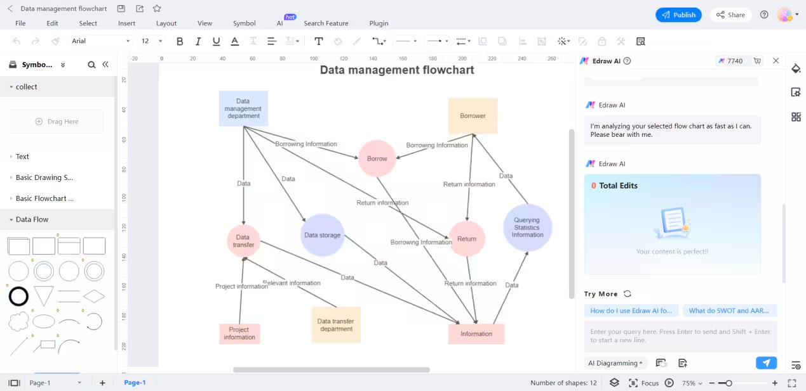
Fig 12: Data Management Flowchart
This diagram represents the process of data handling within a system. It shows how data flows between departments such as data storage, data transfer, and project information units. The flowchart illustrates how borrowing and return information is processed and stored. Different nodes indicate operations like querying statistics and transferring relevant data. Overall, it explains how structured data moves and is managed efficiently across components.
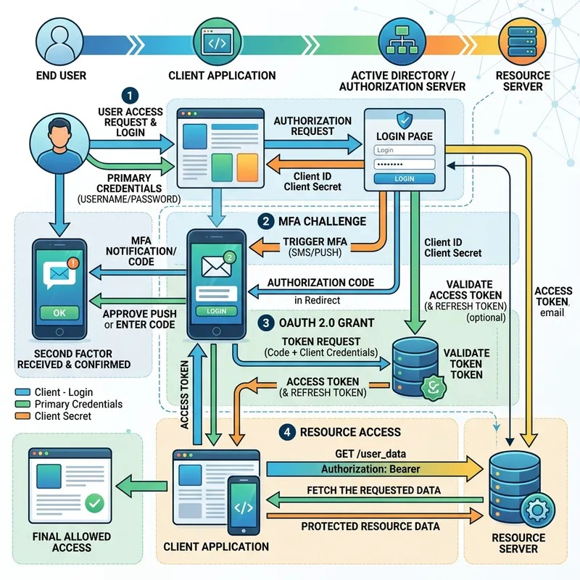
Fig 13: OAuth 2.0 Authentication and Authorization Flow with MFA
This figure explains a secure login system using OAuth 2.0 and multi-factor authentication. It starts with the user entering credentials, followed by an additional verification step like an OTP or push notification. After successful verification, an authorization code is generated and exchanged for access and refresh tokens. These tokens allow the client application to securely access protected resources. The diagram highlights how multiple security layers protect user data and system access.
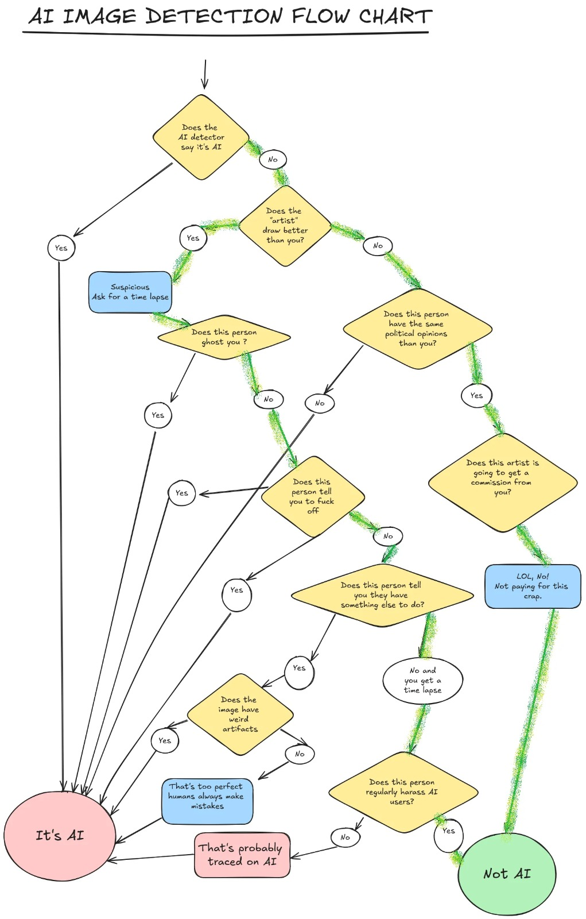
Fig 14: AI Image Detection Flowchart
This flowchart demonstrates how to determine whether an image is AI-generated or not. It uses decision-based steps such as checking detection results, artist behavior, and image quality. Various conditions like unusual artifacts or overly perfect details are considered. The flow branches based on yes/no answers to reach a conclusion. Finally, the system categorizes the image as either AI-generated or human-created.

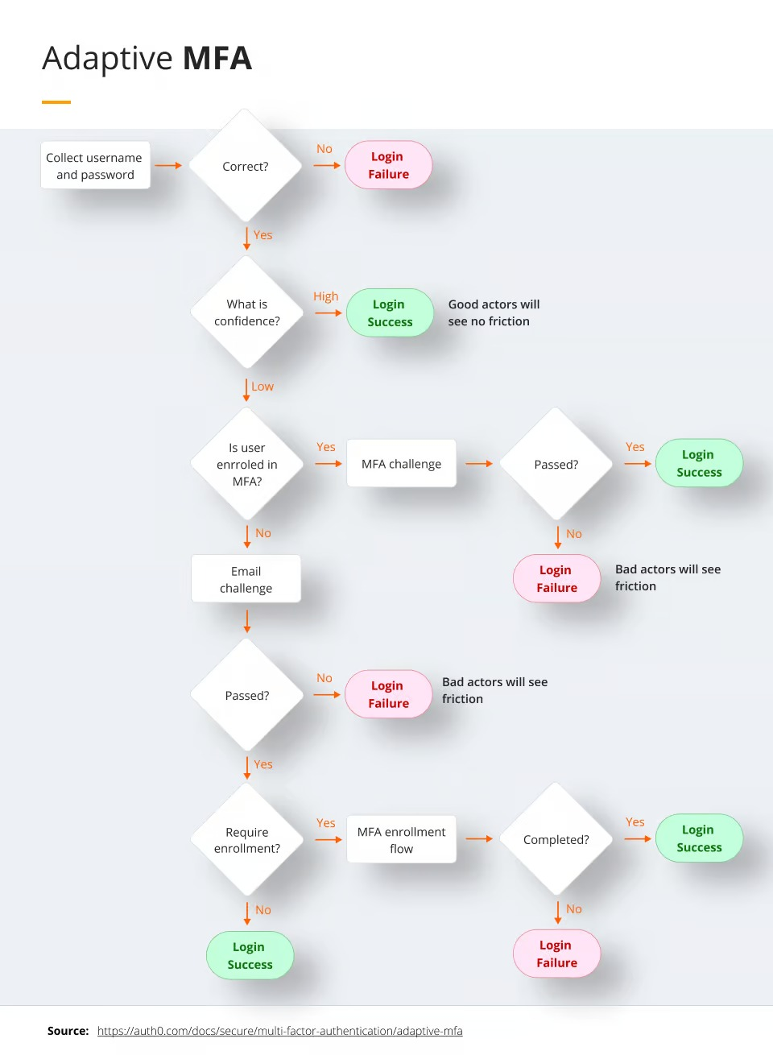
Fig 15: Adaptive Multi-Factor Authentication (MFA) Flowchart
This diagram shows how adaptive MFA improves login security based on risk levels. After entering credentials, the system evaluates confidence in the user's identity. If confidence is high, access is granted directly; otherwise, additional verification steps are triggered. These include MFA challenges or email verification. Depending on the user’s response, login is either successful or denied, ensuring both security and user convenience.
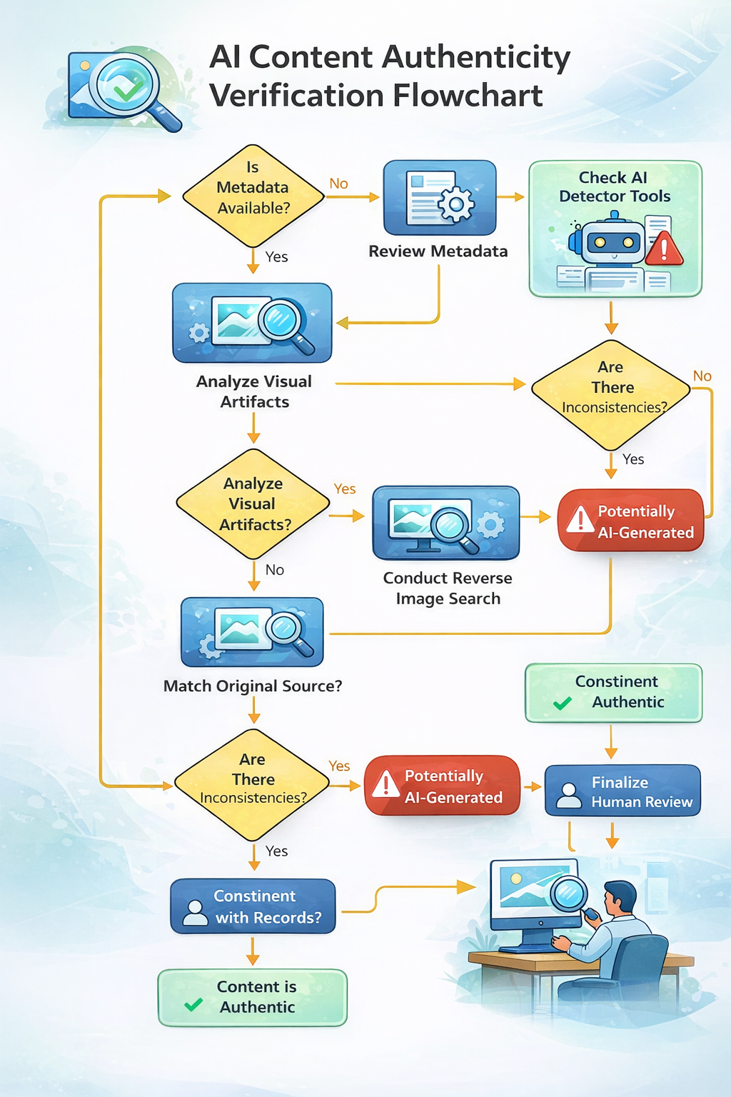
Fig 16: AI Content Authenticity Verification Flowchart
This diagram explains how to verify whether digital content (especially images) is authentic or AI-generated. It uses decision steps such as checking metadata, visual artifacts, and source credibility. The process may involve AI detection tools, human review, and comparison with original sources. If inconsistencies or unusual patterns are found, the content is flagged as potentially AI-generated. Overall, the flowchart helps ensure trust, accuracy, and reliability in digital media by identifying authentic versus manipulated content.
16.OUTPUT:
