

PROJECT PROPOSAL

SEMESTER **SEVEN**

***COLLEGE CATALOG SYSTEM***

BY:

*SANDESH BAJRACHARYA*

BACHELOR OF INFORMATION & COMMUNICATION TECHNOLOGY

SCHOOL OF SCIENCE & TECHNOLOGY

ASIA e UNIVERSITY

Abstract

Table of Contents

INTRODUCTION iii

1.1 Background iii

1.2 PROBLEM STATEMENT iv

1.3 OBJECTIVES v

1.4 SCOPE AND LIMITATIONS vi

1.5 TARGET USER vii

1.6 GANTT CHART vii

CHAPTER 2 viii

LITERATURE REVIEW viii

Review of Existing Systems viii

System Analysis xii

1.6.1 Users xii

1.6.2 Subjects xii

1.6.3 Chapters xii

1.6.4 Repository xiii

1.6.5 Access xiii

**CHAPTER 1**

# INTRODUCTION

## Background

Students often struggle to access comprehensive study materials and final year project repositories. A centralized platform, accessible to both university students and external individuals, is needed to provide reliable and approved academic resources, enhancing learning and collaboration.

Access to quality academic resources is crucial for student success. The College Notes Catalog addresses this need by offering a centralized, digital platform where students can access a wide range of study materials, including notes, lecture summaries, and textbooks. Additionally, it features an approved final year project repository, accessible to both university students and external users. This repository not only serves as a valuable learning tool but also fosters collaboration and innovation. By providing a publicly accessible, organized collection of academic resources, the College Notes Catalog enhances the educational experience and supports academic excellence. It will be used by the following groups:

* University Students: They use the platform for accessing study materials and collaborating on projects.
* External Users: Individuals outside the university can access the final year project repository for reference or collaboration.

The main feature of the College Notes Catalog is its comprehensive, digital repository of academic resources, including notes, lecture summaries, textbooks, and final year projects. This repository is not only accessible to university students but also to external users.

The technology stack for the College Notes Catalog includes several elements. The programming languages used are NodeJS and JavaScript. The markup language is HTML, and the style sheet language is CSS. The web frameworks employed are Tailwind and ReactJS. The database is run on MySQL, and the server used is a Node Server.

## PROBLEM STATEMENT

A significant problem students often face is the difficulty in accessing comprehensive study materials and project repositories. Often, individuals have the knowledge and skills but struggle to find academic resources that align with their learning objectives due to the vast and unorganized nature of academic materials. This lack not only prolongs the learning process but also leads to missed opportunities for both students and external individuals.

1. Difficulty in Accessing Comprehensive Study Materials and Project Repositories
2. Lack of a Centralized Platform for Academic Resources
3. Need for Collaboration Among Students and External Individuals

The College Notes Catalog aims to address these issues by offering a centralized, digital platform where students can access a wide range of study materials, including notes, lecture summaries, and textbooks. By doing so, the platform ensures that students and external individuals are provided with reliable and approved academic resources. This approach streamlines the learning process and enhances the chances of academic excellence. By organizing and prioritizing academic resources based on individual learning needs, the platform reduces the time and effort required to find relevant academic materials, benefiting both students and external users in the long run.

## OBJECTIVES

The College Notes Catalog aims to effectively address the challenges faced by students and external users through the following key OBJECTIVES:

1. Centralize Academic Resources

2. Facilitate Access to Project Repositories

3. Enhance Learning Process

4. Foster Collaboration

5. Support Academic Excellence

College Notes Catalog aims to enhance the learning experience, support academic success and foster collaboration among students and external users.

## SCOPE AND LIMITATIONS

Scope:

1. Offer a wide range of academic resources, including notes, lecture summaries, textbooks, and final year projects.
2. Serve a diverse set of users, including university students and external users.
3. Facilitate collaboration among students and between students and external users.
4. Streamline the learning process by organizing and prioritizing academic resources based on individual learning needs.

Limitations:

1. Depends on the active participation of students and external users to contribute and update academic resources.
2. The quality and usefulness of resources can vary, as they are user-submitted.
3. While the platform is designed to be user-friendly, there may be a learning curve for some users to navigate and utilize the platform effectively.
4. Ensuring the privacy and security of user data can be challenging.

## TARGET USER

- Age Group: 18-55

- Interest: Students seeking for college notes, inspirations and references for final year project.

- Education: +2 Passed and IT Undergrad Students

- Profession: Students, IT Coordinators, Teachers

## GANTT CHART

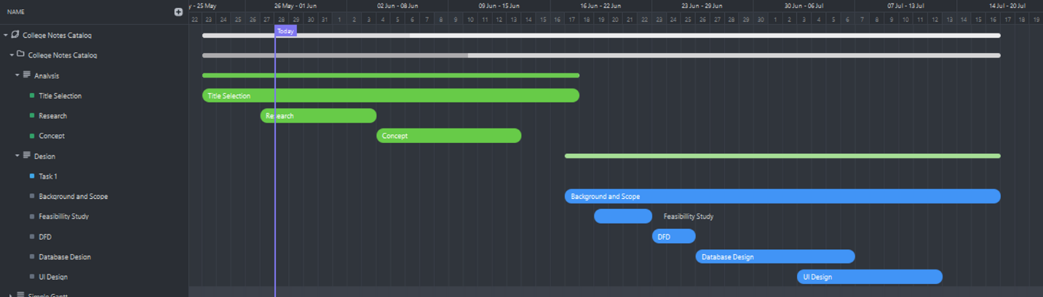

# CHAPTER 2

# LITERATURE REVIEW

Methodology

College Notes Catalog effectively addresses student needs and delivers value quickly by utilizing the Agile development methodology. Agile prioritizes flexibility and rapid iteration. This means we'll work closely with users and stakeholders to define the platform's core functionalities and continuously refine them based on feedback. The project will be broken down into manageable phases, allowing for frequent delivery of features and adjustments based on real-world use. This iterative approach ensures the College Notes Catalog evolves alongside user needs, guaranteeing a platform that truly empowers students, educators, and external users.

## Review of Existing Systems

#### **INSCRIBE - College Notes Sharing Application**

The "INSCRIBE - College Notes Sharing Application" by Priyanshi Jaiswal and Rashi Wadnerkar focuses on enhancing student access to educational materials through a secure, user-friendly platform. The application features user authentication, robust search functionality, and file upload capabilities supporting PDF, DOC, and PPT formats. It significantly reduces the manual efforts involved in note distribution, providing a streamlined and efficient learning environment for students (Jaiswal & Wadnerkar, 2022). The front-end of INSCRIBE utilizes HTML, CSS, and JavaScript, enabling a dynamic and responsive user interface. The back-end is managed using PHP, which processes server-side requests, and MySQL, which handles database operations. This combination ensures that the system is both robust and scalable, capable of handling large volumes of data and multiple user interactions simultaneously.

Furthermore, INSCRIBE incorporates a notification system to alert users about new uploads and updates, fostering a real-time collaborative environment. This feature is particularly beneficial in maintaining student engagement and ensuring that they have access to the latest study materials. The system's design also emphasizes user privacy and data security, with secure login protocols and encrypted data transmission. These features collectively contribute to a comprehensive notes-sharing solution that addresses the core needs of students and educators alike.

#### **Notes Sharing Web Portal**

The "Notes Sharing Web Portal" by Piyush Pathade et al. addresses the inefficiencies of manual note distribution through a centralized, secure system for both students and teachers. This web portal features role-based access, where students and teachers can register and manage their notes. The approval system for uploaded notes ensures that only high-quality and relevant materials are accessible, improving the reliability of the content (Pathade et al., 2022). The portal's synchronization feature across devices ensures that users can access their notes anytime and anywhere, enhancing the flexibility and convenience of the system.

Technologically, the Notes Sharing Web Portal employs HTML, CSS, and JavaScript for the front-end, creating a responsive and intuitive interface. The back-end is powered by PHP, which efficiently handles server-side logic, while MySQL manages the relational database, ensuring data integrity and security. The system's design incorporates data encryption and secure login mechanisms to protect user data. Additionally, the portal includes advanced search functionalities, allowing users to quickly find specific notes based on various criteria such as subject, author, or format. This feature is particularly useful during exam periods when students need quick access to specific information.

**Comparison of Features**

|  |  |  |  |  |
| --- | --- | --- | --- | --- |
| **Feature** | **Lecture Management System** | **GroupNotes** | **Notes Sharing Web Portal** | **Proposed System (College Notes Catalog)** |
| **Primary Objective** | Centralized access to educational materials | Enhance student engagement | Secure online note sharing | Centralized digital repository |
| **Technologies Used** | JavaScript, MySQL | NodeJS, operational transformation | JavaScript | NodeJS, ReactJS, MySQL |
| **Key Features** | Content organization, user management | Real-time synchronization | Document uploads, search functionality | Digital repository of academic resources |
| **Interaction Capabilities** | Limited interactivity | Real-time collaboration | Admin-managed approvals | Facilitate collaboration among users |
| **Pedagogical Impact** | Enhanced access to course materials | Increased student engagement | Enhanced study efficiency | Streamline learning process |
| **Challenges Addressed** | Content distribution, organization | Student disengagement | Manual paperwork | Lack of centralized academic resources |
| **Limitations** | Minimal interactive features | Smartphone dependency | Internet dependency | User-contributed content quality |

**Conclusion**

Lecture Management System and GroupNotes by Mark Reilly and Haifeng Shen, alongside the Notes Sharing Web Portal by Piyush Pathade et al., represent significant advancements in educational technology. Each system addresses distinct challenges in content distribution, student engagement, and resource management within educational settings. However, they also exhibit limitations related to interactivity, technological dependencies, and data security. The proposed College Notes Catalog aims to integrate the strengths of these systems by offering a centralized digital repository while fostering collaboration and accessibility among students and external users. This review underscores the evolution and ongoing efforts in leveraging technology to enhance educational experiences and outcomes.

# System Analysis

1. Data Dictionary

### Users

**Purpose**: To store information about users, including university students, external users, and super admins.

|  |  |  |
| --- | --- | --- |
| **Column Name** | **Data Type** | **Constraints** |
| **user_id** | INT | PRIMARY KEY, AUTO_INCREMENT |
| **username** | VARCHAR | NOT NULL, UNIQUE |
| **email** | VARCHAR | NOT NULL, UNIQUE |
| **password_hash** | VARCHAR | NOT NULL |
| **role** | ENUM | NOT NULL (values: 'student', 'external', 'admin') |
| **created_at** | TIMESTAMP | DEFAULT CURRENT_TIMESTAMP |

### Subjects

**Purpose**: To store information about the subjects offered.

|  |  |  |
| --- | --- | --- |
| **Column Name** | **Data Type** | **Constraints** |
| **subject_id** | INT | PRIMARY KEY, AUTO_INCREMENT |
| **subject_name** | VARCHAR | NOT NULL, UNIQUE |
| **subject_code** | VARCHAR | NOT NULL, UNIQUE |
| **description** | TEXT |  |

### Chapters

**Purpose**: To store information about chapters within subjects.

|  |  |  |
| --- | --- | --- |
| **Column Name** | **Data Type** | **Constraints** |
| **chapter_id** | INT | PRIMARY KEY, AUTO_INCREMENT |
| **subject_id** | INT | FOREIGN KEY REFERENCES Subjects(subject_id) |
| **chapter_name** | VARCHAR | NOT NULL |
| **pdf_path** | VARCHAR | NOT NULL |
| **uploaded_at** | TIMESTAMP | DEFAULT CURRENT_TIMESTAMP |
| **uploaded_by** | INT | FOREIGN KEY REFERENCES Users(user_id) |
| **description** | TEXT |  |

### Repository

**Purpose**: To store information about the GitHub repositories related to final year projects.

|  |  |  |
| --- | --- | --- |
| **Column Name** | **Data Type** | **Constraints** |
| **repository_id** | INT | PRIMARY KEY, AUTO_INCREMENT |
| **repository_url** | VARCHAR | NOT NULL, UNIQUE |
| **project_name** | VARCHAR | NOT NULL |
| **description** | TEXT |  |
| **created_at** | TIMESTAMP | DEFAULT CURRENT_TIMESTAMP |
| **created_by** | INT | FOREIGN KEY REFERENCES Users(user_id) |

### Access

**Purpose**: To manage user access to notes and projects.

|  |  |  |
| --- | --- | --- |
| **Column Name** | **Data Type** | **Constraints** |
| **access_id** | INT | PRIMARY KEY, AUTO_INCREMENT |
| **user_id** | INT | FOREIGN KEY REFERENCES Users(user_id) |
| **note_id** | INT | FOREIGN KEY REFERENCES Notes(note_id) |
| **access_type** | ENUM | NOT NULL (values: 'view', 'edit', 'download') |
| **granted_at** | TIMESTAMP | DEFAULT CURRENT_TIMESTAMP |

1. ER Diagram

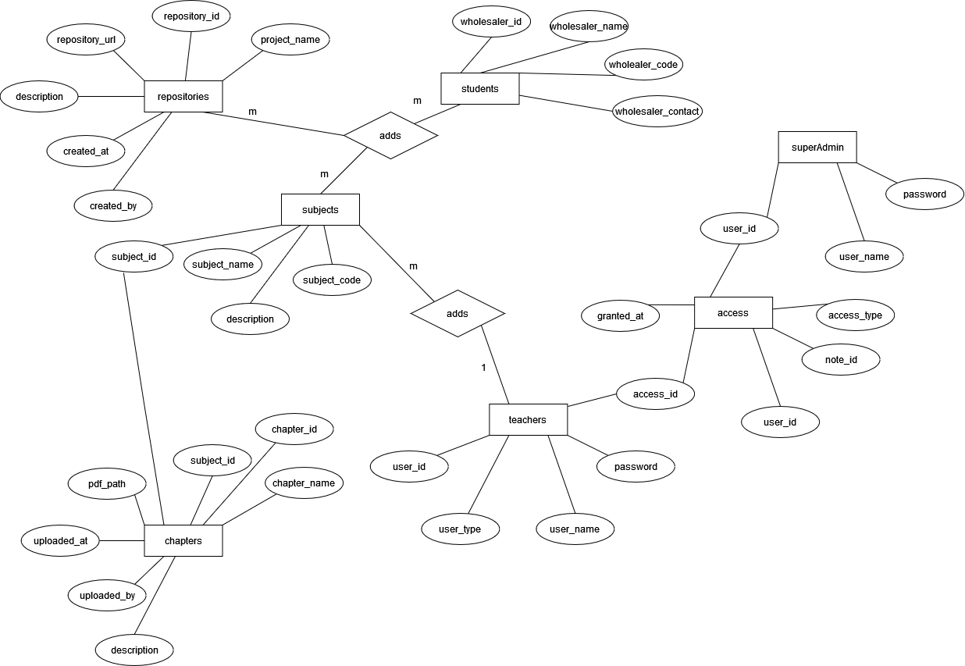

1. Context Diagram

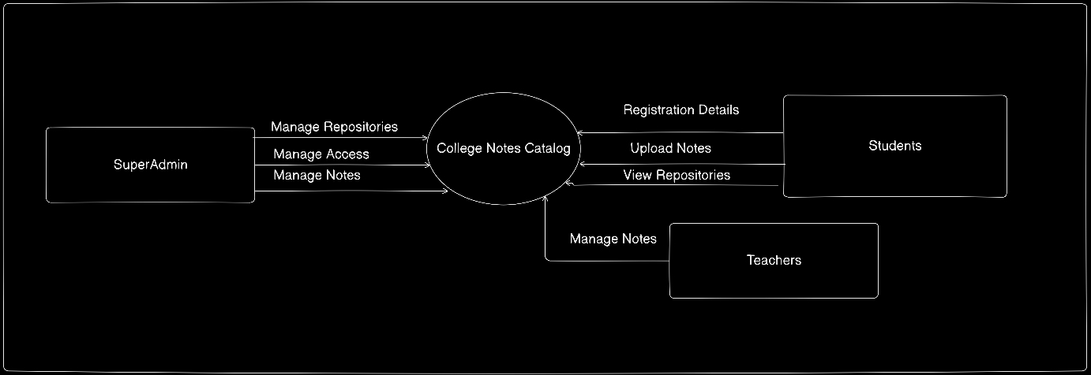

1. DFD Level 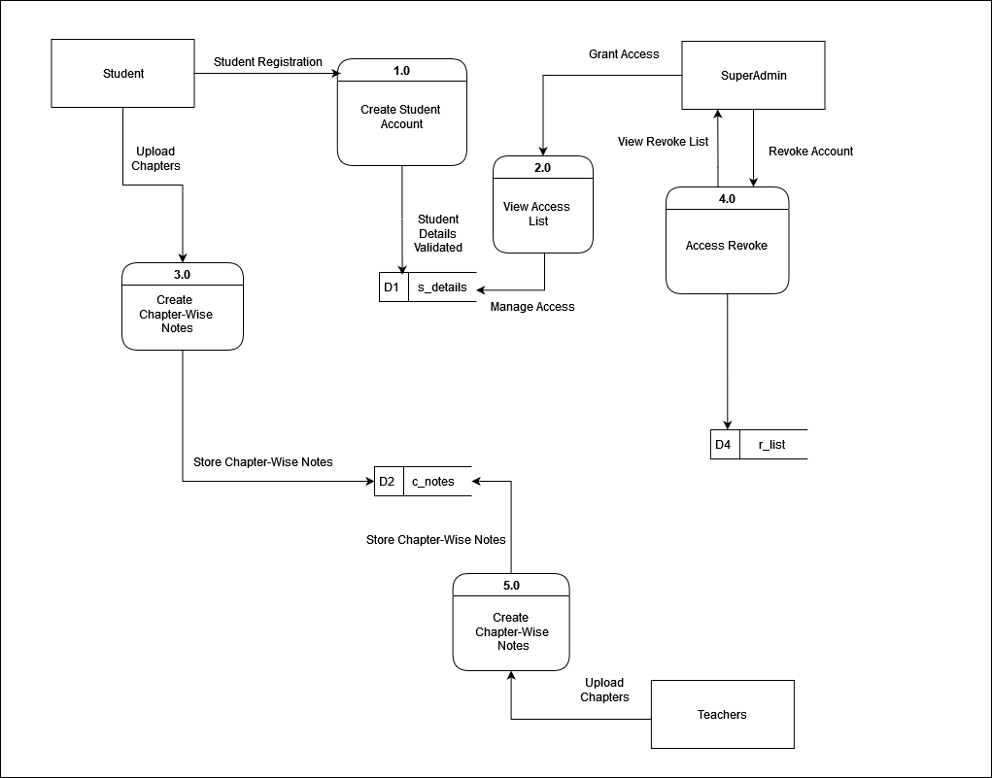
2. Decision Tree and Decision Table

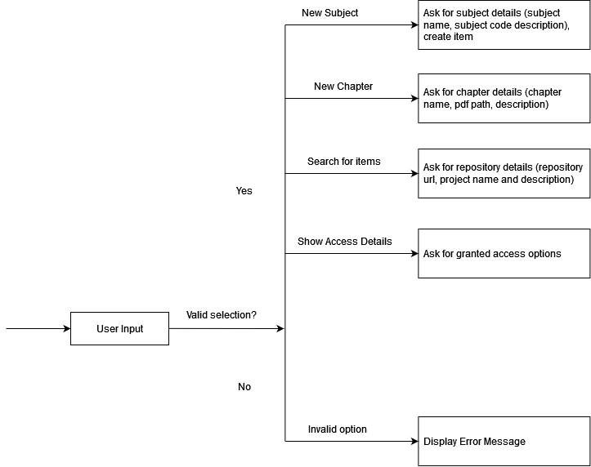

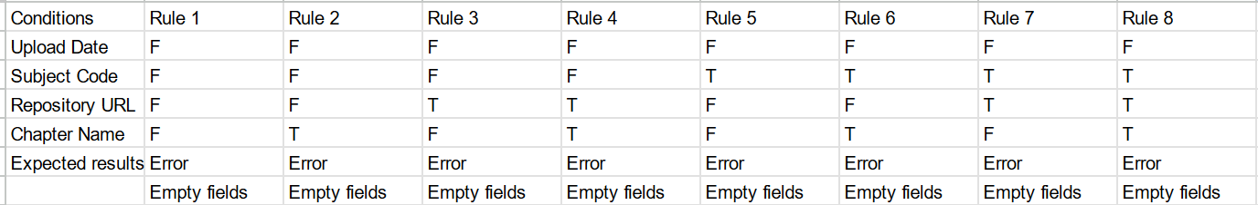

|  |  |  |  |  |
| --- | --- | --- | --- | --- |
| **Conditions** | **Rule 1** | **Rule 2** | **Rule 3** | **Rule 4** |
| **Username** | F | T | F | T |
| **Password** | F | F | T | T |
| **Expected Results** | Error: Username or password is incorrect. | Error: Password is incorrect. | Error: Username is incorrect. | Success: User is logged in. |

1. Use Case Diagram

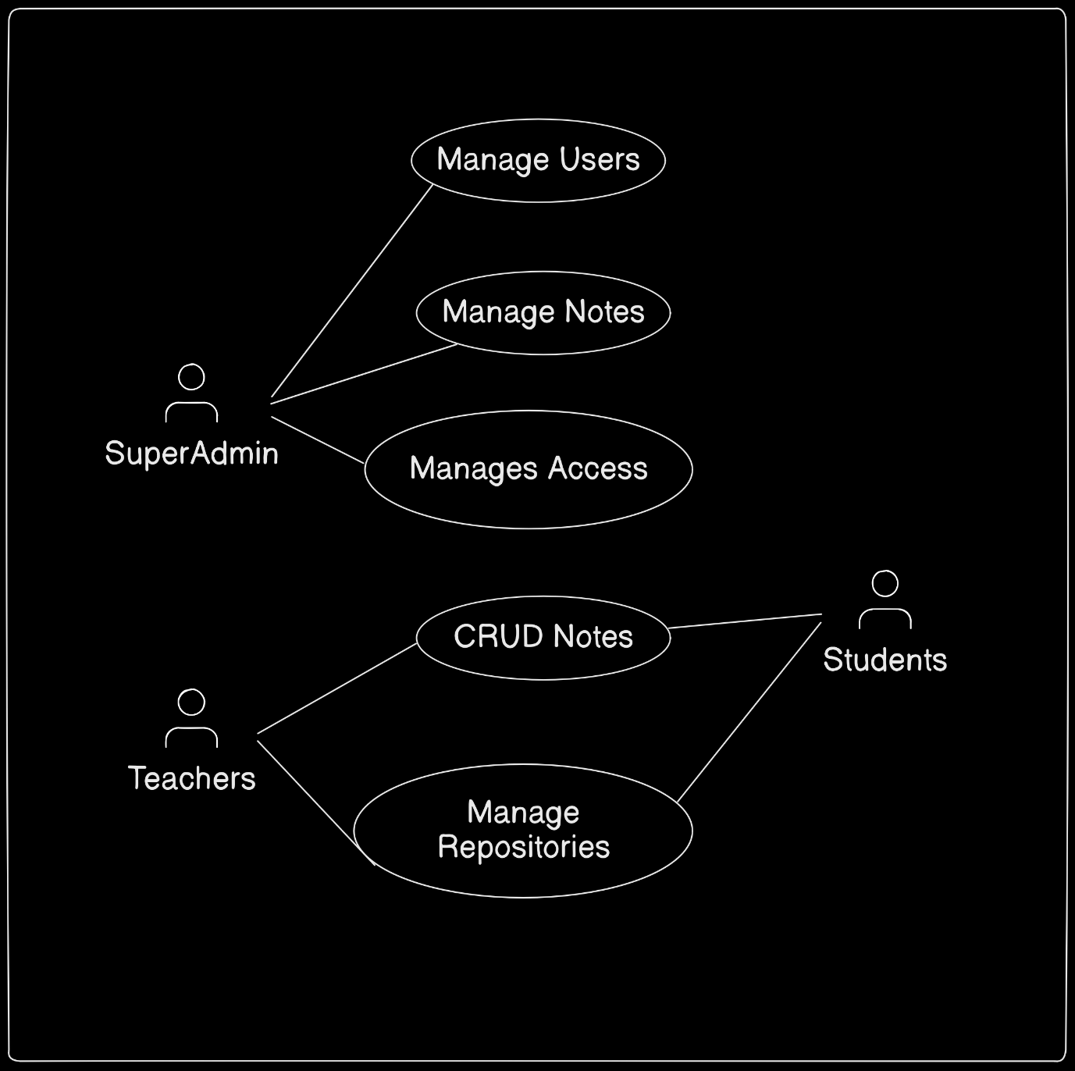

1. 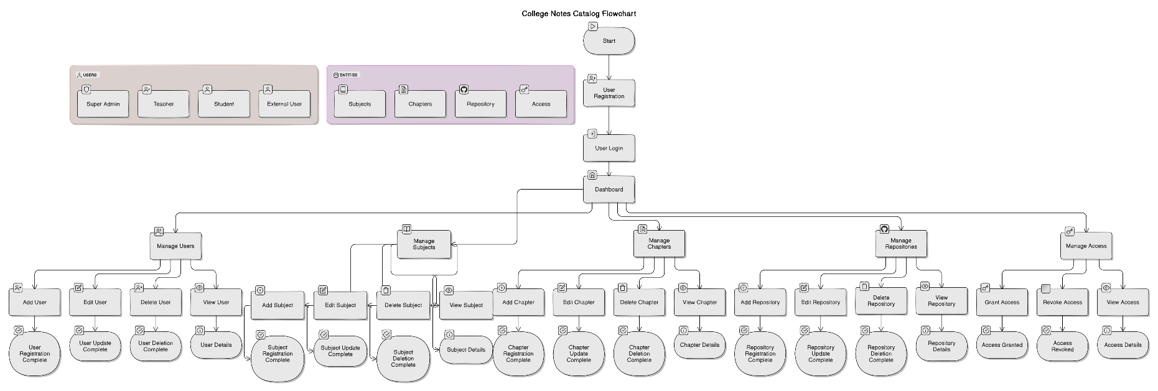Flowchart