Librerouter GUI

Table of Contents
WAN Wizard 3
WLAN WAN Wizard 5
Apps Wizard 6
Security Firewall Wizard 7
Firewall Menu Wizard 8
Categories of Firewall Wizard 9
Security Engines Wizard 10
Main Menu after Wizard 11
Privacy Firewall Wizard 12

WAN Wizard
Following is the WAN connection wizard, where the user need to select WAN settings from either the wired or wireless connection.

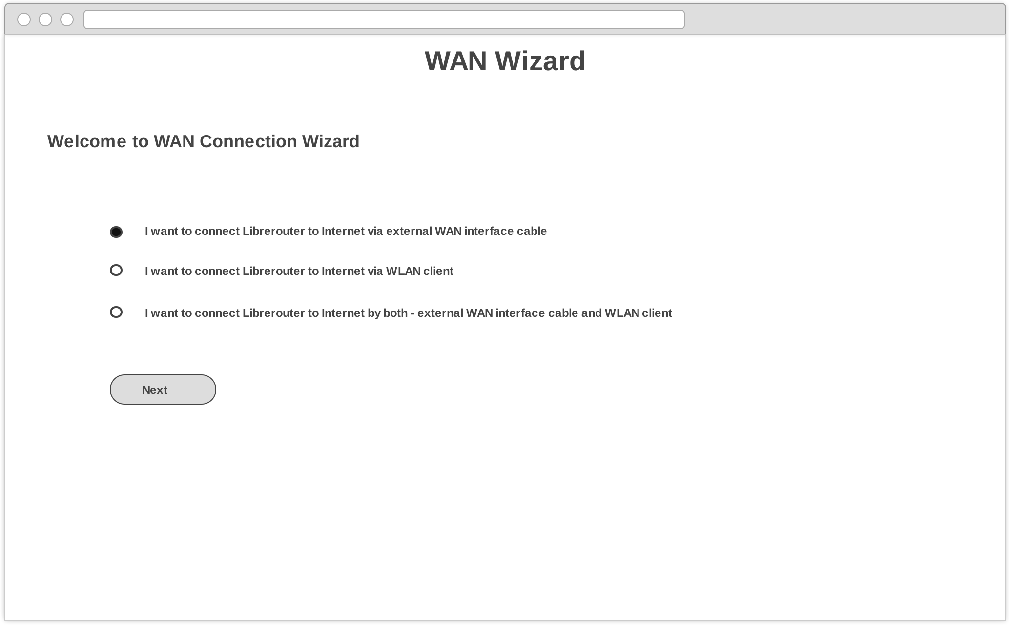

Following is the WAN connection wizard for wired connection. User need to select IP address setting from DHCP or static IP.

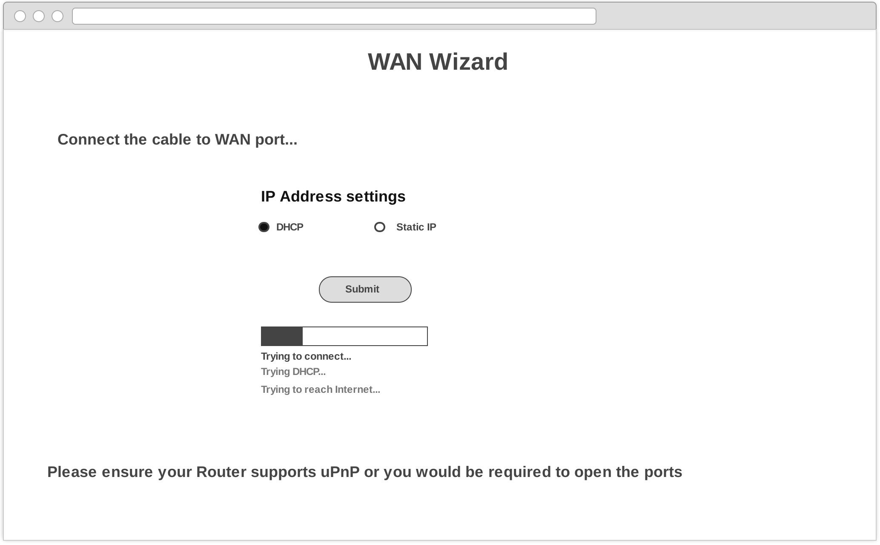

For Static IP address settings, user to provide all the required details like IP address, netmask, gateway and DNS servers.
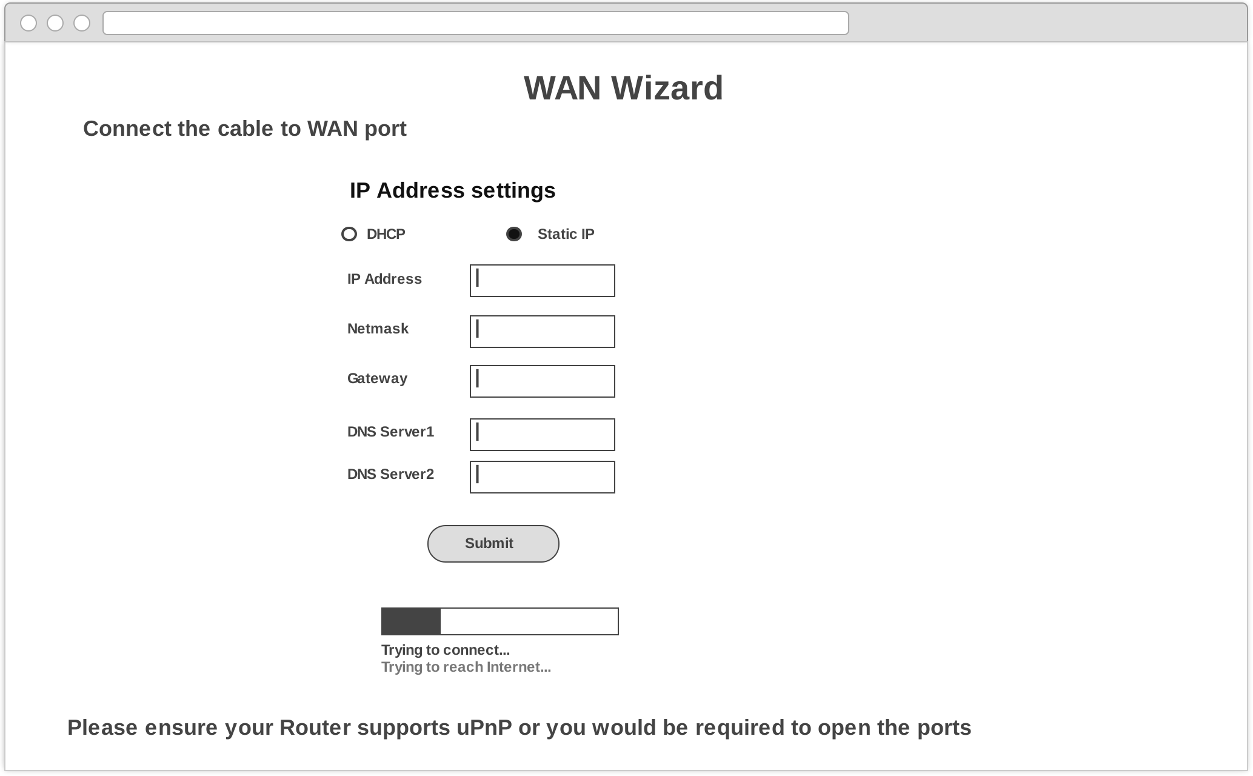

WLAN WAN Wizard
Following is the WLAN WAN connection wizard, where the user need to provide SSID, passphrase for a wireless network to get connected.
User also need to choose between DHCP and static IP address settings.
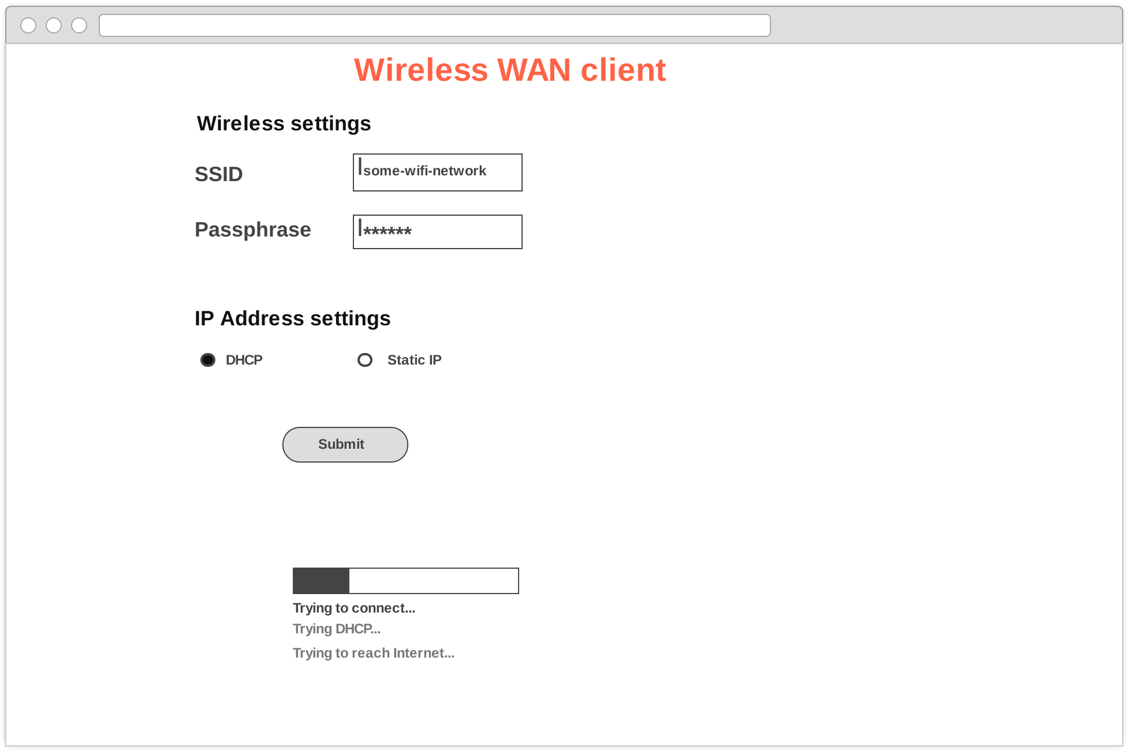
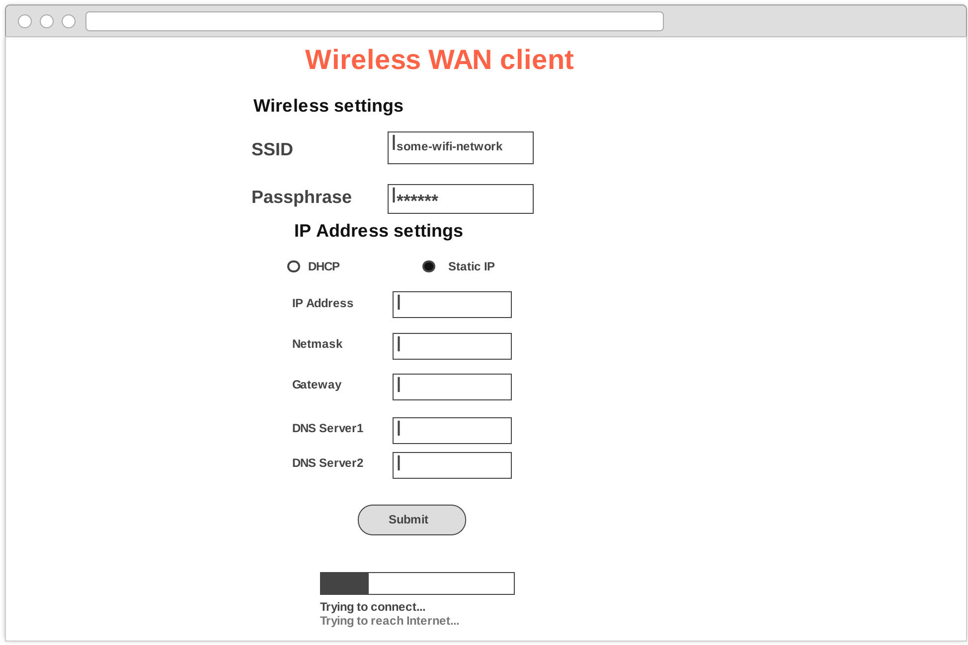
For Static IP address settings, user need to provide the required details like IP address, netmask, gateway and DNS servers.

Apps Wizard
Following is the Apps wizard, where the user need to enable/disable apps.

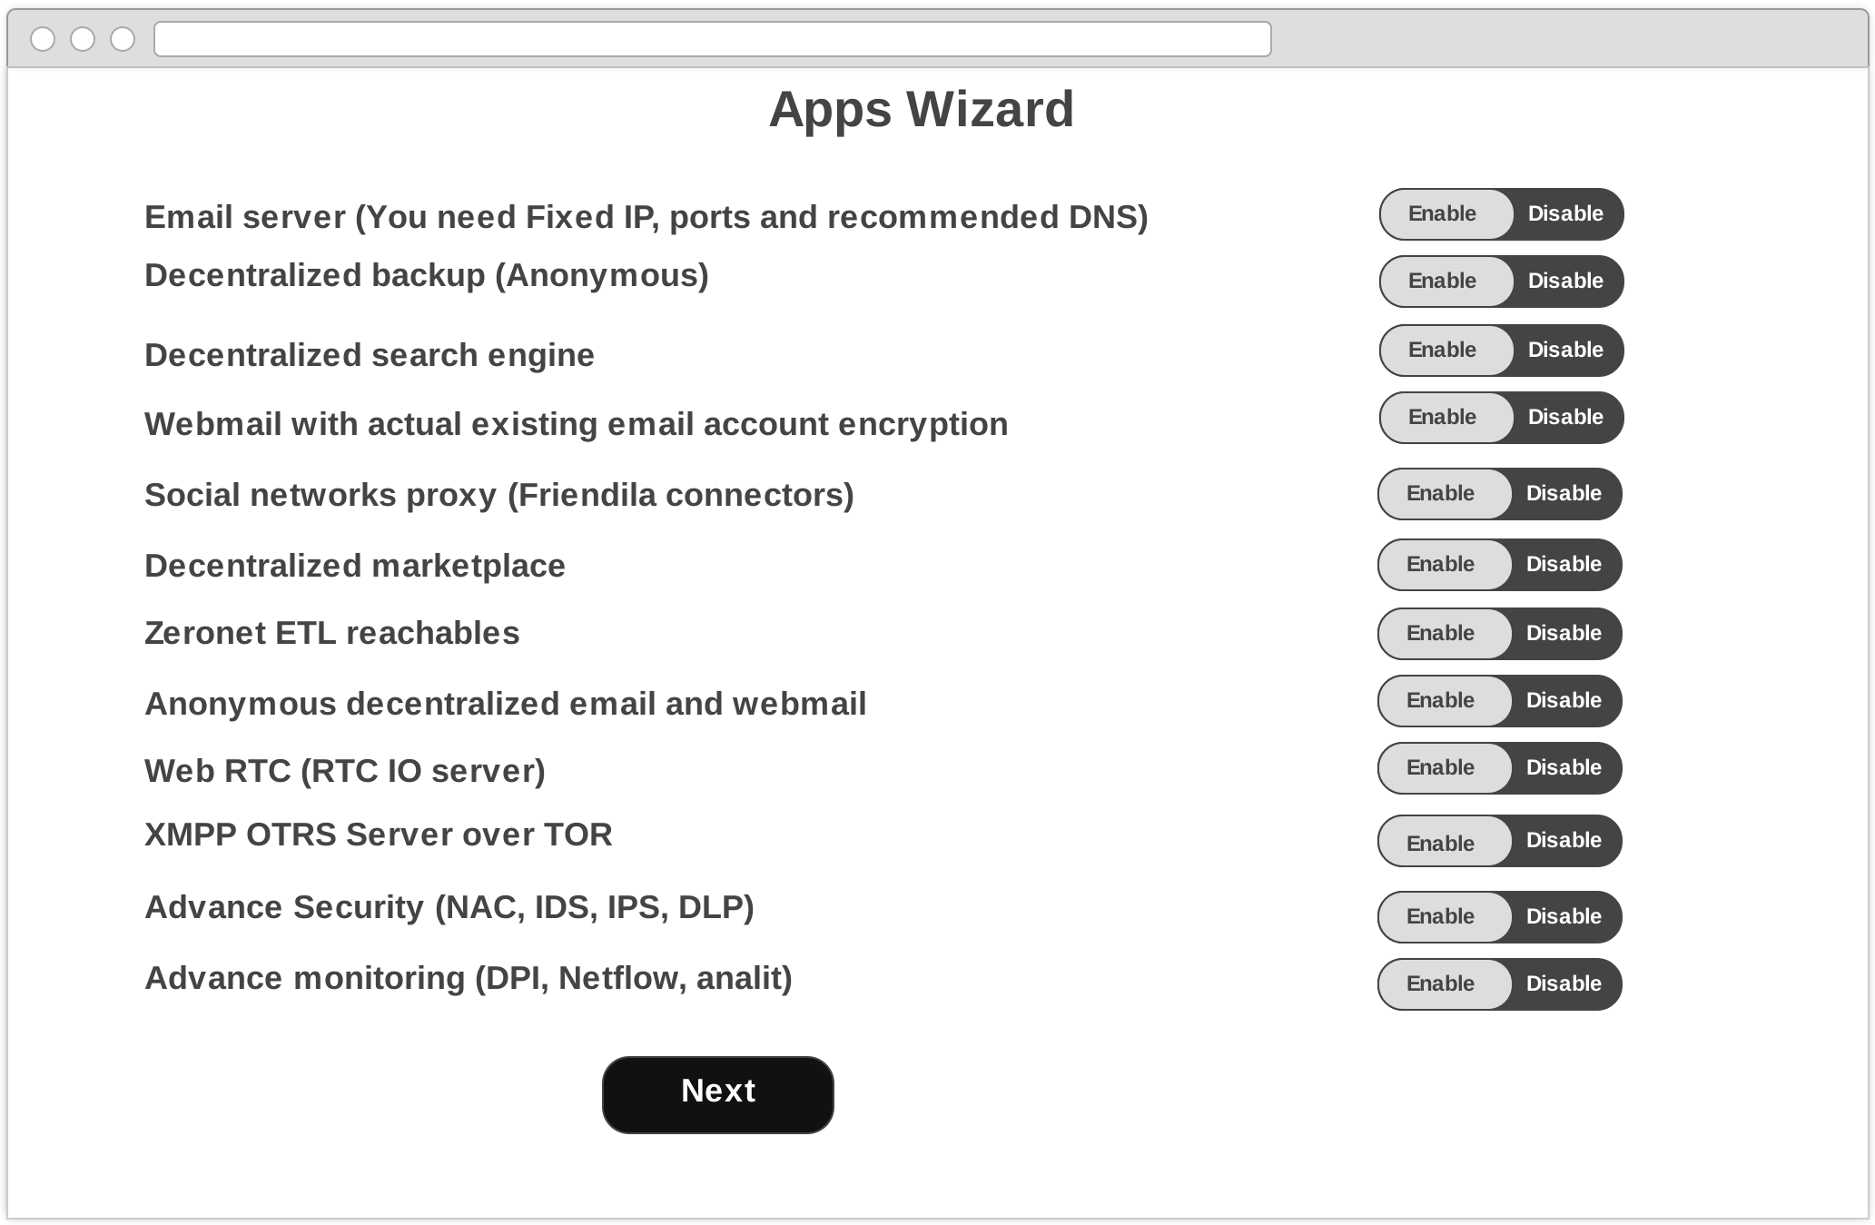

Security Firewall Wizard
Following is the Security Firewall configuration wizard, where the user need to enable/disable firewall configuration items.

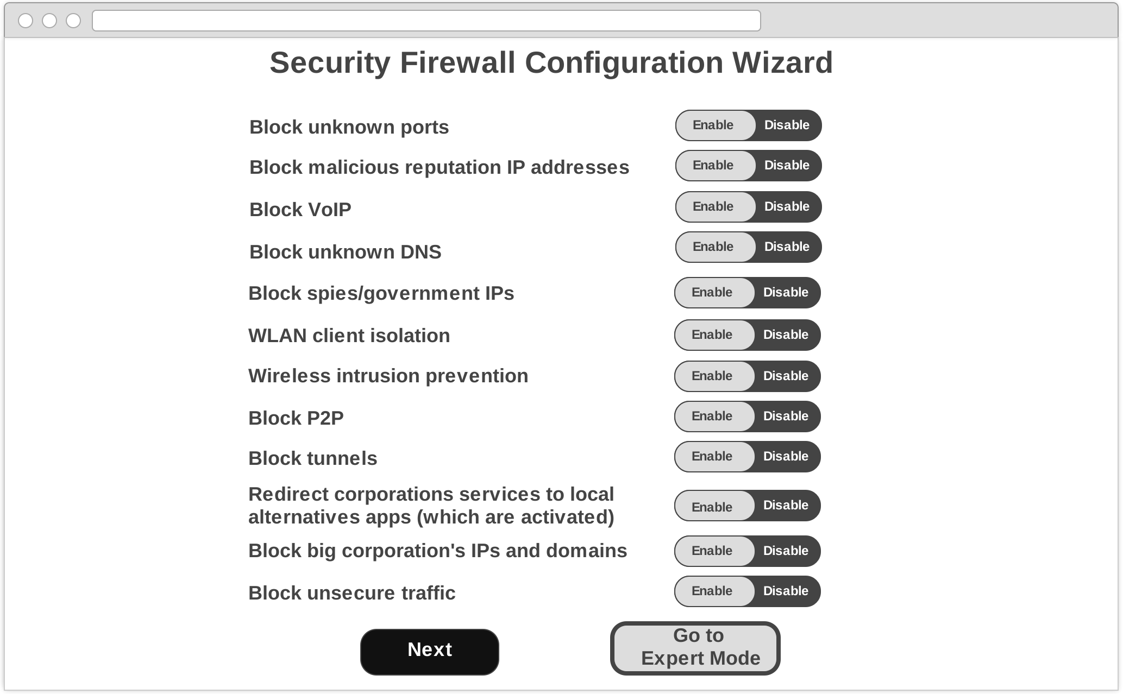

Firewall Menu Wizard
Following is the Firewall Menu wizard, where the user need to select the category of firewall according to the requirement.
To Eric: Some of the words were not recognizable from the scanned images sent by Eric in an email. We have kept “….” on such places inside the below image.

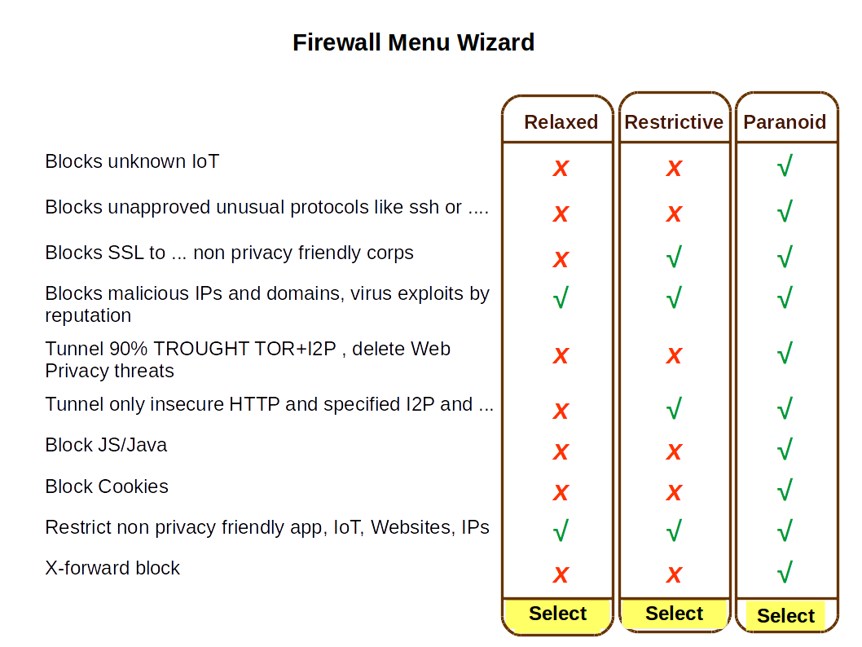

.

Categories of Firewall Wizard
Following is the Firewall categories wizard, where the user can go through different categories of Firewall.
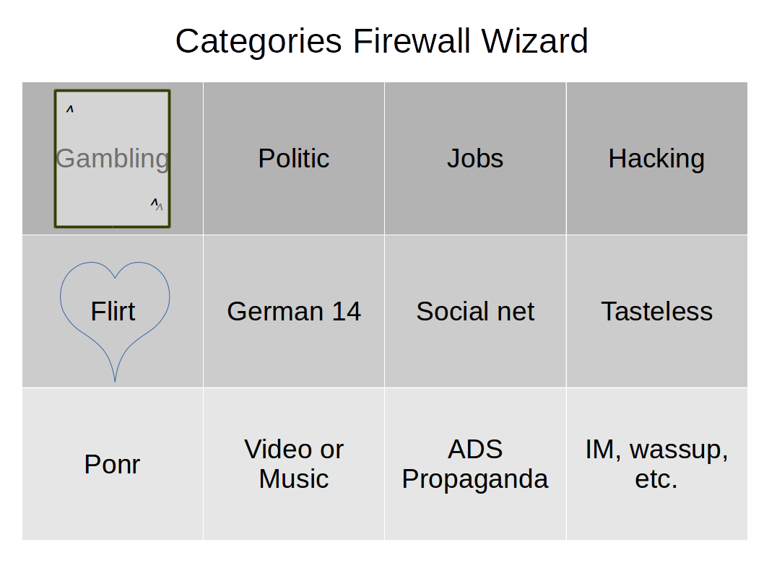

Security Engines Wizard
Following is the Security Engines wizard, where the user need to enable/disable security engines according to the need.

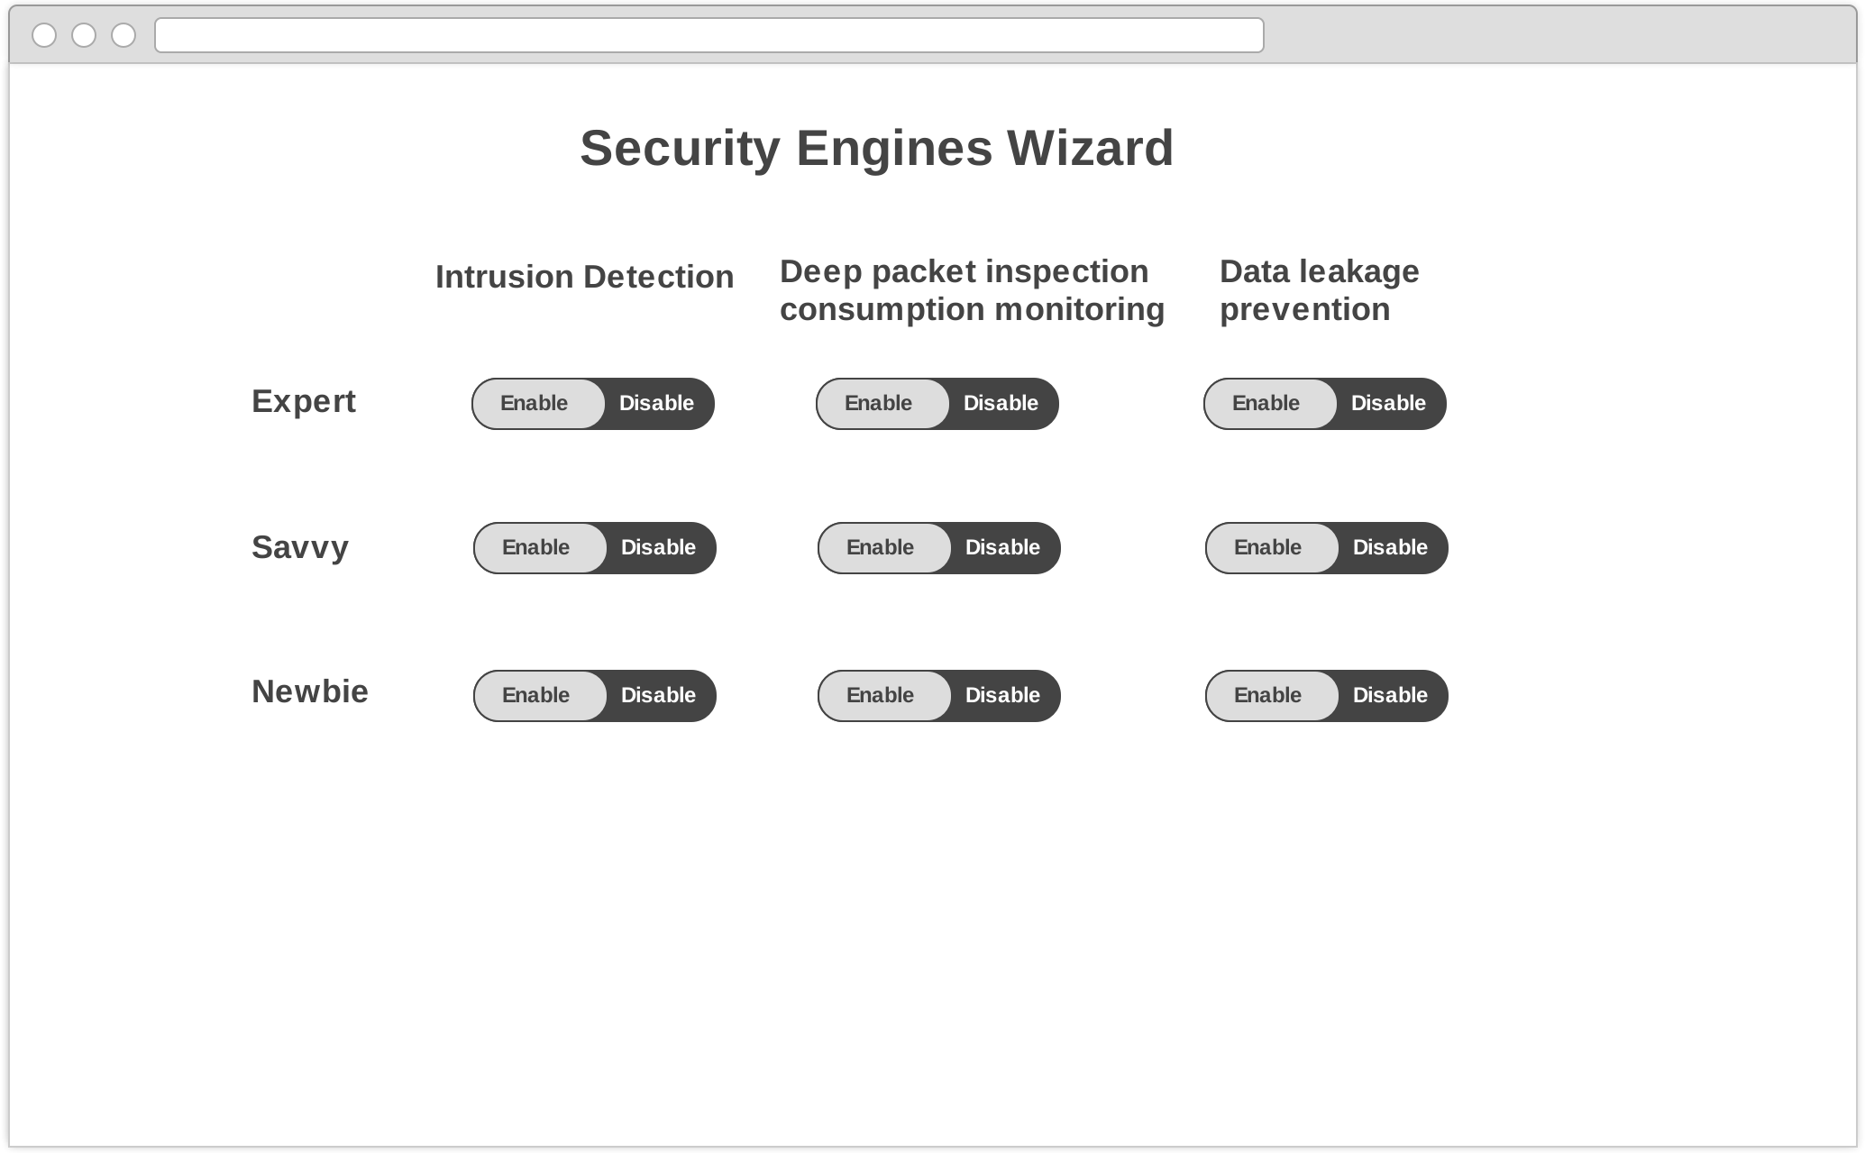

Main Menu after Wizard
Following is the Main menu after wizard.
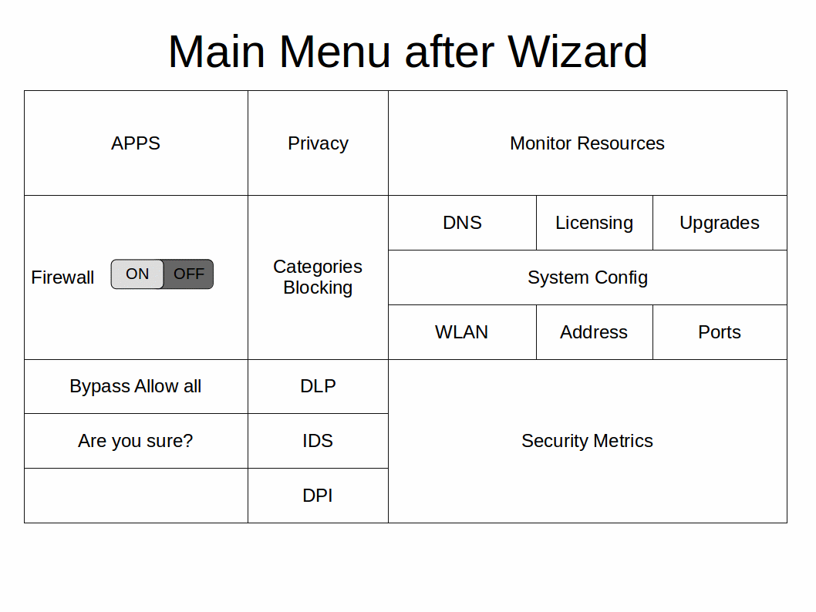

Privacy Firewall Wizard
Following is the Privacy Firewall wizard.





