

Senior-shield

A Next-Gen HealthCare App for Elderly



# ABSTRACT

Senior Sheild is an IoT driven healthcare application meticulously crafted to address the pressing needs of the ageing population by offering real-time monitoring and comprehensive support. In a world where elderly individuals often face challenges related to health management and safety, Senior Shield emerges as a beacon of innovation and practically. Through its sophisticated array of features, including fall detection, heartrate monitoring, medication reminders, and GPS tracking, the application provides a proactive solution to mitigate risks and ensure timely assistance. Imagine an elderly individual living alone, susceptible to falls or sudden health problems. With Senior Shield, they can rest assured that they are being continuously monitored, with any detected abnormalities triggering immediate alerts to designated caregivers. Moreover, the incorporation of GPS tracking offers an added layer of security, allowing caregivers to point out the users’ location in case of emergencies. The application also facilitates seamless communication with the doctors or healthcare professionals through a dedicated chat platform, enabling timely consultations and interventions. Senior Sheild’s user-centric design, characterized by intuitive navigation and adaptive interfaces, ensures accessibility for users of all users. By addressing these critical challenges in eldercare and leveraging IoT technology, Senior Sheild stands as pioneering solution, fostering a safer and more connected environment for ageing individuals and their caregivers alike.

Table of Contents

ABSTRACT 1

INTRODUCTION 3

LITERATURE REVIEW 4

REVIEW OF THE TECHNOLOGIES 5

Arduino UNO 5

ECG Sensor 5

Piezo Electric Sensor 6

Android Studio 6

Flutter and Dart 7

Figma 7

METHODOLOGY 8

Bibliography 9

# INTRODUCTION

The Senior Sheild project represents a groundbreaking endeavor in the realm of elderly healthcare, leveraging cutting-edge technologies to address the unique challenges faced by aging individuals. Developed using Flutter framework, Senior Shield offers a seamless and intuitive user experience across the android platform for now ensuring widespread accessibility and adoption. At the core of the application lies its sophisticated health monitoring capabilities, including real-time heart rate monitoring facilitated by ECG sensors and fall detection enabled through piezoelectric sensors. These sensors work in tandem to continuously monitor the user’s vital signs and detect any sudden falls or abnormalities, thereby providing timely assistance and intervention (Marathe, et al., 2019).

In addition to its advanced monitoring feature, Senior Shield boasts a comprehensive set of functionalities designed to enhance the overall well-being and safety of elderly users. GPS integration enables precise location tracking, empowering caregivers to swiftly locate and assist the user in case of emergencies or wandering. Furthermore, the application facilitates direct communication with healthcare providers through a built-in chat interface, facilitating prompt consultation and medical assistance. Real-time alerts ensure that caregivers are promptly notified of any emergent situations, enabling them to take immediate action and ensure the user’s safety. Moreover, Senior Shield includes medication remainders to help users adhere to their prescribed treatment regimens, promoting better health outcomes and medication compliance.

The project methodology employed in the development of Senior Sheild follows an agile approach, emphasizing iterative development, collaboration, and adaptability. By breaking down the development process into smaller, manageable increments, the agile methodology enables rapid prototyping, continuous feedback, and timely adjustments to meet evolving project needs and requirements. This iterative approach fosters greater flexibility and responsiveness, ultimately resulting in a more robust and user-centric application.

The Senior Sheild application represents pioneer effort in leveraging technology to address the healthcare needs of elderly population. By harnessing the power of Flutter and integrating advanced sensor technologies, the application offers a comprehensive suite of features aimed at promoting the health, safety, and independence of elderly individuals. Through its agile development methodology, Senior Shield exemplifies a commitment to continuous improvement and innovation, ensuring that it remains at the forefront of eldercare solutions.

# LITERATURE REVIEW

The well-being of elderly individuals is profoundly influenced by health challenges that come with ageing, often making self-care difficult. According to the (Roy, et al., June 2022),falls represent the leading causes of injuries, fatalities, and hospitalizations among senior citizens globally, underscoring the critical importance of fall detection in their healthcare system. Additionally, monitoring fluctuations in heartrate and blood pressure can help anticipate and address various health circumstances affecting the elderly. (Madhu, et al., 2023) In today's world, where adult children are typically relied upon to care for their ageing parents, fulfilling this role has become increasingly challenging. Factors such as demanding work schedules, commitments to their own families, and other personal obligations often hinder their ability to provide the level of care their parents may require. While home nurses may be an option in certain cases, some families may find themselves unable to bear the additional expenses of hiring one. However, for these elderly individuals, the advent of the Internet of Thing (I0T) proves to be a blessing.

(Basanta, et al., 2016)The need for improved healthcare services for the elderly is evident, given the unique health challenges they face. Being IoT a boon for them, wearable devices consisting of bio sensors, wireless sensors provide an intensive service platform for the elderly ones. Such devices support real time activity and monitor the health system of elderly people.

# REVIEW OF THE TECHNOLOGIES

The technologies that have been used in this project follows as:

1. Arduino
2. ECG Sensor
3. Piezo Electric sensor
4. Android Studio
5. Flutter and Dart
6. Figma

## Arduino UNO

Arduino UNO is an open-source electronics platform or called as microcontroller that can be easily programmed and updated at any time which was designed for professionals and students to develop devices that can interact with the environment using sensors (Ismailov, et al., 2022).

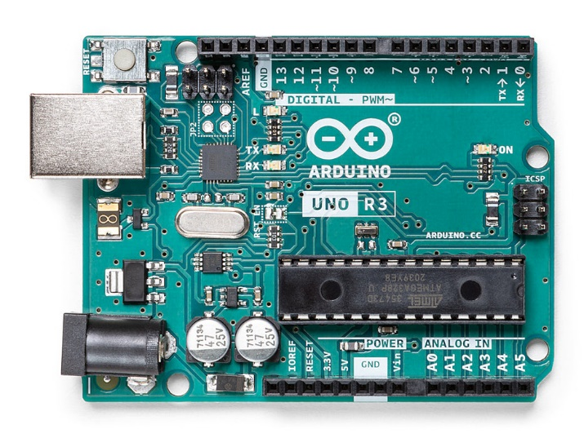The Arduino platform is also divided into Hardware and Software as its parts. The IDE known as Arduino IDE is a software component of the microcontroller whereas the board known as Arduino Development board is its hardware part.

Figure 1 Arduino Uno Rev3

## ECG Sensor

The ECG Sensor, also known as electrocardiogram sensor, plays a crucial role in monitoring heart rate by capturing the electrical impulses generated by the heart’s contractions (Admin, 2022). These sensors are specifically engineered to accurately detect and record these signals, even amidst external interference or movement artifacts. By extracting, amplifying, and filtering the small bio potential signals emitted by the heart, ECG sensors provide valuable insights into cardiac activity, aiding in the diagnosis and management of various heart conditions.

Here in our case, it is being used to monitor the heat rate of the elderly people. Any fluctuations in the heart rate and blood pressure which notify the take carers via notification alerts.

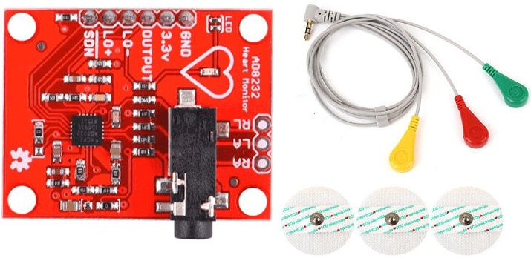

Figure 2 AD8232 ECG Sensor

## Piezo Electric Sensor

A device that uses the piezo electric effect to measure changes in pressure, acceleration, temperature, strain, or force by converting these into electrical charge (Anon., 2019). The capability of changing the mechanical stress into electrical charge is known as piezo electric effect.

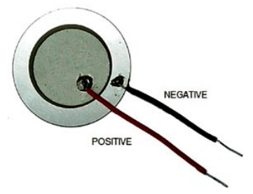

Figure 3 Piezoelectric Sensor 2

Figure 4 Piezoelectric Sensor 1

## Android Studio

It is an official integrated development environment (IDE) for Android application development. This IDE is developed by Google and based on IntelliJ IDEA that offers a comprehensive suite of tools and features tailored specifically for building Android Apps efficiently. UI Design, Code Editing, Emulator, Performance Profiling, Version Control Integration, Gradle Build System and support for various libraries and APIs makes the IDE more suitable and effective to use.

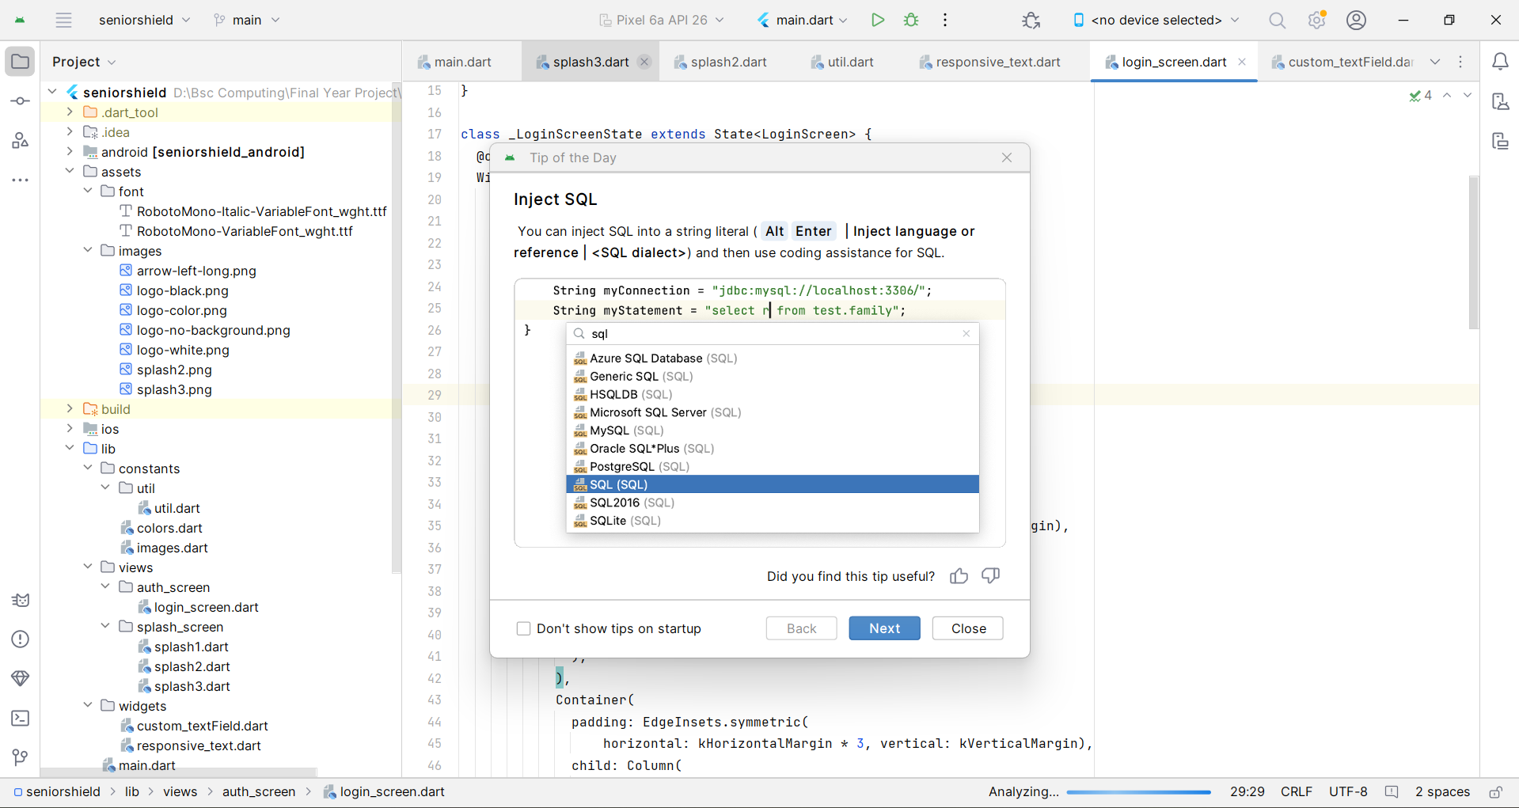

Figure 5 Android Studio IDE

## Flutter and Dart

Flutter is an open-source UI software development kit (SDK) created by Google for creating applications for mobile, web and desktop from single codebase. It is based on Dart programming language. Fast Development, Rich Set of Widgets, Native Performance, Open Source and Community Driven and most importantly single codebases, multiple platforms are some of the features which make Flutter framework perfect for mobile applications development.

Whereas Dart is object-oriented programming language (OOP) which syntax are like Java and JavaScript. It offers classes, interfaces, mixing and optional typing.

Together, Flutter and Dart offer a powerful combination for building cross-platform applications with a focus on performance, productivity, and a modern user experience.

## Figma

Figma is a cloud-based design tool which is used for creating user interfaces, web designs, and app prototypes. In this project, Figma has been used for creating the application design which makes the application development more efficient and productive.

Various features of Figma like Cross-platform compatibility (for both mac and windows), vector editing tools, component-based design, prototyping and animation, inbuilt version control and comments and plugins and integrations makes this software more useful and versatile platform.

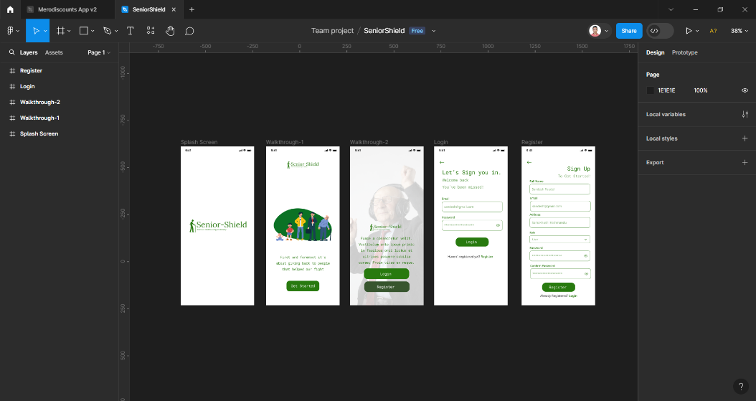

Figure 6 Figma.

# METHODOLOGY

# Bibliography

Admin, 2022. *ECG Graph Monitoring with AD8232 ECG Sensor & Arduino.* [Online]   
Available at: https://how2electronics.com/ecg-monitoring-with-ad8232-ecg-sensor-arduino/  
[Accessed 08 March 2024].

Anon., 2019. *Electronics For You.* [Online]   
Available at: https://www.electronicsforu.com/technology-trends/learn-electronics/piezoelectric-sensor-basics  
[Accessed 09 03 2024].

Basanta, H., P. Huang, Y. & Lee, T. T., 2016. *Intuitive IoT-based H2U healthcare system for elderly people.* Mexico City, Mexico, IEEE, pp. 1-6.

Ismailov, A. S., Jo'rayev, Z. B. & Institure, A. M. B., 2022. Study of arduino microcontroller board. *Science and Education" Scientific Journal,* 3(3).

Madhu, S., Jyothi, K., Pravallika, S. & Sridurga, N., 2023. *IoT-Enabled Applications for Elderly Support and Care: A Systematic Review.* Singapore, Springer.

Marathe, S., Zeeshan, D., Thomas, T. & Vidhya, S., 2019. *A Wireless Patient Monitoring System using Integrated ECG module, Pulse Oximeter, Blood Pressure and Temperature Sensor.* Vellore,India, IEEE, pp. 1-4.

Roy, H. S., Khondakar, M. F. K. & Sarowar, M., June 2022. Internet of things based fall detection and heart rate monitoring system for senior citizens. *International Journal of Electrical and Computer Engineering (IJECE).*