**Find relevant data sources (for example, publicly available news or online social media) and identify trending topics of either “Joe Biden” or “Dexamethasone”**

**Introduction**

Here I have worked on getting top news articles about Joe Biden from GoogleNews API.

**Libraries**

**Pytrends**

It is a library providing an API to Google Trends using Python. It is used to get trending results instead of manually searching for it.

**Pygooglenews**

It is a python library to get Google news. Google news data can be accessed via the RSS. RSS (Really Simple Syndication), an XML - based format for sharing and distributing web content. RSS allows you to subscribe to a news feed from your favorite website and receive automatic updates from the site as they become available.

**Matplotlib**

Matplotlib is an amazing visualization library in Python for 2D plots of arrays. Matplotlib is a multi-platform data visualization library built on NumPy arrays and designed to work with the broader SciPy stack.

**RE**

A regular expression (or RE) specifies a set of strings that matches it; the functions in this module let you check if a particular string matches a given regular expression.

**Visualizing the trends of Joe Biden and Dexamethasone over the period of last 5 years**

First we have to request Google trending topics from Google trends. For that we need to import a method called ‘TrendReq’ from the ‘pytrends.request’ library. I have set a Host language as english and a region as US. And time zone as US CST i.e 360. Setting keywords as “Joe Biden” and “Dexamethasone”, to get their data. Now using the build_payload module over the period of last 5 year and for all types of categories to get the data for keywords. We can now look at the interest over time method to see the number of searches, based on a ranking where 100 is the most popular.

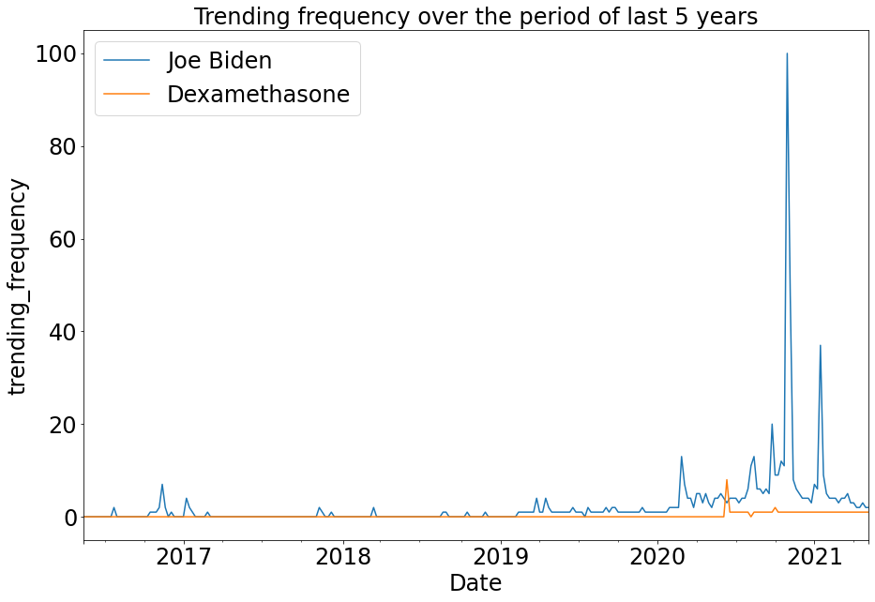

**Getting top news about Joe Biden**

FIrst we need to import the GoogleNews class to get all the news from Google.

Using top_news() we will get only top news from google which I am assuming them as a trending news as well.

Here I am searching for the joe or biden name in the title of the news and getting the result of the published date, url and title of that news only.