SAP cloud platform, API management with SAP cloud Identity Services

SAP cloud Platform allows the customer to connect their SAP Cloud Identity Services with HCP accounts. The details of this are available in

<https://help.hana.ondemand.com/cloud_identity/frameset.htm?61ad3b0796ca4f5bae706632a29b1418.html>

SAP Cloud Identity (SCI) service supports SAML 2.0 for Identity federations and using SAML it can federate and connect to any Custom IDP that supports SAML 2.0.

The high level view for the SAP API Management and the SCI is captured in the diagram below:-



### Establishing the Trust between SCI account and SAP HCP

1. Logon to the [SAP CP cockpit](https://account.hana.ondemand.com/cockpit), navigate to *Trust.* Then in the local service provider from the configurations select *Custom*, click on the *Generate Key Pair* and click *Save.* Click on the *Get Metadata* to generate the metadata.

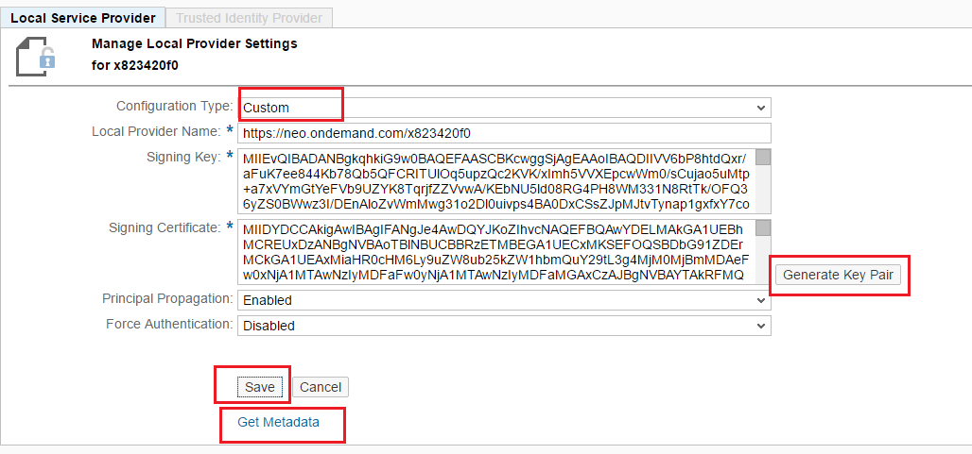

1. This metadata would have to be imported into the SAP Cloud Identity.
2. Logon to the SAP Cloud Identity Admin Cockpit (https://<yourscitenant>.ondemand.com/admin/)
3. Navigate to the Applications page and then click on the Add button as shown in the screen shot.

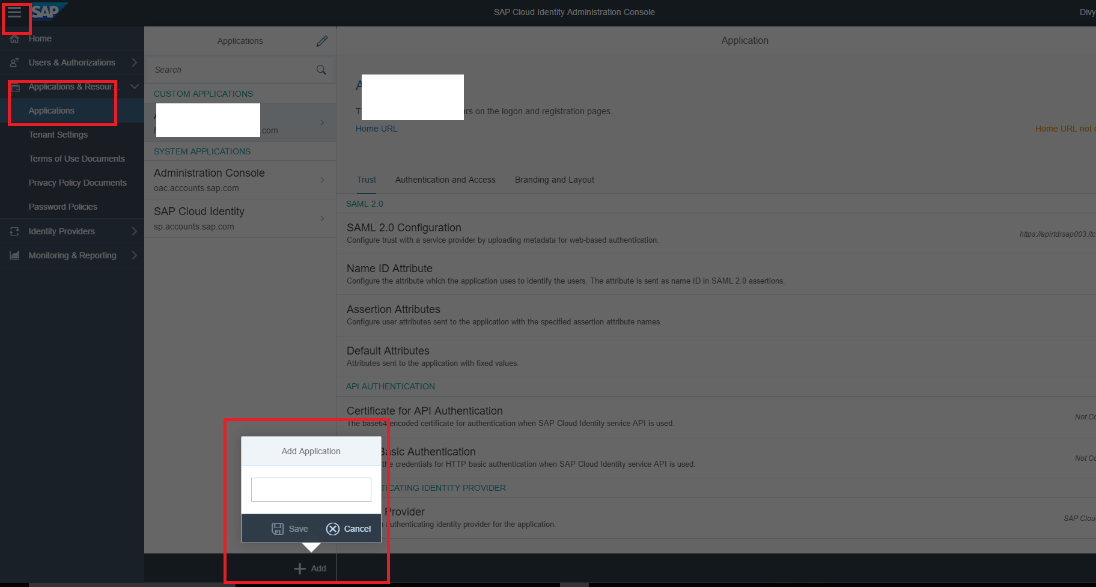

1. Provide an Application name (e.g SAP APIM) and then click on the Save button.
2. In the newly created Application, under the “Trust” tab, click on the option “SAML 2.0 Configuration”

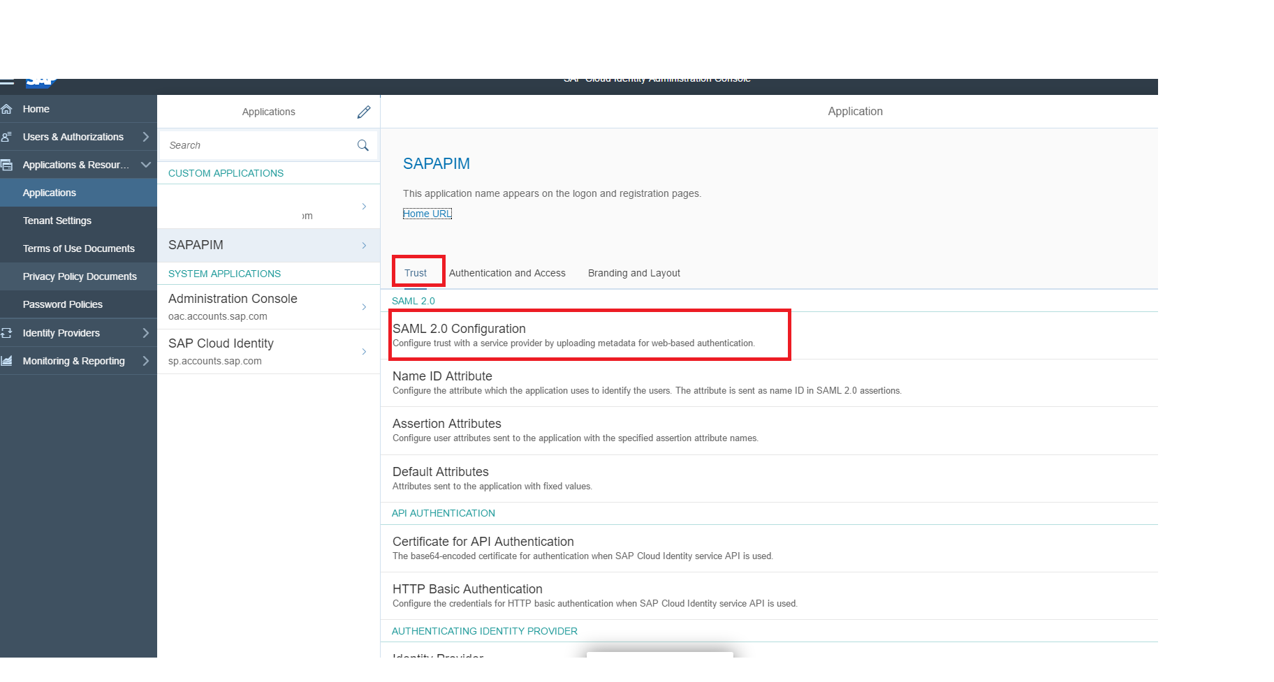

1. Under the Define from Metadata tab “Browse” and upload the SAML metadata downloaded in step 1) and then click on the “Save” button

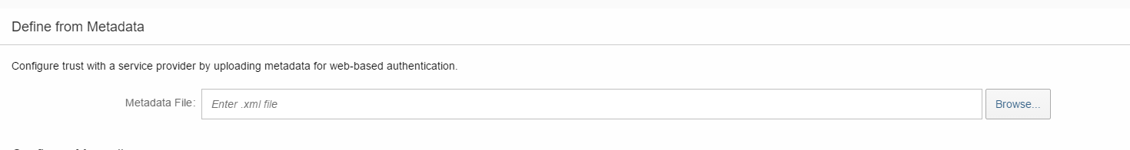

1. Now navigate to the “Assertion Attributes” of the SAML 2.0 configurations, and then provide the mapping between the SAML Assertion values (ref screenshot below). The configurations are required for the Developer on boarding on the Developer Portal side.

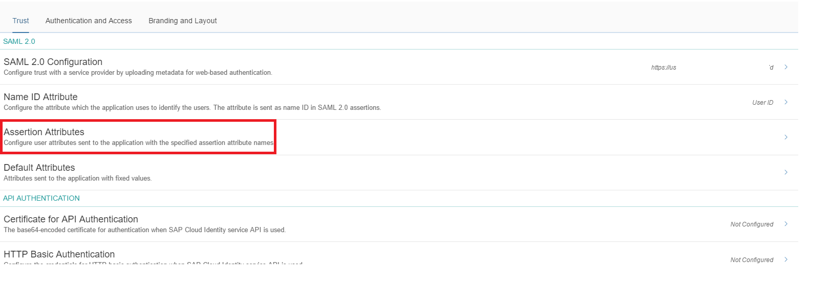

The table contains the mapping between the user attribute and the assertion attribute fields.

|  |  |
| --- | --- |
| **User Attribute** | **Assertion Attribute** |
| Last Name | last_name |
| Display Name | display_name |
| E-Mail | mail |
| First Name | first_name |

Ref screenshot for the added the assertion attributes

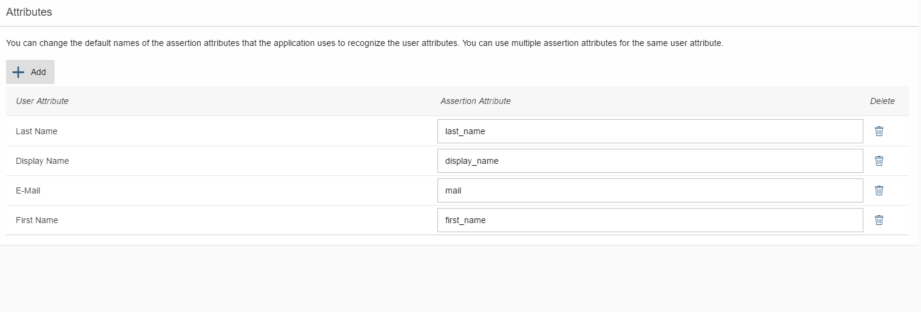

### Establishing the Trust between SAP CP account and SCI

1. Download the SAML metadata from the SCI by Navigating to the Tenant Settings-> SAML 2.0 Configurations. Then in the navigated screen click on the “Download Metadata”. Ref screenshot belows

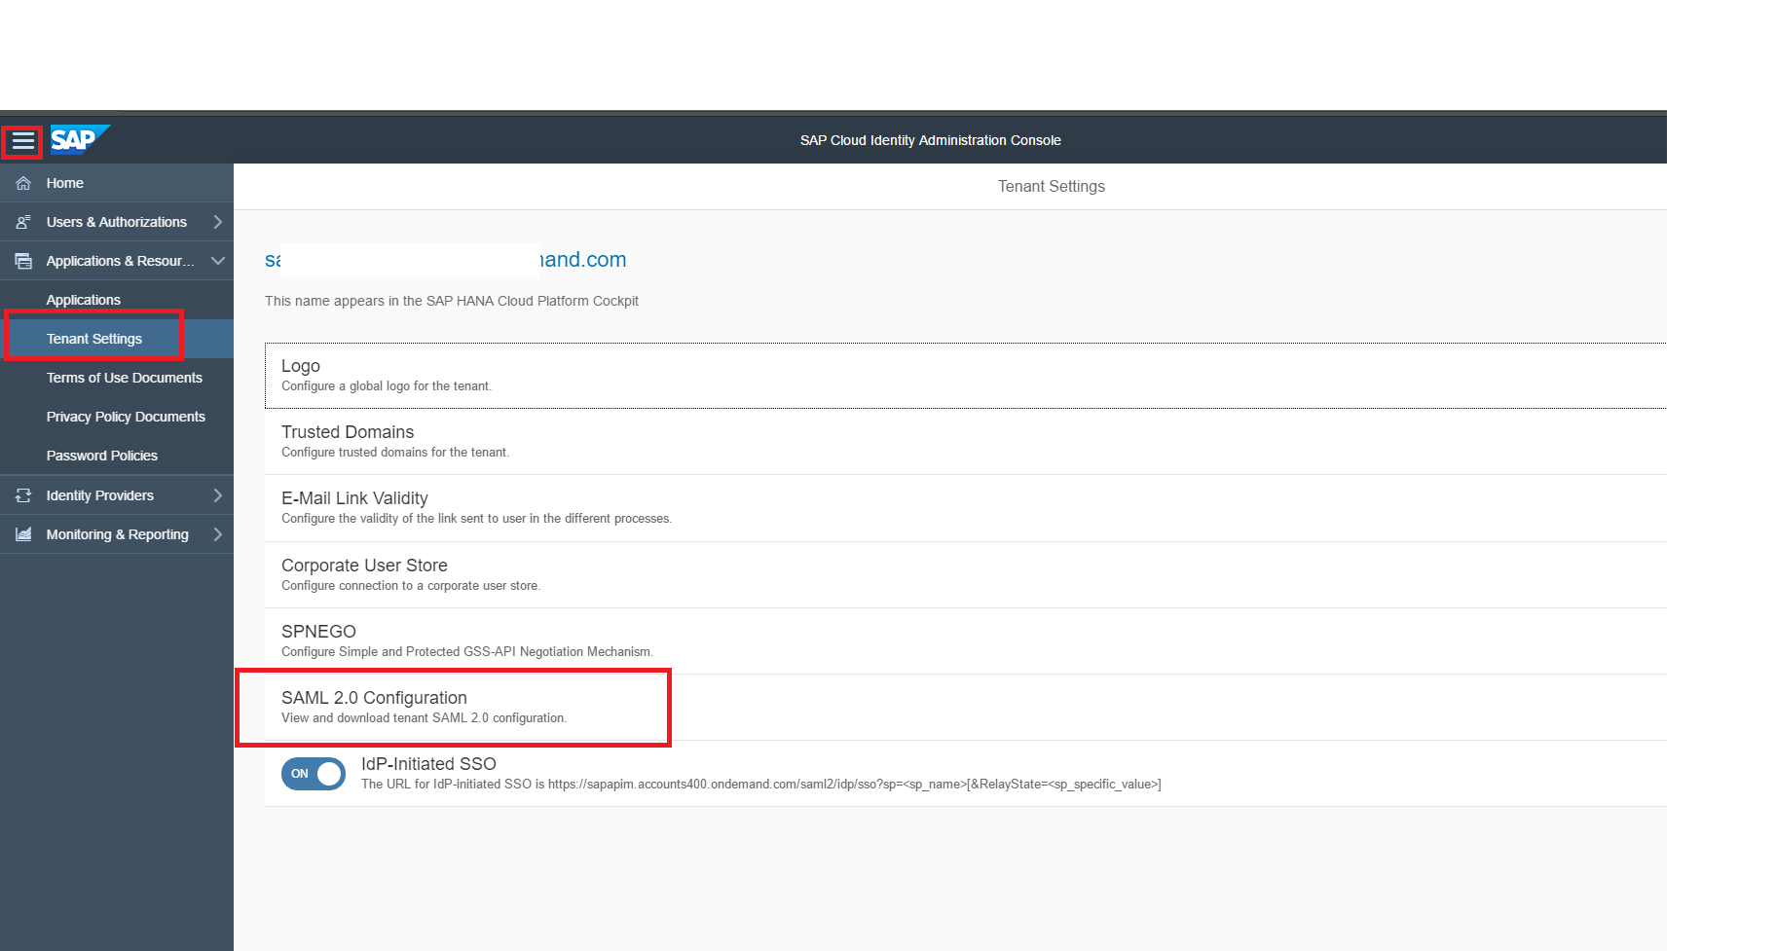

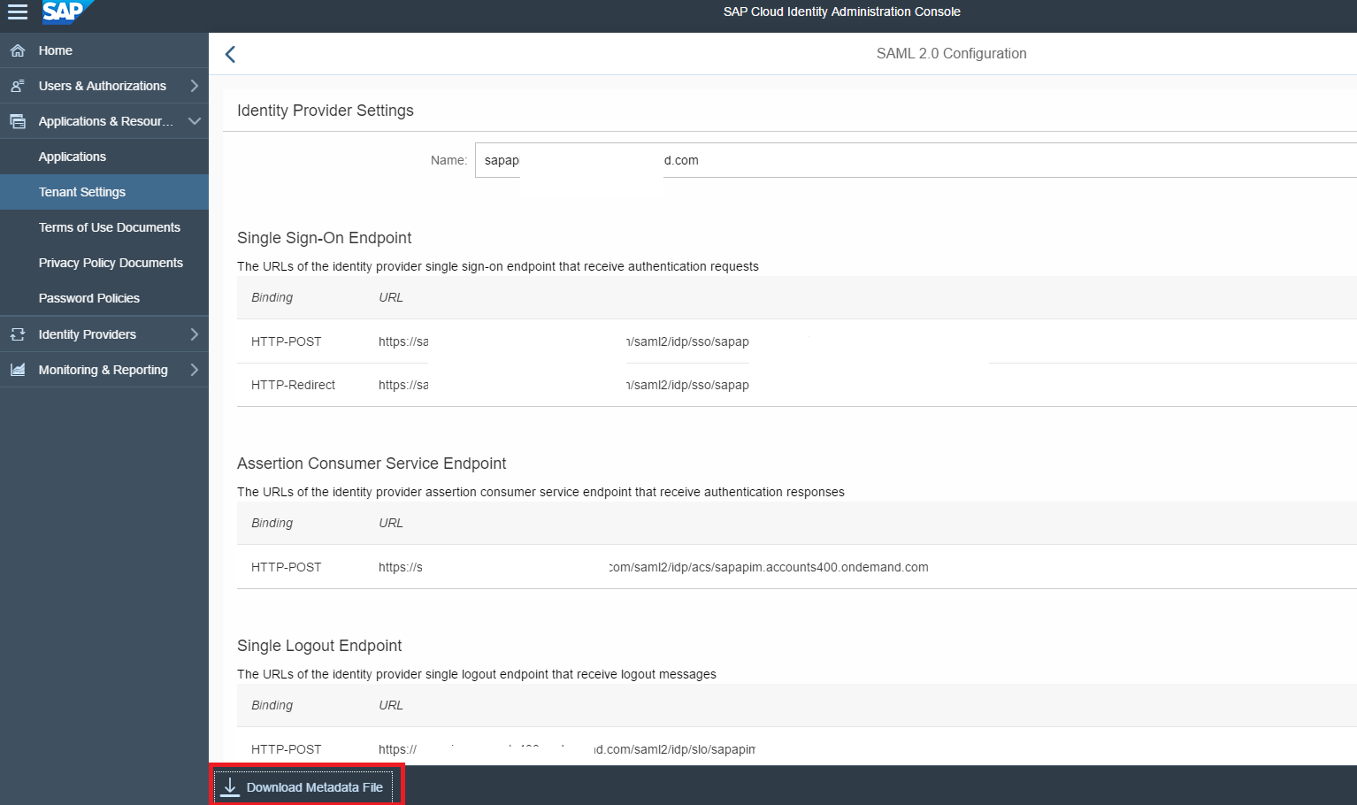

1. Logon to the [SAP HCP cockpit](https://account.hana.ondemand.com/cockpit) and then Navigate to the Trusted Identity Provider tab, click on the “Add Trusted Identity Provider”and then Browse and upload the SAML metadata downloaded in step 9)

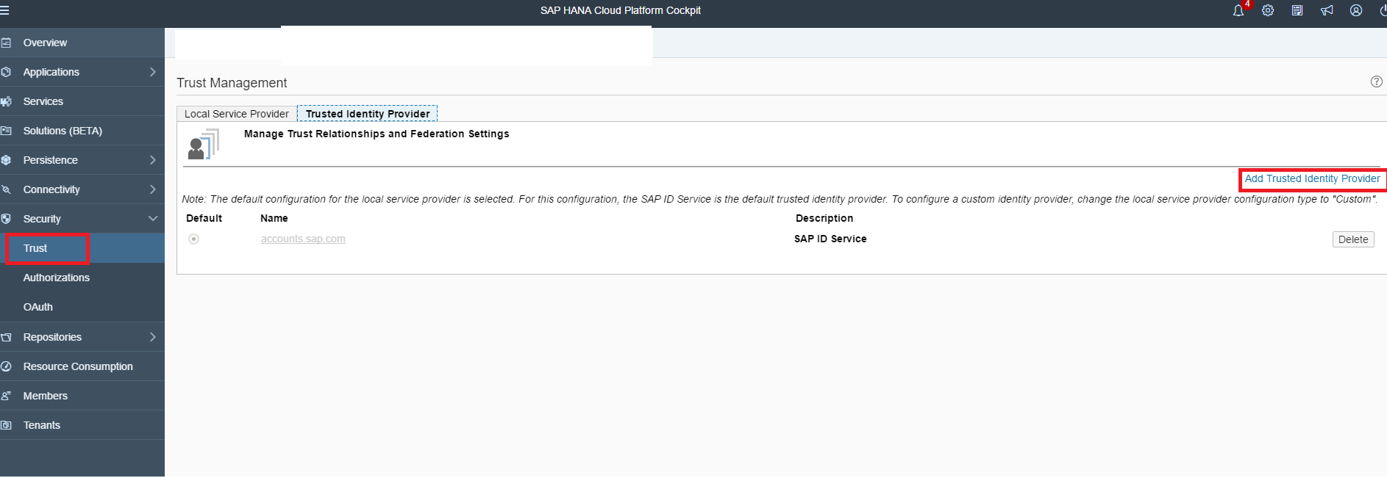

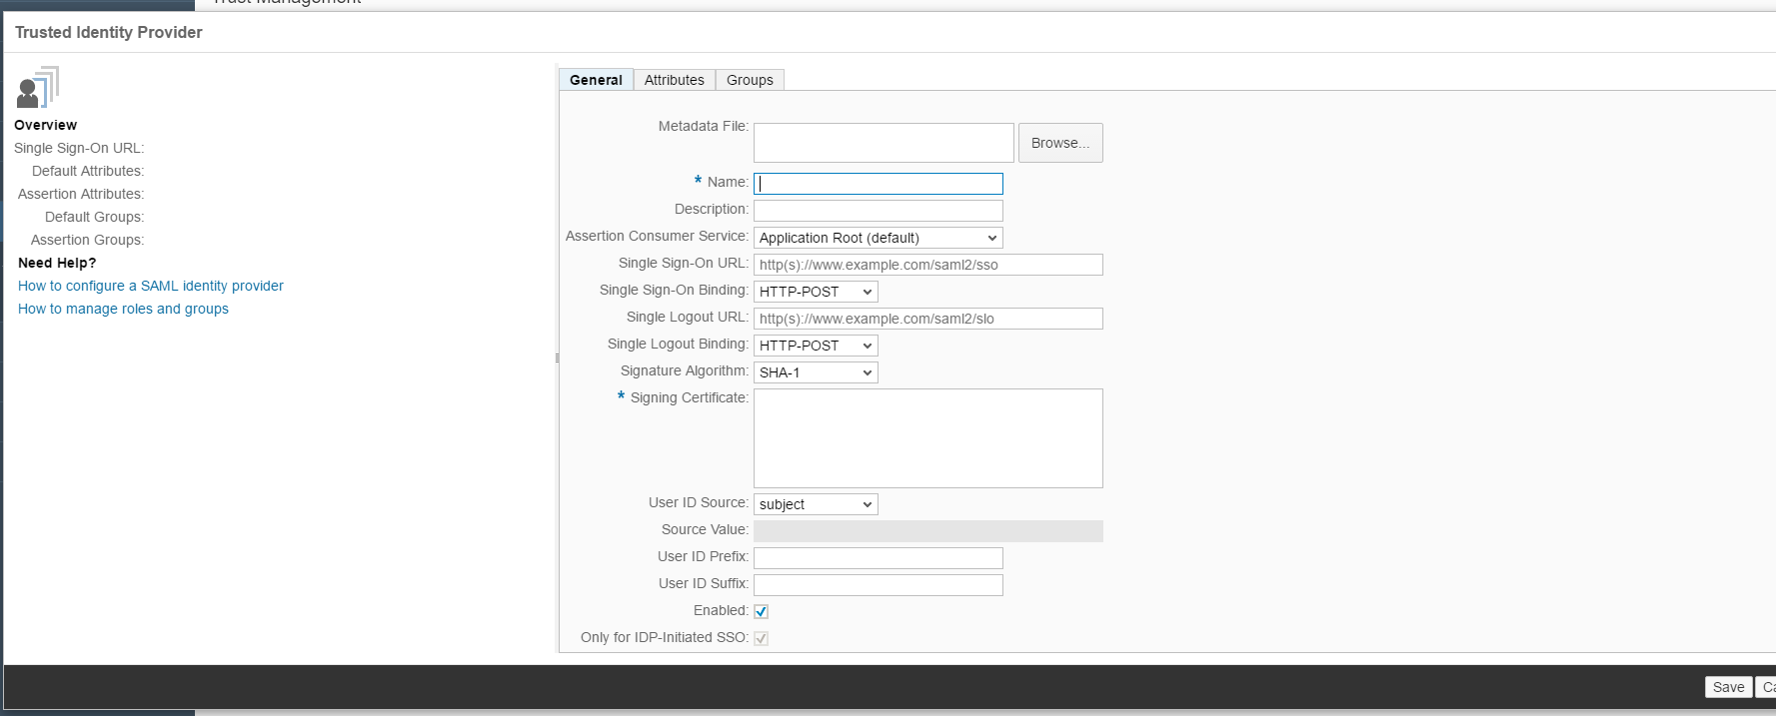

1. Navigate to the “Attributes” tab and then add in the attributes value as shown in the screen shot below

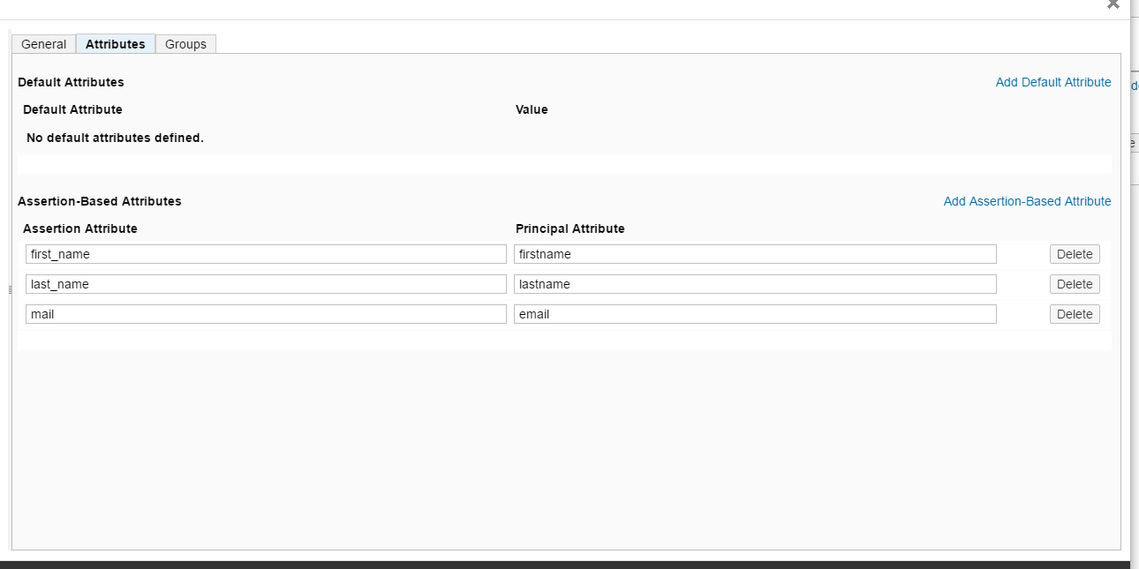

The table below contains the mapping between the Assertion Attribute and the Principal Attribute

|  |  |
| --- | --- |
| **Assertion Attribute** | **Principal Attribute** |
| first_name | firstname |
| last_name | lastname |
| mail | email |

1. Now navigate to the API Portal or Developer Portal then log in using your SAP Cloud IDP users.