A Project Report-I
On
NEXOS – AI-Powered Agentic Operating System
Submitted in partial fulfilment of the requirement of
University of Mumbai for the Degree of

Bachelor of Engineering
In
CSE IOT and Cyber Security including Blockchain

Submitted By
Sandesh Brahmane
Omkar Sonawane
Mahesh Patil
Sarvesh Mane

Supervisor
Dr. Madhu Nashipudimath



A.Y.2026-27
Department of CSE IOT and Cyber Security including Blockchain
SMT. INDIRA GANDHI COLLEGE OF ENGINEERING
An Autonomous Institute with NAAC ‘A’ Grade
Plot No. 1, Sector 8, Ghansoli, Navi Mumbai -400701, Maharashtra, India

UNIVERSITY OF MUMBAI


CERTIFICATE

This is to certify that the requirements for the Major Project-I entitled ‘NEXOS – AI-Powered Agentic Operating System’ have been successfully completed by the following students:
Name Roll No.
Sandesh Brahmane 05
Omkar Sonawane 65
Mahesh Patil 43
Sarvesh Mane 33

in partial fulfilment of Bachelor of Technology of Mumbai University in the Department of CSE IOT and Cyber Security including Blockchain, Smt. Indira Gandhi College Of Engineering, Ghansoli – 400701 during the Academic Year 2026 – 2027 .

_____________________
Supervisor
(Dr. Madhu Nashipudimath)

_____________________ _____________________
Head of Department Principal
(Dr. Madhu Nashipudimath) (Dr. Sunil Chavan)

PROJECT APPROVAL FOR B.E
This project entitled “NEXOS – AI-Powered Agentic Operating System” by Sandesh Brahmane, Omkar Sonawane, Mahesh Patil, Sarvesh Mane Name are approved for the degree of CSE IOT and Cyber Security including Blockchain.

Examiners:
1. ________________
2. ________________
Supervisor
:
1. ________________

Date:
Place:

DECLARATION
We declare that this written submission for the B.E project entitled “NEXOS – AI-Powered Agentic Operating System” represents our ideas in our own words and where others' ideas or words have been included, we have adequately cited and referenced the original sources. We also declare that we have adhered to all principles of academic honesty and integrity and have not misrepresented or fabricated or falsified any ideas / data / fact / source in our submission. We understand that any violation of the above will cause disciplinary action by the institute and also evoke penal action from the sources which have not been properly cited or from whom prior permission have not been taken when needed.

Project Group Members:
Sandesh Brahmane & Sign: __________________________
Omkar Sonawane & Sign: __________________________
Mahesh Patil & Sign: __________________________
Sarvesh Mane & Sign: __________________________

Date:
Place

ACKNOWLEDGEMENTS

We would like to express our sincere thanks and gratitude to Smt. Indira Gandhi College of Engineering and the Principal for having the project, for giving the participants and opportunity to integrate the learning from this graduate course.
Special regards and thanks to our guide Prof______________ for her/his valuable guidance, support and encouragement for carrying out this project work and helping us in the development of designed algorithm and practical insights in application of the various theoretical frameworks.
We would also like to thank head of the department Dr. Madhu N. and co-ordinator and faculty members for giving us this opportunity and guidance and encouragement.

Sandesh Brahmane
Omkar Sonawane
Mahesh Patil
Sarvesh Mane

List of Figures (Sample)

Fig. 1.2 | Technique category | 3
Fig 2.2 | High level content-based architecture | 5
Fig 3.1 | Similarity results for different values of α and β | 7
Fig 3.2 | Similarity results for user based, item based and hybrid based CF | 10
Fig 3.3 | Example Demographic system | 12

List of Tables (Sample)

Table 1.2 | Application Example | 3
Table 2.1 | Summary of Literature Survey | 8
Table 3.1 | Example: User based CF | 14
Table 3.2 | Comparison Between Recommendation Techniques | 20
Table 3.3 | Dataset Statistics | 25

Abstract

NEXOS is an AI-native system layer for Ubuntu 24.04 LTS that makes computing more automatic and easier to manage. It converts natural language commands into machine actions, plans tasks using dependency graphs, and schedules multiple agents using FIFO, priority, and preemption. Its four-level memory system—working, episodic, semantic, and procedural—keeps useful information across sessions. Security is provided through capability-based permissions, risk checks, Bubblewrap sandboxing, and secure audit logs. NEXOS can handle terminal workflows, filesystem searches, and server configuration while resisting prompt injection attacks. It supports local Ollama models and cloud APIs and is available as a .deb package and live ISO.

Table of Contents
Acknoelegments..................................................................................................................... |  |  |  | i
List of Figures...................................................................................................................... |  |  |  | Ii
List of Tables....................................................................................................................... |  |  |  | Iii
Abstract................................................................................................................................ |  |  |  | iv
1. | Introduction................................................................................................................ |  |  | 1
 | 1.1 | Applications................................................................................................... |  | 2
 | 1.2 | Motivation........................................................................................................ |  | 3
 | 1.3 | Organization of the Report…………………………………… |  | 3
2. | Literature Survey....................................................................................................... |  |  | 5
 | 2.1 | Introduction……. ……………………............................................................ |  | 5
 | 2.2 | Literature Review ………………………………………................................ |  | 6
 | 2.3 | Summary of Literature Survey.…………………………................................ |  | 12
3 | Project Overview ....................................................... |  |  | 13
 | 3.1 | Problem Definition……….......................................................................... |  | 13
 | 3.2 | Project Objective ….......................................................................................... |  | 13
 | 3.3 | Scope of the Project
 | 3.4 | Methodology
 | 3.5 | Timeline chart with milestones (Term1 and Term-II).......................................... |  | 14
4. | Proposed System (NEXOS – AI-Powered Agentic Operating System)……………… |  |  | 15
 | 4.1 | Design Steps…………………............................................................................. |  | 15
 |  | 4.1.1 | Existing System Architecture…………….……………………………. | 15
 |  | 4.1.2 | Proposed System Architecture……………………………………….. | 16
 | 4.2 | Requirements for Implementation…….............................................................. |  | 17
 |  | 4.2.1 Algorithms / Techniques....................................................................... |  | 18
 |  | 4.2.2 | Use Case Diagram / Activity Diagram /DFD….…............................. | 19
 |  | 4.2.3 | Sample Dataset/Input ........................................................................... | 20
 |  | 4.2.4 | Hardware and Software Specifications…............................................. | 24
5 | Conclusion …............................................................................ |  |  | 30
6 | Appendix …….......................................................................................... |  |  | 32
7 | References ………………………………………………………………………….. |  |  | 33
List of Publications and Achievements …………...…….…….……………………......... |  |  |  | 34
Paper in IEEE format …………………………………………………………………….. |  |  |  | 35
publication certificate |  |  |  | 36
Personal Information |  |  |  | 37

1. Introduction
1.1 Applications
The applications of NEXOS, a bounded AI-assisted task execution layer for Linux workstations, are deeply embedded in automating complex and repetitive development workflows. The system is designed to streamline development environments by identifying project folders, analyzing runtime metadata, and inspecting dependency manifests without manual developer intervention. Furthermore, NEXOS generates independently verified diagnostic reports and handles file operations safely within an explicitly scoped environment. Beyond core development diagnostics, the architecture extends to productivity applications, such as a deterministic Google Calendar and Meet connector that schedules events strictly through user-approved API operations. This demonstrates its capacity to securely bridge local file system operations with external web services.

1.2 Motivation
Developers repeatedly spend significant time searching for active projects, inspecting dependencies, reading system logs, verifying user services, and producing diagnostic reports across fragmented tools. These manual activities lack a cohesive audit trail of what was checked and how decisions were made. The motivation behind NEXOS is to construct an enforceable, natural language-driven execution layer that dramatically reduces manual interaction times while preserving strict permission boundaries. The overarching goal is to prove that an agentic operating system experience can provide secure, verified, and bounded task execution, distinguishing itself from general-purpose desktop automation that lacks isolation and cryptographic auditing.

1.3 Organization of the Report
This report is structured to comprehensively detail the NEXOS architecture and implementation plan. Section 2 explores the literature survey, analyzing contemporary frameworks like AIOS and OS-Copilot. Section 3 outlines the project overview, including the problem definition, objectives, scope, and timeline. Section 4 delves into the proposed system architecture, design steps, and specific technical requirements. Section 5 concludes the project documentation, followed by appendices, references, and publication details.

2. Literature Survey
2.1 Introduction
The integration of Large Language Models (LLMs) into operating system environments represents a paradigm shift in human-computer interaction. Recent research has focused on structuring these LLMs as core reasoning engines capable of managing system resources, executing code, and orchestrating complex tasks across heterogeneous environments.
2.2 Literature Review
Recent advancements have demonstrated the viability of agent-centric operating system architectures. The "AIOS" framework proposes an LLM Agent Operating System designed to isolate LLM-specific services and computing resources from individual agent applications via a specialized AIOS kernel. By dividing the ecosystem into an application layer and a kernel layer, AIOS enables systematic resource management, context snapshotting, and robust conflict resolution for parallel tool access. The AIOS architecture heavily emphasizes security and efficiency, preventing agents from directly manipulating underlying resources without passing through kernel abstractions.
Similarly, "OS-Copilot" introduces a framework for building generalist computer agents capable of interacting with comprehensive OS elements in Linux and MacOS. Its implementation features the "FRIDAY" agent, which utilizes a sophisticated architecture comprising a Planner, Configurator, and Actor. The FRIDAY agent exhibits self-directed learning and self-refinement, utilizing procedural, declarative, and working memory to dynamically generate and evaluate executable actions, such as Python scripts and bash commands, to complete complex user requests.
2.3 Summary of Literature Survey
The literature reveals a prominent division: AI research prioritizes model planning and natural language reasoning, while systems security research focuses on static containerization and kernel isolation. NEXOS bridges this gap by introducing a deterministic capability broker and independent verification pipeline that sits between an unprivileged inference gateway and the Linux OS, turning unpredictable model output into secure, verifiable workstation automation.
Research Dimension | Conventional Shell Agents | AIOS / OS-Copilot | OSWorld Benchmark PDF | Proposed NEXOS Layer
Execution Authority | Permissive shell (bash -c) | Managed agent scheduler | Unrestricted environment | Deterministic Permission Broker
Privilege Boundaries | Ambient user privileges | Virtualized LLM context | Full guest OS control | Tiered capabilities (T0 to T3)
Subprocess Isolation | None (Host process) | Standard subprocesses | Full VM snapshot rollback | Bubblewrap namespace sandboxing
Outcome Assessment | LLM self-reporting | LLM conversational review | Deterministic external scripts | Independent postcondition oracles
State Persistence | Transient memory / Text logs | Vector context storage | Test fixture checkpoints | SQLite transactional hash journal

3. Project Overview
3.1 Problem Definition
Current AI assistants operate outside the bounded security and verification models of host operating systems. When executing development tasks—such as environment diagnosis or file manipulation—they often lack the ability to respect local permission boundaries, gracefully recover from execution failures, or provide cryptographic proof that a requested action was correctly completed without unauthorized side effects.
3.2 Project Objective
The primary objective of NEXOS is to implement a secure, AI-assisted task execution layer on Ubuntu 24.04 LTS. It aims to translate natural language intents into schema-checked dependency graphs, execute them via sandboxed workers, and independently verify the outcomes before declaring a task successful, thereby providing a measurable reduction in manual workload.
3.3 Scope of the Project
The scope involves developing a native Qt desktop interface and a Python-based background engine (nexosd) that orchestrates specialized agent roles (Supervisor, File, Diagnostics, Workflow, and Productivity). The prototype focuses on diagnosing Node or Python projects, generating verified reports, and securely scheduling Google Meet events. Features outside the current scope include voice input, system-level network configuration, unrestricted root control, and arbitrary continuous background surveillance.
3.4 Methodology
The methodology leverages a deterministic permission broker that completely decouples model suggestions from execution authority. Tasks are processed through a directed acyclic graph (DAG) scheduler. Local tool execution is rigidly sandboxed using Bubblewrap to limit file scopes and deny default network access, while external API writes require one-time cryptographic grants derived from user approvals.
3.5 Timeline chart with milestones (Term1 and Term-II)
- Weeks 1-4 (Term-I): Establish base tool schemas, implement the SQLite persistence layer, develop the local API, and complete a deterministic (non-AI) diagnostic workflow using Bubblewrap sandboxing.
- Weeks 5-8 (Term-I): Integrate the Ollama model gateway, develop the intent parser, implement DAG-based planning, and establish bounded execution budgets and task cancellation protocols.
- Weeks 9-12 (Term-II): Construct the native Qt desktop panel, enforce T2 action approval flows, implement the Google Calendar API connector, and establish full-text retrieval memory.
- Weeks 13-16 (Term-II): Execute the "NEXOS Bench" evaluation suite, package the application components into Debian (.deb) format, and utilize Cubic to build and validate the bootable NEXOS ISO variants.

4. Proposed System (NEXOS – AI-Powered Agentic Operating System)
4.1 Design Steps:
4.1.1 Existing System Architecture
Existing Linux desktop environments rely entirely on manual user interaction via terminal emulators, GUI applications, and shell scripts. While automation exists through bash scripts or standard cron jobs, these mechanisms lack semantic understanding of natural language, do not possess built-in postcondition verification, and cannot dynamically replan workflows when intermediate steps fail.
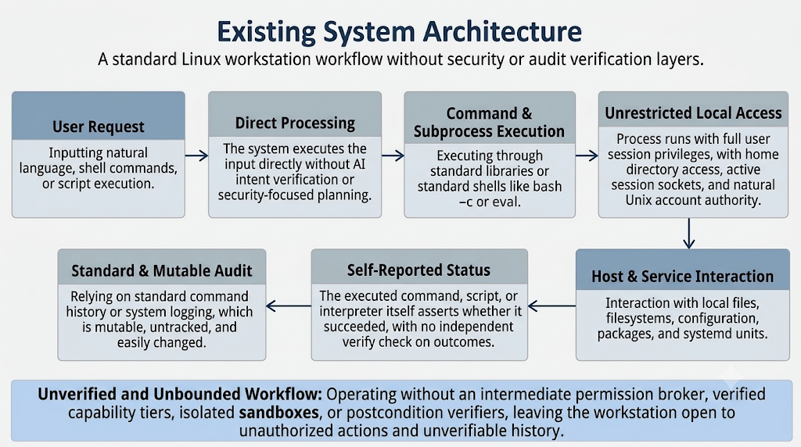
Fig 4.1: Architecture of Exiting Systems

4.1.2 Proposed System Architecture
The proposed architecture operates entirely in user space above the Ubuntu Linux kernel. A native Qt 6 application interfaces with nexosd (a systemd Python daemon) via local Unix sockets. The daemon parses intents and queries a model gateway (local Ollama or cloud). The resulting plan is processed by a durable scheduler that dispatches tasks to specialist agents. A deterministic permission broker validates all actions before execution, routing authorized commands to isolated Bubblewrap adapters. Finally, independent postcondition verifiers confirm the system state, and outcomes are persisted in a SQLite journal.
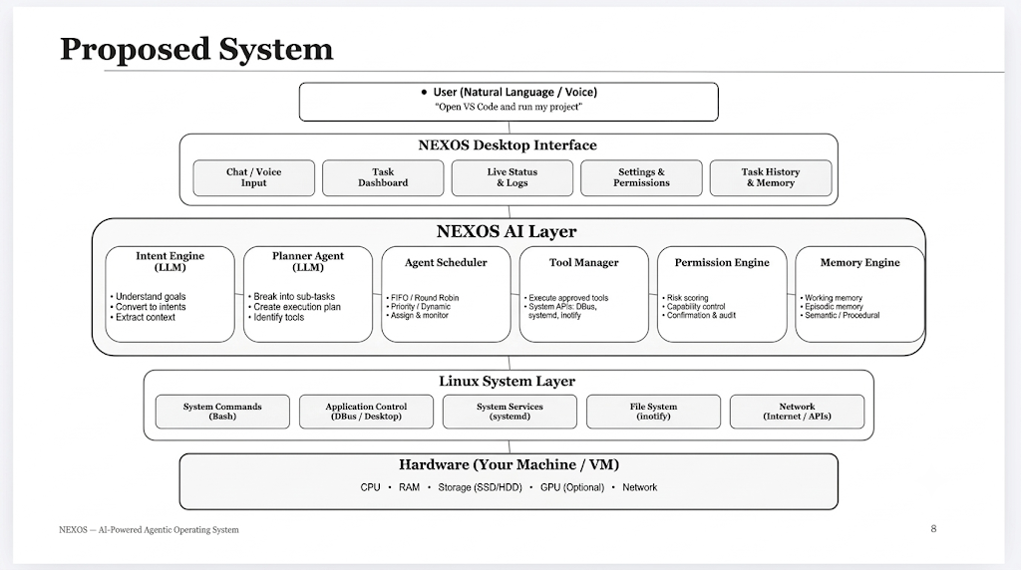
Fig 4.2: Architecture of Proposed System
4.2 Requirements for Implementation:
4.2.1 Algorithms / Techniques
- DAG Scheduling: Algorithms to parse dependencies, detect cycles, and execute ready nodes concurrently using read/write locks.
- Cooperative Preemption: Aging and priority queue algorithms to manage agent tasks and safely interrupt subprocesses without corrupting state.
- Hash-Chained Auditing: Cryptographic hashing to link canonical action records, providing tamper-evident journals of all system operations.
- Full-Text Search (FTS5): Vectorized and metadata-based retrieval mechanisms utilizing SQLite to manage episodic and semantic memory.
4.2.2 Use Case Diagram / Activity Diagram /DFD
- Activity Flow: The user submits a request via the Qt Panel. The Engine resolves constraints, formulates a DAG plan, and requests approval for sensitive (T2) actions. Upon user grant, the Broker executes the authorized adapter, retrieves evidence, and passes it to the Verifier. The final verified state is presented to the user.
4.2.3 Sample Dataset/Input
- Diagnostic Input: "Find the demo API project, check the runtime and dependency manifest, inspect its prepared service status, and save a diagnosis report. Ask before changing anything."
- Productivity Input: "Schedule a 30 minute project review tomorrow at 5 PM with these two email addresses and add a Google Meet link."
4.2.4 Hardware and Software Specifications
- Software: Ubuntu 24.04 LTS (x86_64 base), Python 3.12, Qt 6 (PySide6), SQLite (FTS5), systemd, Bubblewrap, Ollama, and Cubic for ISO generation.
- Hardware Allocation: Developed targeting an HP laptop with an Intel Core i5-8350U CPU and 8 GB RAM. Due to hardware constraints, the development virtual machine is dynamically capped at 2-3 GB RAM and 38 GB of disk space. Because integrated Intel UHD Graphics 620 lacks dedicated VRAM, local GPU inference is bypassed in favor of a consented cloud model gateway to ensure system responsiveness during development.
5. Conclusion
NEXOS presents an architectural blueprint and working implementation of a secure agentic task execution layer for Linux workstations. By establishing an uncompromising boundary between model-driven cognitive planning and system-level execution authority, the system resolves the fundamental reliability and security vulnerabilities that plague contemporary conversational assistants.
Through the integration of schema-validated Directed Acyclic Graphs, deterministic capability brokering, Bubblewrap namespace isolation, and independent postcondition verification, NEXOS proves that an AI assistant can safely interact with a user's local workstation environment without exposing the host to malicious prompt injection, ambient authority escalation, or unchecked execution side effects. The platform's durable state machine and cryptographic event journal ensure full auditability and crash-resilient recovery. Delivered as native Debian packages and an integrated, bootable Ubuntu 24.04 LTS Live ISO, NEXOS provides an auditable foundation for verified workstation automation.

6. Appendix
- Appendix A: JSON Schemas for Tool Registration and Capabilities.
- Appendix B: Bubblewrap Sandbox Profile Configurations.
- Appendix C: NEXOS Bench Evaluation Metrics and Oracles.

7. References
- Mei, Kai, et al. "Aios: Llm agent operating system." arXiv preprint arXiv:2403.16971 (2024).
- Packer, Charles, et al. "Memgpt: Towards llms as operating systems." arXiv preprint arXiv:2310.08560 (2023).
- Wu, Zhiyong, et al. "Os-copilot: Towards generalist computer agents with self-improvement, (2024).
- Jia, Hongrui, et al. "Osworld-mcp: Benchmarking mcp tool invocation in computer-use agents." Vol. 2026. 2026.
- Tan, Weihao, et al. "Cradle: Empowering foundation agents towards general computer control." arXiv preprint arXiv:2403.03186 (2024).
- Yao, Shunyu, et al. "React: Synergizing reasoning and acting in language models." arXiv preprint arXiv:2210.03629 (2022).
- Shinn, Noah, et al. "Reflexion: Language agents with verbal reinforcement learning." Advances in neural information processing systems 36 (2023): 8634-8652.
- Wu, Qingyun, et al. "Autogen: Enabling next-gen llm applications via multi-agent conversation." arXiv preprint arXiv:2308.08155 (2023).

