SLE-3: Architectural Design (Full C4 Model)
Course: 02AML204 - Introduction to Artificial Intelligence
PRN | 25UAM044
Name | Sandesh Patil
Division | A
Date | 04 October 2026
GitHub / Portfolio Link

1. System Title & Short Description
System Title: 8-Puzzle Solver using BFS and DFS
The 8-Puzzle Solver finds a path from an initial puzzle state to a target goal state. It supports Breadth-First Search (BFS) and Depth-First Search (DFS). The user provides the initial puzzle, goal state and search method. The Search Engine explores puzzle states using visited-state tracking and returns the solution path and search result. The system continues the 8-Puzzle BFS vs DFS work from the previous SLE.
2. Context Diagram (Level 1)
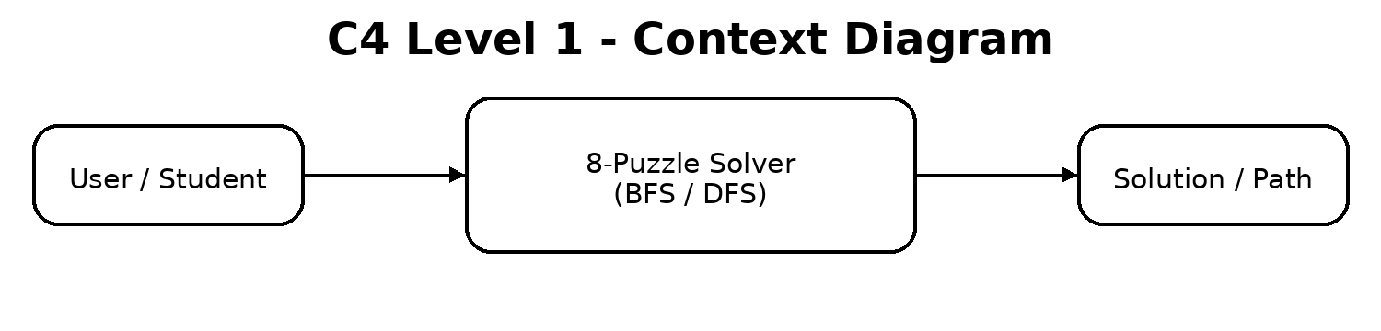
The user supplies the initial 8-puzzle state and selects BFS or DFS. The 8-Puzzle Solver processes the request and returns the discovered solution path and search result. For this system, the user is the main external actor.
3. Container Diagram (Level 2)
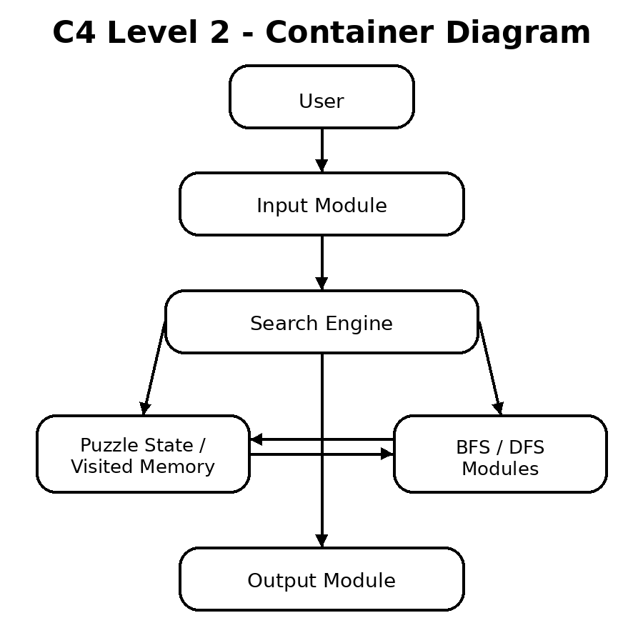
The containers separate input, puzzle/visited memory, search processing, BFS/DFS algorithms and output. The Search Engine controls the complete search process.

4. Component Diagram (Level 3)
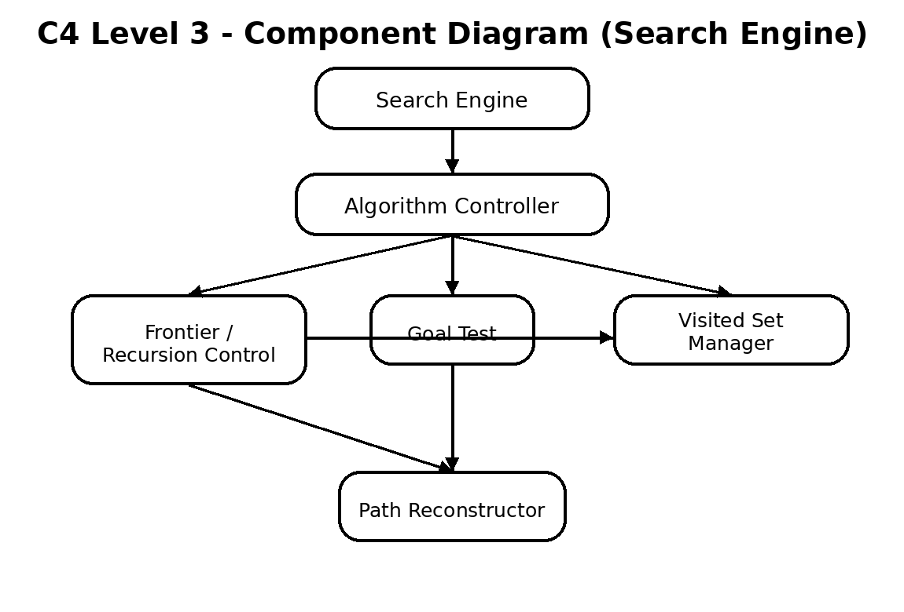
The Search Engine is decomposed because it contains the core search logic. The Algorithm Controller selects BFS or DFS; Frontier / Recursion Control manages the next state; the Visited Set Manager prevents repeated exploration; Goal Test checks for the target; and Path Reconstructor forms the final solution path.
5. Code Level Overview (Level 4)
Function / Data | Responsibility
PuzzleState | Stores the 8-puzzle board state and parent information.
bfs_search(start, goal) | Performs Breadth-First Search using a queue and visited set.
dfs_search(start, goal) | Performs Depth-First Search using recursion/stack and visited states.
get_neighbors(state) | Generates valid next puzzle states.
is_goal(state, goal) | Checks whether the current state matches the goal state.
reconstruct_path(state) | Builds the final solution path from goal to start.
6. Design Decisions
BFS and DFS are grouped under one Search Engine because both solve the same 8-puzzle search problem using different traversal strategies. Input, processing, memory and output are kept separate so the design stays clear and easy to modify. The component view focuses only on the Search Engine, as required by the guideline.
7. AI Contribution Note
AI tools used: ChatGPT
What AI helped with: Organizing the C4 architecture, preparing concise explanations, structuring the report and creating clear C4 diagrams.
What I did myself: Selected and reviewed the 8-Puzzle BFS vs DFS system, checked the algorithm responsibilities, and understood the final architecture for explanation during evaluation.
8. Contribution Log
Activity | Contribution | Status
System selection | Selected 8-Puzzle Solver using BFS and DFS and continued previous SLE work. | Completed
Context level | Documented the user interaction with the 8-Puzzle Solver. | Completed
Container level | Separated Input Module, Search Engine, Puzzle & Visited Memory, BFS/DFS and Output Module. | Completed
Component level | Decomposed the Search Engine into five internal components. | Completed
Code level | Documented the main puzzle, BFS, DFS, neighbor, goal-test and path functions. | Completed
Documentation | Prepared diagrams and contribution documentation for SLE-3. | Completed
9. Conclusion
The Full C4 Model shows the 8-Puzzle Solver from the overall user interaction down to its main functions. The design clearly separates input, search processing, puzzle/visited memory and output. It also makes the roles of BFS and DFS easy to understand while keeping the architecture small, readable and suitable for SLE-3 evaluation.
SLE-3 | 25UAM044 | Sandesh Patil | Division A

