**Output after Running the Python Script**

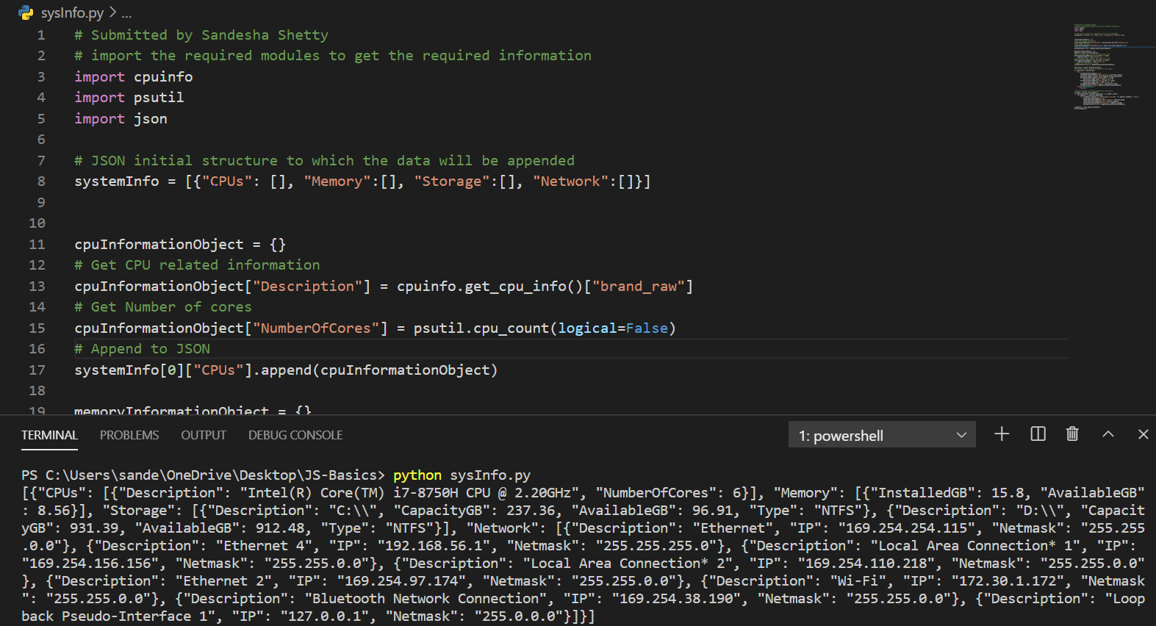

Source Code: sysInfo.py

Output:

[{"CPUs": [{"Description": "Intel(R) Core(TM) i7-8750H CPU @ 2.20GHz", "NumberOfCores": 6}], "Memory": [{"InstalledGB": 15.8, "AvailableGB": 8.56}], "Storage": [{"Description": "C:\\", "CapacityGB": 237.36, "AvailableGB": 96.91, "Type": "NTFS"}, {"Description": "D:\\", "CapacityGB": 931.39, "AvailableGB": 912.48, "Type": "NTFS"}], "Network": [{"Description": "Ethernet", "IP": "169.254.254.115", "Netmask": "255.255.0.0"}, {"Description": "Ethernet 4", "IP": "192.168.56.1", "Netmask": "255.255.255.0"}, {"Description": "Local Area Connection* 1", "IP": "169.254.156.156", "Netmask": "255.255.0.0"}, {"Description": "Local Area Connection* 2", "IP": "169.254.110.218", "Netmask": "255.255.0.0"}, {"Description": "Ethernet 2", "IP": "169.254.97.174", "Netmask": "255.255.0.0"}, {"Description": "Wi-Fi", "IP": "172.30.1.172", "Netmask": "255.255.0.0"}, {"Description": "Bluetooth Network Connection", "IP": "169.254.38.190", "Netmask": "255.255.0.0"}, {"Description": "Loopback Pseudo-Interface 1", "IP": "127.0.0.1", "Netmask": "255.0.0.0"}]}]

Output In JSON:

Output in JSON Viewer as needed by the requirement

