DISCRETE STRUCTURE
- 1. Logic and Induction (8 hours)
  - Review of set theory, relation and function
  - Proposition, connectives in proposition, types of propositions, truth function and propositional logjc.
  - Expressing statements in logic propositional logic, rules of inference in propositional logic, validity of an argument, methods of tableaux
  - Predieate logic and quantification, informal deduction in predicate logic
- Proof Techniques (5 hours)
  - Formal proofs and informal proofs, mathematical reasoning- direct proof and indirect proof (Proof by contradiction and proof by contraposition)
  - Elementary induction and complete induction, strong induction
  - Proof by counter example, vacuous and trivial proofs, proof by cases, mistakes in proof
- Automata Theory, Regular Language and Grammar (10 hours)
  - Alphabet, string, string operations and language, introduction to finite automata
  - Deterministic finite automata (DFA), representation and language of DFA
  - Non deterministic finite automata (NFA), equivalence of DFA and NFA
  - Regular expressions and its characteristics, regular language and its properties
  - Equivalence of regular expression and finite automata
  - Context free grammar and context free language
- Recurrence Relation and Algorithmic Analysis (7 hours)
  - Recurrence relations, recurrence relation for tower of Hanoi (TOH) and Fibonacci series, solving linear recurrence relations (Homogeneous and non-homogeneous)
  - Algorithm and 'its properties, asymptotic notation of algorithm
  - Linear and binary search and their analysis; Bubble and insertion sorting and their analysis
- Graph Theory and Tree (15 hours)
  - Graphs basics, graph terminologies, graph types (Directed, un-directed, simple, Weighted, regular, complete, bipartite, planar graph) and special graphs
  - Subgraphs, graph representation, connectivity in graphs and its components, strongly and weakly-connected graphs
  - Paths and circuits, Euler path and circuit, Hamiltonian path and circuit
  - Shortest path algorithm (Dijkstra's algorithm), graph coloring and four color theorem, applications of graph colorings
  - Graph as network, maximal flows and minimal cuts, the max flow-min cut theorem
  - Introduction and applications, tree traversals, spanning trees, minimum spanning trees (Prim's and Kruskal's algorithm)

Final Exam
Chapters | Hours | Marks distribution*
1 | 8 | 10
2 | 5 | 7
3 | 10 | 14
4 | 7 | 9
5 | 15 | 20
Total | 45 | 60

INSTRUMENTATION

- Introduction (2 hours)
  - Analog and digital instrument: Definition, block diagram, characteristics
  - Microprocessor-based systems: Open vs closed loop, benefits, features and applications in instrumentation design
  - Microcomputer on instrumentation design
- Theory of Measurement (6 hours)
  - Static performance parameters: Accuracy, precision, sensitivity, resolution and linearity
  - Dynamic performance parameters: Response time, frequency response and bandwidth
  - Error in measurement
  - Statistical analysis of error in measurement
  - Measurement of resistance (Low, medium and high)
  - DC / AC bridge (Wheatstone bridge, Maxwell's bridge, Schering bridge)
- Transducer (8 hours)
  - Transducer, workflow of a transducer in typical system, transducer classification
  - Sensor and its working principle (Resistive, capacitive and piezoelectric), generation of sensor, classification of sensor (Analog sensor, digital sensor)
  - Types of sensors (Electrical sensor, chemical sensor, biological sensor, acoustic sensor, optical sensor and other motion sensor), characteristic of sensors
  - Actuator, classification of actuators (Hydraulic, pneu . tic, electric and mechanical), characteristic of actuator
- Interfacing of Instrumentation System (14 hours)
  - Microprocessor and microcontroller and their selection criteria, and applications
  - The PPI 8255 and interfacing of peripherals (LED, 7 segment, dip switch, 8bit ADC, 8/10bit DAC using mode O and model) with 8085 microprocessors
  - Microcontrollers (Atmega328, STM32): Architecture, pin configuration, and their application
  - Sensor/Actuator interfacing with Atmega328P (Arduino): Analog and digital Sensor’s implementation of communication protocols, interrupt-based interfacing 5 Connectivity Technology in Instrumentation System (6 hours)
  - Wired and wireless communication system
  - Wired connectivity: UART, 12C, SPI, CAN
  - Wireless sensor network and •its technology
  - RF modem, Bluetooth, NFC, ZIGBEE and LORA
  - Thermal management; Heat dissipation technique, heat sink
  - Data acquisition system (Data loggers, data archiving and storage), cloud-based data acquisition system
- Circuit Design (4 hours)
  - Converting requirement into design, reliability and fault tolerance
  - High-speed design: Bandwidth, decoupling, crosstalk, impedance matching
  - PCB design: Component placement, trace routing, signal integrity, and ground loops
  - Noise and noise coupling mechanism, noise prevention, filtering, ferrite beads, decoupling
Capacitors, and ESD & its prevention

- Software for Instrumentation Application (6 hours)
  - Overview of software engineering
  - Types of software
  - Software development life cycle (SDLC), software process models
(Waterfall model, prototype model, incremental model, agile model)
  - Software reliability vs hardware reliability
  - Software bugs, software testing, different levels of testing
- Electrical Equipment (6 hours)
  - Voltmeter and ammeter: Types and working principle
  - Energy meter: Types and working principle
  - Frequency meter: Types and working principle
  - Wattmeter: Types and working principle
- Latest Trends (3 hours)
  - Internet of things (IOT): Simple architecture, characteristics, advantages
  - Smart sensors
  - Important of cloud computing in instrumentation system 9.4 Instrumentation in industry 4.0/5.0
- Application of Modern Instrumentation System (5 hours)
  - Instrumentation for power station including all electrical and non-electrical parameters
  - Instrumentation for wire and cable manufacturing and bottling plant
  - Instrumentations for beverage manufacturing and bottling plant
  - Instrumentations required for a biomedical application such as a medical clinic or hospital
  - Instrumentation system design using a processor (Microprocessor, microcontroller or others )

Final Exam
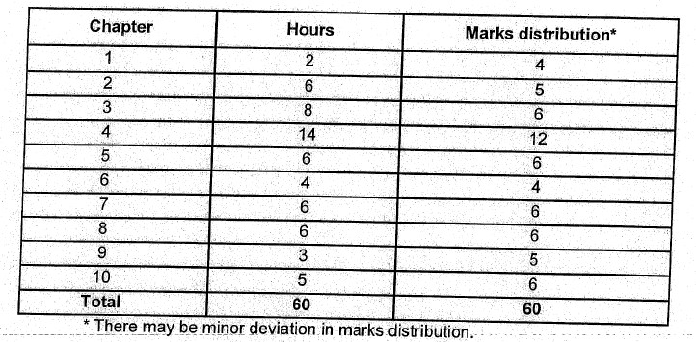

COMPUTER ORGANIZATION AND ARCHITECTURE
- 1. Introduction(6 hours)
  - Organization and architecture
  - Structure and function
  - The evolution of computer architecture (RISC, CISC, BERKELEY RISC l, overlapped register window)
  - Performance assessment
    - Clock speed and instruction per second
    - Instruction execution rate: CPI, MIPS Rate, MFLOPS rate, arithmetic mean, harmonic mean, speed metric, geometric mean, rate metric, Amdahl's law, speed up
  - Computer function
    - Instruction fetch and execute
    - Instruction cycle state diagram
  - Interconnection structure, bus interconnection, multilevel bus hierarchy) PCI
- Central Processor Organization(6 hours)
  - Processor bus organization
  - ALU: Arithmetic circuit, logic circuit, one and multi-stage ALU, shifter
  - Instruction formats: CPU organization, zero and more address instruction formats
  - Addressing modes
  - Instruction set
    - Data transfer instruction
    - Data manipulation instruction: Arithmetic, logical and shift operations
    - Program control instruction
  - Status bit conditions
3 Control Unit (5 hours)
  - Definition, block diagram, control signals
  - Hardwired and microprogrammed CU
  - Microprogramming approach
    - Control memory and its organization
    - Computer organization
    - Microprogram organization
    - Address sequencing
    - Mapping bf micro operations
3.3-6 Microinstruction formats
    - Microprogramming examples
    - Microprogram sequencer
    - Field decoding
4 Memory System (8 hours)
  - Characteristics of memory system
  - Memory classification and hierarchy
  - RAM - (SRAM and DRAM) and ROM organization: Circuit level implementation
  - Locality Of reference
  - Cache memory principle
    - Cache and main memory
    - Cache / main memory structure
    - Cache read operation
  - Typical cache organization
  - Elements of cache design (Cache address, cache size, mapping techniques, replacement algorithms, write policy, line size, number of caches)

- Computer Arithmetic (8 hours)
  - Integer and floating-point representation
  - Integer arithmetic
    - Addition and subtraction
52.2 Multiplication
5.2.3 Division
  - Floating-point arithmetic
    - Addition and subtraction
    - Multiplication
    - Division
- Pipelining and Vector Processing (4 hours)
  - Pipelining concept
  - Types of pipelining: Instruction and arithmetic pipelining
The major hurdle and hazards of pipelining: Data, structure and control hazards 6.4 Vector computation
    - Vector computation approach
    - Implementation: Pipelined ALU, parallel ALU and parallel processors
- Input Output (110) Organization (4 hours)
  - Peripheral device
  - I/O modules
  - I/O interface
  - Modes of transfer
  - Programmed I/O
  - Interrupt driven I/O
704.3 DMA
  - I/O processor
  - Data communication processor
- Multicore Computer (4 hours)
  - Multicore computer
  - Hardware performance issues
82.1 Increase in parallelism
8.2.2 Power consumption
  - Software performance issue: Software in multicore
  - Multicore organization

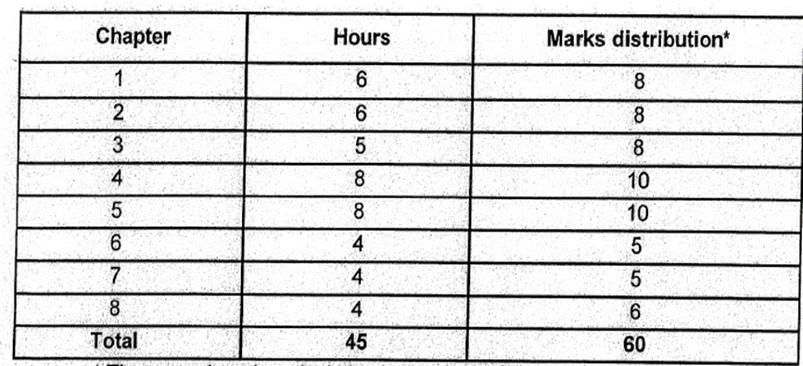

ELECTROMAGNETICS
- Introduction (4 hours)
  - Scalar and vector fields
  - Operations on scalar and vector fields
  - Co-ordinate systems (Cartesian, cylindrical and spherical) and conversions
- Electric Field (15 hours)
21 Coulomb's law
  - Electric field intensity
  - Electric flux density
  - Gauss's law and applications
25 Physical significance of divergence, divergence theorem
  - Electric potential, potential gradient
  - Energy density in electrostatic field
  - Electric properties of material medium
  - Free and bound charges, polarization, relative permittivity, electric dipole electric boundary conditions
  - Current, current density, conservation of charge, continuity equation, relaxation time
  - Boundary value problems, Laplace and Poisson equations and their solutions, uniqueness theorem
- Magnetic Field (9 hours)
  - Biot-Savart's law
  - Magnetic field intensity
  - Ampere's circuital law and its application
  - Magnetic flux density
  - Physical significance of curl, Stoke's theorem
  - Scalar and magnetic vector potential
  - Magnetic properties of material medium
  - Magnetic force, magnetic torque, magnetic moment, magnetic dipole, magnetization
  - Magnetic boundary condition
- Time Varying Fields (4 hours)
  - Faraday's law, transformer EMF, motional EMF
  - Displacement current
  - Maxwell's equations in integral and point forms

- Plane Waves (9 hours)
  - Wave propagation in lossless and lossy dielectric
  - Plane waves in free space, lossless dielectric, good conductor
  - Power and poynting theorem average power density
  - Reflection of plane wave at normal incidence
  - Standing wave and SWR
  - Input intrinsic impedance
- —Transmission Lines (4 hours)
  - Transmission line equations (Taking analogy from wave equations)
  - Lossless, lossy and distortionless transmission lines
  - Input impedance, reflection coefficient, standing wave ratio

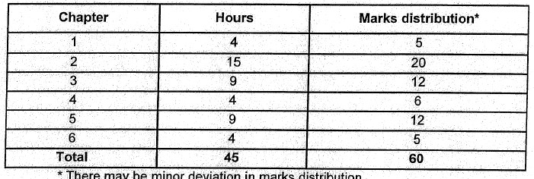

Final Exam

Signal & Systems
- Signal and its Types(7 hours)
  - Introduction to signal and signal processing
  - Classification of signal based on dimension
  - Classification of one-dimensional signal (CT and DT) and properties
  - Fundamental signals: Delta function, unit step, ramp, rectangular pulse, signum function
  - Relationship between unit step and delta function
  - Signal classification based on causality
  - Classification of signals based on periodicity (CT and DT)
  - Transformation of the independent variable
  - Energy and power signals
  - Even and odd signals
  - System, types of systems: Linear and non-linear, causal and non-causal, timeinvariant and time-variant
- Fourier Series (9 hours)
  - Introduction to Fourier series
  - Fourier series representation of continuous time periodic signal
  - Properties of continuous time Fourier series: Linearity, time shifting time scaling, time reversal, convolution, multiplication, frequency shifting, conjugate symmetry, Parseval's relation
  - Fourier series representation of discrete time periodic signal
  - Properties of discrete time Fourier series: Linearity, time shifting, time scaling, time reversal, convolution, modulate conjugate symmetry, Parseval's relation 2.6. Applications of Fourier series
- Fourier Transform (9 hours)
  - Introduction to Fourier transform
  - Continuous time Fourier transform
  - Properties of continuous time Fourier transform: Linearity, time shifting, frequency shifting, time scaling, time reversal, convolution, multiplication, duality, conjugation, Parseval's relation
  - Discrete time Fourier transform
  - Properties of discrete time Fourier transform: Linearity, time shifting, frequency shifting, time reversal, convolution, modulation, conjugation, Parseval's relation
  - Fourier transform for periodic signals
  - Applications of Fourier transform
- Linear Time Invariant (LTI) System (7 hours)
4,1 Linear time invariant (LTI) system
  - Convolution integral properties of LTl system
  - Representation of discrete-time signals in terms of impulses –
  - 4.4 -Convolution sum
  - Representation of continuous-time signals in terms of impulses
  - Convolution integral
  - Practical applications of convolution
- Sampling (6 hours)
  - Introduction to sampling
5.2 Sampling theorem
  - Practical consideration of sampling and impulse-train sampling
  - Signal reconstruction from sampled version
  - Aliasing
5.6 Band limited signals
- Frequency Response of Continuous and Discrete Time Systems (7 hours)
  - Frequency response of continuous time systems
  - Transfer function of continuous time system
  - Impulse response of ideal low-pass, band-pass and high-pass filter
  - Response of ideal low pass filter to a step function input
  - Frequency and Impulse response of RC filter
  - Frequency response of discrete time systems: Transfer function
  - Impulse response of low-pass, band-pass and high-pass filter

Final Exam
Chapter | Hours | Marks distribution*
1 | 7 | 10
2 | 9 | 12
3 | 9 | 12
4 | 7 | 10
5 | 6 | 7
6 | 7 | 9
Total | 45 | 60

NUMMERICAL METHODS
- Solution of Non-Linear Equations (7 hours)
  - Errors and accuracy in numerical computations
  - Bisection method
  - Regula Falsi method and secant method
  - Newton Raphson method
  - Fixed point iteration method
  - Comparison of the methods (Bracketing vs open-ended methods and rates of convergence)
  - Solution of system of non-linear equations
    - Direct approach
    - Newton Raphson method
- Solution of System of Linear Algebraic Equations (8 hours)
  - Direct methods 2.1.1 Gauss Jordan method
    - Gauss elimination method, pivoting strategies (Partial and complete)
    - Mattix inverse using Gauss Jordan and Gauss elimination methods
    - Factorization methods (Do-Little^{f}s method and Crout's method)
  - Iterative methods
2.2,1 Jacobi's method
    - Gauss-Seidal method
  - Determination of largest and smallest Eigen values and corresponding vectors using the power method
- Interpolation (9 hours)
  - Polynomial, Interpolation
    - Finite differences (Forward, backward, central and divided differences)
    - Interpolation with equally spaced intervals: Newton's forward and backward difference interpolation, Stirling's and Bessel's central difference interpolation
    - Interpolation with unequally spaced intervals: Newton's divided difference ^{i}nterpolation, Lagrange interpolation
  - Least square method of curve fitting
3,2.1 Linear form and forms reducible to linear form
3.22 Quadratic form and forms reducible to quadratic form
3.2.3 Higher degree polynomials
  - Cubic spline interpolation
    - Equally Spaced 'interval
    - Unequally spaced interval
- Numerical Differentiation and Integration (6 hours)
  - Numerical differentiation
    - Differentiation using polynomial interpolation formulae for equally spaced intervals
    - Local maxima and minima from equally spaced data
  - Numerical integration
42.1 Newton Cote's general quadrature formula
    - Trapezoidal rule, Simpson's 1/3 and 3/8 rules, Boole's rule, Weddle’s rule
    - Romberg integration
    - Gauss-Legendre integration (up to 3-point formula)
- Solution of Ordinary Differential Equations (ODE) (8 hours)
  - Initial value problems 5.1.1 Solution of first order equations: Taylor's series method, Euler's method, Runge-Kutta methods (Second and fourth order)
    - Solution of system of first order ODEs via Runge-Kutta methods
    - Solution of second order ODEs via Runge-Kutta methods
  - Two-point boundary value problems
5,2.1 Shooting method
    - Finite difference method
- Solution of Partial Differential Equations (7 hours)
  - Introduction and classification
  - Finite difference approximations of partial derivatives
  - Solution of elliptic equations
6.3.1 Laplace equation
6.32 Poisson's equation
  - Solution of parabolic and hyperbolic equations
    - One-dimensional heat equation: Behdre-Schmidt method, Crank-Nicolson method
    - Solution of wave equation

Final Exam

Each chapter contains 10 marks

