**Objectives**

* Demonstrate displaying a card with image, title and body
  + card, card-title, card-body, card-text, change mouse cursor on hovering an icon
* Demonstrate displaying list of cards with RWD
  + Display a list of cards using grid system and thus enabling RWD

**Design rating display for a product**  
  
For displaying a product in hTrack application, the product rating needs to be displayed similar to the layout defined below. For displaying star, use the Google Material Icon.  
 https://cognizant.e-box.co.in/uploads/Image/BTS/bts11.JPG

**Design display of Price for a product**

For displaying a product in hTrack application, the product price needs to be displayed similar to the layout defined below. For displaying offer image, use the Google Material Icon.

https://cognizant.e-box.co.in/uploads/Image/BTS/bts12.JPG

Design Add to Cart and Favorite for a product

For displaying a product in hTrack application, each product needs to be displayed with Add to Cart and Add to Favorite options. The layout should be similar to the one defined below. For displaying heart symbol, use the Google Material Icon. On hovering over the “heart”, the mouse pointer should be displayed in red and the mouse cursor needs to be changed as pointing hand. 

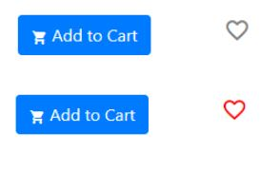

**Displaying a Product using Card**

A product in hTrack application needs to be displayed as per the below specified layout using Card component. Use the various components built in the previous exercises to build this layout.  
  
Get the image from <https://unsplash.com/> , which is a free stock image site. Search for keyword "product" and the below product can be found.   
  
NOTE: It is recommended not to download the file. Get the image URL from unsplash.com and include it in the src attribute of img tag.

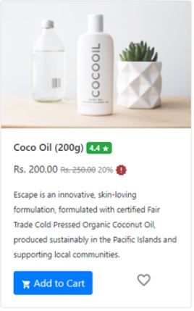

**Display multiple Products using Cards**

Display multiple products as per the screen layout below. Each row will have four products displayed. In mobile devices there will be only one product displayed in a row. For images get the image links from unsplash.com.

**Desktop Layout**

**Top part of the screen**  
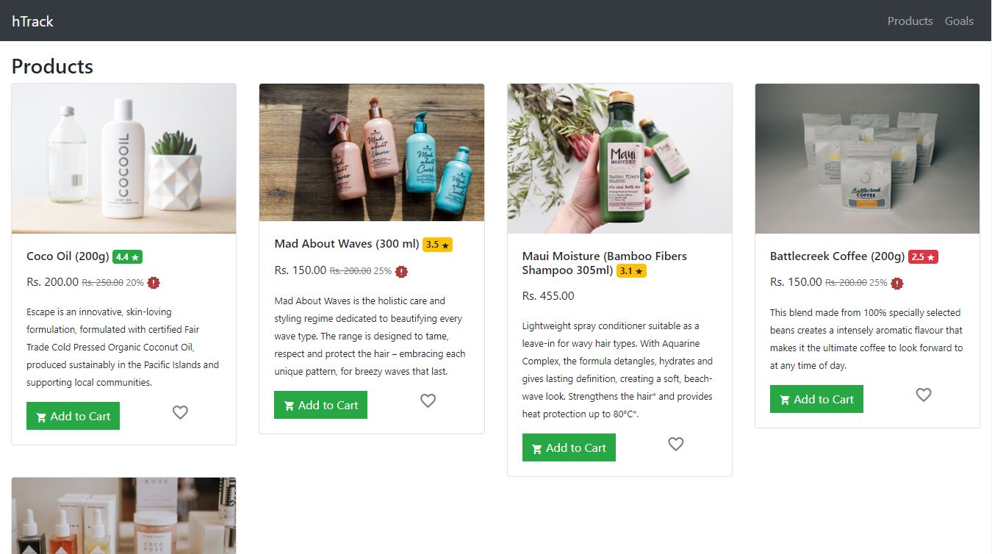  
  
**Screen after scrolling**  
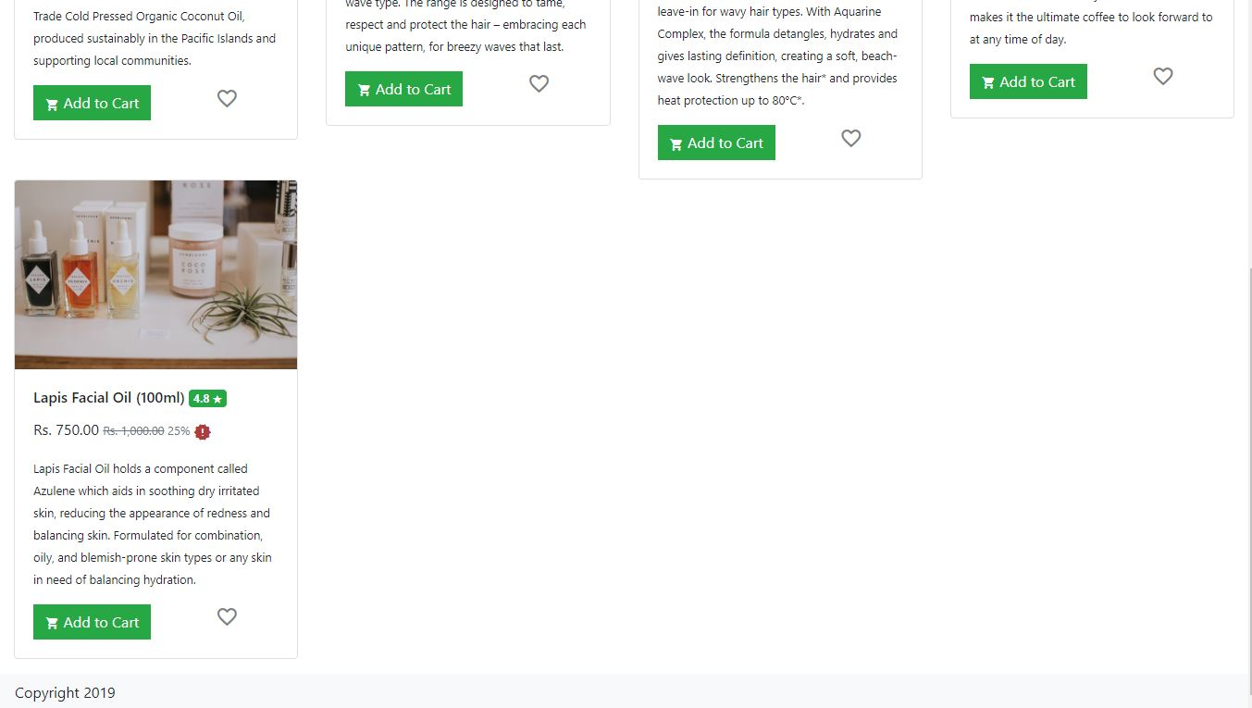

**Mobile Device Layout**

