1. Create a remote git hub repository using Git Hub*. (you can use any email id for creating)*

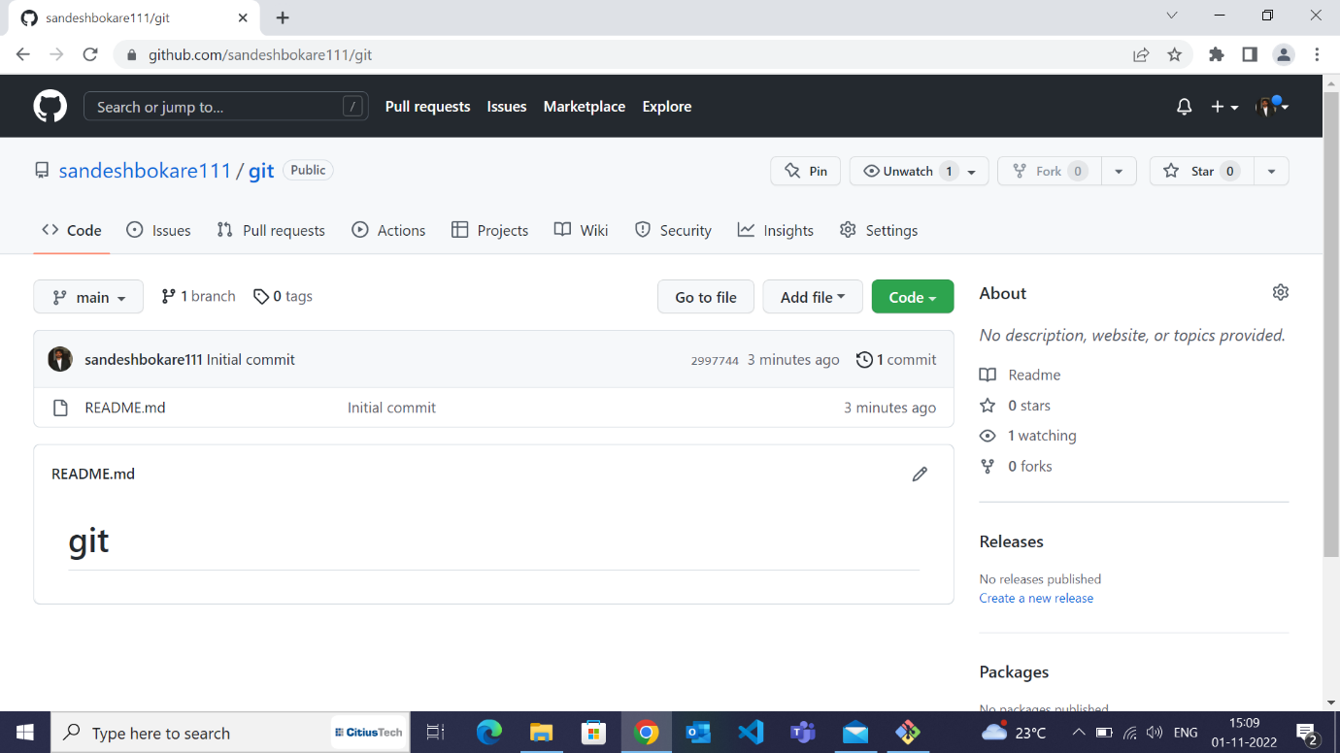

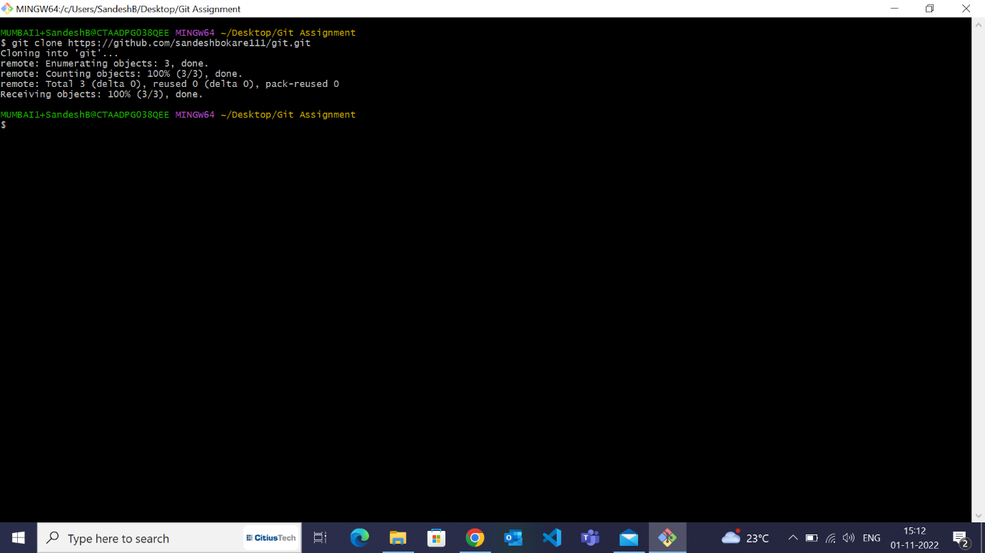2. Clone the repository on your local machine.

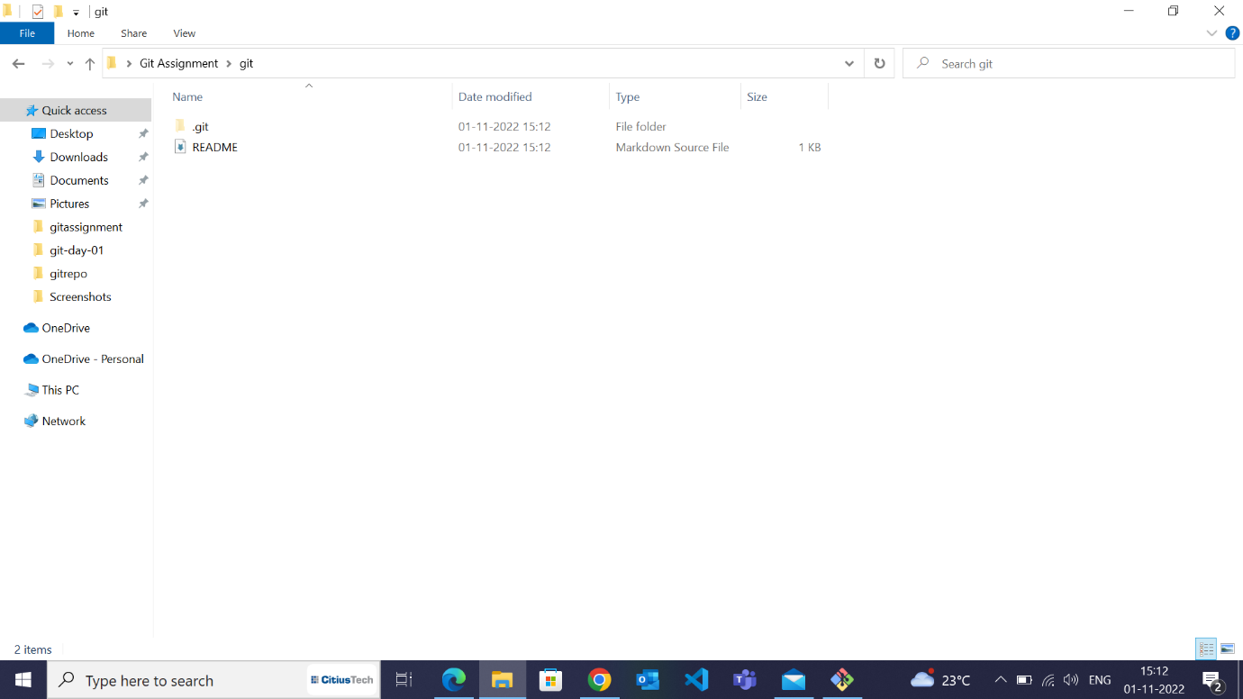3. Using *git config*, set the username & email to your name and your CT email id 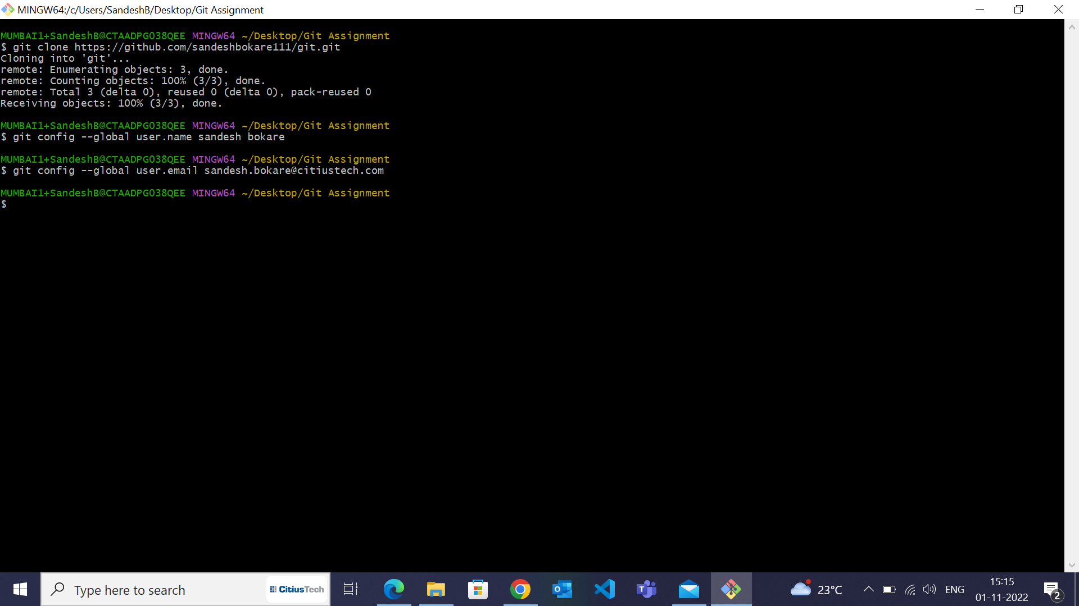respectively.

4. two empty text files named **f1.txt** and **f2.txt** inside the cloned repository.

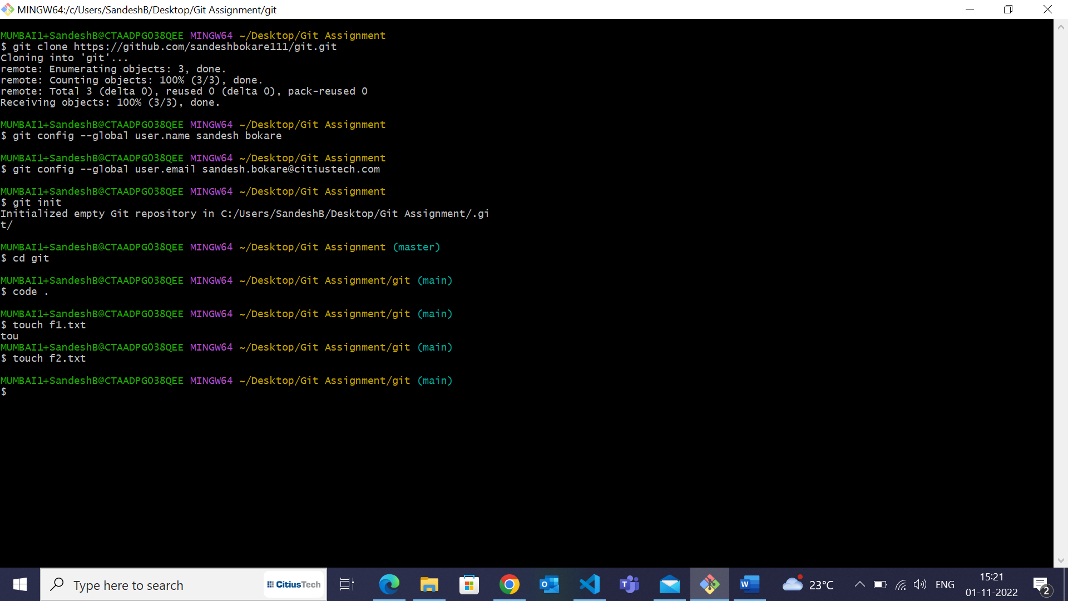

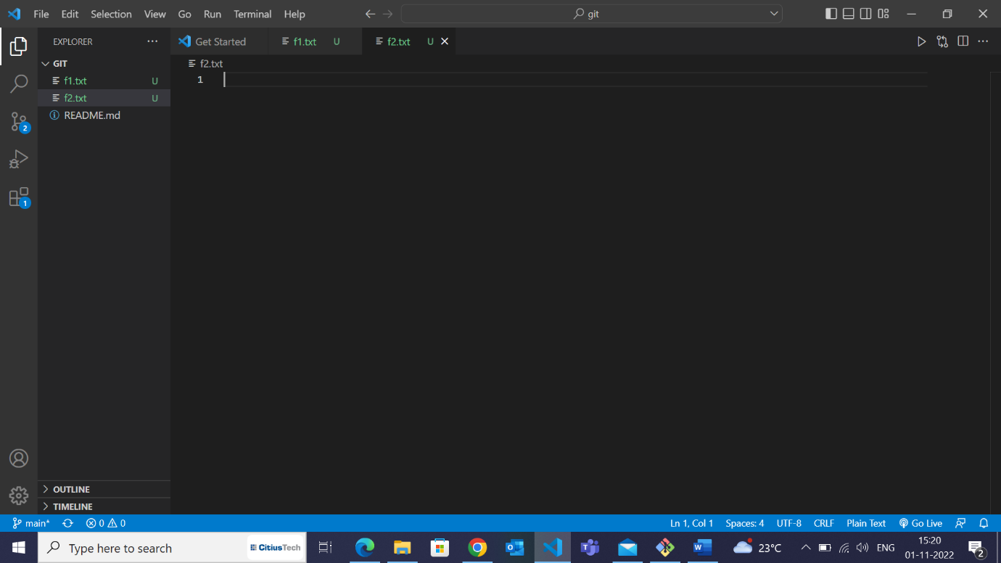

5. Commit and push the changes to the remote repository.

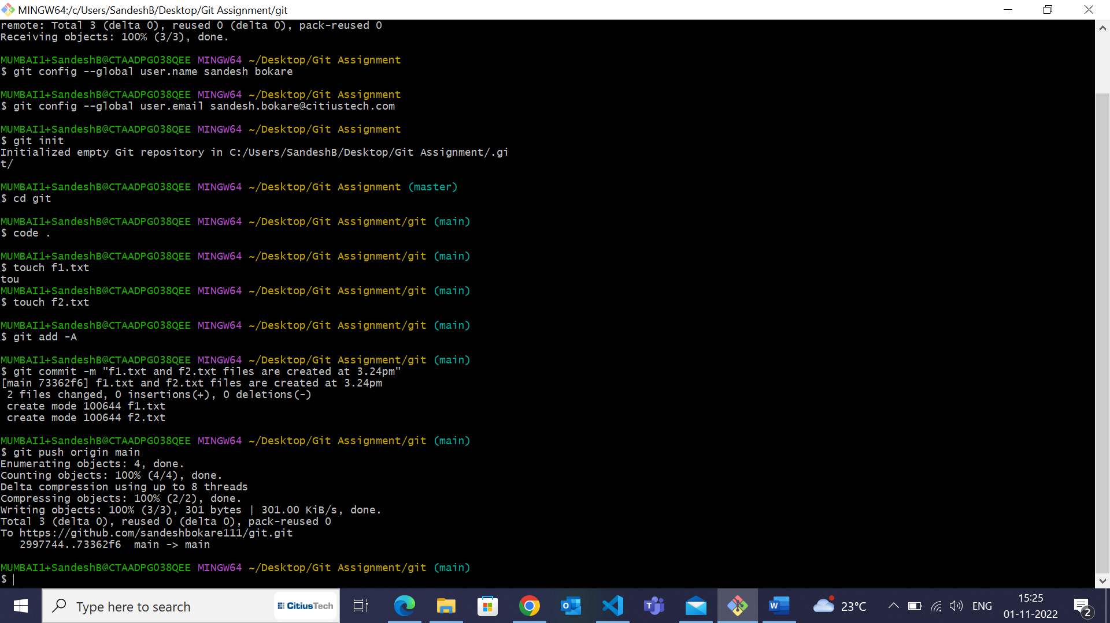

6. Check the status of the local repo.

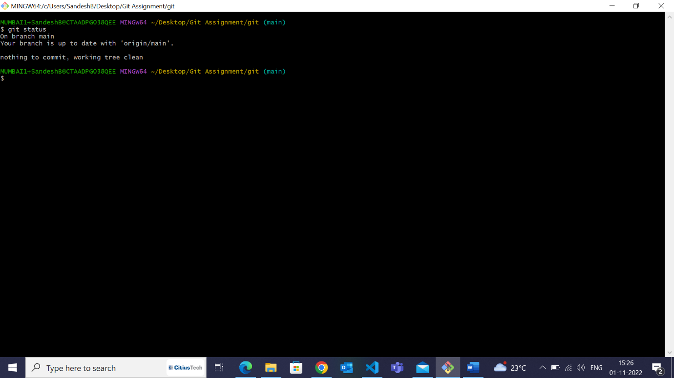

7. Go to the remote repository & check what files are present.

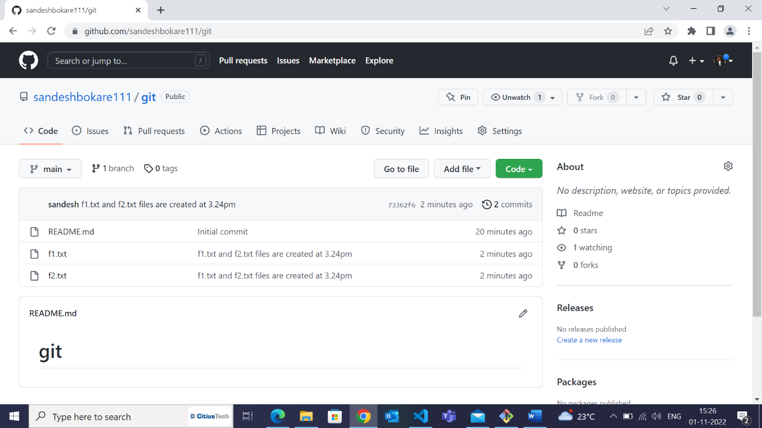

8. Add some text in **f2.txt** and save the changes.

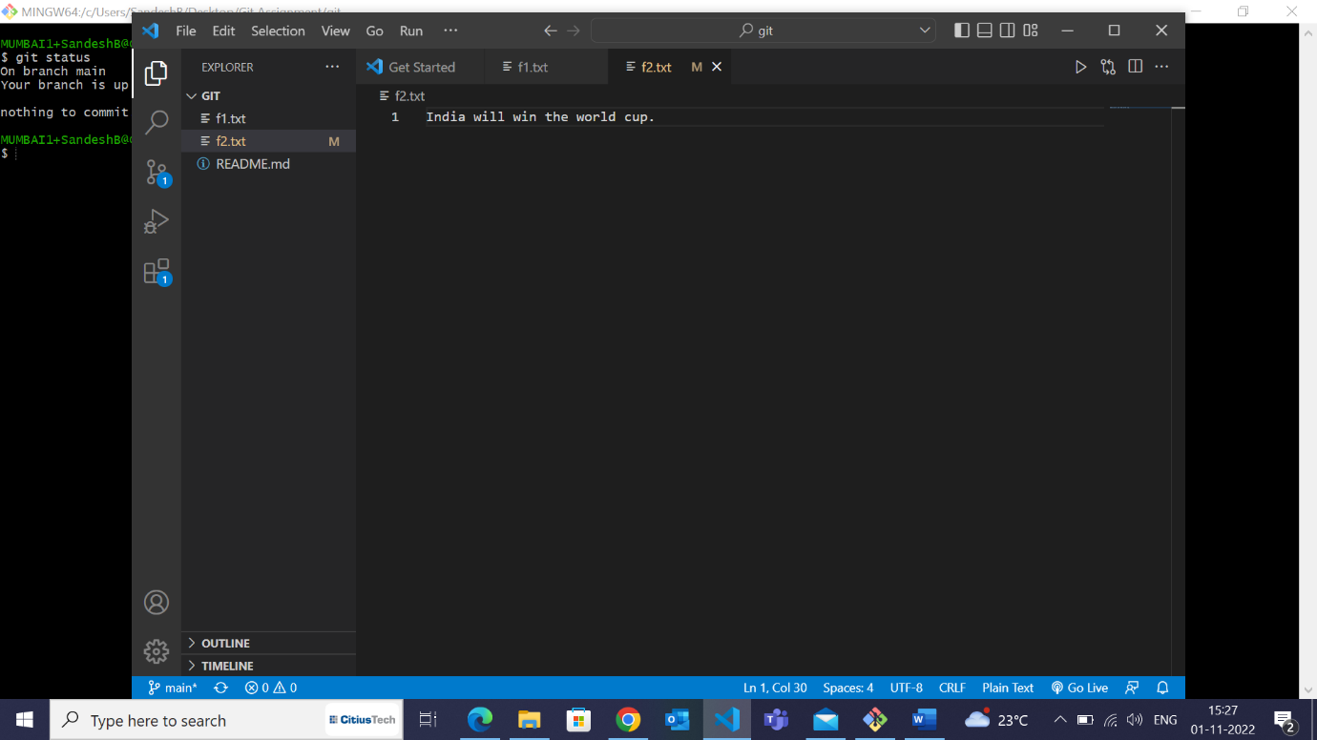

9. Check the status of the local repo.

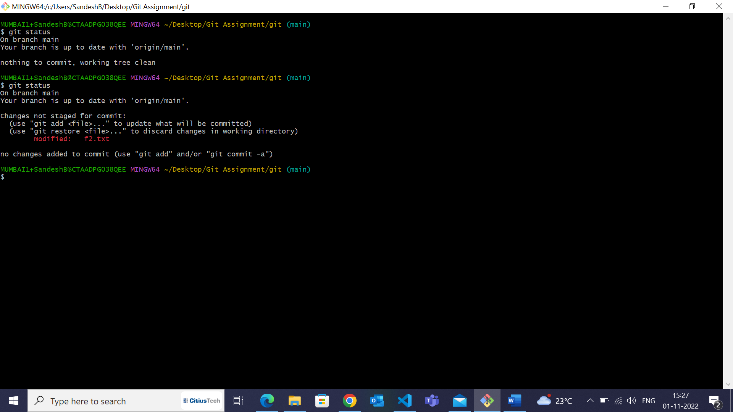

10. Go to the remote repository & check the contents of **f2.txt.** What do you see and why?

🡪 In the remote repository there will be no changes as we have not pushed the changes of f2 file to remote repo from the local repo.

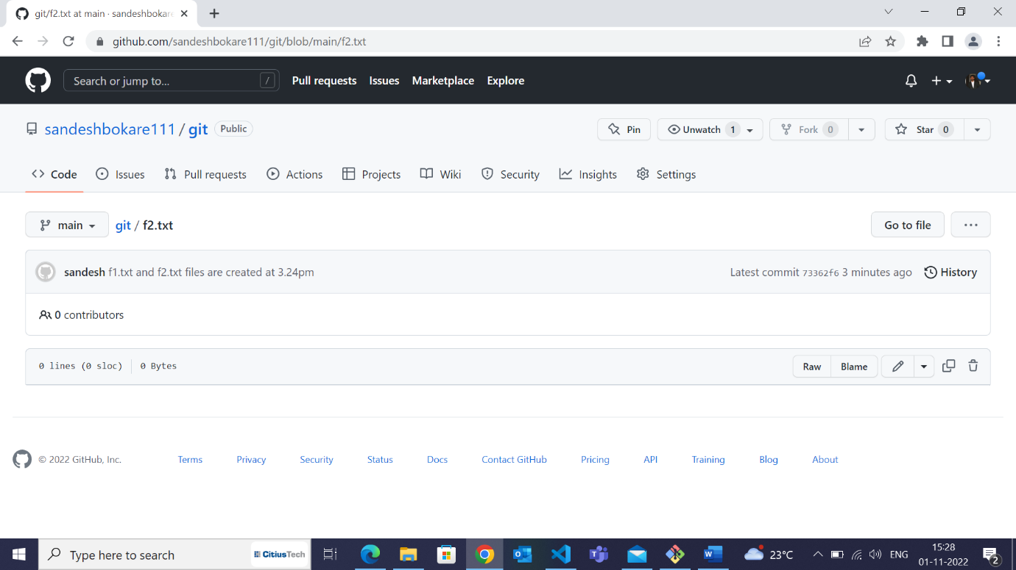

11. Add the file **f2.txt** into staging.

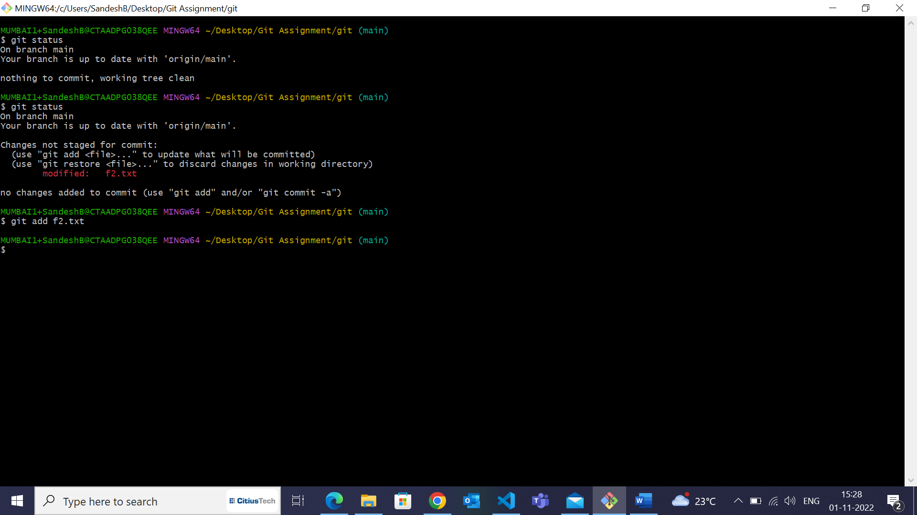

12. Check the status of the local repo.

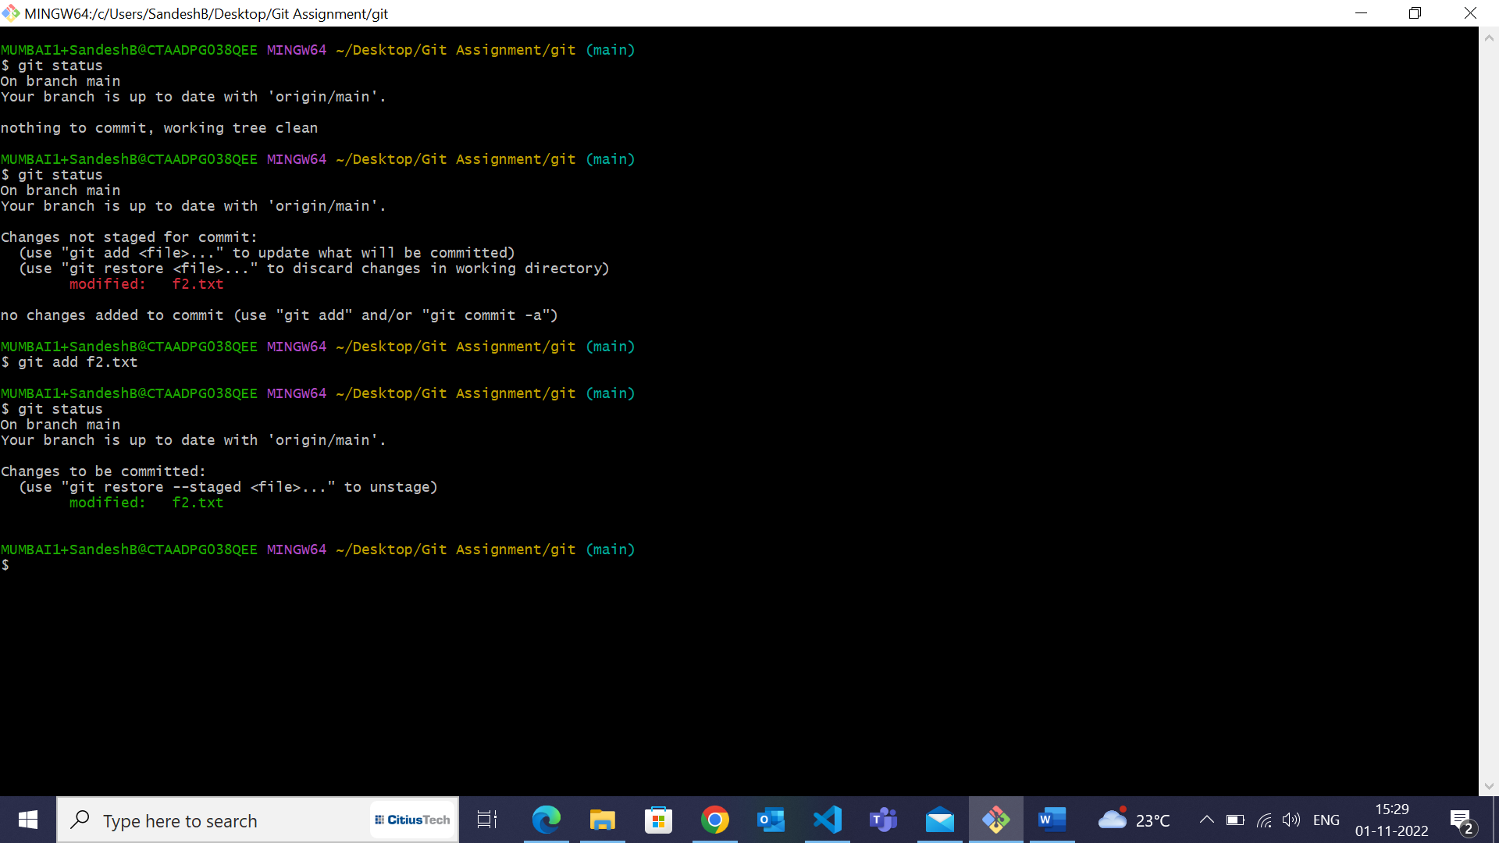

13. Go to the remote repository & check the contents of **f2.txt.** What do you see and why?

🡪 Still we can’t see any changes in remote repo as we have added the files to the staging area not pushed to the remote repo.

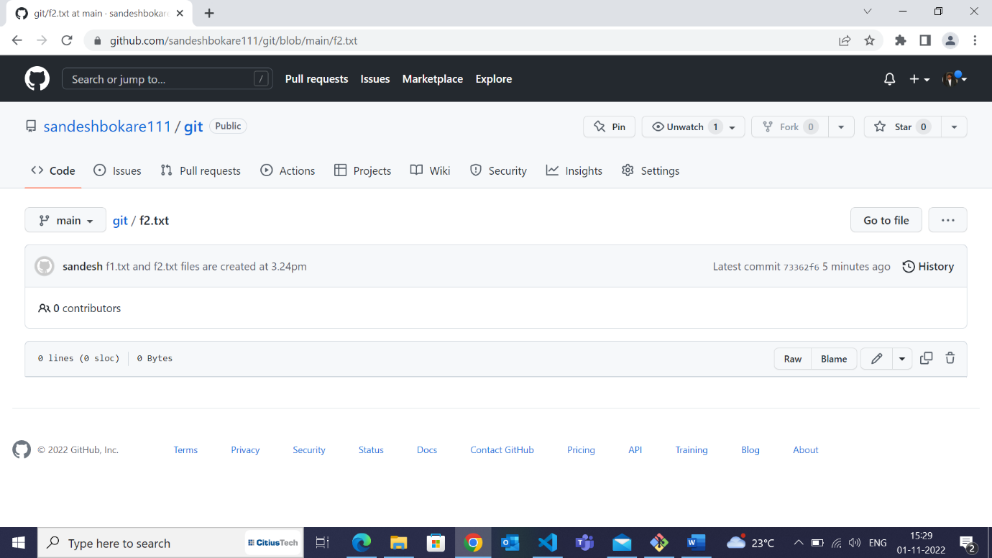

14. Use appropriate Git commands to push the changes to the remote repository.



