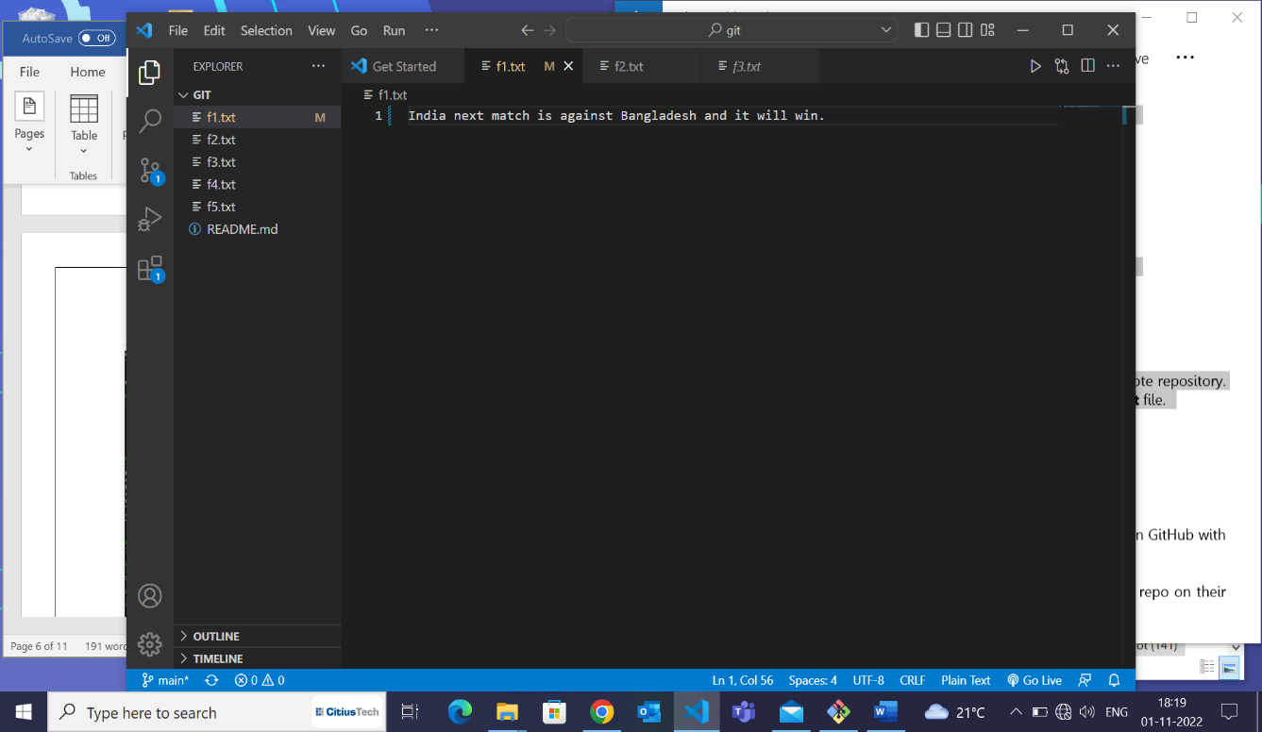1. Continuing from the previous assignment, make sure that there are no files in the staging area & that the remote repository contains files **f1.txt** and **f2.txt** with some content.

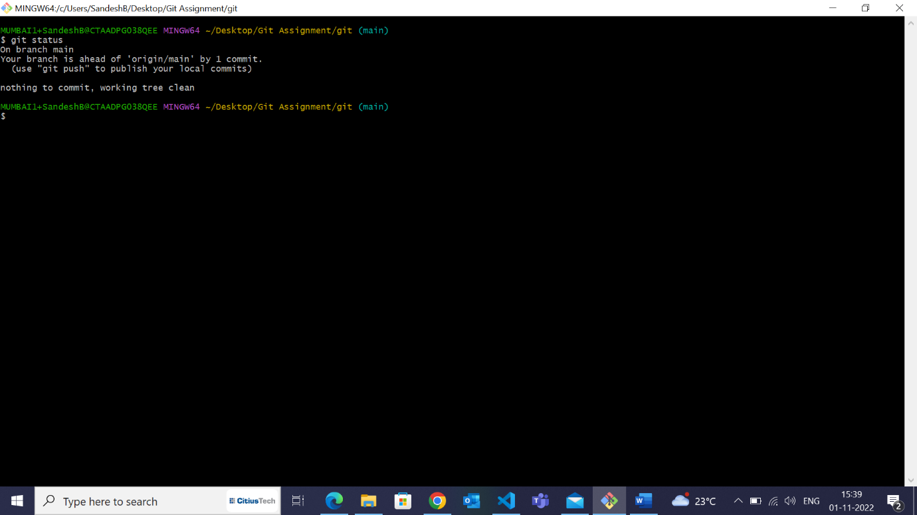

2. Create 3 new files named **f3.txt, f4.txt** and **f5.txt** respectively.

3. Commit the changes. *(do not push)*

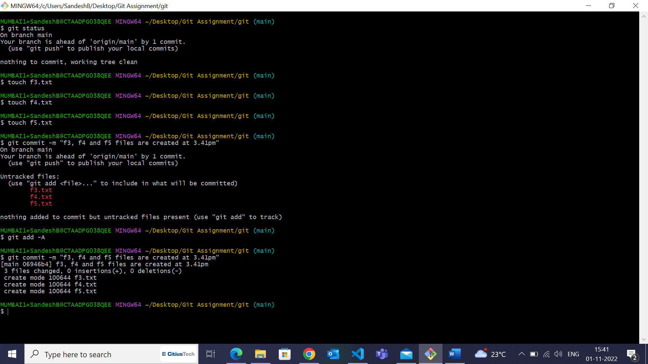

4. Add some text again in **f1.txt** and save the changes.

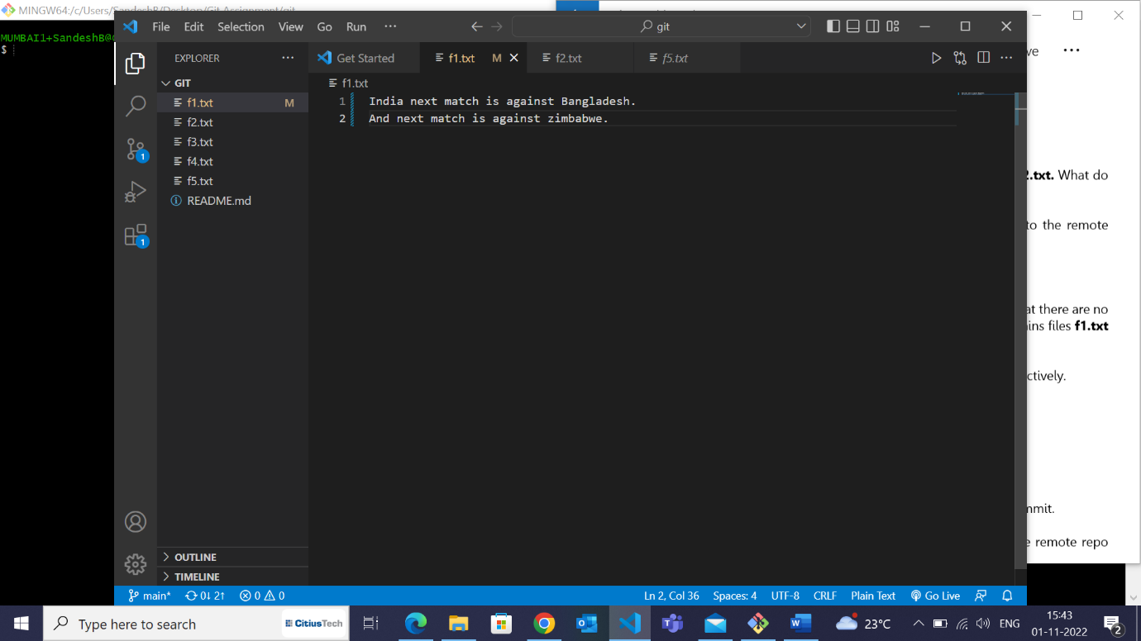

5. Stage the changes made to **f1.txt.**

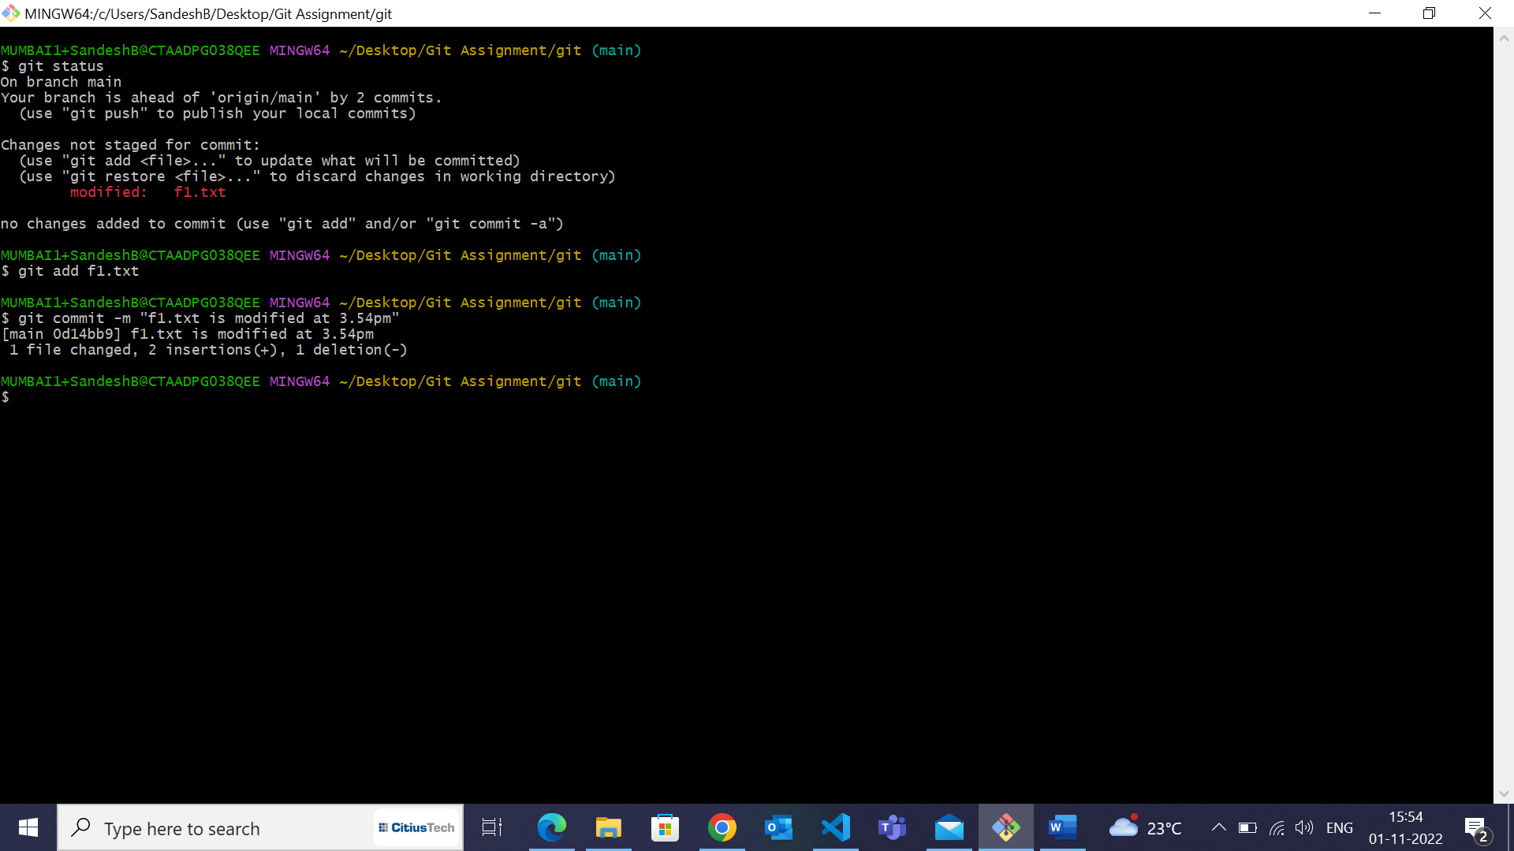

6. Use the *commit –amend* command to undo the last commit.

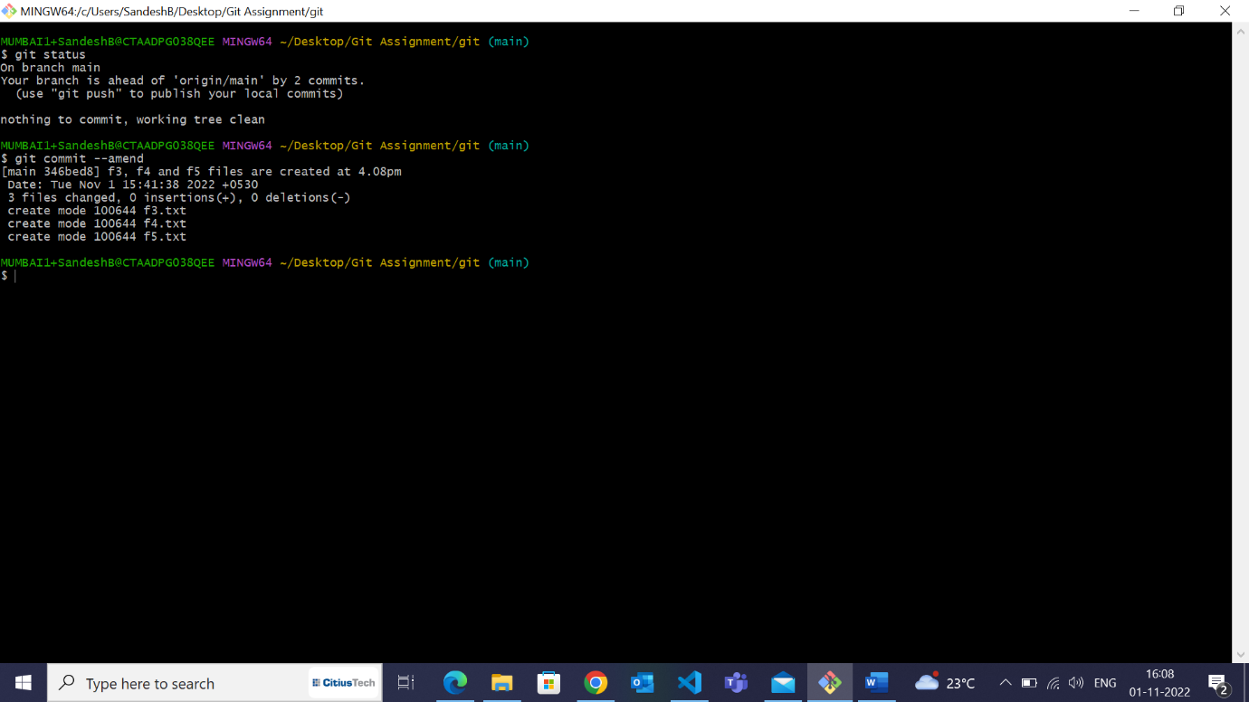

7. Push the changes to the remote repo finally. Go to the remote repo and check the results. 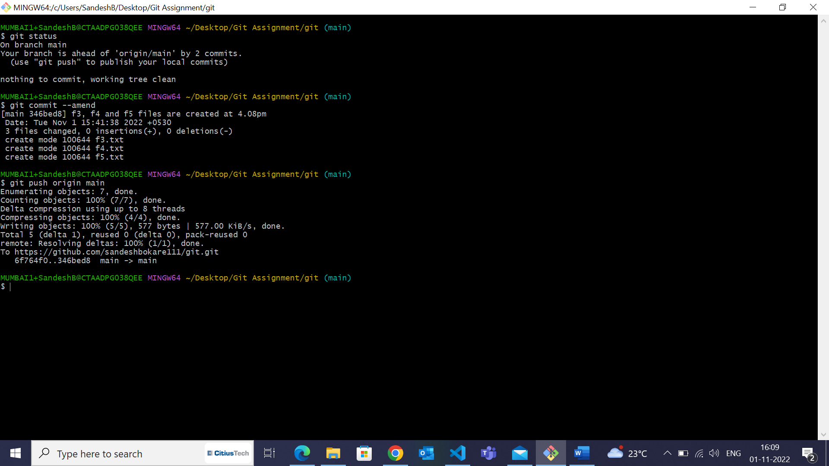

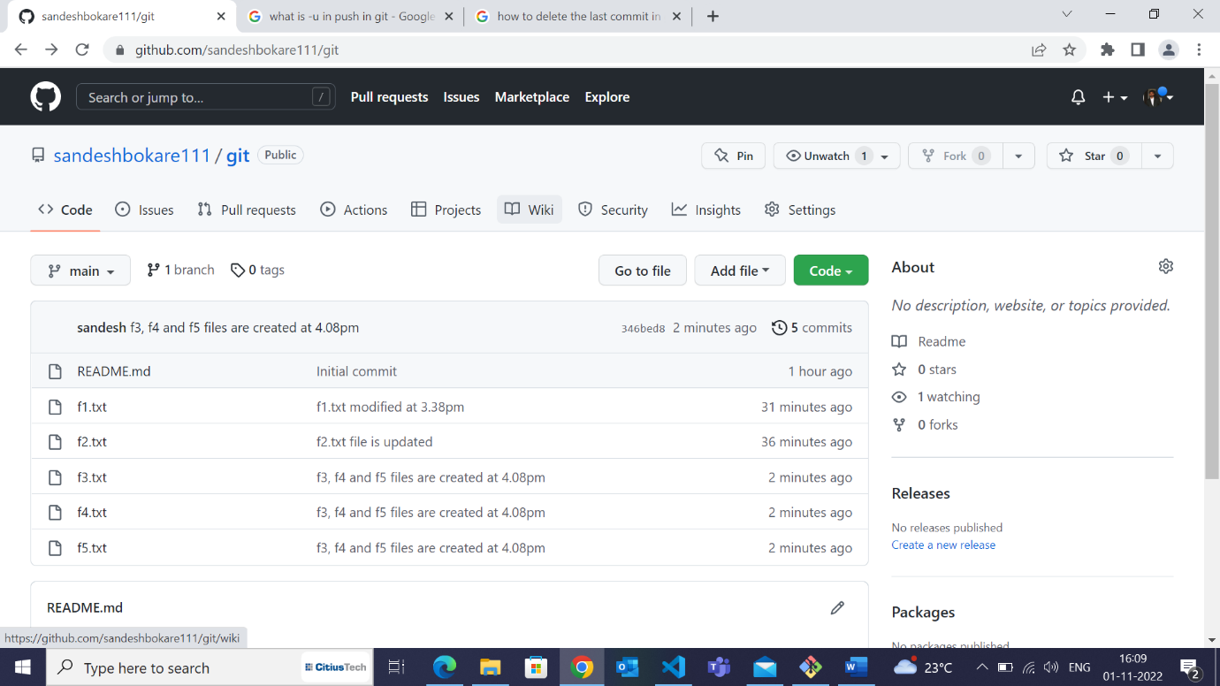

8. Create a new branch named **branch1.**

9. Switch to this branch.

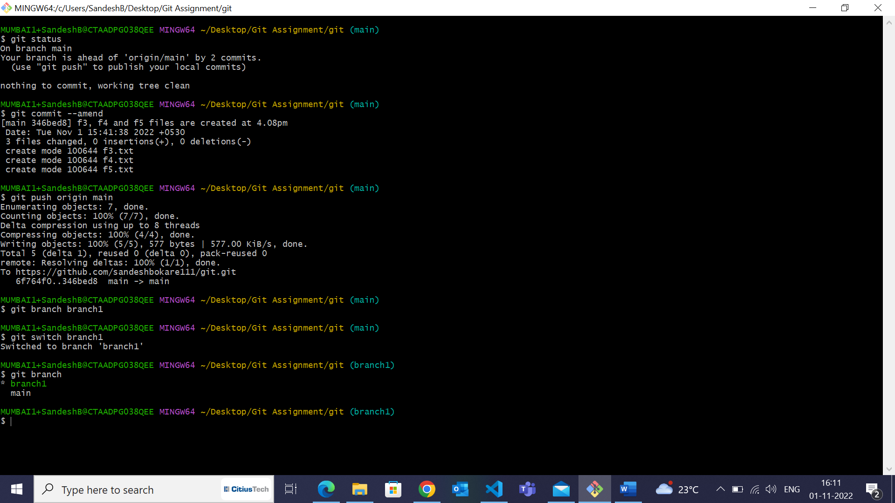

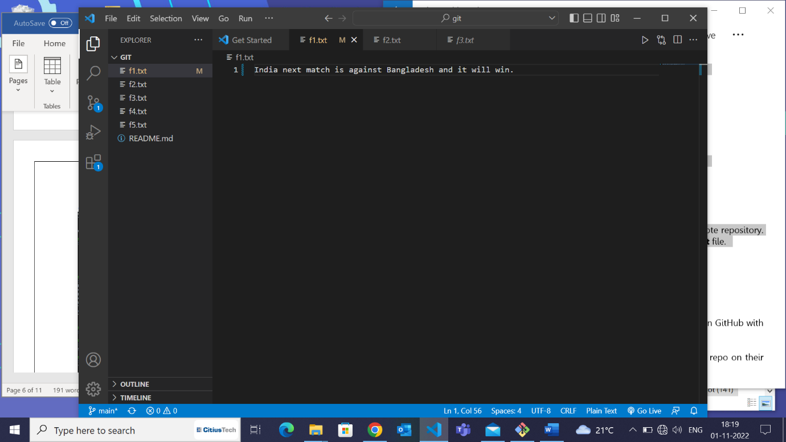 10. Add some lines in the file **f1.txt** and save the changes.

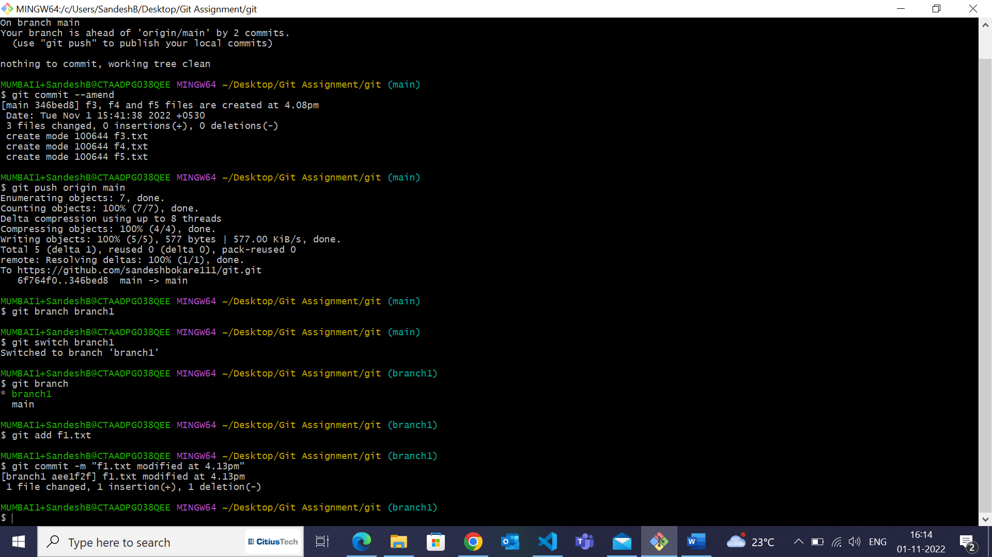11. Stage and commit. *(do not push)*.

12. Check the contents of the file. 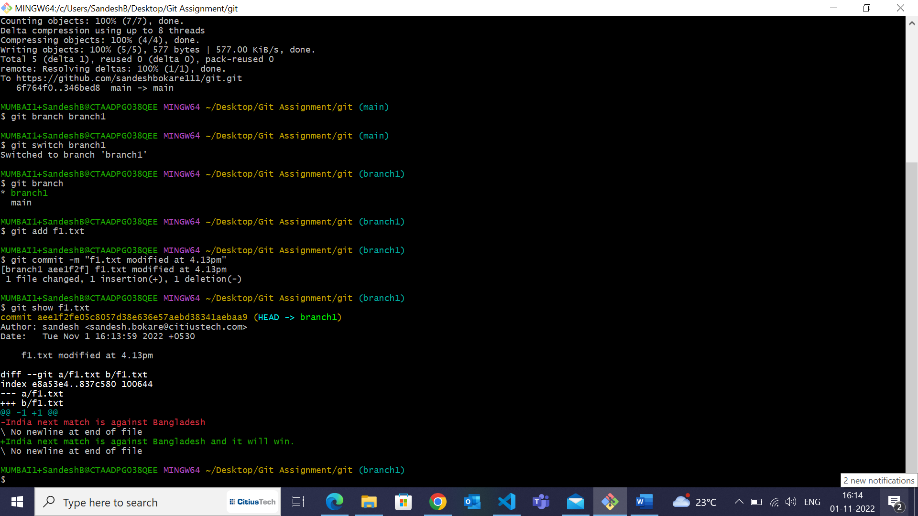

13. Switch back to the master branch. 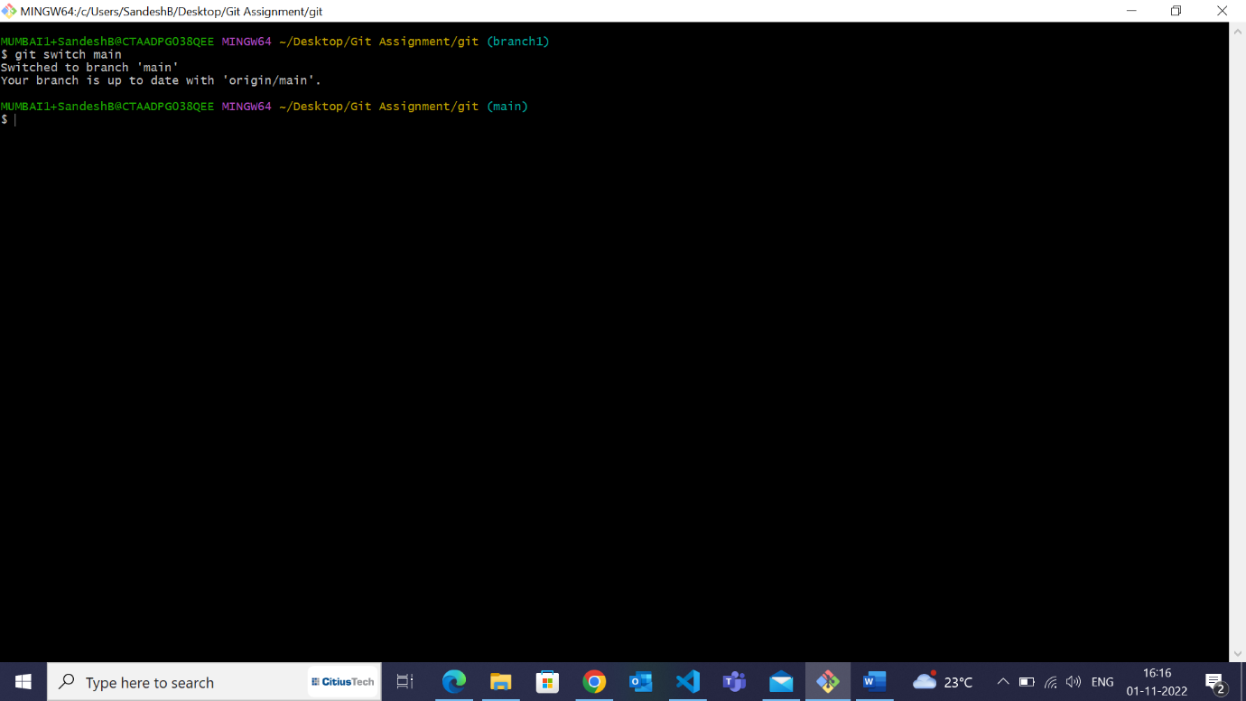

14. Add some lines in the file **f1.txt** and save the changes.

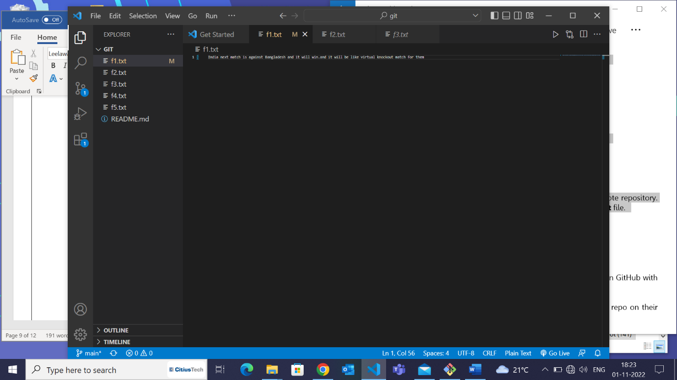

15. Stage and commit. *(do not push)*

16. Check the contents of the file.

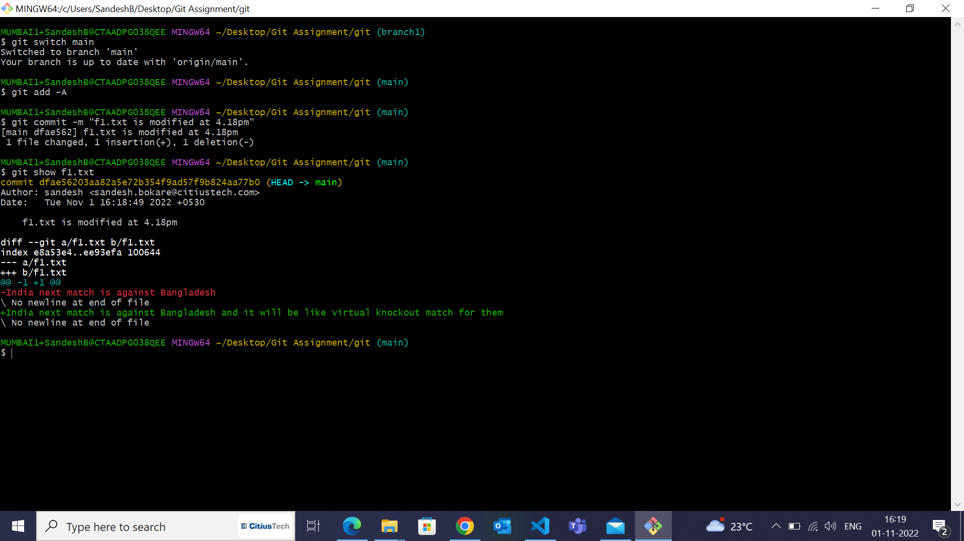

17. From the master branch, push the changes to the remote repository. Go to the remote repo and check the contents of the **f1.txt** file.

