A STAAD Pro Course Is A Must To Become A Structural Engineer

About STAAD Pro:

STAAD is nothing but Structural Analysis And Design. STAAD Pro programming is broadly utilized as a part of structural analysis and designing structures – towers, buildings, bridges, transportation facilities, utility and industrial structures. Designs can include building structures incorporating culverts, petrochemical plants, bridges, tunnels, piles; and construction materials such as timber, steel, concrete, aluminum and cold-formed steel.

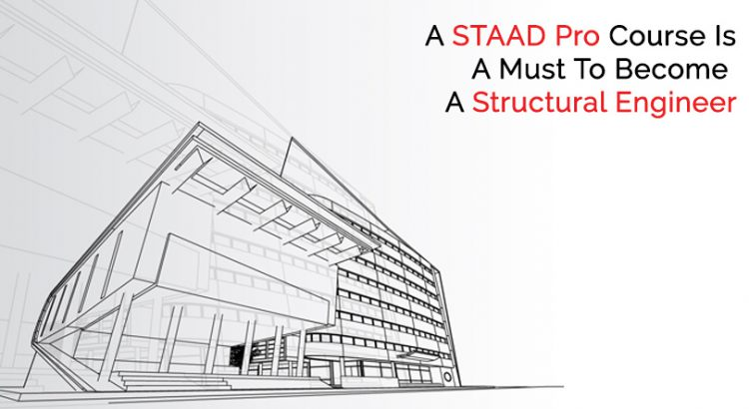

Considered to be amongst the most popular structural engineering courses.

How does STAAD Pro help?

STAAD Pro software enables structural engineers to automate their undertakings by evacuating the repetitive and lengthy procedures of the manual methods.

The need to learn:

STAAD Pro happens to be a structural analysis software that accompanies an adaptable modeling environment, advanced features, and smooth data collaboration. It is the world's numero uno structural analysis and design software that backs Indian and every single global codes.

STAAD Pro enables structural engineers to dissect and outline for all intents and purposes any sort of structure. auxiliary specialists, divisions in development organizations, proprietor/administrators, and government offices, and seaward stage fashioners' utilization this product broadly.

STAAD Pro design software gives options to structural engineers to dissect and design for all intents and any sort of structures. Departments in construction companies, proprietor/administrators, structural engineering firms and government offices etc .and offshore platform designers' make use of this software broadly.

Topics covered as a part of this course:

Usually, the following features are covered as a part of this course:

- Model Generation:

Interaction based menu-driven model creation with concurrent 3D display 2Dand 3D graphics creation utilizing rectangular or polar coordinate frameworks Segments of redundant geometry used to produce complex structural models.

- Model Verification:

On screen 3D/2D drawings and in addition on plotter/printer Full 3D shapes for outlines, components Isometric or any rotations for a full 3D view.

- Secondary Analysis:

Limited component capacities, concrete design, steel design and timber design. Displacements and forces at portions between nodes. Minimum and maximum force envelopes.

- Static Analysis:

2D/3D analysis in view of state-of-the-art Matrix strategy to deal with a substantial degree of job. Linear, analysis of p-delta, non-linear examination with automatic load and stiffness amendment.

- Seismic/Dynamic Analysis:

Mass modeling, extraction of recurrence and mode shapes Response spectrum, time history examination Modal damping proportion for individual models.

You could also get hands on training on the STAAD pro latest version.

Benefits of learning :

Here are some ways in which you can benefit post learning STAAD Pro.

- You will come to know how to have isometric and point of view perspectives and 3D shapes.
- You will be aware how to design concrete structures like columns/beams/slabs/footings according to the international codes.
- You will get to learn how to generate text/graphics input
- You will come to know how to execute flexible zoom and numerous views.
- You will have the knowledge on how to perform code check, member selection and optimized part selection comprising of design/analysis cycles.
- You will know how to utilize built-in command file editor and straightforward command language.
- You will learn how to finish complete object-oriented instinctive 3D/2D graphic model creation.
- You can learn how to do effective algorithm that limits disk space prerequisites.
- You will have the knowledge to perform exact and numerically productive plate/shell component consolidating out-of-plane shear and in-plane rotation; programmed element mesh creation; complete component stress yield incorporating in-plane stresses, out-of-plane shear, bending and main stresses at nodal and also user indicated focuses.
- You will come to know how to utilize pull down menus, drifting toolbars, tool tip help.
- Get to know how to take presentation quality printer plots related to geometry and results as a major aspect of run yield.
- You will figure out how to accomplish user determined design parameters to alter design.

That was about the STAAD Pro Course. You can also undergo professional training for civil engineers, it would also help you get a job.

