Climate Change: What Civil Engineers Can Contribute In Sustainable Adaptation

Summary:
Climate change and the need to adapt to it in a sustainable manner. What role can civil engineers play? All this and more...
--------------------------------------------
Climate change has become a harsh reality. That's what we need to accept first.

The question however is: How can Civil Engineers help in sustainable adaptation against climate change?
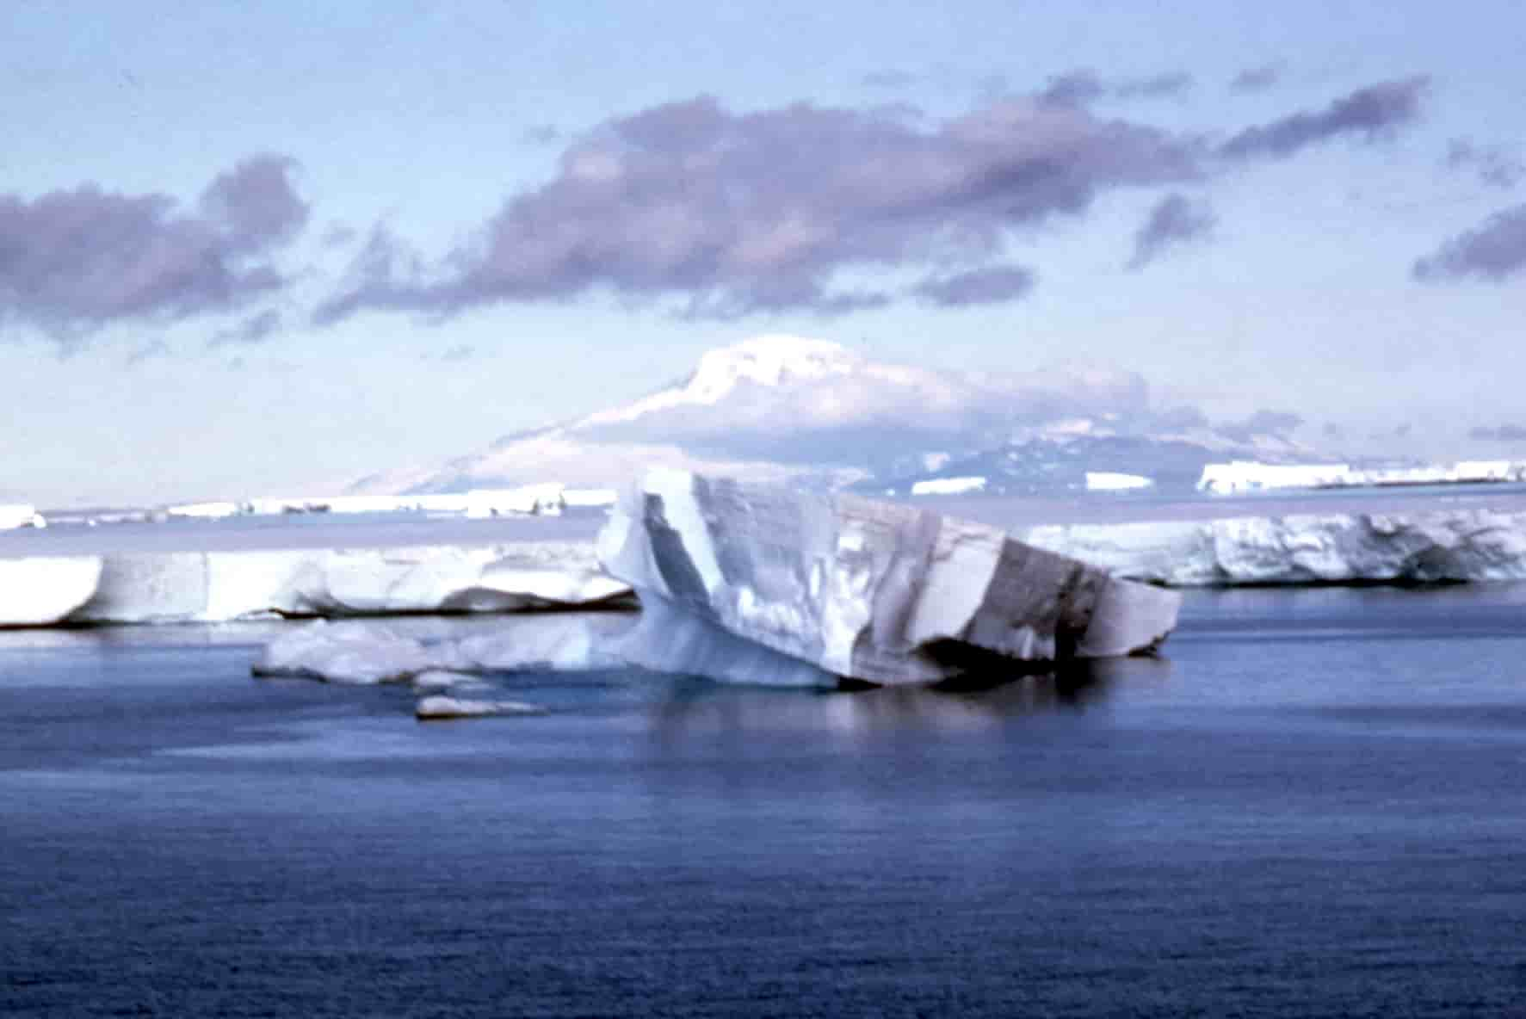
Well, we are going to try and find an answer to this.

Before that, we would like to tell you that civil engineering is a challenging field and you can become a part of it by opting for civil training courses. So, go ahead !

Coming back to the above question,

One of the major challenges for civil engineers in the twenty-first century is to answer to mankind's own creation i.e.: change in climate. Carbon dioxide levels have ascended in the course of recent years to be at a level not seen for no less than 400 000 years (NASA, 2017) and worldwide surface temperatures have transcended 0.85 °C above pre-industrial levels (IPCC, 2014).

Adaption that would sustain:

Adapting to environmental change is a procedure that needs long haul planning, cross-division activity and dynamic stakeholder cooperation.

Short-spanned, barely defined and top-down execution is probably not going to be long lasting. "Poor” adaption would require further, impromptu adaption at more prominent cost and which would be harder to materialize.

In any case, civil engineers ought not be scared to be inventive, and additionally utilize flexible administration – for instance, adaptable solutions that can be balanced through time. To help demonstrate the route forward, ICE has recently distributed the first of a two-part themed issue of its Engineering Sustainability journal on long lasting adaptation to environmental change.

Newer techniques of modeling:

Looking for adaption that is sustainable is probably going to require newer modelling systems, specifically those which can quickly test substantial quantities of future situations and the execution of numerous conceivable portfolios of adaptation methods. Simulation models have this capacity.

There is as yet an assumption by some that adaptation should sit tight for more exact and accurate projections, or to perceive what occurs in future. Both methodologies are flawed. In the second case, unless adaptation is fast and simple, it will be past the point of no return – particularly considering that serious events, which are frequently the occasions of most concern, regularly happen rarely.

In the first case, there is no assurance that more prominent accuracy will be accessible – and regardless approval would likewise require some holding up. Where science can aid specifically is in recognizing vulnerabilities and, if conceivable, diminishing critical ambiguities.

Enhanced Water Management:

Counter to customary preservation management, Muller contends that we should go for 'hydrosupportive', instead of simply 'hydrocentric', water resource management, adjusting our water needs with those of the surroundings. In any case, to be sustainable this requires action past current practice.

The connection amongst water and agriculture and the result of these frameworks to climate change is investigated by David Evans (2017). He exhibits that progressions to rainfall and particularly dissipation will prompt huge parching in eastern England and a considerably more noteworthy requirement for irrigation than has been the situation or has been beforehand forecasted.

Water storage, both on-farm however especially in bigger reservoirs, is viewed as the best adaptation measure, with some potential for water transfer. More coordinated planning is called for and is in progress, for instance in the Water Resources East undertaking (WRE, 2017).

More sustainable transport:

In the last paper of the initial part of this themed issue, we turn our consideration towards railways. British railways are eminent for their association with the climate, outstandingly the regular impact on the rail line of leaves on the line, in spite of the fact that as we write, trains are plying at decreased speed because of the danger of rail buckling.

Adapting water, transport and agriculture is crucial for these systems, yet in addition guarantees that the basic foundation and administrations they accommodate a well-working society and economy can sustain as long as possible.

Thus one can see that civil engineers have a role to play here as well.

If you want to become one, institution of civil engineers training courses would prove to be of great help !

