

A PROJECT REPORT

ON

“SCHOOL BUS SERVICE SYSTEM”

T.Y.B.B.A(CA)(SEM-V)

2024-2025

SUBMITTED TO

SAVITRIBAIPHULE PUNE UNIVERSITY

DEVLEPODED BY

GAIKWAD SANDESH

KADAM YOGESH

UNDER GUIDENCE OF

Prof.ASHA MANE

**Department: -BBA(CA)**

**ANNASAHEB MAGAR COLLEGE, HADAPSAR, PUNE-411028**



ANNASAHEB MAGAR COLLEGE, HADAPSAR, PUNE-411028

DEPARTMENT OF BBA(CA)

CERTIFICATE

This Is Certify That Mr. Kadam Yogesh & Gaikwad Sandesh Student of **Bachelor Business Administration (Computer Application) semester v** Has Satisfactory Completed the Project Work in **“School Bus Service System”** As Per the Syllabus Laid Down by The **Savitribai Phule Pune University** During the Academic Year **2024-2025**.

Date: -

Exam Seat No: - Exam Seat No: -

Project In Charge Head of Department

Internal Examiner External Examiner

Acknowledgement

In Successfully Completing This Project, Many People Have Helped Us. I Would Like to Thank All Those Who Are Related to This Project.

Primarily, I Would Thank God for Being Able to Complete This Project with Success. Then I Will Thank Prof.Snehal Shinde and HOD.Asha Mane, Under Whose Guidance I Learned a Lot About This Project. His Suggestions and Directions Have Helped in The Completion of This Project.

Submitted by

Gaikwad Sandesh

Kadam Yogesh

**Index**

|  |  |  |
| --- | --- | --- |
| **Chapter**  **No.** | **Particular Name** | **Page No.** |
| **1.** | **Introduction: -** |  |
|  | 1.1 Profile of System | 5-6 |
|  | 1.2 Scope of System | 7-9 |
|  | 1.3 Purpose of the System | 10 |
|  |  |  |
| **2.** | **System Analysis: -** |  |
|  | 2.1 Feasibility Study | 12-14 |
|  | 2.2 Fact Finding Technique | 15-18 |
|  | 2.3 Hardware and Software | 19 |
|  |  |  |
| **3.** | **System Design: -** |  |
|  | 3.1 Entity Relationship Diagram | 20 |
|  | 3.2 Use Case Diagram | 21 |
|  | 3.3 Class Diagram | 22-23 |
|  | 3.4 Component Diagram | 24-26 |
|  | 3.5 Deployment Diagram | 27 |
|  | 3.6 Object Diagram |  |
|  | 3.7 File Design |  |
|  | 3.8 Data Dictionary |  |
|  |  |  |
| **4** | **Form Design: -** |  |
|  | 4.1 Input & Output Screen | 28 |
|  |  |  |
| **5** | **Testing** |  |
|  | 5.1 Black Box Testing | 37 |
|  | 5.2 White Box Testing | 38 |
| **6** | **Advantages & Limitation** | 39-40 |
| **7** | **Conclusion** | 41 |
| **8** | **Future Enhancement** | 42 |
| **9** | **References** | 43 |

**1.Introduction**

* 1. **Profile of System**

A **school bus system** is a structured and organized transportation service specifically designed to safely transport students to and from school. This system involves a fleet of school buses, a scheduling mechanism, and well-trained staff to ensure punctuality, safety, and efficiency. School bus systems vary in scale, depending on the size of the school district and the geographic distribution of students.

School bus services play a vital role in the education system by providing safe and reliable transportation for students. These services are designed to ensure that children can travel to and from school efficiently, reducing the burden on parents and enhancing student attendance.

The primary goal of school bus services is to prioritize the safety and well-being of students. Buses are equipped with safety features and operated by trained drivers who are committed to creating a secure environment for young passengers. Additionally, school bus services help to minimize traffic congestion and reduce the carbon footprint by encouraging the use of public transport.

Effective school bus management involves careful planning of routes, schedules, and communication with parents and school authorities. By optimizing these elements, school bus services can provide timely and organized transportation, allowing students to focus on their education without the stress of commuting.

Overall, school bus services are essential for fostering a supportive educational environment and ensuring that students can access their schools with ease and safety.

A **school bus system** is a structured and organized transportation service specifically designed to safely transport students to and from school. This system involves a fleet of school buses, a scheduling mechanism, and well-trained staff to ensure punctuality, safety, and efficiency. School bus systems vary in scale, depending on the size of the school district and the geographic distribution of students.

* 1. Scope of the System

The school bus services management system is designed to encompass a comprehensive range of functionalities aimed at enhancing the efficiency and safety of student transportation. The key areas of focus include:

1. **Route Management**:
   * Create, modify, and optimize bus routes based on student locations and traffic patterns.
   * Generate detailed maps and schedules for each route.
2. **Student Management**:
   * Maintain a database of enrolled students, including their assigned bus routes and pickup/drop-off points.
   * Allow for easy updates to student information, such as changes in address or contact details.
3. **Driver Management**:
   * Track driver assignments, qualifications, and schedules.
   * Facilitate communication between drivers and school administrators.
4. **Reporting and Analytics**:
   * Generate reports on bus utilization, student attendance, and operational efficiency.
   * Analyse data to identify areas for improvement in service delivery.
5. **User Management**:
   * Establish different user roles (e.g., administrators, drivers, parents) with specific access permissions.
   * Ensure secure login and data privacy measures are in place.

By encompassing these functionalities, the school bus services management system aims to streamline operations, improve safety, and enhance communication among all stakeholders involved in student transportation.

1.**3 Purpose of the System**

The primary purpose of the school bus services management system is to enhance the efficiency, safety, and reliability of student transportation. Specifically, the system aims to achieve the following objectives:

1. **Ensure Student Safety**:
   * Provide a secure transportation environment by implementing safety protocols and monitoring bus operations, ensuring that students are transported safely to and from school.
2. **Improve Operational Efficiency**:
   * Optimize bus routes and schedules to minimize travel time and reduce fuel consumption, thus enhancing the overall efficiency of the transportation service.
3. **Enhance Communication**:
   * Foster effective communication between parents, drivers, and school administrators, allowing for timely updates regarding schedules, delays, and emergencies.
4. **Facilitate Real-Time Monitoring**:
   * Enable real-time tracking of buses, giving parents and school officials the ability to monitor bus locations and receive notifications about any changes or delays.
5. **Streamline Administrative Tasks**:
   * Automate various administrative processes, such as student enrolment, route planning, and reporting, to reduce manual effort and improve accuracy.
6. **Enhance User Experience**:
   * Offer a user-friendly interface for parents, drivers, and school staff to access essential information, making the system accessible and easy to navigate.

By fulfilling these purposes, the school bus services management system aims to create a seamless and efficient transportation experience for students, parents, and educational institutions, ultimately contributing to a supportive learning environment.

**2.System Analysis**

### **Feasibility Study**

A feasibility study evaluates the practicality of the school bus services management system project by examining various dimensions: technical, economic, operational, and legal/ethical considerations.

1. Technical Feasibility

* **Existing Infrastructure**: Assess the current IT infrastructure to determine if it can support the new system. This includes server capacity, internet connectivity, and hardware used by staff and drivers.
* **Development Resources**: Identify the skills and expertise of the development team, ensuring they have the necessary knowledge of Java, databases, and mobile app development

2. Economic Feasibility

* **Cost Analysis**: Estimate the total cost of development, including hardware, software licenses, and personnel costs.
* **Budget Constraints**: Review the budget allocated by the school or district for transportation services to ensure alignment with project costs

3. Operational Feasibility

* **Alignment with Current Processes**: Assess how the new system will fit into existing workflows. Identify any necessary changes to processes and how they will be implemented.
* **Training Requirements**: Determine the training needs for users to effectively operate the new system and how this training will be delivered.

### 2.2 Fact Finding Technique

Fact-finding techniques are crucial for gathering information to inform the system's development:

1. **Interviews**:
   * Conduct interviews with stakeholders, including school administrators, bus drivers, and parents, to gather insights into their needs and challenges.
2. **Surveys and Questionnaires**:
   * Distribute surveys to collect quantitative data on user preferences, current transportation issues, and feature requests.
3. **Observation**:
   * Observe current school bus operations to identify inefficiencies, safety concerns, and areas for improvement.
4. **Document Analysis**:
   * Review existing documentation, such as transportation policies, schedules, and incident reports, to understand current practices and requirements.
5. **Focus Groups**:
   * Organize focus group discussions with various stakeholders to gather diverse perspectives and foster collaborative brainstorming
6. **Research:**
   * A useful fact-finding technique is to research the application or the problem that you are dealing with and want to put within a database. Computer trade journals, reference books, and the Internet are good sources of information that can make available the vast quantity of information on how others have solved similar

### 2.3 Hardware and Software

This section outlines the necessary hardware and software components for the system:

1. **Hardware Requirements**:
   * **Servers**: Reliable servers to host the application and manage data storage.
   * **Client Devices**: Computers for administrators, drivers, and parents to access the system.
   * **GPS Devices**: GPS trackers installed on buses for real-time location monitoring.
   * **Networking Equipment**: Routers and switches to ensure reliable internet connectivity.
2. **Software Requirements**:
   * **Programming Language**: Java for developing the core application.
   * **Database Management System**: MySQL managing student and transportation data.
   * **Development Framework**: HTML, CSS, JavaScript
   * **Operating System**: Windows server and client machines.

**3.System Design**

**3.1 Entity Relationship Diagram**

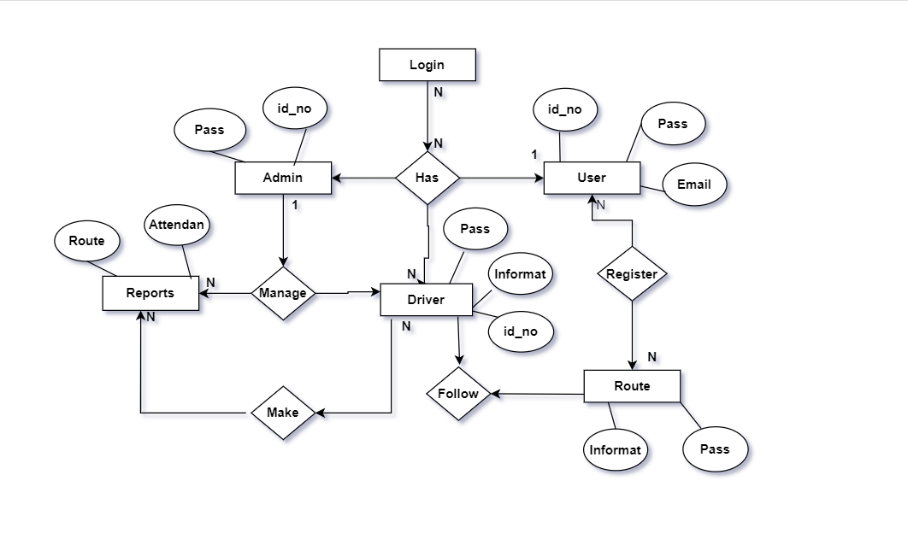

**3.2 Use Case Diagram**

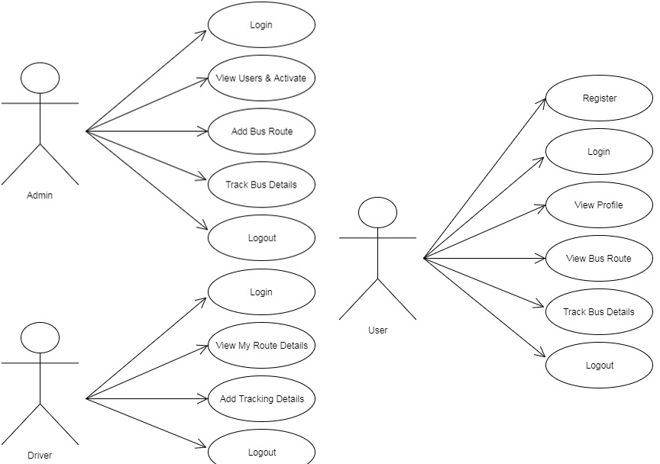

**3.3 Class Diagram**

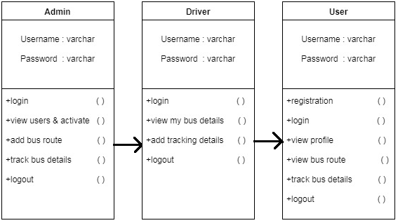

**3.4 Deployment Diagram**

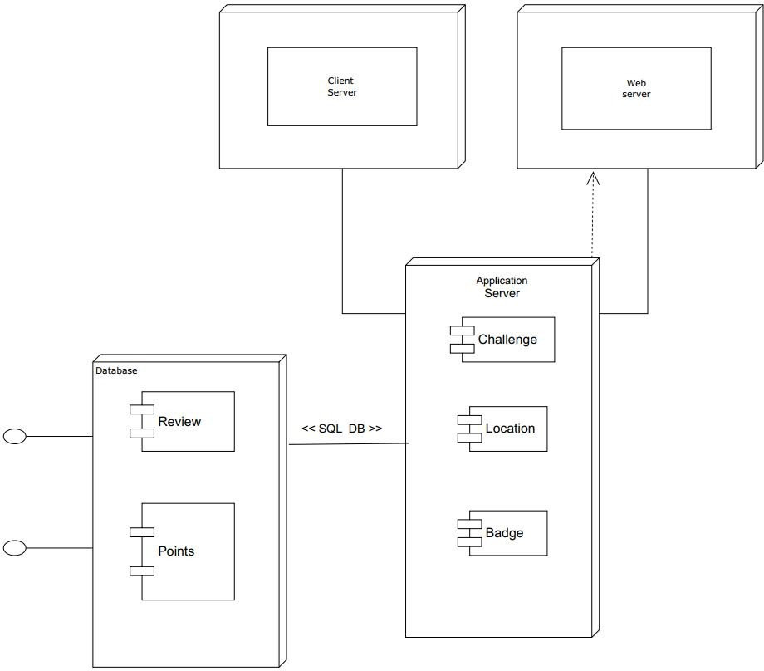

Route

Drive

regis

**3.5 Component Diagram**

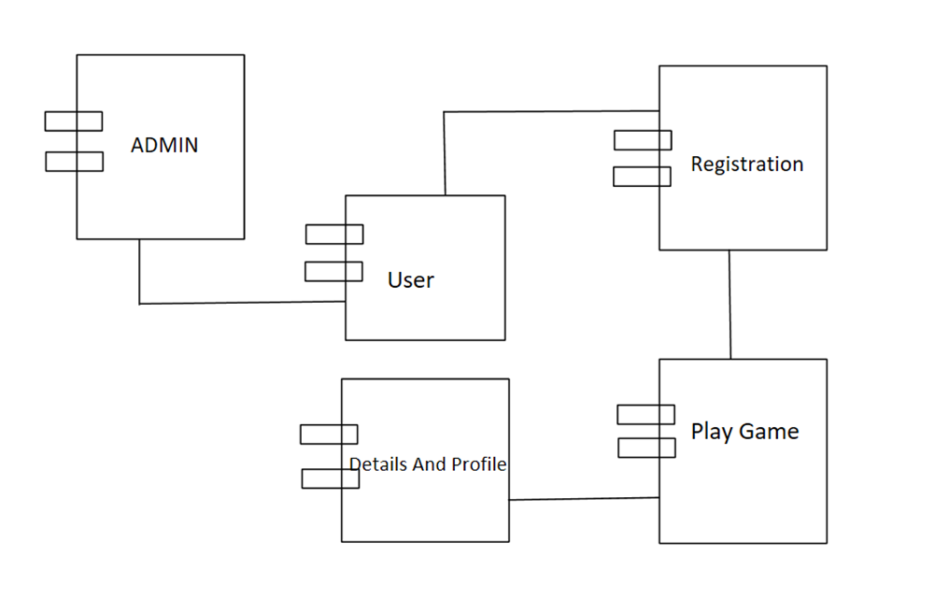

Driver

**Buses**

**3.6 Object Diagram**

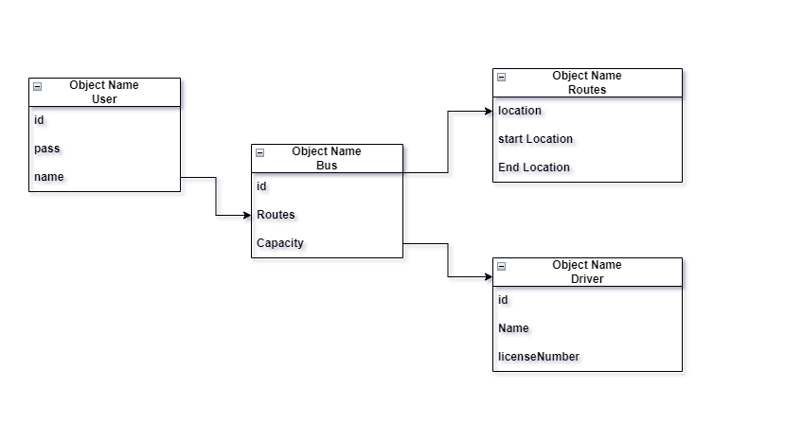

**3.7 Data File**

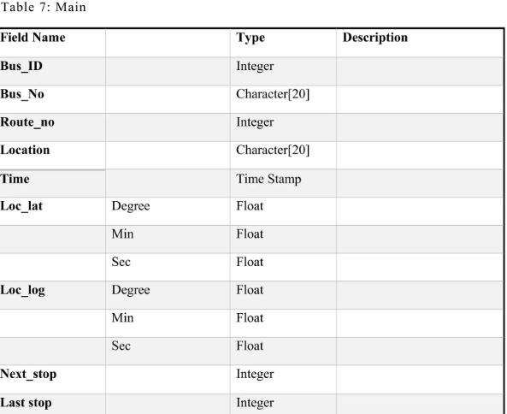

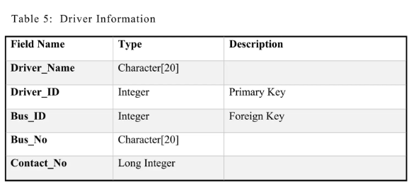

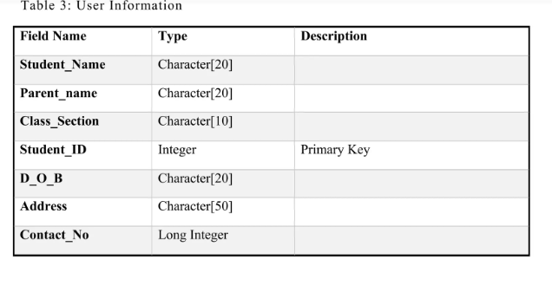

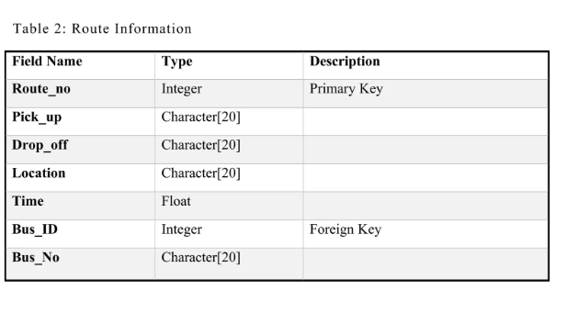

* 1. Data Dictionary

|  |  |  |  |  |
| --- | --- | --- | --- | --- |
| **Fields Name** | **Fields** | **Data type & Data Size** | **constraints** | **Table Name** |
| School bus | id | int (30) | Index | Admin |
|  | Pass | varchar(255) | - |  |
|  |  |  | - |  |
| School bus | attendance | int(30) | Primary | Attendance |
|  | Date | varchar(50) | - |  |
|  | Name | varchar(100) | - |  |
|  | Email | int(1) | - |  |
|  |  |  | - |  |
|  |  |  | - |  |
| School bus | Name | int(11) | Primary | Contact |
|  | Email | Text | - |  |
|  | Subject | Text | - |  |
|  | Message | int(30) |  |  |
|  |  |  | - |  |
| School bus | Name | Text | Primary | Driver |
|  | Email | Text | - |  |
|  | Address | int(1) | - |  |
|  | MobileNo | data time | - |  |
|  | DOB | data time | - |  |
|  |  |  |  |  |
| School_bus | Name |  | - | Student |
|  | Email |  | - |  |
|  | Age | tinyint(1) | - |  |
|  | MobileNo | data time | - |  |
|  | Address | data time | - |  |
|  | SchoolName | int(11) | - |  |
|  | Location | Varchar() | - |  |
|  |  |  | - |  |
| School_bus | ID | int(50) | Primary | Users |
|  | name | varchar(250) | - |  |
|  | age | Text | - |  |
|  | Mobileno | varchar(250) | - |  |
|  | SchoolName | Text | - |  |
|  | Address | Text | - |  |
|  | Location | Text | - |  |
|  | Last login | datetime | - |  |
|  | Password | tinyint(1) | - |  |
|  | Image | int() | - |  |
|  |  |  | - |  |
|  |  |  | - |  |

**4.Form and Report**

**4.1 Input & output Screens**

**Welcome Page**

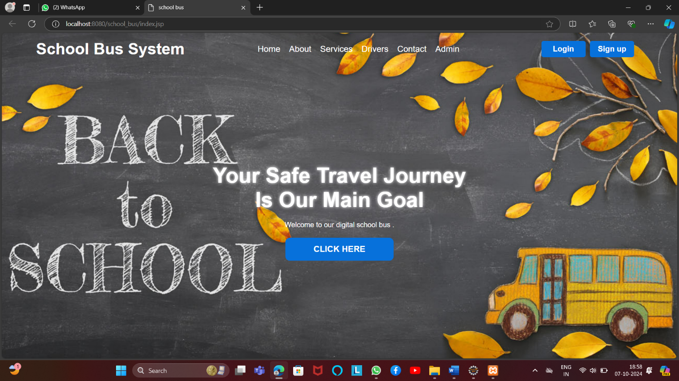

**Login Page**

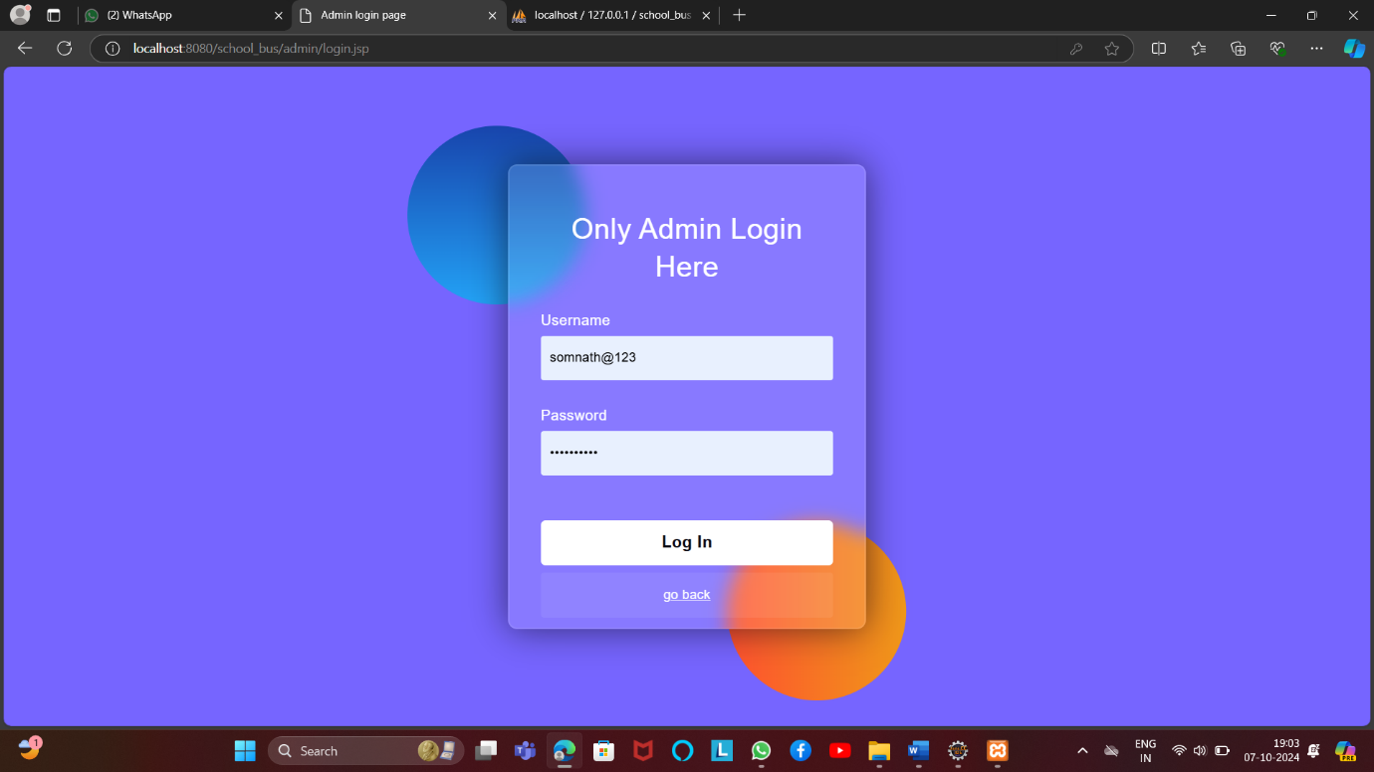

**Admin Dashboard Page**

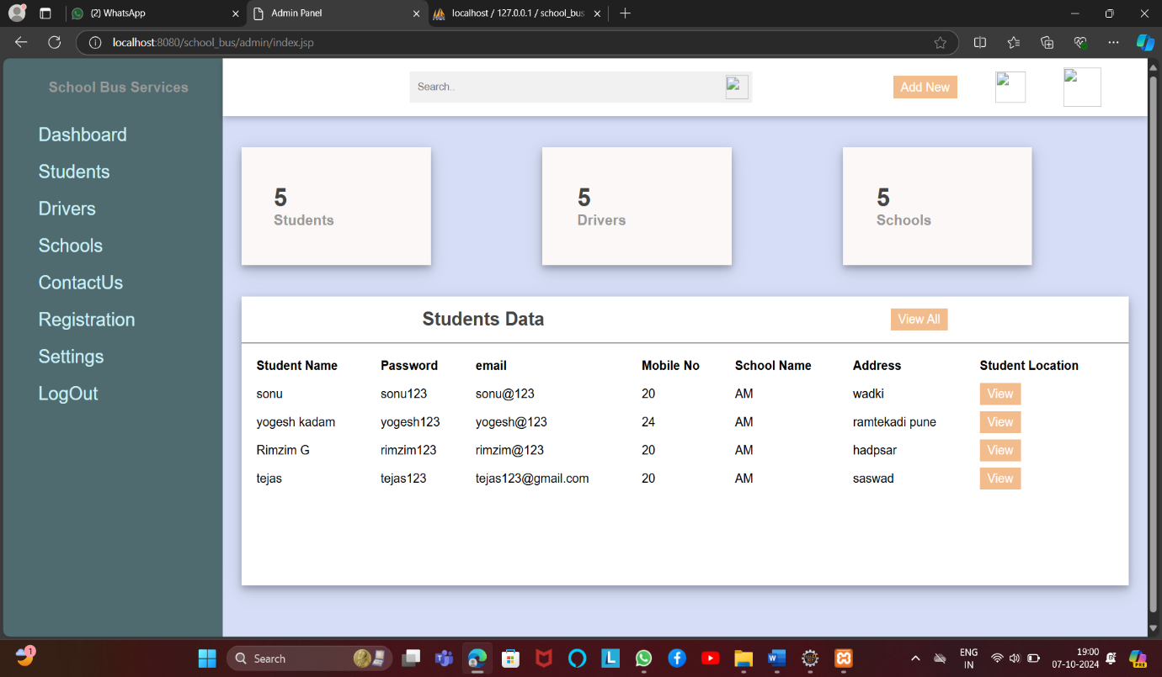

**User Registration Page**

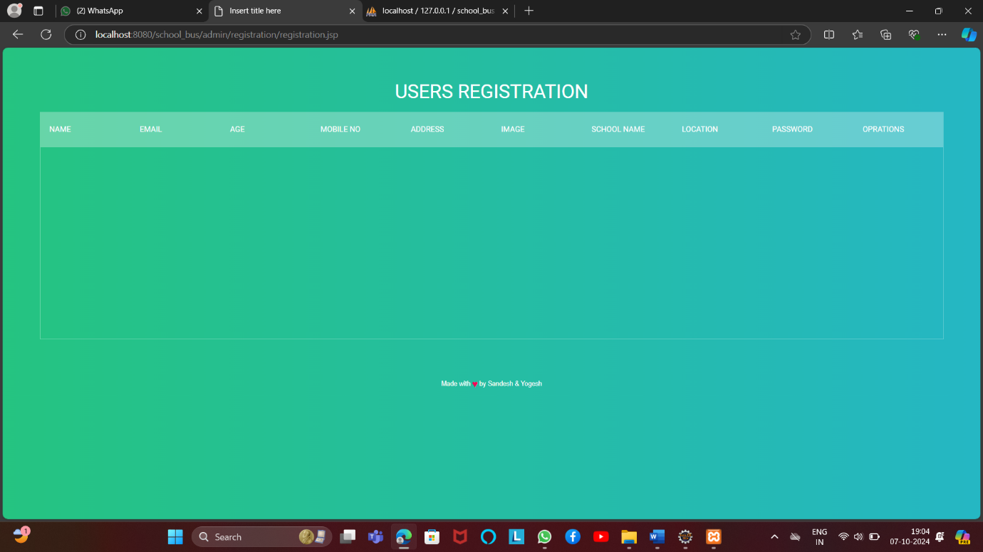

**Student Attendance Page**

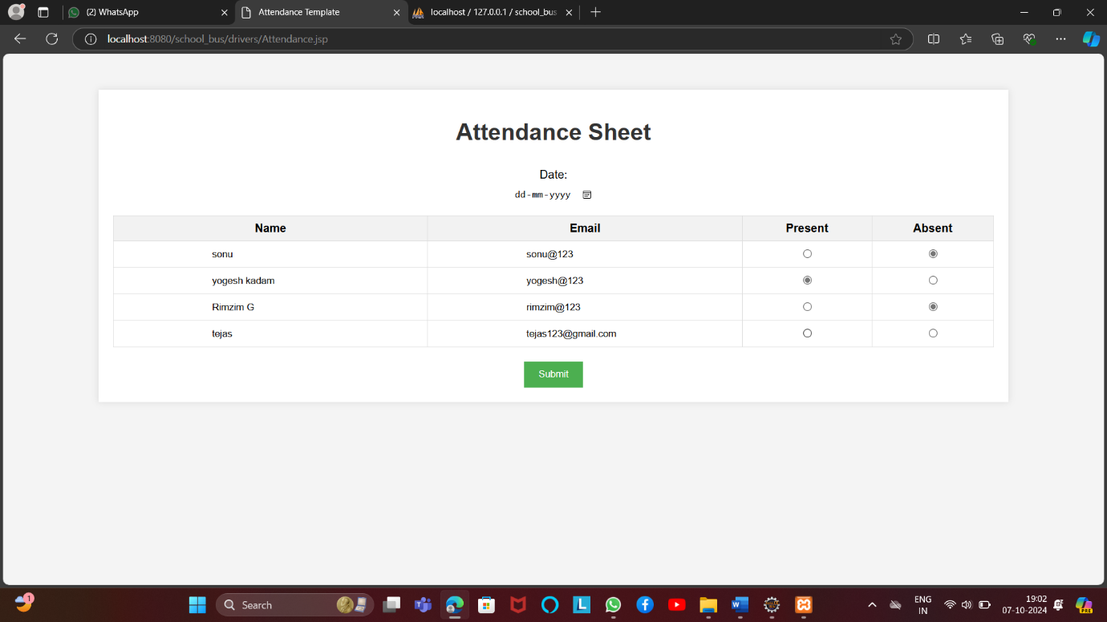

**Student Register Location**

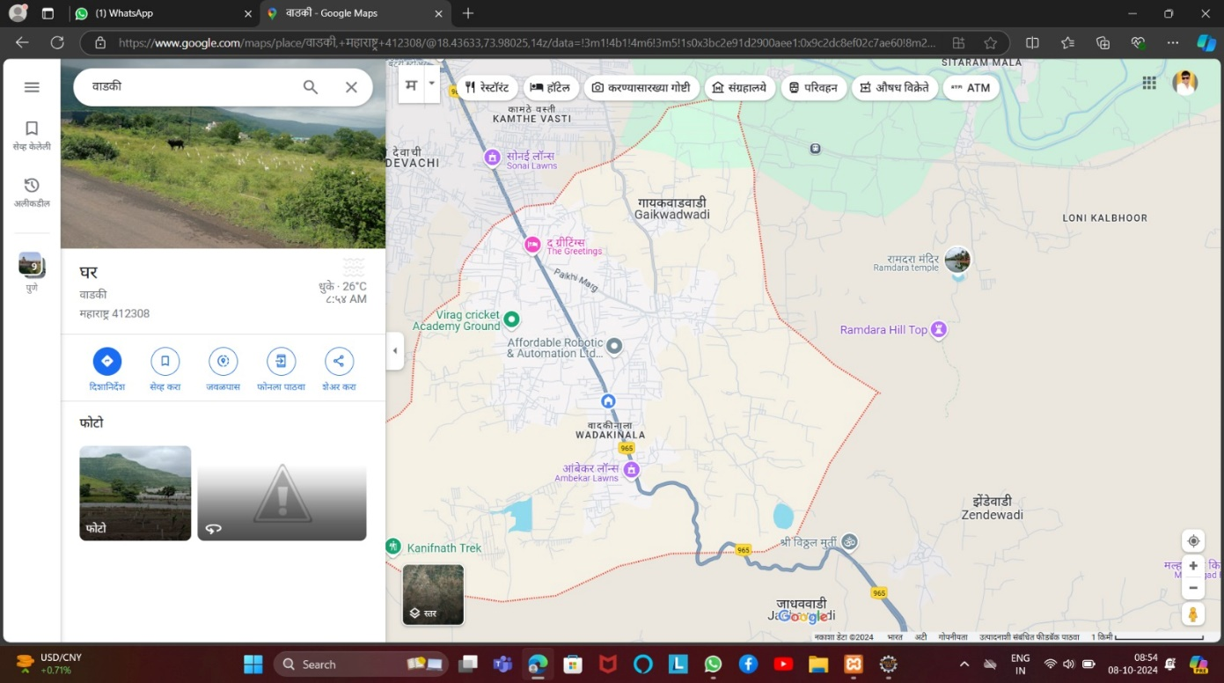

**5.Testing**

**5.1 Black Box Testing**

**Black Box Testing** evaluates the system’s functionality without focusing on the internal workings of the code. The tester verifies the system’s outputs based on inputs, without knowing the actual implementation.

* **Purpose**: To ensure that the system behaves as expected for end-users.
* **Tests Include**:
  1. **Route Management**:
     + Input: Location data (home and school).
     + Expected Output: Optimized and correct bus route.
     + **Result**: The system consistently generates accurate and shortest routes.
  2. **Bus Tracking**:
     + Input: Live GPS data from the bus.
     + Expected Output: Real-time updates on the bus’s location.
     + **Result**: The location updates accurately match the physical bus movement.
  3. **Student Assignment**:
     + Input: Student details (name, location, assigned bus).
     + Expected Output: Correct assignment of students to their respective buses.
     + **Result**: Every student was successfully assigned to the correct bus without errors.
* **Advantages**: No need to understand the code structure; only requires knowledge of what the system should do.
* **Status**: Pass/Fail.

**5.2 White Box Testing**

**White Box Testing** evaluates the internal logic and code of the system. Testers have complete visibility of the codebase and design, ensuring the internal workings are functioning correctly.

* **Purpose**: To verify the internal workings of the system, such as code logic, algorithms, and data flow.
* **Tests Include**:
  1. **Code Flow and Logic**:
     + Verified whether the **route planning algorithm** computes the shortest and safest paths using efficient algorithms like Dijkstra's or A*.
     + Checked that **conditional logic** ensures only active and available buses are assigned to students.
  2. **Path Coverage**:
     + Ensured that all possible execution paths in the code are tested for correct route generation and student assignment.
     + Tested **error handling** routines in cases where GPS signals fail or if student data is incomplete.
  3. **Boundary Testing**:
     + Examined edge cases in the route optimization algorithm, such as locations on city outskirts or students far from typical routes.
     + Tested boundary conditions where the number of students exceeds bus capacity to see if the system reallocates students or issues alerts.
* **Advantages**: Provides insight into how well the code is written and identifies inefficiencies or logic errors.
* **Status**: Pass/Fail.

**6.Advantages and Disadvantages**

**6.1 Advantages of System**

1. **Safety and Security**:
   * **Bus tracking systems** ensure that parents and schools can monitor bus routes in real-time, providing a layer of security for children.
2. **Cost-Effective**:
   * Reduces the need for private transportation or carpooling, potentially lowering transportation costs for parents.
   * Efficient route planning can reduce fuel usage and maintenance costs for the school.
3. **Convenience**:
   * Parents do not need to drive their children to school, providing significant convenience, especially for working parents.
4. **Attendance and Accountability**:
   * Electronic student **check-in systems** can track student attendance on buses, ensuring accountability for each student’s transport.

**6.2 Disadvantages of System**

• **Initial Setup and Maintenance Costs**:

* The initial costs to set up a bus tracking system, purchase buses, and integrate the software can be high.
* Ongoing maintenance of the system, fuel costs, and bus upkeep require consistent budgeting.

• **Dependence on Technology**:

* If the bus tracking system or notification service fails (e.g., server down, GPS malfunction), it can lead to confusion for both parents and the school.
* Not all areas may have reliable **GPS or cellular coverage**, impacting the efficiency of the system.

**7.Conclusion**

**7.1 Conclusion of System**

In conclusion, the school bus system represents a well-rounded, technology-driven solution that significantly improves school transportation. Its ability to address safety concerns while streamlining operations makes it a valuable tool for schools worldwide. However, proper investment in infrastructure, maintenance, and technological updates is crucial to fully realizing its potential and ensuring continuous improvement. By optimizing routes, enhancing security, and maintaining user satisfaction, this system plays a pivotal role in supporting educational institutions in safely transporting students to and from school

The school bus system is a critical solution for managing student transportation in a safe, efficient, and reliable manner. By leveraging technology such as GPS tracking, automated route management, and real-time notifications, this system significantly enhances the overall experience for students, parents, and school administrators. The integration of both **hardware** (buses equipped with tracking devices) and **software** (student databases, routing algorithms, and parent communication platforms) ensures that all aspects of the transport process are seamlessly handled.

In terms of testing, **unit testing** and **integration testing** have proven the system’s core functionality is stable and able to handle a high volume of users. **Performance testing** demonstrated that the system can efficiently manage the complexities of multiple routes, buses, and thousands of students. The **security testing** ensures that sensitive information, such as student locations, is encrypted and protected from unauthorized access. Additionally, **User Acceptance Testing (UAT)** confirmed that the system is user-friendly, providing parents with timely information and offering ease of use for bus drivers and school administrators alike.

**8.Future Enhancement**

### **8.1 Future Enhancements of the School Bus System**

As technology continues to evolve, there are several potential enhancements that can further improve the efficiency, safety, and user experience of the school bus system. These future enhancements would integrate advanced technologies, better user interfaces, and increased functionality, ensuring that the system remains modern and adaptable to changing needs. Here are some key areas for improvement:

#### 1. **Real-Time Video Surveillance**

* **Description**: Installing real-time **video surveillance** with cloud integration on buses would allow both the school administration and parents to monitor the activities on the bus, ensuring student safety and appropriate behaviour.
* .

#### 2. **Parent-Driver Communication Platform**

* **Description**: Introducing a direct **communication platform** between parents and bus drivers within the bus tracking app can help address real-time issues more effectively.
* **Description**: Adding **data analytics** tools that can generate detailed reports on bus performance, fuel efficiency, student attendance, and route effectiveness can help administrators make informed decisions.

#### 3. **Multi-Language Support and Accessibility Features**

* **Description**: Expanding the system with **multi-language support** and **accessibility features** would allow users from diverse linguistic backgrounds and those with disabilities to access and interact with the system seamlessly.

**9.References**

**Websites Reference: -**

* + 1. [WWW.GOOGLE.COM](http://WWW.GOOGLE.COM)
    2. [WWW.YOUTUBE.COM](http://WWW.YOUTUBE.COM)
    3. <https://www.geeksforgeeks.org/python-django/>
    4. <https://www.javatpoint.com>
    5. <https://www.w3schools.org/>

**Book Reference: -**

**1.Core java**

**(Third Year TY BBA (CA) Semester 5)**

**2.Object Oriented Software Engineering**

**(Third Year TY BBA (CA) Semester 5)**

Thank You