Sandesh Ghimire
School of Computer Information Sciences, University of the Cumberlands
MSCS630: Algorithm and Data Structures
Dr. Michael Solomon
July 18, 2026

Github: https://github.com/sandeshghimire2020/MSCS-532-Algo/tree/main/Assignment3
Introduction
Heap data structures are essential in algorithm design, providing an efficient way to manage dynamic collections of elements and enabling quick access to extremal values. As Cormen et al. (2022) state, "the (binary) heap data structure is an array object that we can view as a nearly complete binary tree" (p. 161). This mapping allows for both simplicity and efficiency in heap operations.
This report covers two main topics. First, I analyze Heapsort, an in-place sorting algorithm with a guaranteed time complexity of O(n log n). I will empirically compare it with Quicksort and Merge Sort to evaluate their performance. Second, I implement a priority queue using a binary max-heap and demonstrate its use in a task scheduling simulation, showcasing a common real-world application of heaps.

Heapsort Implementation and Analysis
1. Implementation Details
The Heapsort implementation follows the standard two-phase approach described in Section 6.4 of Cormen et al. (2022):
Building a Max-Heap: Convert the input array into a max-heap by applying the `max_heapify` function on each non-leaf node, starting from the last non-leaf and moving up to the root. After this, the largest element will be at index 0.
Repeated Extraction: To sort the array, swap the root (maximum) with the last unsorted element, reduce the heap size by one, and call `max_heapify` on the new root. Repeat until the heap is empty.
The `max_heapify` subroutine compares a node at index i with its children, swaps it with the larger child if needed, and recurses downward, running in O(log n) time since the heap's height is ⌊log₂ n⌋ (Cormen et al., 2022, Section 6.2).

2. Time Complexity Analysis
Heapsort is notable for having the same asymptotic complexity in all cases, which I'll walk through below.
Worst case: The Build-Max-Heap phase runs in O(n) time since it calls max_heapify on about n/2 nodes, leading to a total work bounded by O(n) as noted in Cormen et al. (2022). During the extraction phase, there are n - 1 calls to max_heapify, each taking O(log n), for a total time complexity of O(n log n). Thus, the worst-case time complexity is O(n log n).
Average case: O(n log n): Heapsort's running time is consistent regardless of input distribution, differing from Quicksort, which relies on pivot selection. Every input undergoes the same process of building and dismantling the heap, resulting in an average case of O(n log n) (Schaffer & Sedgewick, 1993).
Best case: O(n log n): Even when the array is already sorted, Heapsort still performs O(n log n) comparisons because the extraction phase always requires sifting down through the full height of the heap. Unlike insertion sort, Heapsort does not have an early termination mechanism. Wegener (1993) demonstrated that Heapsort makes at least \( n \log_2 n - O(n) \) comparisons in all cases, confirming the Ω(n log n) lower bound.
Space complexity: Heapsort has O(1) auxiliary space, meaning it sorts in place. The only additional memory used consists of a constant number of variables for indices and temporary swaps. This is a significant advantage compared to Merge Sort, which requires O(n) auxiliary space (Cormen et al., 2022, Section 2.3).

3. Empirical Comparison
I compared Heapsort, Randomized Quicksort, and Merge Sort across arrays of sizes 100, 500, 1,000, 5,000, and 10,000, using four input distributions: random, sorted, reverse-sorted, and repeated elements. Each measurement was averaged over three trials.

Observed Results
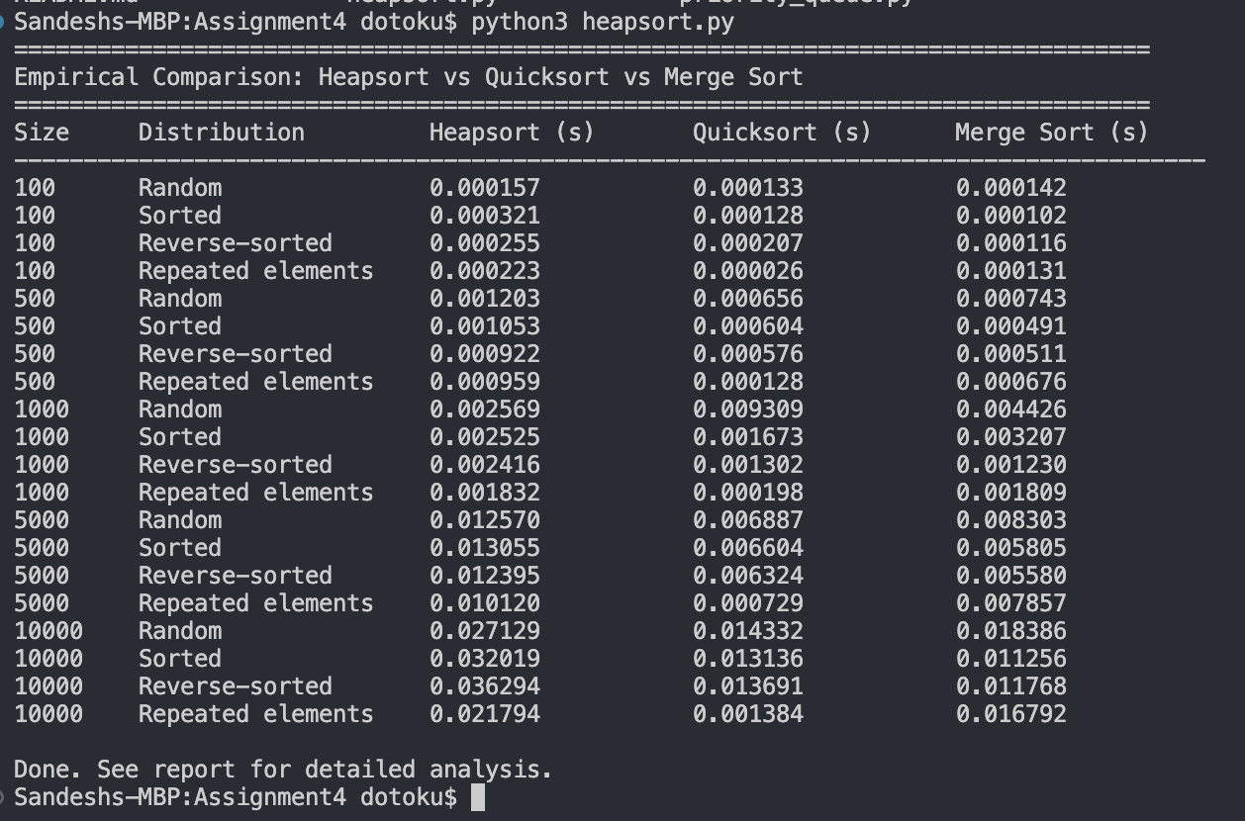

Discussion
The empirical results reveal several interesting patterns that align well with the theoretical analysis.
Heapsort vs. Quicksort: In all examined distributions, Randomized Quicksort consistently outperformed Heapsort, often by a factor of 2 to 3 times on larger input sizes. This result is not surprising; while both algorithms have a time complexity of O(n log n), Quicksort exhibits significantly better cache locality. Quicksort operates on contiguous subarrays, whereas Heapsort frequently jumps between parent and child nodes that may be located farther apart in memory. As Sedgewick and Wayne (2011) noted, this cache behavior is a major reason why Quicksort generally surpasses Heapsort in practice, despite having a worse theoretical worst-case performance. However, it is important to highlight that, unlike deterministic Quicksort, randomized Quicksort avoids the O(n²) worst-case scenario. Therefore, the comparison is between two O(n log n) algorithms that vary in their constant factors.
Heapsort vs. Merge Sort: Merge Sort was typically faster than Heapsort, but slower than Quicksort. It benefits from sequential memory access patterns during the merge step, resulting in decent cache performance. However, Merge Sort requires O(n) additional space, which can be a practical disadvantage for large datasets. In contrast, Heapsort operates in-place, making it more suitable for memory-constrained environments (Cormen et al., 2022, Chapter 6).
Consistency of Heapsort: One notable aspect of the data is Heapsort’s stability in running time across varying input distributions. Whether the input was random, sorted, or reverse-sorted, the execution times remained nearly identical across all sizes. This predictability is a key strength of Heapsort, as it offers a hard O(n log n) guarantee that is unaffected by pathological inputs. This characteristic is crucial in real-time or safety-critical systems, where worst-case guarantees are often more important than average-case performance.

Priority Queue Implementation and Applications

Priority Queue Implementation
1. Data Structure Design
Array-Based Binary Heap: I represent the binary max-heap using a Python list, which maps well onto a contiguous array. For an element at index `i`, its parent is at `⌊(i − 1) / 2⌋`, the left child is at `2i + 1`, and the right child is at `2i + 2` (Cormen et al., 2022). This structure avoids the memory overhead of pointers used in linked trees and improves cache performance during sift operations.
Task Class: Each task contains a unique identifier (`task_id`), priority (integer), arrival time (timestamp), an optional deadline, and a description. Comparison operators based on priority allow the heap to directly order tasks.
Max-Heap Choice: A max-heap is suitable here since it processes the highest-priority task first. The root holds the maximum element, making `extract_max` return the most urgent task. If the scenario required the lowest-priority task first, a min-heap would be better (Cormen et al., 2022).
Index Map: To enhance `increase_key` and `decrease_key` operations, I maintain a dictionary mapping each `task_id` to its current index, allowing O(1) lookups for fast key changes while retaining O(log n) performance.

Core Operations and Time Complexity
insert(task), O(log n): A new task is added to the end of the array in O(1) time and then sifted up, potentially traversing the height of the tree, which is `⌊log₂ n⌋`.
extract_max(), O(log n): The root (maximum) is saved and replaced by the last element. The new root is sifted down, ensuring the heap property, which also takes O(log n).
increase_key(task_id, new_priority), O(log n): The task is located in O(1), the priority is increased, and it is sifted up.
decrease_key(task_id, new_priority), O(log n): Similar to `increase_key`, but it is sifted down after the priority reduction.
is_empty(), O(1): A straightforward check to see if the list is empty.

Scheduler Simulation

The simulation represents realistic system tasks with varying priorities. The scheduler:
1. Inserts all tasks into the priority queue.
2. Performs a priority escalation for a low-priority task, simulating an emergency.
3. Processes tasks in strict priority order.
This priority-based approach is fundamental in operating systems. Heaps are preferred for implementing priority queues due to their balance of efficiency and lower overhead (Levitin, 2012).
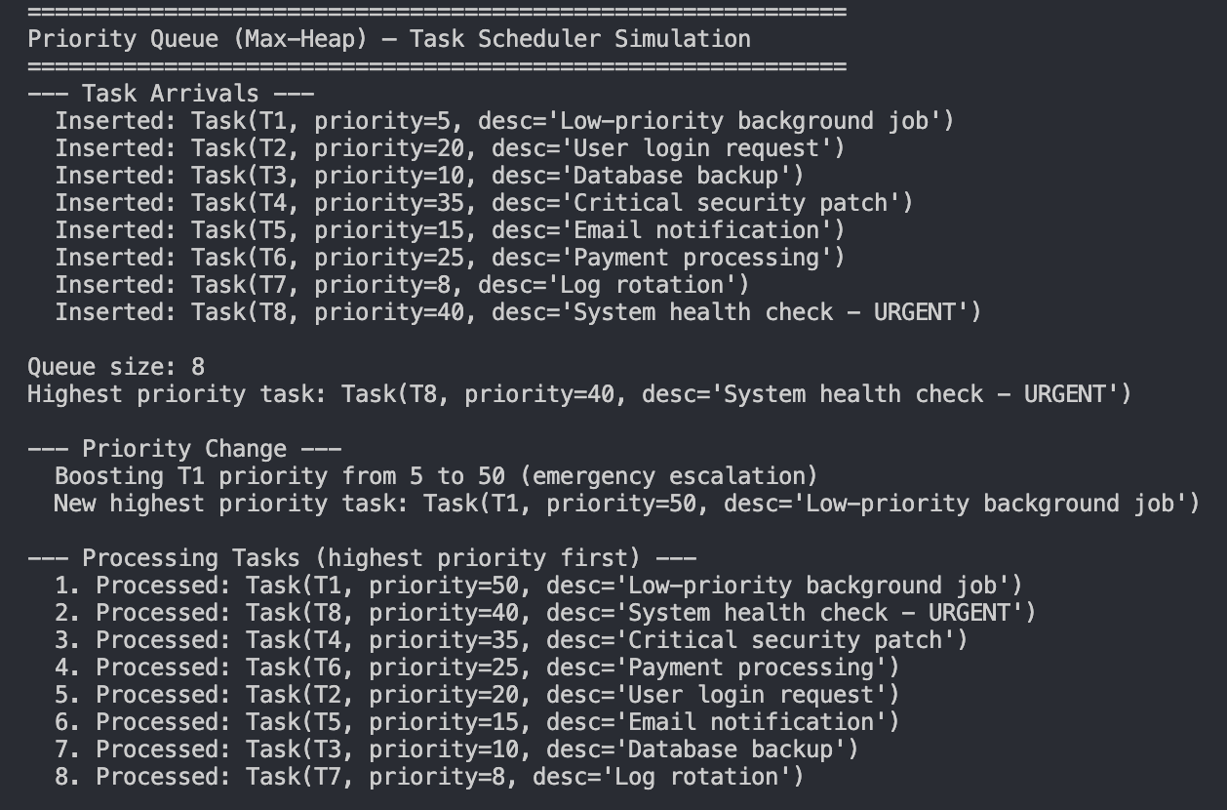

Conclusion

This assignment explored heap data structures theoretically and practically. Heapsort is reliable at O(n log n), though it can be slower than Quicksort due to cache behavior. Its in-place characteristics make it useful in memory-limited situations. The priority queue implementation demonstrates how heaps effectively support dynamic scheduling. The index map optimizes key changes and maintains O(log n) performance. Understanding both the theoretical aspects and practical considerations allows for better tool selection in algorithm design.

References
Cormen, T. H., Leiserson, C. E., Rivest, R. L., & Stein, C. (2022). Introduction to algorithms
(4th ed.). MIT Press.
Levitin, A. (2012). Introduction to the design and analysis of algorithms (3rd ed.). Pearson.
Schaffer, R., & Sedgewick, R. (1993). The analysis of heapsort. Journal of Algorithms.
https://doi.org/10.1006/jagm.1993.1031
Sedgewick, R., & Wayne, K. (2011). Algorithms (4th ed.). Addison-Wesley.
Wegner, L. M. (1993). Bottom-up heapsort, a new variant of heapsort beating, on average,
quicksort (if n is not very small). Theoretical Computer Science, 118(1), 81–98.
https://doi.org/10.1016/0304-3975(93)90364-Yy.

