Sandesh Ghimire
School of Computer Information Sciences, University of the Cumberlands
MSCS630: Algorithm and Data Structures
Dr. Michael Solomon
July 18, 2026

Github: https://github.com/sandeshghimire2020/MSCS-532-Algo/tree/main/Assignment3
Introduction
Sorting and hashing are two of the most extensively studied problems in computer science. Efficient implementations of these operations are fundamental to much of modern software, ranging from database indexing to real-time data processing. This report presents the implementation and analysis of two important algorithms: Randomized Quicksort and Hashing with Chaining. The aim is to examine how algorithmic design choices, particularly the use of randomization, affect both theoretical guarantees and practical performance across different input conditions.
Quicksort, introduced by Hoare in 1962, is one of the most popular comparison-based sorting algorithms due to its strong average-case performance. However, as Cormen et al. (2022) noted in Chapter 7, its worst-case performance heavily depends on the selection of the pivot element. Randomized Quicksort, which selects pivots uniformly at random, is a well-known strategy for mitigating the risk posed by adversarial inputs (Cormen et al., 2022, Section 7.3). On the hashing side, chaining is a classical collision-resolution technique whose expected efficiency is closely linked to the table’s load factor and the quality of the hash function (Cormen et al., 2022, Chapter 11).

Randomized Quicksort Analysis
1. Implementation Details
The implementation includes two variants of quicksort:
Randomized Quicksort: The pivot is randomly selected from the current subarray using Python's `random.randint()`. This method, as noted by Cormen et al. (2022) in Section 7.3, typically yields a balanced partition regardless of the input distribution.
Deterministic Quicksort: This version uses the first element of the subarray as the pivot. While straightforward, it can perform poorly on sorted or nearly sorted inputs (Cormen et al., 2022, Section 7.2).
Both implementations employ three-way partitioning to categorize elements as less than, equal to, or greater than the pivot, which efficiently handles arrays with many duplicates. Edge cases like empty or single-element arrays are covered in the recursion's base case.

2. Average-Case Time Complexity Analysis
The average-case running time of Randomized Quicksort can be analyzed using indicator random variables, following the approach presented in Section 7.4 of Cormen et al. (2022). Let the input array have n elements. For a given pair of elements z_i and z_j (where i < j in the sorted order), define the indicator random variable X_ij that equals 1 if z_i and z_j are compared during the execution of the algorithm, and 0 otherwise.

The total number of comparisons is:
T(n) = Σ Σ X_ij (for all i < j)
Two elements z_i and z_j are compared if and only if one of them is the first element from the set {z_i, z_{i+1}, ..., z_j} to be chosen as a pivot. Since the pivot is chosen uniformly at random, the probability that either z_i or z_j is picked first from this set of (j − i + 1) elements is:
Pr[X_ij = 1] = 2 / (j − i + 1)
Taking the expectation:
E[T(n)] = Σ_{i=1}^{n-1} Σ_{j=i+1}^{n} 2 / (j − i + 1)
Substituting k = j − i:
E[T(n)] = Σ_{i=1}^{n-1} Σ_{k=1}^{n-i} 2 / (k + 1)
This inner sum is bounded by the harmonic series H_n, which is O(log n). Summing over all i gives:
E[T(n)] = O(n log n)
This result holds regardless of the input distribution because the randomness comes from the algorithm itself, not the input (Cormen et al., 2022, Section 7.3). In contrast, Deterministic Quicksort with a fixed pivot strategy has a worst-case of O(n²) when the input is already sorted or reverse-sorted, because every partition produces one empty subarray and one subarray of size n − 1 (Cormen et al., 2022, Section 7.2).

3. Empirical Comparison
The empirical comparison was conducted by running both algorithms on arrays of sizes 100, 500, 1,000, 5,000, and 10,000, across four input distributions:
Randomly generated arrays: elements chosen uniformly at random.
Already sorted arrays: elements in ascending order.
Reverse-sorted arrays: elements in descending order.
Arrays with repeated elements: elements drawn from a small set of values.
Each measurement was averaged over three independent trials to reduce variance.

Observed Results
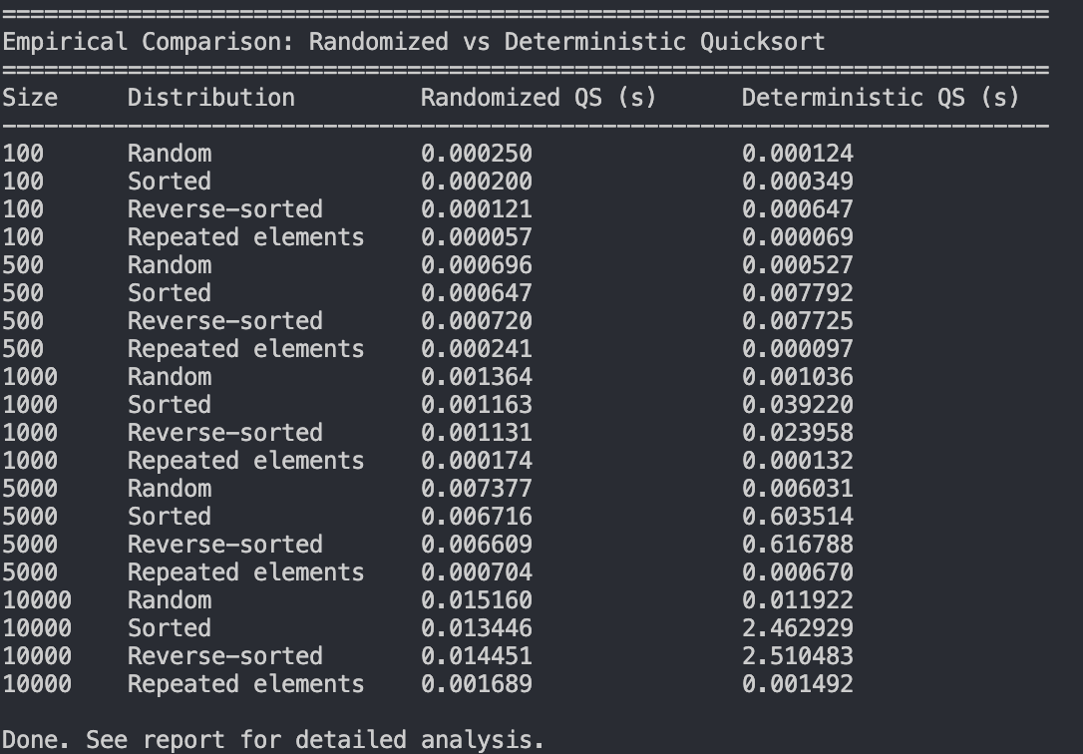
Discussion
The empirical results align with theoretical expectations. Both algorithms perform similarly on randomly generated arrays with repeated elements, as selecting the first element as the pivot typically yields reasonable partitions. However, the Deterministic Quicksort struggles significantly with sorted and reverse-sorted arrays that have the first element as either the minimum or the maximum. This results in one partition of size 0 and another of size \( n - 1 \), leading to a recursion depth of \( n \) and \( O(n^2) \) comparisons (Sedgewick & Wayne, 2011).
Randomized Quicksort, in contrast, consistently achieves O(n log n) performance regardless of the input distribution. By selecting a random pivot, the algorithm effectively "shuffles" its behavior, making it less dependent on the order of the input. This is a significant advantage of randomized algorithms: they offer strong expected-case performance guarantees without requiring any assumptions about the input (Motwani & Raghavan, 1995).
One minor point to note is that the overhead associated with random number generation in Randomized Quicksort can make it slightly slower than Deterministic Quicksort for small, randomly ordered inputs. This overhead is constant across recursive calls, but it becomes negligible as the input size increases.

Hashing with Chaining
1. Implementation Details
The hash table is implemented using chaining, where each slot in the underlying array contains a list (chain) of key-value pairs that hash to that slot. The implementation includes:
Universal hash function: The hash function is drawn from the Carter-Wegman universal hash family (Carter & Wegman, 1979), as recommended by Cormen et al. (2022, Section 11.3.3). It is defined as h(k) = ((a · k + b) mod p) mod m, where p is a large prime, a and b are randomly chosen constants (with a ≠ 0), and m is the table capacity. This family guarantees that for any two distinct keys, the probability of collision is at most 1/m.
Dynamic resizing: When the load factor exceeds 0.75, the table's capacity doubles, and all entries are rehashed. Conversely, if the load factor falls below 0.2 after deletions, the table shrinks by half. This approach maintains a bounded load factor and ensures that the average length of chains remains short.

Operations:
Insert: Computes the hash, traverses the chain at that index to check for an existing key (and updates if found), otherwise appends the new pair.
Search: Computes the hash and traverses the chain at the corresponding index.
Delete: Computes the hash, finds the key in the chain, removes it, and potentially triggers a resize.
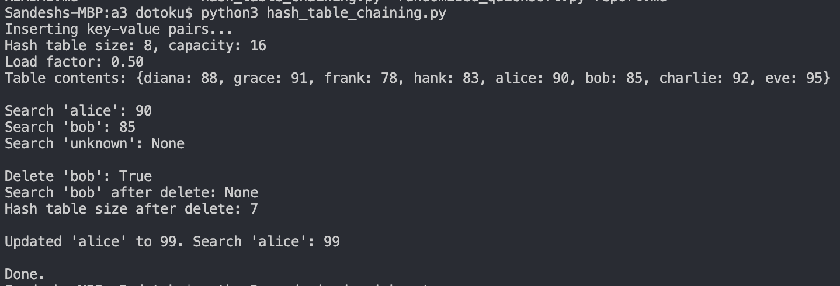
2. Analysis of Expected Operation Times
Assuming simple uniform hashing, where each key is equally likely to be placed in any of the m slots independently of other keys, the expected performance of operations depends on the load factor α = n/m, with n as the number of stored elements and m as the number of slots. This analysis is based on Theorems 11.1 and 11.2 from Cormen et al. (2022, Section 11.2).

Search (unsuccessful): The expected time is Θ(1 + α). The algorithm computes the hash in O(1) and then traverses a chain of expected length α.
Search (successful): The expected time is Θ(1 + α/2), since, on average, the target key is found halfway through the chain. This simplifies to Θ(1 + α).
In the worst case, the algorithm must first search the chain to detect duplicates, taking Θ(1 + α). If no duplicate is found, appending to the chain takes O(1). So the expected time is Θ(1 + α).
Similar to search, the algorithm must find the key in the chain in Θ(1 + α) and then remove it in O(1).
When the load factor is maintained at a bounded level (e.g., α ≤ 0.75 through dynamic resizing), all operations are expected to run in O(1) amortized time. Although the resizing operation itself requires O(n) time, the fact that the table size doubles each time keeps the amortized cost per insertion at O(1). This is consistent with the standard amortized analysis discussed in Cormen et al. (2022, Chapter 16).

3. Load Factor and Collision Strategies
The load factor (α) is the most crucial parameter affecting a hash table's performance. A high load factor leads to longer chains and slower operations, while a low load factor can waste memory. The standard practice is to maintain a load factor below a threshold, usually 0.75, and to resize the hash table when that threshold is exceeded.
Strategies for maintaining good performance include:
Dynamic resizing: Doubling the table size when α exceeds the threshold ensures that the amortized cost of insertions remains O(1). Similarly, halving the table size when α drops too low after many deletions helps reclaim unused memory.
Good hash functions: Using a universal hash function family guarantee that the probability of two keys colliding is at most 1/m, regardless of how the keys are distributed. This assurance provides a worst-case expectation for the chain length, even under adversarial conditions (Carter & Wegman, 1979).
Rehashing: When resizing a hash table, all keys are rehashed according to the current hash function parameters. This process redistributes the entries evenly across the new table.
These strategies work together to ensure that the hash table performs operations in near-constant time, which aligns with the theoretical time complexity of O(1 + α).

Conclusion
This assignment examined how randomization affects algorithm performance through two case studies. The first focused on Randomized Quicksort, which uses a random pivot selection to avoid the worst-case behavior of deterministic strategies, achieving O(n log n) performance regardless of input order. Empirical benchmarks showed that while Deterministic Quicksort struggled with sorted inputs, Randomized Quicksort remained efficient.
The second case study on hashing with chaining revealed that expected operation times depend on the load factor. By using a universal hash function with dynamic resizing, the implementation achieves amortized O(1) time for core operations. Overall, these findings emphasize that randomization and adaptive data structures are essential for effective algorithm design in diverse and unpredictable contexts.

References
Carter, J. L., & Wegman, M. N. (1979). Universal classes of hash functions. Journal of
Computer and System Sciences, 18(2. https://doi.org/10.1016/0022- 0000(79)90044-8
Cormen, T. H., Leiserson, C. E., Rivest, R. L., & Stein, C. (2022). Introduction to algorithms
(4th ed.). MIT Press.
Hoare, C. A. R. (1962). Quicksort. The Computer Journal, https://doi.org/10.1093/comjnl/5.1.10
Motwani, R., & Raghavan, P. (1995). Randomized algorithms. Cambridge University Press.
Sedgewick, R., & Wayne, K. (2011). Algorithms (4th ed.). Addison-Wesley.

