WEEK 2 - SOFTWARE ARCHITECTURE DESIGN AND DOCUMENTATION
Junior Software Developer - Agribusiness Solution
Proposed Solution: FarmBridge - Digital Agribusiness Management Platform
Prepared by: Sandesh Gorde | Date: 9 October 2026 | Builds on the Week 1 report (27 September 2026) | Repository: github.com/sandeshgorde/agribusiness-solution

1. Purpose and How Week 1 Feedback Was Addressed
Week 1 defined what FarmBridge must do. This report defines how it will be built: the architecture, the components and their interfaces, the data flows, the technology choices and the integration and security approach. It follows the Week 1 requirements (FR-01 to FR-12) and the Week 1 stack decision (Java + Spring Boot, PostgreSQL, React).
Week 1 scored 62.3/100. The evaluator's feedback was that the report was comprehensive but lacked specific data and worked examples to support some claims, and that required sections should be fully developed with concrete evidence. This report is written to fix exactly that. Every design claim below is backed by a number, a schema, a payload or a traced example, and every estimate is labelled as an assumption (A1 to A6) so it can be challenged.
Week 1 feedback | What Week 2 does about it | Where
Lacks specific data | Sizing from explicit assumptions (460 users, about 3,500 requests/day, about 125k rows/year); a millisecond latency budget; a weighted scoring matrix for the backend choice. | Sections 2, 9, 12
Lacks worked examples | One end-to-end tomato trade (Order #1001, Rs 7,200) traced through every layer, plus a two-buyer stock race with the exact SQL and the exact HTTP responses. | Sections 5, 7, 8
Sections not fully developed | Each module has inputs, outputs, dependencies and failure behaviour. Key tables are given as real DDL with constraints and indexes. | Sections 4, 6
Needs concrete evidence | A traceability table maps every Week 1 requirement FR-01 to FR-12 to a module, an endpoint and a table. The security section lists each threat with its control and how it will be tested. | Sections 4.3, 11

2. Requirements Recap and System Sizing

2.1 Scope carried over from Week 1
The P0 and P1 scope is unchanged: authentication and role-based access, farmer/FPO/buyer profiles, crop and lot records, buyer requirements, offers and orders, then dashboard, audit log, notifications and basic market prices. Logistics is designed now so that the data model does not need to change later, but it is built after the core trade flow works. One deliberate change from Week 1: the order lifecycle drops the Draft state (offers are created directly as Offered, so Draft had no use case) and adds an Expired state for offers that pass their validity time (Section 7).

2.2 Sizing assumptions
The architecture is sized for a single-district pilot, not for national scale. The numbers below are my assumptions, chosen to be realistic and to be verified with pilot users; they are not measurements.
ID | Assumption | Value | Derived result
A1 | Pilot users (one district, e.g. Amravati) | 400 farmers/FPO members + 40 buyers + 15 transporters + 5 admins | 460 registered users
A2 | Daily active share of users | 30% | 460 x 0.30 = about 140 daily active users
A3 | API calls per active user per day | 25 | 140 x 25 = 3,500 calls/day
A4 | Peak hour carries 20% of daily traffic | 3,500 x 0.20 | 700 calls/hour = about 0.2 requests/s; burst target 10x = 2 req/s
A5 | Stress-test target (worst case) | 50 concurrent users, 1 call per 5 s each | 10 requests/s
A6 | Data growth per year | 1,600 lots/month, 300 orders/month, about 10 audit rows per order, 6 notifications per order | Lots 19,200 + orders 3,600 + offers 5,400 + notifications 21,600 + audit about 74,400 = about 125,000 rows/year, roughly 125 MB at about 1 KB/row

What this means for the design. Even the stress target (10 req/s) is a small load, and one year of data is about 0.1 GB. So the MVP needs one application instance and one PostgreSQL instance on a 2 vCPU / 4 GB virtual machine. It does not need sharding, a cache layer, a message broker or microservices. These would add cost and failure modes without solving a problem the pilot has. Section 12 defines the load test that will confirm this in Week 4.

2.3 Measurable quality targets
Quality attribute | Target | How it will be verified
Response time | p95 at or below 2 s at 50 concurrent users | k6 load test, 10 minutes (Section 12)
Error rate | Below 1% of requests under the same load | k6 thresholds
Availability | 99% per month = at most 7.2 h downtime (720 h x 1%) | Health-check uptime log
Stock integrity | available_qty_kg is never negative | Database CHECK constraint + 20-thread concurrency test (Section 7.3)
Recovery | RPO 24 h (nightly backup), RTO 4 h | One restore drill from backup before demo
Security | Every protected endpoint rejects the wrong role | Automated test per endpoint x role (Section 11)

3. Overall Software Architecture

3.1 Architectural style: modular monolith
FarmBridge is a modular monolith: one Spring Boot application, deployed as one unit, internally split into modules with strict boundaries, backed by one PostgreSQL database. Figure 1 (next page) shows the tiers. The decision rests on two facts from Section 2 and one from the workflow:
- Load is small. At most 10 req/s and 125 MB/year (A5, A6), so there is no scaling pressure that would justify distribution.
- Team size is one. A microservice split into auth, user, inventory, trading, logistics and notification means about 6 deployables plus a gateway and a message broker, which is 8 or more things to build, deploy and monitor.
- The core action must be atomic. Accepting an offer must (a) reduce lot stock, (b) create the order and (c) write the audit row, all or nothing. In one database this is a single ACID transaction. Across services it would need a saga with compensating actions, which is much more complex and easier to get wrong.
Option | Deployables | Accept-offer atomicity | Ops effort (solo) | Verdict
Single-layer monolith | 1 app + 1 DB | Simple ACID transaction | Low | Works, but modules blur into each other
Modular monolith (chosen) | 1 app + 1 DB | Simple ACID transaction | Low | Chosen. Boundaries without distribution cost
Microservices | About 6 services + gateway + broker (8 or more) | Saga + compensation needed | High | Rejected: cost far above benefit at this size

3.2 Client-server interaction: life of one request
Every call in the system follows the same seven steps, which is what keeps the design consistent and testable:
- The React app sends an HTTPS request with the header Authorization: Bearer <JWT>.
- Nginx terminates TLS and applies the rate limit (100 requests/minute per IP).
- A Spring Security filter validates the JWT signature and expiry and extracts the user id and role.
- The controller maps the JSON to a DTO and runs Bean Validation (types, ranges, required fields). Invalid input returns 422 before any business logic runs.
- The service runs the business rule inside a @Transactional method, including ownership checks (for example, only the offer's requirement owner may accept it).
- The repository reads and writes PostgreSQL. The audit row is inserted in the same transaction.
- The controller returns JSON. After the transaction commits, notifications are dispatched asynchronously, so a notification failure can never roll back an order.

Figure 1 - System architecture (tiers, modules and external integrations)
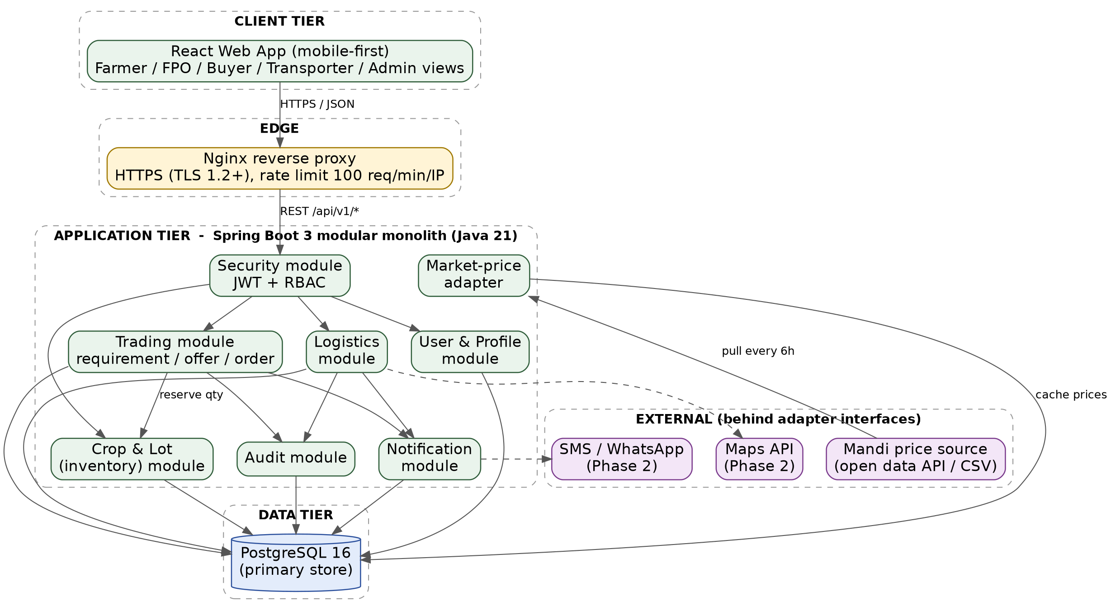
Solid arrows are MVP calls. Dashed arrows are Phase 2 integrations. Every external system sits behind an adapter interface inside the application tier.

4. Component Design

4.1 Component interaction
Figure 2 shows how a request travels from the UI through controllers, services and repositories. Two rules keep the modules separate: (1) a controller only calls its own module's service; (2) a module reads another module's data only through that module's service interface, never through its repository. The Crop & Lot module is the only code allowed to change available_qty_kg, so stock rules live in exactly one place. A planned ArchUnit test fails the build if either rule is broken.
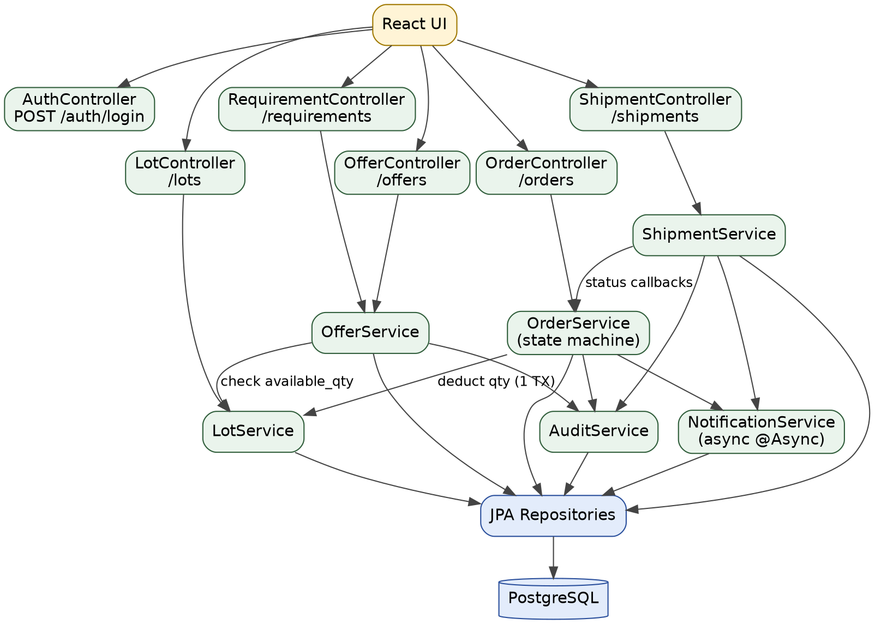
Figure 2 - Component interaction chart (the label on an arrow says what is exchanged)

4.2 Module definitions
Module | Responsibility | Inputs | Outputs | Depends on | Failure behaviour
Security | Authenticate users, issue and validate JWTs, enforce roles on every endpoint | Phone + password; Bearer token | Access + refresh token; 401/403 | User | Account locked for 15 min after 5 failed logins. Invalid token gives 401, never partial access
User & Profile | Registration, profile, farm records, admin verification | Register DTO; admin verify command | User and Farm records | Security | Duplicate phone gives 409. Unverified users may browse but cannot submit offers or accept orders
Crop & Lot | Crops, produce lots, available quantity (sole owner of stock changes) | Create lot; reserve(qty); release(qty) | Lot views; stock events | User | Reserve above available quantity throws OutOfStock, returned as 409
Trading | Requirements, offers, and the order state machine | Requirement and offer DTOs; accept / confirm / cancel | Orders; state changes; domain events | Crop & Lot, User | Illegal transition gives 409 INVALID_TRANSITION. Expired offer gives 410
Logistics | Shipments and delivery status | Create shipment; status update | Shipment rows; events | Trading | Only the assigned transporter can update. Out-of-order status is rejected
Notification | In-app notifications now; SMS/WhatsApp later via an outbox | Domain events (after commit) | Notification rows | Trading, Logistics (events only) | Runs asynchronously. Failure never rolls back the order. Up to 5 retries
Audit | Append-only history of critical actions | Domain events | audit_log rows with old and new values | None | Written in the same transaction. If the audit insert fails, the business change fails too
Market-price adapter | Pull mandi prices and cache them behind a MarketPriceProvider interface | Scheduled pull every 6 h | market_price rows with source and fetched_at | External price source | On failure keep last data; flag as stale after 24 h

4.3 Traceability: Week 1 requirements to design
Req. | Requirement (short) | Module | Main endpoint(s) | Tables
FR-01 | Register and select a role | Security, User | POST /auth/register | users
FR-02 | Login, logout, role-based access | Security | POST /auth/login, /auth/refresh | users
FR-03 | Crop and harvest records | Crop & Lot | POST/GET /crops | farm, crop
FR-04 | Produce lots with quantity and grade | Crop & Lot | POST/GET /lots | produce_lot
FR-05 | Market info with source and time | Market adapter | GET /market-prices | market_price
FR-06 | Buyer requirements | Trading | POST/GET /requirements | buyer_requirement
FR-07 | Offers on requirements | Trading | POST /requirements/{id}/offers | offer
FR-08 | Order lifecycle | Trading | POST /offers/{id}/accept, /orders/{id}/confirm|cancel|complete | orders
FR-09 | Notifications on status changes | Notification | GET /notifications | notification
FR-10 | Admin verification and support | User | PATCH /admin/users/{id}/verify | users
FR-11 | Audit log of critical actions | Audit | GET /admin/audit | audit_log
FR-12 | Dashboards | Trading, Crop & Lot (read side) | GET /dashboard/summary | orders, produce_lot

5. Data Flow: One Complete Trade, Step by Step
All names and prices below are illustrative data. A farmer, Ramesh, in Amravati has 500 kg of Grade A tomatoes. A wholesaler in Nagpur needs 400 kg. Figure 3 gives the flow; the table shows what happens inside the system at each step.
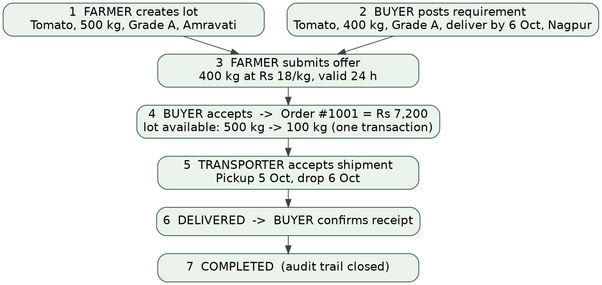
Figure 3 - Data flow for Order #1001
Step | API call | What changes in the database | Audit / notification
1. Create lot | POST /lots | INSERT produce_lot: total 500.00 kg, available 500.00 kg, grade A, status AVAILABLE | Audit LOT_CREATED
2. Post requirement | POST /requirements | INSERT buyer_requirement: Tomato, A, 400 kg, deliver by 6 Oct, Nagpur | None
3. Submit offer | POST /requirements/45/offers | Check 400 kg is at most the 500 kg available. INSERT offer: 400 kg at Rs 18.00/kg, valid 24 h, status OFFERED. Stock is not reserved yet | Notify buyer
4. Accept offer | POST /offers/88/accept | One transaction: UPDATE produce_lot available 500 to 100; INSERT orders total 400 x 18.00 = Rs 7,200.00; UPDATE offer to ACCEPTED | Audit OFFER_ACCEPTED + ORDER_CREATED; notify farmer
5. Shipment | POST /orders/1001/shipments, then PATCH /shipments/{id}/status | INSERT shipment (Amravati to Nagpur, pickup 5 Oct); status PICKED_UP then IN_TRANSIT; order becomes DISPATCHED | Audit + notify buyer
6. Delivery | PATCH /shipments/{id}/status, then POST /orders/1001/complete | Shipment DELIVERED; order DELIVERED; buyer confirms; order COMPLETED | Audit ORDER_COMPLETED; notify both

Check on the numbers: 400 kg x Rs 18.00 = Rs 7,200.00, and 500 kg - 400 kg = 100 kg left available for the next buyer. The remaining 100 kg stays visible in lot listings, which is the inventory visibility Week 1 identified as part of reducing post-harvest loss.

6. Data Model
The model is in third normal form with a few deliberate choices, shown in Figure 4 (next page). Money and quantities use NUMERIC, never floating point, because binary floating point cannot store values such as 0.1 exactly, and an order total must be exact. The orders table stores total_amount even though it could be recomputed, so the amount agreed at acceptance stays fixed as a record. The figure shows the 10 core entities; market_price (commodity, market, price, unit, source, fetched_at) and notification are omitted for readability.

6.1 Key tables as DDL
CREATE TABLE produce_lot (
id BIGSERIAL PRIMARY KEY,
crop_id BIGINT NOT NULL REFERENCES crop(id),
grade CHAR(1) NOT NULL CHECK (grade IN ('A','B','C')),
total_qty_kg NUMERIC(10,2) NOT NULL CHECK (total_qty_kg > 0),
available_qty_kg NUMERIC(10,2) NOT NULL
CHECK (available_qty_kg >= 0 AND available_qty_kg <= total_qty_kg),
status VARCHAR(12) NOT NULL DEFAULT 'AVAILABLE',
version INT NOT NULL DEFAULT 0, -- optimistic lock
created_at TIMESTAMPTZ NOT NULL DEFAULT now()
);

CREATE TABLE offer (
id BIGSERIAL PRIMARY KEY,
requirement_id BIGINT NOT NULL REFERENCES buyer_requirement(id),
lot_id BIGINT NOT NULL REFERENCES produce_lot(id),
qty_kg NUMERIC(10,2) NOT NULL CHECK (qty_kg > 0),
price_per_kg NUMERIC(8,2) NOT NULL CHECK (price_per_kg > 0),
valid_until TIMESTAMPTZ NOT NULL,
status VARCHAR(12) NOT NULL DEFAULT 'OFFERED'
);

CREATE TABLE orders (
id BIGSERIAL PRIMARY KEY,
offer_id BIGINT NOT NULL UNIQUE REFERENCES offer(id), -- 1 offer = 1 order
total_amount NUMERIC(12,2) NOT NULL CHECK (total_amount > 0),
status VARCHAR(12) NOT NULL,
payment_status VARCHAR(8) NOT NULL DEFAULT 'UNPAID', -- manual flag in MVP
created_at TIMESTAMPTZ NOT NULL DEFAULT now()
);

The CHECK on available_qty_kg is the last line of defence: even if application code had a bug, PostgreSQL itself refuses to let stock go negative.

6.2 Indexes and the query each one serves
Index | Query it serves | Why it is needed
users(phone) UNIQUE | Login lookup; duplicate-phone check | Runs on every login; uniqueness is a business rule
produce_lot(status, crop_id) | Buyer browsing available lots | Most-used list; without the index it scans all lots (about 19,200 after a year per A6)
buyer_requirement(commodity, status, deliver_by) | Farmer browsing open requirements for a crop | Filters on all three columns together
offer(requirement_id, status) | Show offers for a requirement | Foreign-key lookups are not indexed automatically in PostgreSQL
orders(status, created_at) | Dashboards: open orders, recent completions | Dashboard is the heaviest read
audit_log(entity, entity_id, created_at) | Full history of one order or lot | Audit grows fastest (about 74,400 rows/year)

Figure 4 - Entity-relationship diagram (core entities)
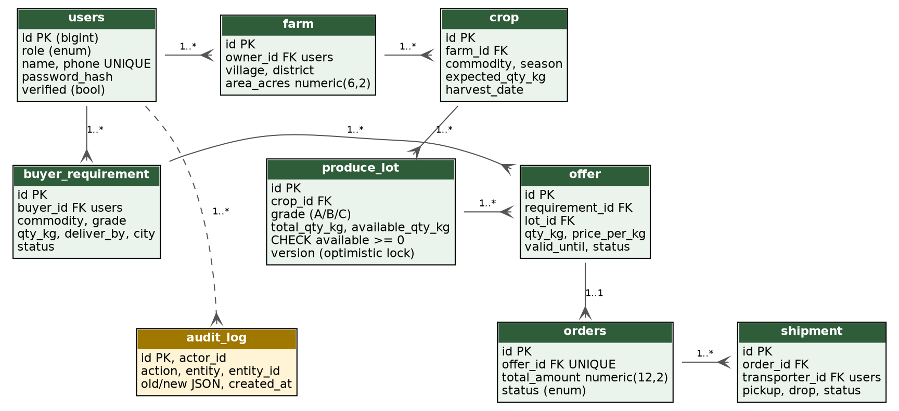
PK = primary key, FK = foreign key. Crow-foot ends mean "many". An offer produces at most one order (offer_id is UNIQUE in orders).

7. Order Lifecycle and Concurrency

7.1 State machine
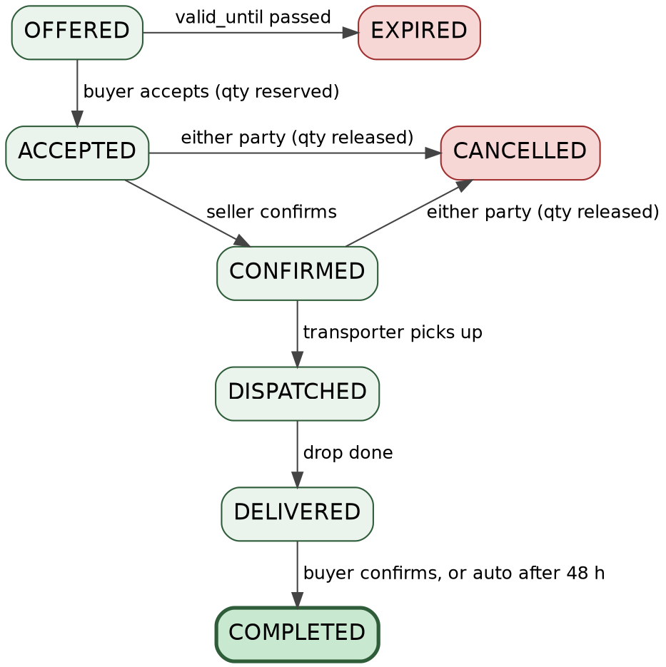
Figure 5 - Order and offer lifecycle

7.2 Allowed transitions
Any transition not in this table is rejected with HTTP 409 INVALID_TRANSITION. The rule is enforced in one place (the Trading service), not in the UI.
From | To | Who | Guard condition | Side effects
OFFERED | ACCEPTED | Buyer who owns the requirement | now is at most valid_until AND lot available is at least offer qty | Reserve stock; create order
OFFERED | EXPIRED | System (scheduled job, every 5 min) | now is after valid_until | None; notify seller
ACCEPTED | CONFIRMED | Seller | Seller is verified | Notify buyer
ACCEPTED or CONFIRMED | CANCELLED | Buyer or seller (admin override) | No shipment picked up yet | Release stock (add quantity back)
CONFIRMED | DISPATCHED | Assigned transporter | Shipment picked up | Notify buyer
DISPATCHED | DELIVERED | Assigned transporter | Drop recorded | Notify buyer
DELIVERED | COMPLETED | Buyer, or system after 48 h | Buyer confirms or 48 h passed without a dispute | Order closed in the audit trail

After DISPATCHED an order cannot be cancelled by the parties; a problem goes to an admin as a dispute. This protects the seller once goods are on the road.

7.3 Worked example: two buyers, one lot
Lot #7 has 100 kg available at version 3. Buyer A accepts an offer for 80 kg and Buyer B accepts an offer for 60 kg at the same instant. Together they want 140 kg, but only 100 kg exists. The accept step runs this guarded update:
UPDATE produce_lot
SET available_qty_kg = available_qty_kg - :qty,
version = version + 1
WHERE id = 7
AND version = 3 -- nobody else changed it
AND available_qty_kg >= :qty; -- enough stock left

Request | Rows updated | Result
Buyer A, 80 kg (arrives first) | 1 | available 100 to 20, version 3 to 4. Order created. HTTP 201
Buyer B, 60 kg (arrives second) | 0 (version is now 4, and 20 is less than 60) | Service throws OutOfStock. Transaction rolls back, so no order row exists. HTTP 409 LOT_QTY_CHANGED
Final state |  | available = 20 kg, never negative; exactly one order

Acceptance test (planned for Weeks 3-4): 20 threads each try to accept an offer for 10 kg from a 100 kg lot. Pass condition: exactly 10 succeed, exactly 10 receive 409, the final available quantity is 0, and no order total is created for stock that did not exist.

8. Interface Specifications

8.1 Conventions
- Base path /api/v1, JSON bodies, timestamps in UTC ISO-8601, money as decimal numbers in rupees.
- Lists are paginated with page (from 0) and size (default 20, maximum 50).
- Status codes: 201 created, 200 ok, 401 not logged in, 403 wrong role or not the owner, 409 conflict or illegal state, 410 offer expired, 422 validation failed, 429 rate limited.
- Every error uses one format: timestamp, status, code, message, path.

8.2 Endpoint catalogue
Method | Path | Allowed roles | Purpose | Success / main errors
POST | /auth/register | Public | Register as farmer, FPO, buyer or transporter | 201 / 409, 422
POST | /auth/login | Public | Get access and refresh tokens | 200 / 401, 429
POST | /auth/refresh | Refresh token | Rotate tokens | 200 / 401
GET | /me | Any | Own profile | 200
POST | /crops | Farmer, FPO | Record a crop and expected harvest | 201 / 422
POST | /lots | Farmer, FPO | Create a produce lot | 201 / 403, 422
GET | /lots?commodity=&grade=&district= | Any logged in | Browse available lots | 200
POST | /requirements | Buyer | Post a buyer requirement | 201 / 422
GET | /requirements?commodity= | Farmer, FPO | Browse open requirements | 200
POST | /requirements/{id}/offers | Farmer, FPO (verified) | Submit an offer | 201 / 409 qty above available
POST | /offers/{id}/accept | Buyer (owner) | Accept offer, creating the order | 201 / 409, 410
POST | /orders/{id}/confirm | Seller | Confirm the order | 200 / 409
POST | /orders/{id}/cancel | Buyer, seller | Cancel and release stock | 200 / 409
POST | /orders/{id}/shipments | Seller | Create a transport request | 201
PATCH | /shipments/{id}/status | Assigned transporter | Update pickup / transit / delivered | 200 / 403, 409
POST | /orders/{id}/complete | Buyer | Confirm receipt | 200 / 409
GET | /market-prices | Any logged in | Latest prices with source and time | 200
GET | /dashboard/summary | Any logged in | Role-specific counts and totals | 200
GET | /notifications | Any logged in | Own notifications | 200
PATCH | /admin/users/{id}/verify | Admin | Verify a user | 200
GET | /admin/audit?entity=&entityId= | Admin | History of one record | 200

8.3 Example payloads (the Order #1001 trade)
Step 1 - create the lot. POST /api/v1/lots
// request
{ "cropId": 12, "grade": "A", "totalQtyKg": 500.00 }
// response 201
{ "id": 7, "cropId": 12, "commodity": "Tomato", "grade": "A",
"totalQtyKg": 500.00, "availableQtyKg": 500.00,
"status": "AVAILABLE", "version": 0 }

Step 3 - submit the offer. POST /api/v1/requirements/45/offers
// request
{ "lotId": 7, "qtyKg": 400.00, "pricePerKg": 18.00, "validHours": 24 }
// response 201
{ "id": 88, "requirementId": 45, "lotId": 7, "qtyKg": 400.00,
"pricePerKg": 18.00, "status": "OFFERED",
"validUntil": "2026-10-04T10:30:00Z" }

Step 4 - accept the offer. POST /api/v1/offers/88/accept. There is no request body: the client sends only the offer id, and the server computes the total itself, so the buyer cannot tamper with the price.
// response 201
{ "orderId": 1001, "offerId": 88, "totalAmount": 7200.00,
"status": "ACCEPTED", "lotAvailableQtyKg": 100.00 }

Failure case - the lost race from Section 7.3. POST /api/v1/offers/91/accept by Buyer B
// response 409
{ "timestamp": "2026-10-03T09:15:42Z", "status": 409,
"code": "LOT_QTY_CHANGED",
"message": "Requested 60.00 kg but only 20.00 kg is available.",
"path": "/api/v1/offers/91/accept" }

9. Technology Choices and Justification
Each choice is judged against the sizing in Section 2 and my situation as a solo junior developer targeting a Java backend role. Where a choice has a real cost, the cost is stated.
Layer | Chosen | Alternatives | Pros | Cons / trade-off
Backend | Java 21 + Spring Boot 3 | Django, Node/Express | Strong typing; mature @Transactional support; Spring Security for JWT and RBAC; matches my career goal; widely used in industry | Higher memory and slower startup than Node or Python (to be measured in Week 4); more boilerplate; steeper learning curve
Database | PostgreSQL 16 | MySQL, MongoDB | Full ACID transactions; CHECK constraints protect stock; NUMERIC for money; JSONB available for audit old/new values | Needs a little more setup than a file database; one node is a single point of failure (accepted for MVP)
Frontend | React (mobile-first) | Vue, server-rendered Thymeleaf | Large ecosystem; reusable components; easy to later share the API with a mobile app | Separate build step; I must learn state management; extra care for slow networks
API style | REST + JSON | GraphQL, gRPC | Simple; easy to test with curl and Postman; maps cleanly to the resources and states | Some over-fetching; no built-in schema (mitigated with an OpenAPI document)
Authentication | JWT (15 min) + refresh token (7 days) | Server sessions | Stateless, so the app can be restarted without logging everyone out; works for a future mobile client | Tokens cannot be revoked instantly (so access tokens are kept short and refresh tokens are stored hashed)
Packaging | Docker Compose | Manual install, Kubernetes | Same environment on my laptop and the server; one command to start 3 containers | Kubernetes would be over-engineering at 460 users

9.1 Weighted comparison for the backend
Scores are 1 (poor) to 5 (excellent). The weights and scores are my judgement, so the first criterion in particular is subjective and is shown openly. Even if that weight were reduced to zero and redistributed, Spring Boot would still lead on the transaction and security criteria.
Criterion | Weight | Spring Boot (Java) | Django (Python) | Node + Express
Fit with my Java-backend career goal | 30% | 5 | 2 | 2
Strong transactions / type safety | 25% | 5 | 4 | 3
Built-in security ecosystem | 20% | 5 | 4 | 3
Learning curve for me | 15% | 3 | 4 | 4
Hosting footprint (RAM/startup) | 10% | 2 | 3 | 4
Weighted total (max 5.00) | 100% | 4.40 | 3.30 | 2.95

Arithmetic for the chosen option: 5 x 0.30 + 5 x 0.25 + 5 x 0.20 + 3 x 0.15 + 2 x 0.10 = 1.50 + 1.25 + 1.00 + 0.45 + 0.20 = 4.40.

10. Integration Strategy

10.1 Internal integration
Modules talk through service interfaces and Spring application events. When an order is accepted, the Trading module publishes an OrderAccepted event. The Audit listener runs inside the same transaction, while the Notification listener runs after commit (@TransactionalEventListener with AFTER_COMMIT) and asynchronously. This is why a failed notification can never undo an order, but a failed audit write does.

10.2 External integration
Every external system is reached through an interface (a port) with one implementation (an adapter), so a provider can be replaced or switched off without touching business code.
Integration | Pattern | Phase | Failure handling
Mandi price data (open-data price feeds, for example the Agmarknet mandi dataset on data.gov.in; terms and API availability must be verified before use) | MarketPriceProvider interface; scheduled pull every 6 h; result cached in market_price with source and fetched_at | MVP (P1) | Timeouts 5 s connect / 10 s read; 3 retries at 1 s, 2 s, 4 s; on failure keep the last data and show "may be outdated" once older than 24 h; fallback is a manual CSV import by an admin
SMS / WhatsApp notifications | Outbox table: notification rows go PENDING to SENT; a worker polls every 30 s | Phase 2 | Up to 5 attempts, then FAILED and visible to admin; in-app notification always works regardless
Maps and distance | DistanceService interface | Phase 2 | Fallback to straight-line (Haversine) distance estimate
Payments | Out of scope; payment_status is a manual flag | Future (P3) | Not applicable in MVP

11. Security Considerations

11.1 Authentication and session handling
- Passwords hashed with BCrypt (cost factor 12); plain text is never stored or logged.
- JWT access token valid 15 minutes; refresh token valid 7 days, stored hashed and rotated on every use. The signing secret is read from an environment variable, never committed to the repository.
- Login is limited to 5 failed attempts, then the account is locked for 15 minutes.

11.2 Role-based access control
Capability | Farmer | FPO | Buyer | Transporter | Admin
Create / edit own crops and lots | Yes | Yes | - | - | -
Browse available lots | Yes | Yes | Yes | - | Yes
Post a buyer requirement | - | - | Yes | - | -
Submit an offer (verified users only) | Yes | Yes | - | - | -
Accept an offer | - | - | Yes | - | -
Confirm an order | Yes (seller) | Yes (seller) | - | - | Override
Cancel an order | Yes (own) | Yes (own) | Yes (own) | - | Override
Update shipment status | - | - | - | Yes (assigned) | -
Verify users and read the audit log | - | - | - | - | Yes

Role checks use Spring Security method annotations, and ownership checks (is this lot mine?) are in the service layer, because a correct role alone does not prove ownership.

11.3 Threats, controls and how each is tested
Threat | Concrete example | Control | Test
Credential guessing | Bot tries many passwords on one phone number | BCrypt; lockout after 5 failures; Nginx rate limit | 6th wrong login returns 429 / locked
Price tampering | Buyer edits the total in the accept request | Accept takes only the offer id; server computes qty x price | Send a forged totalAmount; response total is unchanged
Broken access (IDOR) | Farmer A calls GET /lots/{B's lot id} on a private resource | Ownership check in the service layer | A requests B's resource and gets 403
Privilege escalation | User sends role=ADMIN to /auth/register | Register accepts only four roles; admins are created by seed script | Register with role ADMIN returns 422
Repudiation | Seller says "I never accepted that" | Append-only audit_log with actor, time, old and new values; the app's DB user has INSERT and SELECT only on that table | Attempt UPDATE on audit_log fails
Injection / XSS | Malicious text in a crop name | JPA parameterised queries; Bean Validation; React escapes output; Content-Security-Policy header | Submit a script tag as a name; it is shown as text
Denial of service | One client floods the API | Nginx 100 req/min per IP; page size capped at 50; request body capped at 1 MB | Request size=500 returns 50 rows
Data exposure | Phone numbers scraped from listings | Listings show masked numbers (98XXXXXX21) until an order is accepted | Listing JSON contains no full number

11.4 Data protection
- HTTPS (TLS 1.2 or higher) on all traffic; PostgreSQL is reachable only inside the Docker network, never from the internet.
- Data minimisation: name, phone, village/district and farm area only. No Aadhaar or bank details are collected in the MVP.
- Application logs exclude passwords, tokens and full phone numbers.
- Nightly pg_dump backup kept for 7 days (this defines the 24 h recovery point in Section 2.3).

12. Verification Plan for Performance and Reliability

12.1 Latency budget for one typical request
This budget shows where the 2-second target (Section 2.3) is spent for a typical read such as the lot list. The network figure assumes a slow rural 3G round trip; the rest are my engineering estimates to be replaced by measurements in Week 4.
Stage | Budget (ms)
Mobile network round trip (assumed slow 3G) | 400
Nginx (TLS already established, proxy) | 5
JWT validation | 5
Controller + Bean Validation | 10
Service logic | 30
Database query (indexed, per Section 6.2) | 50
JSON serialisation | 15
Total | 515
Target | 2,000 (headroom: 1,485)

12.2 Test plan
- Load: k6, 50 virtual users for 10 minutes, 70% reads and 30% writes. Pass if p95 is at or below 2 s and errors are below 1%.
- Concurrency: the 20-thread stock test from Section 7.3.
- Authorisation: one automated test per endpoint and role (the matrix in Section 11.2 has 9 rows by 5 roles).
- Recovery: restore a backup into a clean container once and confirm the order count matches.

13. Deployment View
One virtual machine (2 vCPU, 4 GB RAM) runs three containers under Docker Compose: web (Nginx serving the built React files and proxying /api), app (Spring Boot) and db (PostgreSQL with a persistent volume). Database schema changes are versioned with Flyway migrations so every environment has the same schema. The Spring Boot Actuator endpoint /actuator/health is used for uptime checks (the 99% target). Configuration and secrets come from environment variables.

14. Risks, Limitations and Next Steps

14.1 Design risks
Risk | Impact | Mitigation
Module boundaries erode over time in a monolith | Code becomes tangled; hard to test | ArchUnit test fails the build on cross-module repository access
Single server is a single point of failure | Downtime until restore (RTO 4 h) | Accepted for a pilot; nightly backups; restore drill
Market-price source has unclear terms or no stable API | FR-05 incomplete | Adapter interface plus manual CSV import fallback
Assumptions A1 to A6 are wrong | Under- or over-sized system | Re-run Section 2 arithmetic after the pilot; load test has 5x headroom (50 users vs 10 req/s needed at the stress point)
Solo developer capacity | Scope not finished | Strict P0-first order; logistics and SMS after the core trade flow

14.2 Honest limitations
- The numbers in Section 2 are assumptions, not measurements. They have not yet been checked with real farmers or buyers.
- The threat table is a developer-level review, not a professional penetration test.
- The latency budget is an estimate until the Week 4 load test replaces it with measured values.

14.3 Next steps (build order)
- Spring Boot project, Flyway migrations for the tables in Section 6, Docker Compose.
- Security module: register, login, JWT, role checks, with the endpoint-by-role tests.
- Crop & Lot module and the guarded stock update with its concurrency test.
- Trading module: requirements, offers, accept, and the state machine with its transition tests.
- React screens for the farmer and buyer flows; then audit, notifications, logistics.

