FarmBridge: Week 4 Report
Evaluation, Debugging and Presentation Documentation
Author: Sandesh Gorde
Internship: Junior Software Developer (Agribusiness Solution)
Repository: https://github.com/sandeshgorde/agribusiness-solution (code: farmbridge-core, evidence logs: docs/week4-logs)

1. Executive Summary
This week I evaluated the Week 3 FarmBridge prototype (produce lot and buyer requirement validation, plus matching) by trying to break it. The Week 3 test suite of 11 tests all passed, but passing tests only prove the cases I thought of. I wrote 6 additional adversarial tests. Four of them failed, which exposed one real correctness bug and, separately, I measured one performance weakness.
Finding | Summary
Bug 1 (correctness) | Quantity values NaN and Infinity passed validation in both ProduceLot and BuyerRequirement. Fixed. 4 failing tests now pass.
Issue 2 (performance) | Grade validation compiled a regular expression on every object creation. Creating 1,000,000 lot and requirement pairs took 534 to 707 ms. After the fix it took 6 to 72 ms, roughly 8 to 15 times faster in the more reliable rounds.
Final state | 17 tests, 0 failures, BUILD SUCCESS. Evidence logs are saved in the repository.

Why this matters to the business: FarmBridge only helps farmers if a match between a produce lot and a buyer is trustworthy. A lot with an impossible quantity matching real buyers would create orders that cannot be delivered and would damage trust in the platform in its first pilot. Fast validation matters when a farmer cooperative uploads many lots at once.

2. Evaluation Process and Methodology
I followed a simple loop for every issue: reproduce, find the root cause, fix, re-run everything, and keep the evidence.
- Baseline: ran the full Week 3 suite on a fresh clone of the repository on a second computer. Result: 11 tests, 0 failures, BUILD SUCCESS. This also showed that the project builds from the repository alone.
- Adversarial testing: wrote BugHuntTest with 4 tests aimed at suspected weak spots (NaN and Infinity quantity for both models) and 2 control tests that should pass (case-insensitive crop name, exact quantity match). Controls make sure a failure points to the code and not to a broken test.
- Root cause analysis: read the failing assertion messages and traced them to the validation condition.
- Fix and regression run: changed the condition, then re-ran all tests so the fix could not silently break older behaviour.
- Performance measurement: timed 1,000,000 matches and 1,000,000 object creations in a plain Java program (PerfCheck), three rounds each, before and after the change.
- Evidence: saved the Maven output before and after each change as log files.
Qualitative evaluation (reading the code): the model classes are small and readable and fail fast with clear messages. The weaknesses are duplicated validation across the two models and grades stored as strings.
Quantitative evaluation: test counts, failure counts and timings in milliseconds, shown in the sections below.

3. Identified Bugs and Performance Issues

3.1 Bug 1: NaN and Infinity quantity accepted
Item | Detail
Where | ProduceLot and BuyerRequirement constructors, the quantity check
Faulty code | if (quantityKg <= 0)
Symptom | new ProduceLot("Tomato", Double.NaN, "A") and Double.POSITIVE_INFINITY created objects without any exception.
Root cause | Every comparison with NaN is false in Java, so NaN <= 0 is false and the check never fires. Infinity is greater than 0, so it also passes. My Week 3 tests only covered zero and negative numbers, so they never exercised this.
Business impact | A lot of infinite kilograms would satisfy every buyer requirement, producing orders no farmer can deliver. A requirement with NaN quantity gives matching results with no real meaning. Both create failed deliveries and lost trust.
Detected by | 4 failing tests: lotRejectsNaNQuantity, lotRejectsInfiniteQuantity, requirementRejectsNaNQuantity, requirementRejectsInfiniteQuantity.
Severity | High for data integrity. Low likelihood from normal users, but easy to trigger from a bad spreadsheet import or a calculation error.

3.2 Issue 2: slow object creation from regex grade check
Item | Detail
Where | Grade validation in both constructors
Faulty code | grade.matches("[ABC]")
Symptom | String.matches compiles the regular expression again on every call. Creating 1,000,000 pairs took 534 to 707 ms, while 1,000,000 matches took only 7 to 21 ms, so creating objects cost far more than the real business logic.
Business impact | At the pilot load of about 10 requests per second nobody would notice. But a cooperative importing tens of thousands of lots in one upload would spend most of the time on validation, not on useful work.
Severity | Medium now, grows with bulk imports.

4. Debugging Steps and Logs
Step | Action | Result
1 | mvn test on fresh clone | 11 tests, 0 failures, BUILD SUCCESS (7.2 s including first-time downloads)
2 | Added BugHuntTest (6 tests), ran mvn test | 17 tests run, 4 failures, BUILD FAILURE. Log saved as bug-before.log
3 | Read the failure messages | "Expected java.lang.IllegalArgumentException to be thrown, but nothing was thrown" at BugHuntTest lines 16, 22, 28 and 34
4 | Reasoned about the cause | NaN and Infinity both slip past quantityKg <= 0
5 | Changed the condition to !Double.isFinite(quantityKg) || quantityKg <= 0 in both classes, and updated the message | Verified with grep that both files changed
6 | Re-ran mvn test | 17 tests, 0 failures, BUILD SUCCESS. Log saved as bug-after.log
7 | Ran PerfCheck (timing program) | Creation of 1,000,000 pairs: 707, 585, 534 ms
8 | Replaced the regex with grade.length() != 1 || "ABC".indexOf(grade.charAt(0)) < 0 in both classes | Same rule, no regex compilation
9 | Re-ran mvn test | 17 tests, 0 failures, BUILD SUCCESS. Log saved as bug-after-perf-fix.log
10 | Re-ran PerfCheck | Creation of 1,000,000 pairs: 45, 72, 6 ms

Key log excerpt before the fix:
[ERROR] Failures:
[ERROR] BugHuntTest.lotRejectsInfiniteQuantity:22 Expected IllegalArgumentException to be thrown, but nothing was thrown.
[ERROR] BugHuntTest.lotRejectsNaNQuantity:16 Expected IllegalArgumentException to be thrown, but nothing was thrown.
[ERROR] BugHuntTest.requirementRejectsInfiniteQuantity:34 ...
[ERROR] BugHuntTest.requirementRejectsNaNQuantity:28 ...
[ERROR] Tests run: 17, Failures: 4, Errors: 0, Skipped: 0
[INFO] BUILD FAILURE

After the fix:
[INFO] Tests run: 17, Failures: 0, Errors: 0, Skipped: 0
[INFO] BUILD SUCCESS

5. Performance Analysis

5.1 Quantitative results
Round | Before (ms) | After (ms) | Change
1 | 707 | 45 | About 15 times faster
2 | 585 | 72 | About 8 times faster
3 | 534 | 6 | Not reliable (see limits)

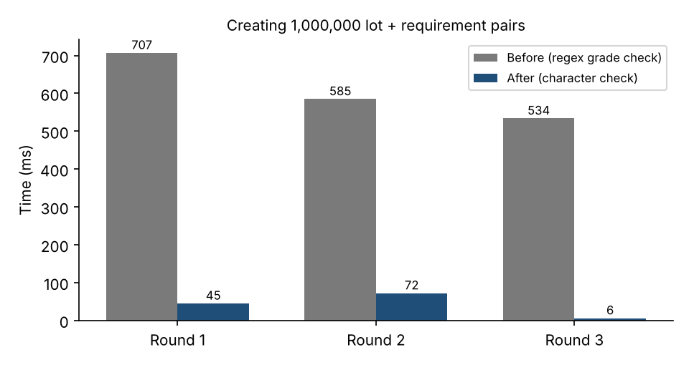
Figure 1: Time to create 1,000,000 lot and requirement pairs, before and after.
Matching itself was already fast: 1,000,000 matches took 7 to 21 ms before the change and 11 to 47 ms after. That difference is noise from JVM warm-up and the machine, not a real slowdown, because the matching code was not modified.

5.2 Limits of this measurement
- Round 3 after the change (6 ms) is probably too good. After warm-up the JVM can optimise away objects that are barely used, so I do not claim a 90 times improvement. I report 8 to 15 times, from rounds 1 and 2.
- This is a simple timing loop in a main method, not a proper benchmark. A tool such as JMH would give more trustworthy numbers.
- Results come from one machine on one day, so exact milliseconds will differ elsewhere. The size of the improvement is the meaningful part.

5.3 Qualitative analysis
- Readability: both models are short and clear. The new grade check is slightly less readable than the regex, which I accepted for the speed gain and could hide behind a Grade enum later.
- Maintainability: the same validation exists in two classes, so my fix had to be applied twice. This shows the duplication has a real cost.
- Testability: because the logic is plain Java with no framework, finding and confirming both issues took minutes.

6. Recommendations for Future Development
No. | Recommendation | Why it matters
1 | Replace grade strings with a Grade enum (A, B, C) that carries its own rank | Removes string checks and the compareTo trick, and makes invalid grades impossible
2 | Move shared quantity and crop validation into one validator class | A fix like Bug 1 then needs to be made in one place
3 | Store quantity in whole grams or use BigDecimal | Avoids floating-point surprises in billing and stock calculations
4 | Run mvn test automatically on every push with GitHub Actions | Catches regressions before they reach the main branch
5 | Add property-style tests with random and extreme inputs | Would have found Bug 1 in Week 3 without me guessing it
6 | Add the Offer and Order steps, with matching reused from MatchingService | Completes the workflow from the Week 1 design
7 | Support partial matches (several small lots combined for one large requirement) | Real cooperatives often split produce across lots
8 | Benchmark with JMH once the Spring Boot API exists | Measures real request performance, not just object creation

7. What I Did Not Test
To be clear about the limits of this evaluation: I did not test concurrent use, any database layer, crop names with unusual characters or extra internal spaces, or very large numbers short of Infinity. These are not confirmed bugs, only areas the current tests do not cover.

8. Conclusion
Week 3 tests passed, but deliberate attacks found a real validation gap that the happy-path tests missed, and a measurable performance cost in a simple line of code. Both were fixed with evidence: failing tests turned green, and creation time fell by roughly 8 to 15 times. The main lesson is to test the cases I did not think of, such as NaN, and to measure instead of assuming. The prototype is now safer for the planned pilot, and the recommendations above set out the next steps toward the full Spring Boot application.

