Project for Third semester of Bachelor of Information Technology

**AUTOMATIC LIGHT**



**Abhiyan Limbu (S.N.330494)**

**Dinesh Bajagain (S.N.330504)**

**Dipendra Kumar Thapa (S.N.330505)**

**Sandesh Khadka (S.N.330523)**

**KIST College of Information Technology**

**Faculty of Science and Technology**

**Purbanchal University, Nepal**

**July,2024**

**Student’s Declaration**

We following students, hereby declare that the Project Report entitled “**AUTOMATIC LIGHT”** submitted in partial fulfillment of the requirement for the degree of Bachelor in Information Technology (BIT) of the Purbanchal University, Biratnagar, Nepal. It is our original work and has not been submitted for award of any other degree, diploma, fellowship or other similar title or prizes.

|  |  |  |  |  |
| --- | --- | --- | --- | --- |
| S.N. | Student’s Name | Reg No. | Symbol No | Signature |
| 1 | Abhiyan Limbu | 058-3-2-05267-2022 | 330494 |  |
| 2 | Dinesh Bajagain | 058-3-2-05277-2022 | 330504 |  |
| 3 | Dipendra Kumar Thapa | 058-3-2-05278-2022 | 330505 |  |
| 4 | Sandesh Khadka | 058-3-2-05299-2022 | 330523 |  |

Date:

**To Whom It May Concern**

This is to certify that Abhiyan Limbu (S.N: -330494), Dinesh Bajagain (S.N: -330504), Dipendra Kumar Thapa (S.N: -330505), Sandesh Khadka (S.N: -330523) of Bachelor in Information Technology (B.I.T) have studied as per the curriculum of B.I.T Third Semester and completed the project entitled **Automatic Light**. This project is the original work andwas carried out under the supervision of Mr. Miraj Pandey, Assistant Professor as per the guidelines provided by Purbanchal University, and certified as per the student’s declaration that the project **‘Automatic Light’** has not been presented anywhere as a part of any other academic work.

Student’s Name: Abhiyan Limbu

Dinesh Bajagain

Dipendra Kumar Thapa

Sandesh Khadka

Semester: 3rd Semester

Subject: Project III

Subject Code: BIT206CO

Project title: AUTOMATIC LIGHT

…………………..

Deepak Khadka

Program Coordinator, BIT

Date:

**Acknowledgement**

First of all, we take this opportunity to express our profound appreciation and unfathomable regards to the Information Technology (IT) department for the commendable guidance, monitoring and constant encouragement throughout the course of this project. The help and guidance given by them shall carry us a long way, in the journey on which we are about to embark.

We are also deeply appreciative of Mr. Miraj Pandey, our dedicated instructor, whose expertise and constructive feedback significantly contributed to refining our ideas and methodologies. Miraj sir commitment to fostering our learning experience has been truly commendable.

We also take this opportunity to thanks Mr. Deepak Khadka, our esteemed coordinator, for his invaluable guidance and support from the initial stages to the culmination of this endeavor. His encouragement and insights have been instrumental in shaping this project.

We would like to acknowledge the unwavering support of our friends who stood by us with patience and encouragement throughout this journey.

Finally, we would also like to express lots of thanks to PURBANCHAL UNIVERSITY for designing such a wonderful course structure. It will help us to get more knowledge in the field of Information Technology and help us to have a bright future in the field of the technology.

**Abstract**

It aims to design and implement a system that automatically turn on the light whenever the motion is detected with the help of using 8051 Microcontroller. Automatic light project is designed in such a way that whenever motion is detected it turns on the light. The implementation of this system is carried out using programming environments such as keil microvision IDE and Progisp, ensuring efficient code development and deployment. Whenever the motion is detected, it turns on the light in LCD with the help of 8051 microcontroller.

The project helps to develop a system capable of detecting motion using a sensor interfaced with the 8051 Microcontroller. It is used to implement a mechanism to turn on or adjust the intensity of lights upon detecting motion in the monitored area. It helps to ensure rapid response to motion events to provide timely illumination and enhance safety like real time responsiveness. It optimizes energy usage by automatically turning off lights when no motion is detected for a specified period.

The project utilizes an 8051 microcontroller as the central processing unit. A motion sensor is interfaced with the microcontroller to detect changes in infrared radiation caused by motion. When motion is detected, the sensor sends a signal to the microcontroller, triggering appropriate outputs to control the lighting system. The system includes algorithms to manage lighting states efficiently, ensuring lights remain on or adjust according to detected motion. This approach provides seamless automation of lighting control, enhancing convenience and energy efficiency in various environments.

**Table of Contents**

**1. INTRODUCTION……………………………………………………………….1**

1.1 Background of Study………………………………………………………......1

1.2 Problem Statement…………………………………………………………......2

1.3 Objective of the Project………………………………………………………...3

1.4 Scope of the Project……………………………………………………………4

1.5 Limitations……………………………………………………………………. 5

**2. LITERATURE REVIEW……………………………………………………….6-8**

**3. METHODOLOGY……………………………………………………………….9**

3.1 System requirement……………………………………………………………9-10

**4. SYSTEM DESIGN……………………………………………………………….11**

4.1 Source Code…………………………………………………………………....11

4.2 Algorithm……………………………………………………………………....12

4.3 Flowchart……………………………………………………………………….13

4.4 Block Diagram………………………………………………………………….14

4.5 Circuit Diagram…………………………………………………………………15

4.6 Gantt Chart……………………………………………………………………...16

**5. CONCLUSION…………………………………………………………………….17**

**6. BIBLIOGRAPHY………………………………………………………………….18**

**1.INTRODUCTION**

**1.1 Background of the study**

Automatic lighting systems are designed to control the illumination of a space based on specific conditions, such as the presence of individuals or ambient light levels. These systems can be implemented in various settings, including homes, offices, and public areas, to improve energy efficiency and user convenience. The 8051 microcontroller is a versatile and cost-effective option for implementing automatic lighting systems. Its architecture allows for easy programming and integration with various sensors and actuators. In the context of automatic lighting, the microcontroller can be programmed to process inputs from sensors and control lighting devices accordingly.

The automatic lighting system operates based on a feedback loop that continuously monitors sensor inputs and adjusts the lighting accordingly. The system typically includes an 8051 microcontroller, sensors (such as infrared (IR) sensors or Light Dependent Resistors (LDRs)), and relays for controlling the lights. The sensors are responsible for detecting the presence of individuals or measuring ambient light levels. When a sensor detects a change in the monitored condition (e.g., a person enters the room or ambient light falls below a certain threshold), it sends an electrical signal to the 8051 microcontroller. The microcontroller processes this signal based on pre-defined parameters and determines whether to activate or deactivate the relay. If the conditions are met, the microcontroller triggers the relay, which in turn switches the lights on or off. This process continues in a loop, ensuring that the lights remain on as long as necessary and turn off when the monitored conditions change, such as when no one is present in the room or when sufficient natural light is available. The 8051 microcontroller's programmability allows for customization of the system's behavior based on specific requirements, making it suitable for various applications, including residential lighting, street lighting, and commercial spaces.

The integration of the 8051 microcontroller in automatic lighting systems exemplifies the convergence of electronics and programming to create efficient and user-friendly solutions. By leveraging sensor technology and microcontroller capabilities, these systems not only improve convenience but also contribute to energy conservation efforts in various environments. Understanding the principles behind these systems is crucial for designing effective automatic lighting solutions that enhance safety and efficiency.

**1.2 Problem Statement**

Traditional lighting systems often rely on manual operation or basic timers, leading to inefficient energy usage and inconvenience for users. In many environments, such as homes, offices, and public spaces, there is a need for efficient utilization of energy while ensuring adequate lighting conditions. This project seeks to address these challenges by developing an Automatic Light Control System using a microcontroller 8051 and light sensors. Some of the key challenges associated with conventional lighting systems include:

**1. Energy Wastage:** Lights left on in unoccupied rooms or during daylight hours result in unnecessary energy consumption and higher electricity bills.

**2. Inconvenience:** Manually turning lights on and off can be inconvenient, especially in large spaces or when users forget to switch them off.

**3. Lack of Adaptability:** Fixed lighting schedules or manual control cannot adapt to changing occupancy patterns or varying daylight conditions throughout the day.

**4. Safety Risks:** Poorly lit areas due to forgotten or malfunctioning lights can pose safety hazards, especially in high-traffic zones or emergency situations.

**5. Limited Accessibility:** Conventional lighting systems may not be easily accessible or user-friendly for individuals with disabilities or mobility limitations.

To address these challenges, there is a need for an automatic lighting system that can intelligently control illumination based on occupancy and ambient light levels. By leveraging the capabilities of the 8051 microcontroller, such a system can provide enhanced energy efficiency, improved user convenience, and increased safety in various applications. The proposed automatic light sensor project aims to develop a cost-effective and reliable solution that can be easily integrated into existing or new lighting infrastructure. By combining sensors, the 8051 microcontroller, and appropriate control algorithms, the system will automatically adjust lighting levels based on real-time conditions, ensuring optimal energy usage while maintaining a comfortable and safe environment for occupants.

**1.3 Objective of the Project**

The automatic light sensor project utilizing the 8051 microcontroller aims to create an intelligent lighting control system that enhances energy efficiency and user convenience. By leveraging advanced sensor technology, this system will automatically adjust lighting based on occupancy and ambient light conditions, addressing common challenges associated with traditional lighting systems. Some of the objectives are mentioned below:

**1.Develop an Intelligent Lighting Control System:** Design and implement an automatic lighting system that utilizes the 8051 microcontroller to intelligently control lighting based on occupancy and ambient light levels.

**2.Enhance Energy Efficiency:** Create a system that minimizes energy consumption by ensuring that lights are only activated when needed, thereby reducing electricity costs and environmental impact.

**3.Improve User Convenience:** Provide a user-friendly solution that eliminates the need for manual operation of lights, allowing for seamless transitions based on real-time conditions.

**4.Ensure Safety and Security:** Design the system to enhance safety by ensuring adequate lighting in high-traffic areas and automatically turning on lights in response to detected movement, thereby reducing the risk of accidents.

**5.Facilitate Easy Installation and Maintenance:** Create a system that is easy to install and maintain, making it accessible for residential and commercial applications without requiring extensive modifications to existing infrastructure.

**6.Conduct Performance Evaluation:** Test and evaluate the system's performance in real-world scenarios to ensure reliability, responsiveness, and effectiveness in various lighting conditions and occupancy patterns.

By achieving these objectives, the project aims to deliver a comprehensive automatic lighting solution that enhances energy efficiency, user convenience, and safety in various environments.

**1.4 Scope of the Project**

The automatic light sensor project has a wide scope, as it can be applied in various settings, including residential, commercial, and industrial environments. The system can be designed to control lighting in individual rooms, entire buildings, or even outdoor areas, making it versatile and adaptable to different needs.

**1.Residential Applications:** The automatic light sensor system can be implemented in homes to control lighting in rooms, hallways, and outdoor areas. It can automatically turn on lights when someone enters a room and turn them off when the room is empty, enhancing energy efficiency and convenience for homeowners.

**2.Commercial Applications:** The system can be used in commercial buildings such as offices, retail stores, and restaurants to optimize lighting based on occupancy and daylight availability. This can lead to significant energy savings and improved working conditions for employees and customers.

**3.Outdoor Applications:** The system can be adapted for outdoor lighting control, such as in parking lots, streets, and public spaces. By integrating with sensors that detect motion or ambient light levels, the system can automatically turn on and off outdoor lights, enhancing safety and security while reducing energy consumption.

**4.Customization and Integration:** The scope of the project includes the ability to customize the system based on specific requirements and integrate it with existing building management systems or smart home technologies. This allows for seamless integration and optimization of lighting control within a larger ecosystem.

**5.Scalability:** The system can be designed to scale up or down depending on the size of the application, making it suitable for small-scale projects like a single room or large-scale projects like multi-story buildings or entire campuses.

By leveraging the capabilities of the 8051 microcontroller and sensor technology, this project has the potential to significantly impact energy efficiency, user convenience, and safety in various built environments.

**1.5 Limitations**

While the automatic light sensor project using the 8051 microcontroller offers numerous benefits in terms of energy efficiency, user convenience, and safety, it is essential to acknowledge the limitations and constraints associated with this system. These limitations may impact the overall effectiveness, scalability, and cost-effectiveness of the project, requiring careful consideration during the design and implementation phases. Some of the limitations are listed below:

**1.Sensor Limitations:** The effectiveness of the automatic light sensor system is heavily dependent on the accuracy and reliability of the sensors used. Factors such as environmental conditions, sensor placement, and potential obstructions can affect their performance, leading to false triggers or missed detections.

**2.Microcontroller Constraints:** The 8051 microcontroller has limited processing power and memory compared to more advanced microcontrollers. This may restrict the complexity of algorithms that can be implemented, potentially limiting the system's ability to handle multiple inputs or sophisticated control strategies.

**3.Limited Range of Detection:** Sensors such as IR and LDRs have specific ranges and may not cover large areas effectively. In larger spaces, multiple sensors may be required to ensure comprehensive coverage, increasing complexity and cost.

**4.Environmental Sensitivity:** The performance of light sensors can be influenced by environmental factors such as dust, humidity, and temperature. These conditions may affect sensor accuracy and reliability, leading to inconsistent lighting control.

**5.Maintenance Requirements:** Regular maintenance of sensors and the microcontroller is necessary to ensure optimal performance. Dust accumulation, sensor degradation, or software issues may require periodic checks and updates.

By recognizing these limitations and addressing them through appropriate design choices and mitigation strategies, the automatic light sensor project can achieve its full potential while minimizing the impact of these constraints.

**2.LITERATURE REVIEW**

The literature on automatic light sensors utilizing the 8051 microcontroller reveals a significant evolution in technology and application, reflecting advancements in embedded systems, sensor technology, and energy efficiency. This review synthesizes findings from various academic articles, technical reports, and industry publications to provide a comprehensive overview of the topic.

**Historical Context**

The concept of using automated systems for lighting control has roots that trace back to the increasing demand for energy efficiency and convenience in residential and commercial settings. The 8051 microcontroller, introduced in the late 1970s, has become a popular choice for such applications due to its versatility and ease of use. Early implementations focused on simple on/off control mechanisms, gradually evolving to more sophisticated systems that incorporate sensor technology for enhanced functionality.

**Sensor Integration and Functionality**

Automatic light sensors, particularly those using the 8051 microcontroller, typically integrate infrared (IR) sensors or light-dependent resistors (LDRs) to detect human presence or ambient light levels. Infrared sensors detect motion by sensing changes in infrared radiation emitted by objects, such as humans. Projects utilizing the 8051 microcontroller often employ two IR sensors to create a bidirectional visitor counter, turning lights on when someone enters and off when the last person leaves. Light-dependent resistors, on the other hand, measure ambient light intensity, allowing the system to automatically turn lights on or off based on the surrounding light conditions. For instance, if the light level drops below a certain threshold, the system activates the lights to conserve energy.

**Control Mechanisms**

The control mechanisms in these systems are typically based on simple programming logic within the 8051 microcontroller. The microcontroller processes input from the sensors and executes commands to control lighting based on predefined conditions. This functionality enhances energy efficiency and user convenience, as lights are only activated when necessary.

**Notable Research Contributions**

One significant paper titled "Automatic Street Light Control System" by Ravi Shankar Singhal et al. (2020) discusses the implementation of an automatic street lighting system using ultrasonic sensors and the ATmega328P microcontroller. This study emphasizes energy conservation by automating the switching of street lights based on ambient light levels and movement detection, thus reducing electricity wastage and eliminating manual operations.

The paper "Proposed Topic ON AUTOMATIC LIGHT CONTROL SYSTEM" presents a theoretical framework for applying frequency response analysis to automatic lighting control systems. This research lays the groundwork for understanding how dynamic system responses can be utilized in the design of more effective automatic light control mechanisms.

A practical exploration is found in "Automatic Room Lighting" from Engineers Garage, which details a project using the AT89S52 microcontroller. This study describes the use of IR sensors to control room lighting automatically, providing a prototype that demonstrates the feasibility of using microcontrollers for energy-efficient lighting solutions

In the paper "Automatic Light Control and Home Security using PIR Sensor, GSM and Arduino System," the authors Nishant Harkesh Meena et al. (2019) investigate a dual-purpose system that not only automates lighting based on human presence detected by Passive Infrared (PIR) sensors but also incorporates a GSM module for home security. This integration of lighting control with security features highlights the versatility of automatic light systems in modern applications

**Current Research Trends**

Current research in this field focuses on enhancing the capabilities of automatic light sensors through improved sensor technology and smart integration. Ongoing advancements aim to develop more sensitive and reliable sensors that can operate effectively in diverse environmental conditions, thereby enhancing system performance. The integration of IoT technology with 8051 microcontroller-based systems is gaining traction, allowing for remote monitoring and control, enabling users to manage lighting systems via smartphones or other devices. Furthermore, research continues to explore methods to optimize energy consumption, including adaptive algorithms that learn user behavior and adjust lighting accordingly.

**Conclusion**

In conclusion, while the 8051 microcontroller-based automatic light sensors provide a practical and efficient solution for lighting control, ongoing advancements in sensor technology and integration with smart systems are expected to enhance their functionality and applicability in various settings. Future research should focus on overcoming current limitations, such as sensor sensitivity and environmental adaptability, to further improve the reliability and effectiveness of these systems.

**3.METHODOLOGY**

**3.1System Requirements**

To run a project using the 8051 microcontroller, you will need the following system requirements:

**Hardware Requirements**

**1.8051 Microcontroller Development Board:** This board should include the 8051-microcontroller chip, along with necessary components like crystal oscillator, reset circuit, and power supply.

**2.Programming Interface:** You will need a programmer or an In-System Programming (ISP) module to load the compiled code into the microcontroller's memory. This could be a USB-based programmer or a serial port programmer.

**3.Sensors and Actuators:** Depending on your project requirements, you may need various sensors (e.g., temperature sensor, light sensor, motion sensor) and actuators (e.g., LEDs, motors, relays) to interface with the microcontroller.

**4.Power Supply:** The development board and connected components will require a stable power supply, which can be provided by a wall adapter or a USB connection.

**5.Breadboard and Jumper Wires:** For prototyping and connecting the microcontroller with sensors and actuators, you will need a breadboard and jumper wires.

**Software Requirements**

**1.Integrated Development Environment (IDE):** You will need an IDE that supports the 8051 microcontroller, such as Keil μVision, SDCC (Small Device C Compiler), or Arduino IDE (for Arduino-based 8051 boards).

**2.Compiler:** The IDE should include a compiler that can generate machine code from your source code (written in assembly language or C).

**3.Simulation Software:** To test your code before uploading it to the microcontroller, you may use simulation software like Proteus or ISIS.

**4.Operating System:** The IDE and programming tools should be compatible with your computer's operating system such as Windows 7/XP is a minimum requirements.

**5.Serial Terminal Software:** If your project requires serial communication, you will need a serial terminal software like PuTTY or TeraTerm to communicate with the microcontroller.

**Additional Requirements**

**1.Knowledge of 8051 Microcontroller Architecture:** Understanding the 8051 microcontroller's architecture, including its memory organization, registers, I/O ports, timers, and interrupts, is essential for developing projects.

**2.Programming Skills:** Proficiency in assembly language or C programming is necessary to write code for the 8051 microcontroller.

**3.Familiarity with Embedded Systems:** Knowledge of embedded systems concepts, such as interfacing sensors and actuators, handling interrupts, and managing power consumption, is beneficial for developing robust projects.

By ensuring that you have the necessary hardware, software, and knowledge, you can successfully run projects using the 8051 microcontroller.

**4.SYSTEM DESIGN**

**4.1 Source Code:**

#include <Reg52.h>

#include “LCD_DISPLAY.h”

sbit input = P1^0;

sbit output = P1^1;

void main () {

//LCD_Init ();

//LCD_String (“Detecting….”);

while (1) {

output = 0;

LCD_Init ();

LCD_String (“Detecting….”);

if (input == 1) {

output=1;

LCD_Command(0x01);

LCD_String (“Motion Detected”);

delay (500);

}

if (input == 0) {

}

}

}

**4.2 Algorithm:**

1.Start.

2.Define the input and output pins.

3.Initialize the LCD.

4.Display the message "Detecting......" on the LCD.

5.Set initial states of input and output pins to 0.

6.If input pin == 1, perform following steps:

6.1 Set output pin to 1.

6.2 Clear the LCD display using LCD command(0x01).

6.3 Display the message "MOTION DETECTED" on the LCD.

6.4 Move the cursor to the second line using LCD command(0xC0).

6.5 Display an empty string on the second line.

6.6 Delay for 500 milliseconds.

else,

Perform no actions.

7.Go to step3.

**4.3 Flowchart:**

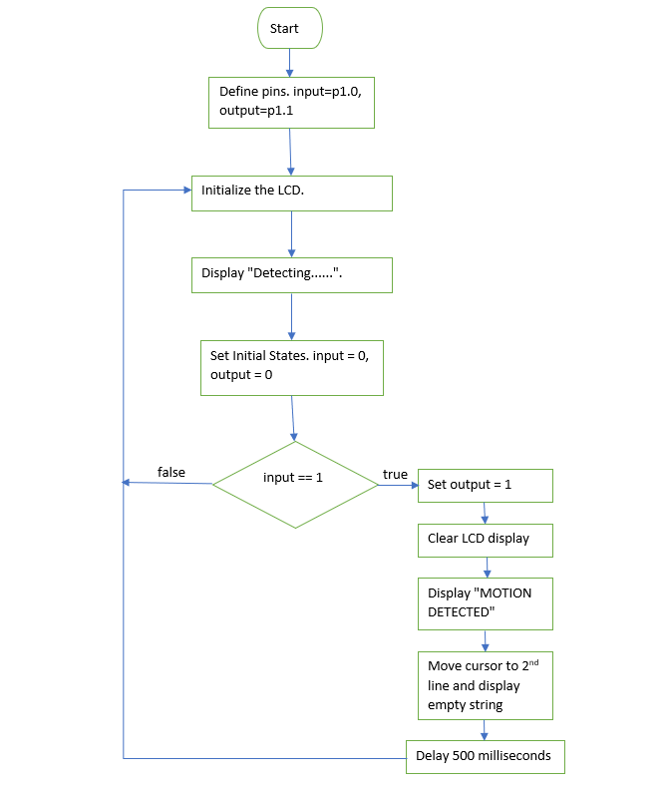

**4.4 Block Diagram**

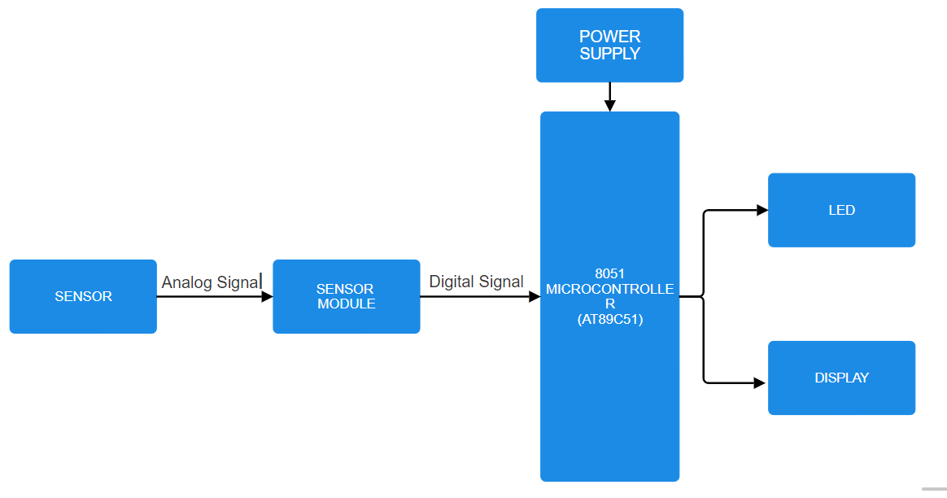

**4.5 Circuit Diagram**

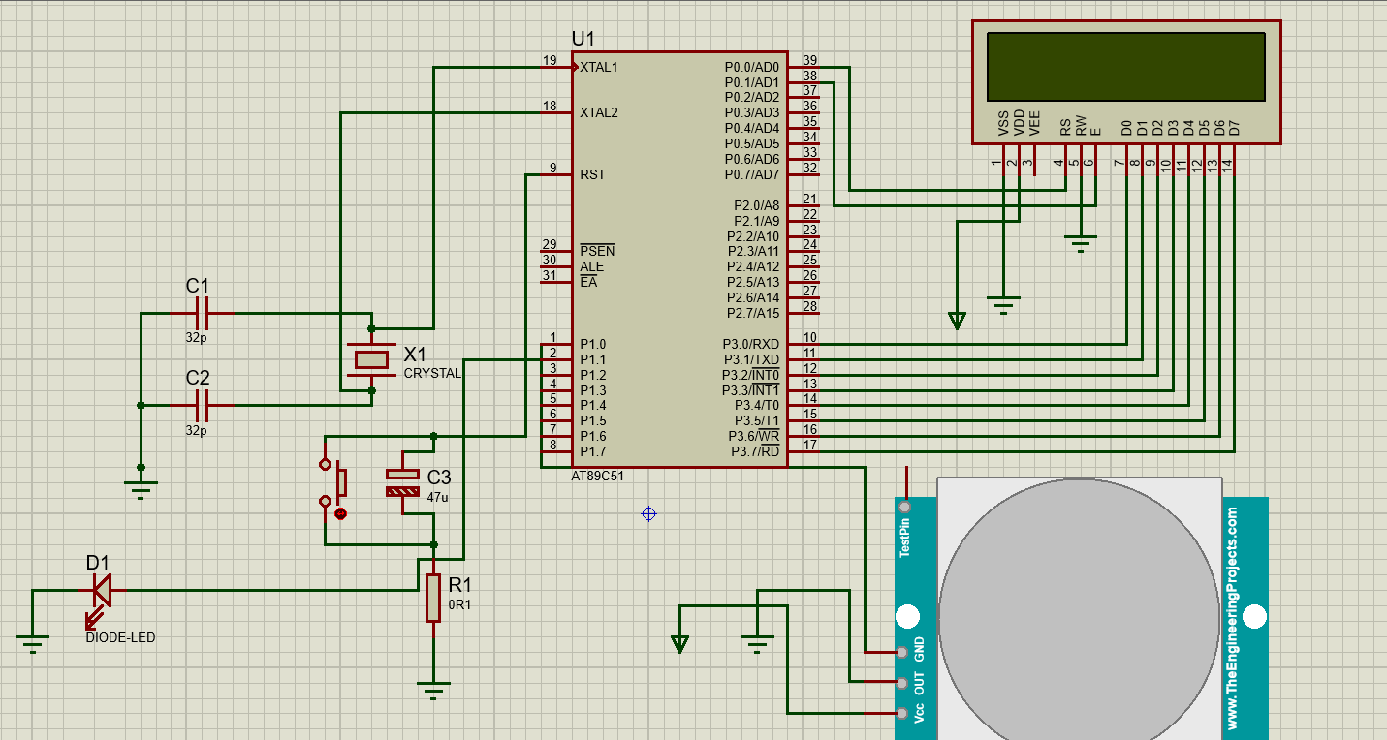

**4.6 Gantt Chart**

|  |  |  |  |  |  |  |
| --- | --- | --- | --- | --- | --- | --- |
| **S.N.** | **Task** | **Week1** | **Week2** | **Week3** | **Week4** | **Week5** |
| **1** | **Planning** |  |  |  |  |  |
| **2** | **Analysis** |  |  |  |  |  |
| **3** | **Designing** |  |  |  |  |  |
| **4** | **Coding** |  |  |  |  |  |
| **5** | **Testing** |  |  |  |  |  |
| **6** | **Documentation** |  |  |  |  |  |

Total Time: 5 Weeks

**5**.**CONCLUSION**

In conclusion, the implementation of an automatic light sensor using the 8051 microcontroller represents a significant advancement in modern automation technology. This project has demonstrated the practical application of microcontroller-based systems in enhancing energy efficiency and convenience in everyday environments. By seamlessly adjusting lighting levels based on ambient conditions, the sensor ensures optimal use of resources while providing enhanced user comfort and safety. Moreover, the integration of the 8051 microcontroller showcases its versatility and reliability in real-world applications, underscoring its role in the evolution towards smarter and more sustainable living spaces. As technology continues to evolve, projects like these pave the way for further innovations that promise to revolutionize our interaction with the built environment.

Implementing an automatic light sensor using the 8051 microcontroller brings numerous practical uses and advantages to modern environments. Foremost among these benefits is the significant enhancement in energy efficiency. By continuously monitoring ambient light levels and adjusting lighting accordingly, the sensor ensures lights are only activated when necessary. This not only reduces energy consumption but also lowers utility costs, making it a financially prudent investment for both residential and commercial applications. Moreover, the system enhances user convenience by eliminating the need for manual adjustments. Residents and occupants benefit from a seamlessly managed lighting environment that responds autonomously to changing conditions, enhancing comfort and usability.

In conclusion, the implementation of an automatic light sensor using the 8051 microcontroller represents a pivotal advancement in smart technology applications. It not only promotes sustainability by reducing energy consumption and environmental impact but also enhances user comfort, safety, and operational efficiency in today's increasingly interconnected world. As technology continues to evolve, such innovations pave the way for more intelligent and sustainable living and working environments.

**6.BIBILIOGRAPHY**

* Jain, Suraj (Nov, 2018)“Alearningroom – YouTube” [www.youtube.com](http://www.youtube.com), Suraj Jain November 2018, youtube.com/user/alearningroom.
* Joshi, S. (Aug 9,2018). Microcontroller 8051 Playlist. Ekeeda. From <https://www.youtube.com/user/@Ekeeda>
* Elprocus. (Mar 13, 2015). Interfacing LED with 8051 microcontroller, from <https://www.elprocus.com/led-interfacing-with-8051-microcontroller/>
* The Engineering Projects. (2015). LED blinking project using 8051 microcontroller & Proteus. from <https://www.theengineeringprojects.com/2015/12/led-blinking-project-using-8051/>