

**College Chatbot using chatterbot**

Name : Sandesh Thapa Magar

WLV ID: 2038578

Supervisor: Susmita Rai

**Testing Approach**

**Artefact**

**Introduction**

* Web based chatbot for the college.
* Tries answer the college quires
* Student Management System

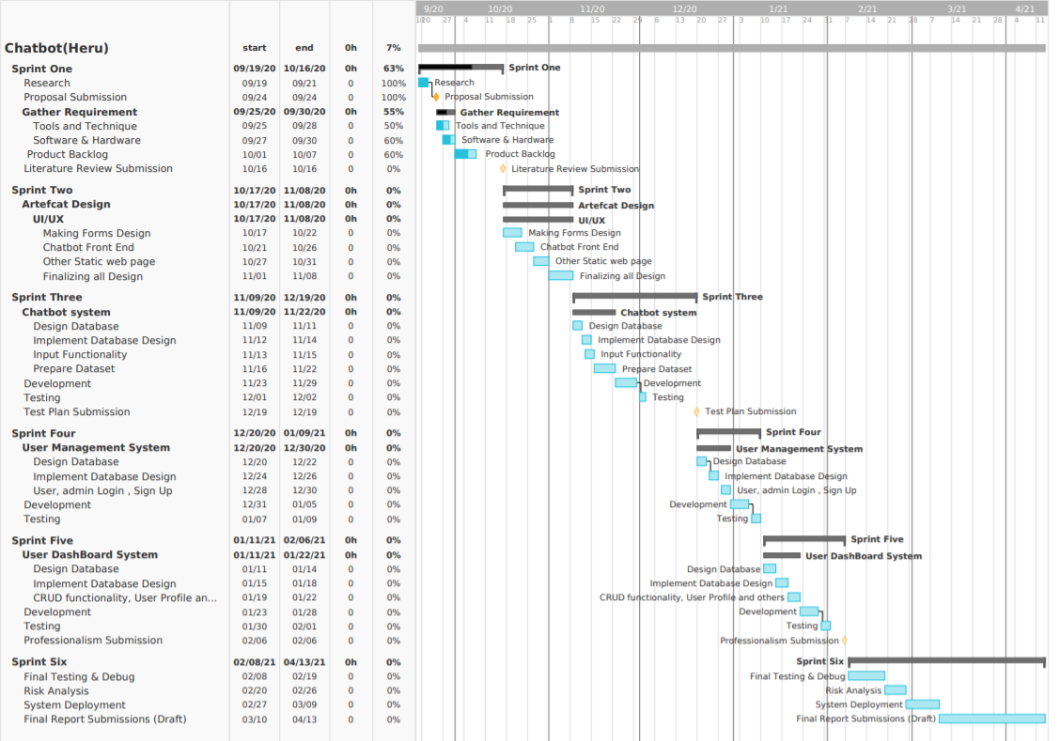

**Academic Question**

* How will it solve the college problem to interact with students?
* How much accurate is it?
* Which algorithm is used?

Figure 1 Gannt Chart

**Research Evidence**

**Conclusion**

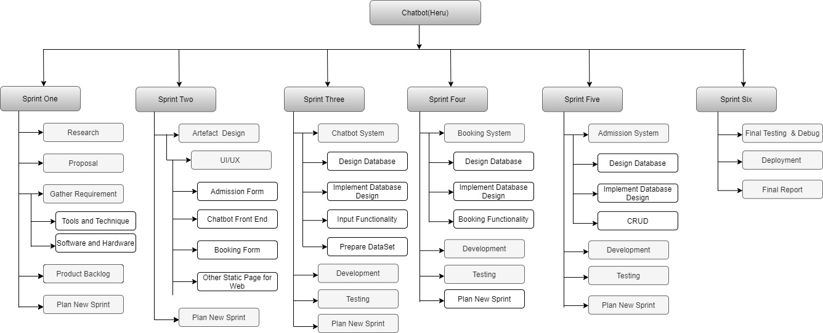

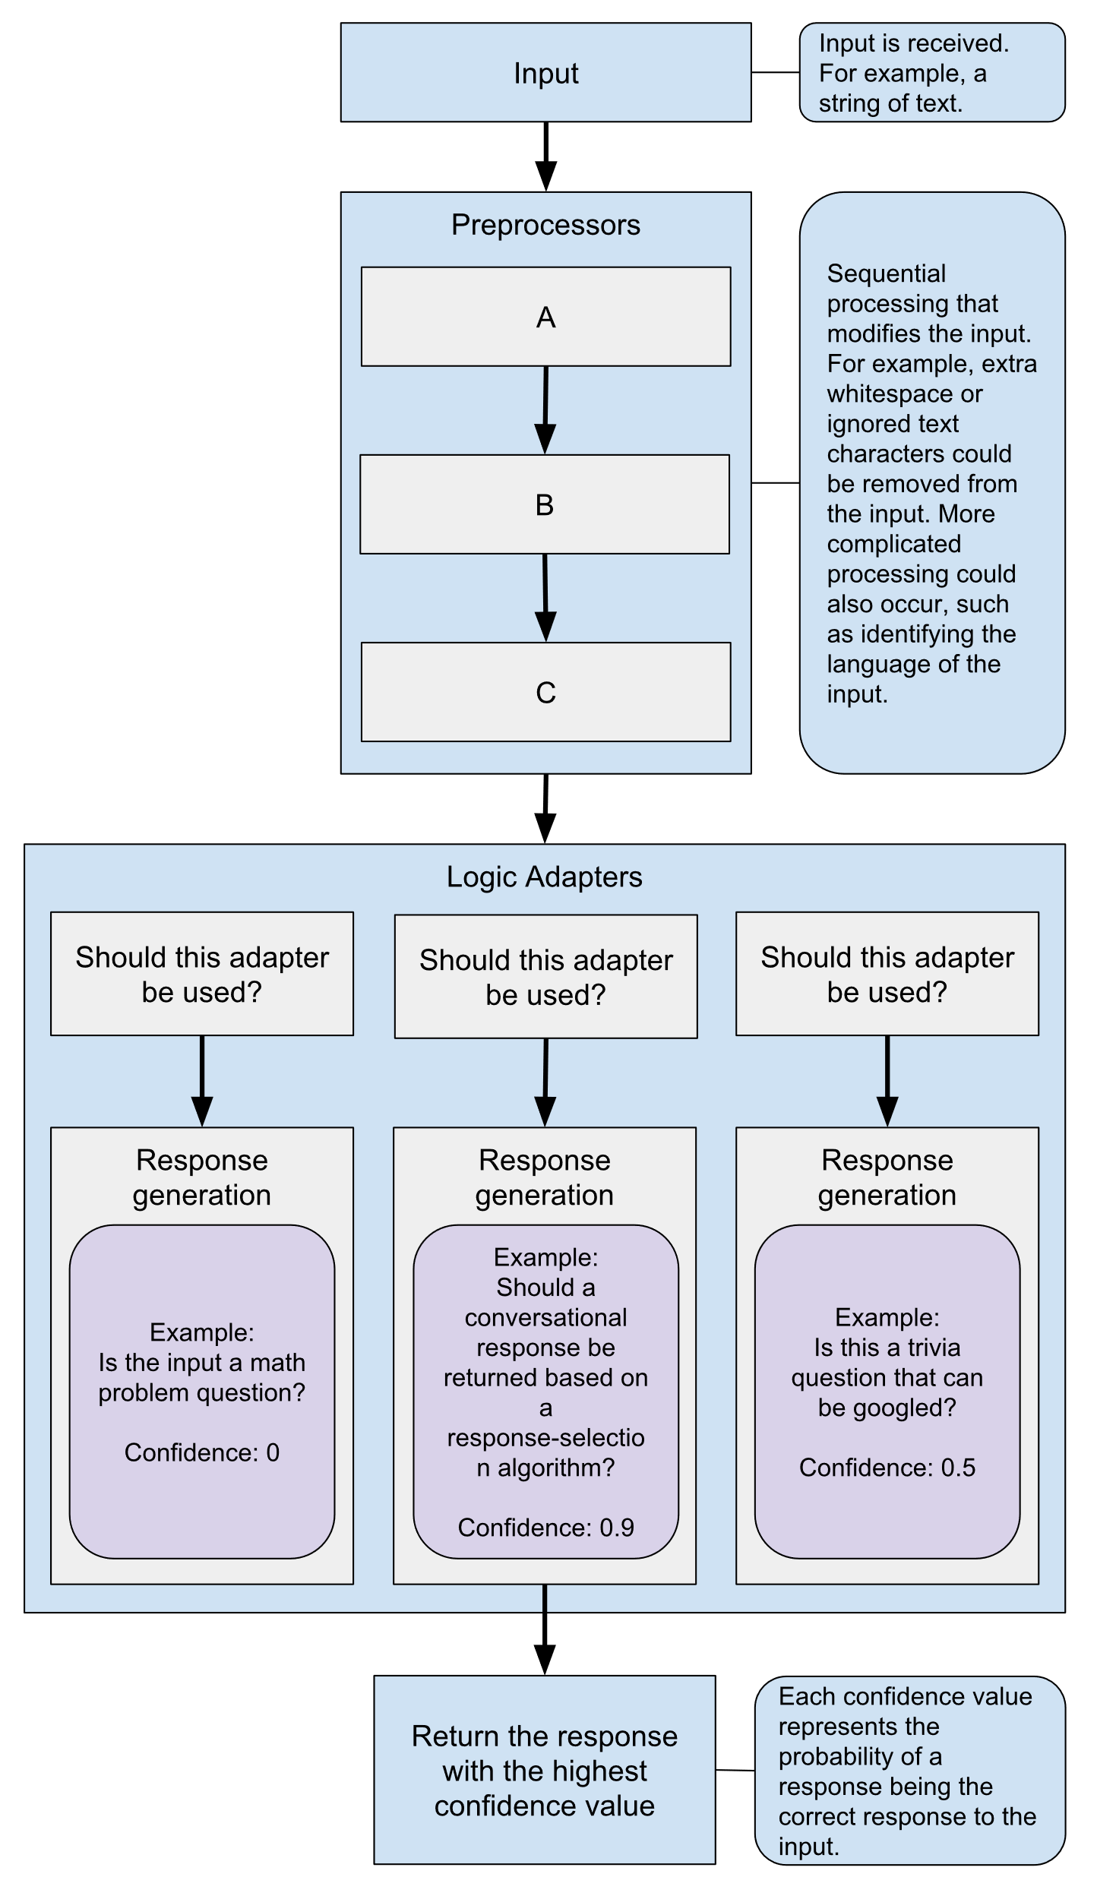

**Evaluation**

Figure 2 Logic Adapter of Chatterbot

**Aims and Objectives**

* To provide retrieval-based chatbot for college
* To remove hassle of interacting with every student
* To provide user friendly chatbot
* Doing Research on Journal, books, magazines and conferences paper to know how retrieval chatbot is made
* Finding out similarities and differences by comparison and choosing the best methodology to build it.
* Making owe dataset for the chatbot, to remove the hassle of data cleansing.
* Choosing the right framework and development tools

Figure 3 WBS