**RESULTS**

**Code Output-**

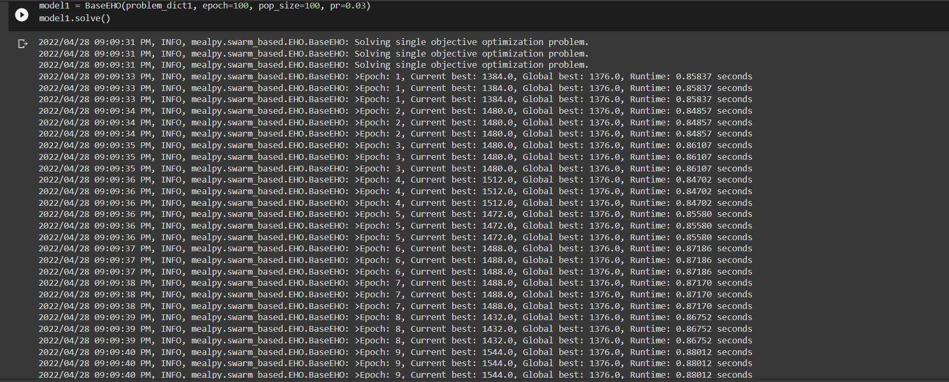

Final array displaying Global Best.



**Comparing Execution Time (Global Best) of Elephant herd optimization VS Particle swarm optimization-**

**Parameters Used-**

* No. of VMs (5,10)
* Epoch
* Population Size
* No. of task
* Global best

**When VM=5**

|  |  |  |  |  |
| --- | --- | --- | --- | --- |
| **Epoch** | **Population Size** | **No. of Task** | **Global Best (EHO)** | **Global Best (PSO)** |
| 100 | 100 | 100 | 112 | 95.9 |
| 100 | 100 | 500 | 192 | 571 |
| 100 | 100 | 1000 | 824 | 1187 |
| 100 | 100 | 1500 | 992 | 1733 |
| 100 | 100 | 2000 | 2272 | 2318 |
| 100 | 100 | 2500 | 2352 | 2816 |
| 100 | 100 | 3000 | 368 | 3550 |

**When VM=10**

|  |  |  |  |  |
| --- | --- | --- | --- | --- |
| **Epoch** | **Population Size** | **No. of Task** | **Global Best (EHO)** | **Global Best (PSO)** |
| 100 | 100 | 100 | 62.8 | 64 |
| 100 | 100 | 500 | 336 | 300 |
| 100 | 100 | 1000 | 639.9 | 611 |
| 100 | 100 | 1500 | 952 | 902 |
| 100 | 100 | 2000 | 1280 | 1228 |
| 100 | 100 | 2500 | 1664 | 1540 |
| 100 | 100 | 3000 | 2040 | 1714 |

**Findings-**

After comparing the dataset by testing it with increasing no. of tasks and by keeping other parameters same we observed that when the resources were less like in VM=5 table EHO gave better results compared to PSO but when tasks were very less(appx.100) PSO was better.

But when the resources were more like in VM=10 table we didn’t saw much difference in our results so when resources are more both the algorithms gave good results.

Comparing both the tables we can say using EHO is good.

**Comparing Execution Time (Global Best) of Elephant herd optimization VS Particle swarm optimization-**

**Parameters Used-**

* No. of VMs (5,10)
* Epoch
* Population Size
* No. of task
* Global best

**When VM=5**

|  |  |  |  |  |
| --- | --- | --- | --- | --- |
| **Epoch** | **Population Size** | **No. of Task** | **Global Best (EHO)** | **Global Best (PSO)** |
| 100 | 100 | 500 | 192 | 562 |
| 100 | 200 | 500 | 628 | 524 |
| 100 | 300 | 500 | 616 | 524.57 |
| 100 | 100 | 1500 | 992 | 1838.85 |
| 100 | 200 | 1500 | 2040 | 1747 |
| 100 | 300 | 1500 | 2088 | 1588 |

**When VM=10**

|  |  |  |  |  |  |
| --- | --- | --- | --- | --- | --- |
| **Epoch** |  | **Population Size** | **No. of Task** | **Global Best (EHO)** | **Global Best (PSO)** |
| 100 |  | 100 | 500 | 336 | 305.14 |
| 100 |  | 200 | 500 | 308 | 301 |
| 100 |  | 300 | 500 | 314 | 297 |
| 100 |  | 100 | 1500 | 952 | 908.57 |
| 100 |  | 200 | 1500 | 976 | 920 |
| 100 |  | 300 | 1500 | 937 | 913 |

**Findings-**

When we increase the population size in both the algorithm we didn’t saw any major change in the global best. Only when population size was less in 5 VM we saw some differences in EHO.

**Comparing Elephant herd optimization VS Particle swarm optimization by Visualizing–**

|  |  |  |  |  |  |  |
| --- | --- | --- | --- | --- | --- | --- |
| **S No.** | **Epoch** | **Population Size** | **No. of Task** | **No. of VM** | **Global Best (EHO)** | **Global Best (PSO)** |
| 1 | 100 | 100 | 500 | 5 | 80 | 541 |
| 2 | 100 | 200 | 1000 | 5 | 784 | 1147 |
| 3 | 100 | 300 | 500 | 10 | 314.28 | 297 |
| 4 | 100 | 100 | 1000 | 10 | 639 | 634 |

**1. Comparing Runtime Per Epoch-**

|  |  |  |
| --- | --- | --- |
| S No. | EHO | PSO |
| 1 |  |  |
| 2 |  |  |
| 3 |  |  |
| 4 |  |  |

**2. Comparing Local Best by Local Objective chart-**

|  |  |  |
| --- | --- | --- |
| S No. | EHO | PSO |
| 1 |  |  |
| 2 |  |  |
| 3 |  |  |
| 4 |  |  |

**3. Comparing Global Best by Global Objective chart-**

|  |  |  |
| --- | --- | --- |
| S No. | EHO | PSO |
| 1 |  |  |
| 2 |  |  |
| 3 |  |  |
| 4 |  |  |

**4. Comparing Diversity Measurement chart-**

|  |  |  |
| --- | --- | --- |
| S No. | EHO | PSO |
| 1 |  |  |
| 2 |  |  |
| 3 |  |  |
| 4 |  |  |

**CONCLUSION**

Task Scheduling in cloud is one of the most challenging things. So, we have proposed the Elephant Herd Optimization (EHO) as a method to solve cloud task scheduling problems in cloud. The EHO algorithm is inspired by behavior of elephant herd and its relationship.

In our project we had done various performance analysis of our proposed algorithm EHO and compared it with another nature inspired machine learning algorithm Particle Swarm Optimization (PSO). At first, we had solved the set of tasks ranging from 100 task to 3000 tasks. Then we had solved the by keeping number of tasks constant and varying population size. At last, we had done both of our first task with higher number of virtual machines. The performance of the proposed algorithm to solve the task scheduling problem was compared with other heuristic algorithms for data. It can be concluded that the proposed algorithm had provided better performance than the existing algorithm in many scenarios.

We conclude that EHO has a good characteristic as optimization algorithm and it can be used for solving complex optimizations problems.

In future we will be working on simulating this entire thing on CloudSim simulation environment and will enhance the throughput of cloud system by minimizing the execution time of the assigned with the minimum wastage of cloud resource from the virtual machines.