Let me take a step back and review what I have done in past 2 days to create this basic functioning website.

This is how my website looks

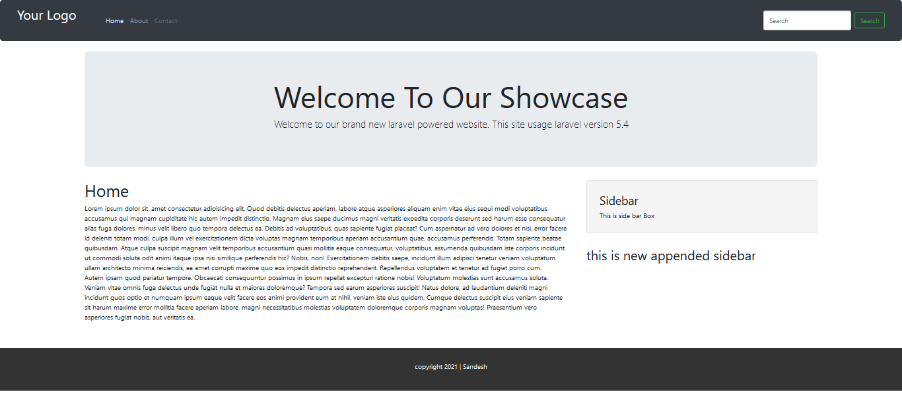

Logo with a href tag ‘/’ to the base URL means brings back to Home page.

Bootstrap Nav-bar home about contact menu which take to their respective page ‘/’ , ‘/about’, ‘/contact’

With jumbotorn to showcase your product which is only visible in home page with the logic

@if (Request∷is (‘/’))

//@include that file (‘’) and @endif

Home content and sidebar are two separated with bootstrap col-md-8 and col-md-4 to give a side bar feel from the layout file that is app.blade.php and two contents are pulled dynamically even you can see the text below sidebar that is also sidebar but if you need to append side bar some time you can just create a side bar where you need it in this case we need default and new side bar then we can create new section with side bar in home.balde file and call @parent if we need the default side bar. If not we can erase the @parent in the [home.blade.php](http://home.blade.php) file and in the include file where we have side bar we can use @show command to call that section sidebar. And if we don’t use @show then that new side bar will not appear.

After that we have a footer with id footer and in css we have #footer and use some css to make it look like as it is shown.

But how css works here is different. What is runs from is public/css/app.css that looks compiled and we can’t understand a thing over there so what actually we need to do is we have another folder called SASS under resource/assets/sass/app.scss i.e it use preprocess and we can write css over there which then it will compile and apply to the project. So how it’s done lets summarized it.

COMPILE ASSETS

(Laravel use mix which you can look at /webpack.mix.js)

We can use plain css also but let’s do it professionally.

First we need nodejs run time environment which we will also get package manager npm let’s download from nodejs.org site and run npm install (inside the project folder) It will talk few minutes.

Npm run dev

Or

You can use npn run watch (to let it check in background that if anything changes has been made to the proejct file so that it will compile everytime and shows us)

Now we can create new custom css file with _ at first as it’s written _custom.scss and we need to include that file in the resource/css/app.scss with this command @import “custom”; we don’t need to write _ at front because it knows. Smart laravel huh !

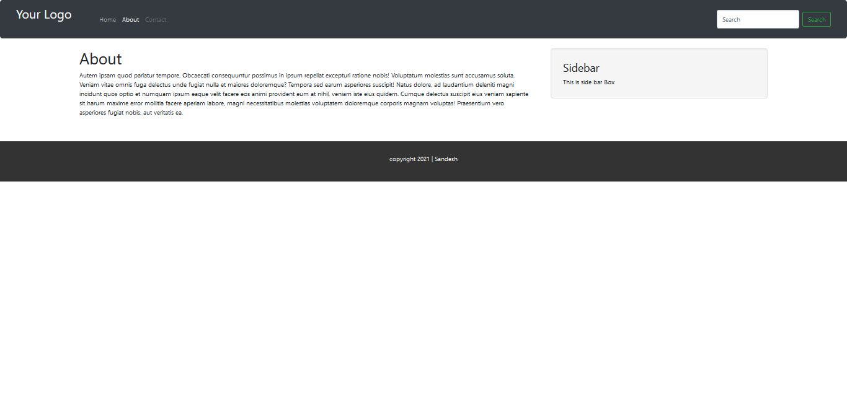

About us page has separate about.blade.php file which is basically simple with side bar included

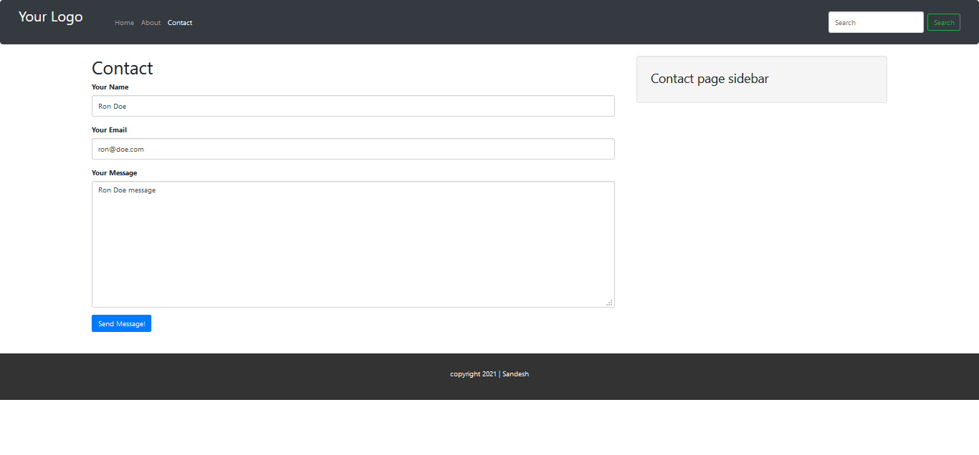

This is contact page where I have made a simple form with using bootstrap and POST method and action ‘/submit/message/’

It will check if there are empty fields in name and email and if yes it throws the error

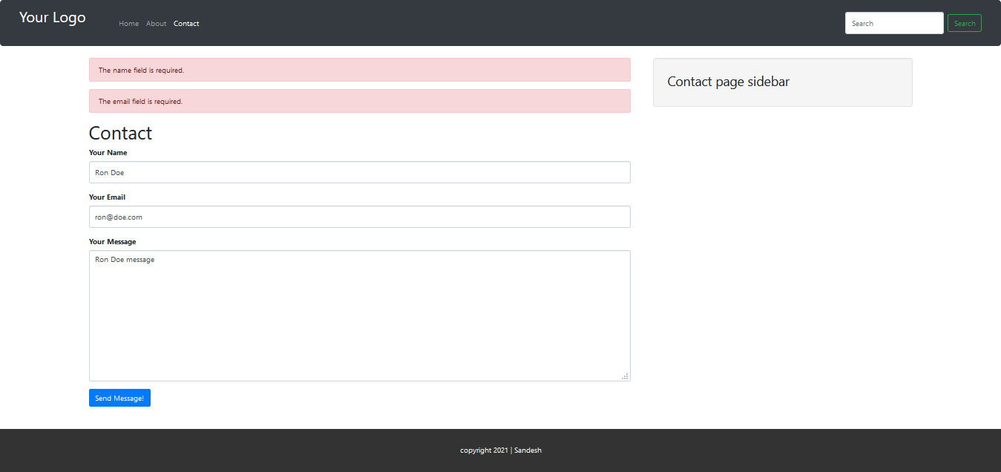

There has been looped with the @if (count($error)>0) after it’s looped and displayed in a div class alert alert-danger which is bootstrap style.

And after it’s sent it is return redirected (‘/’,) → with (‘success’, ‘message has been sent’) in MessageController after the email has been sent. And to check those error as shown above there’s a validate function in submit function in MesagesController.

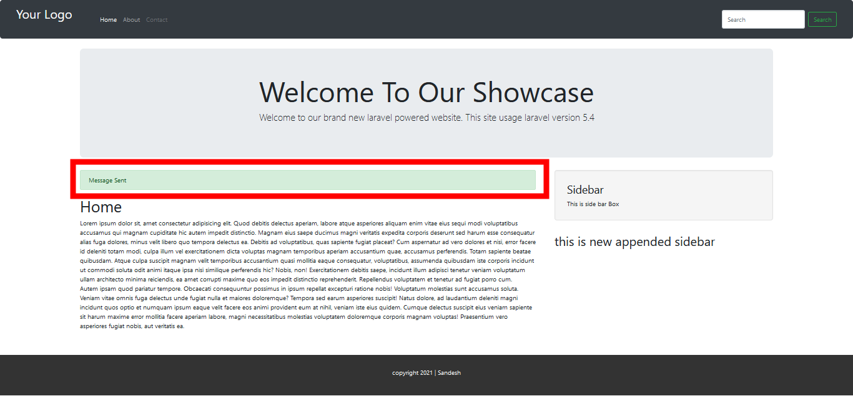

See my database

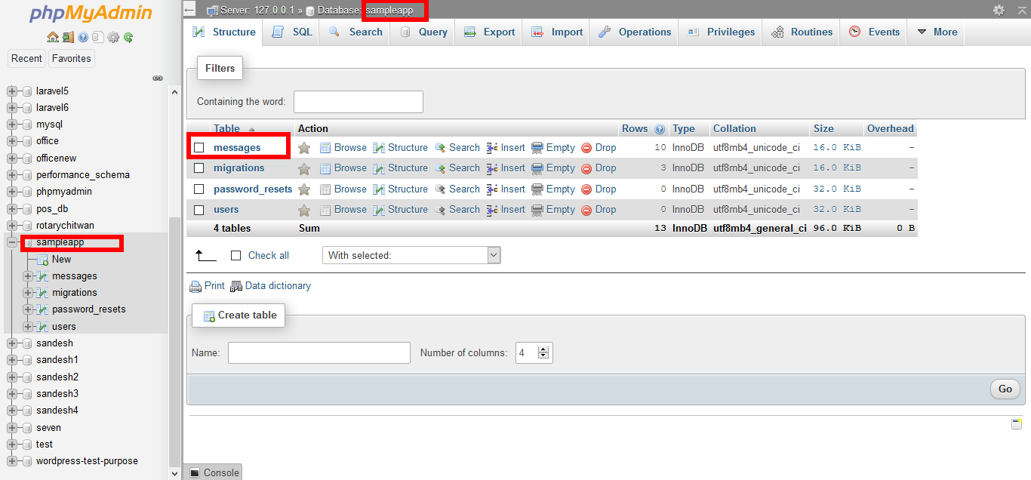

Inside message

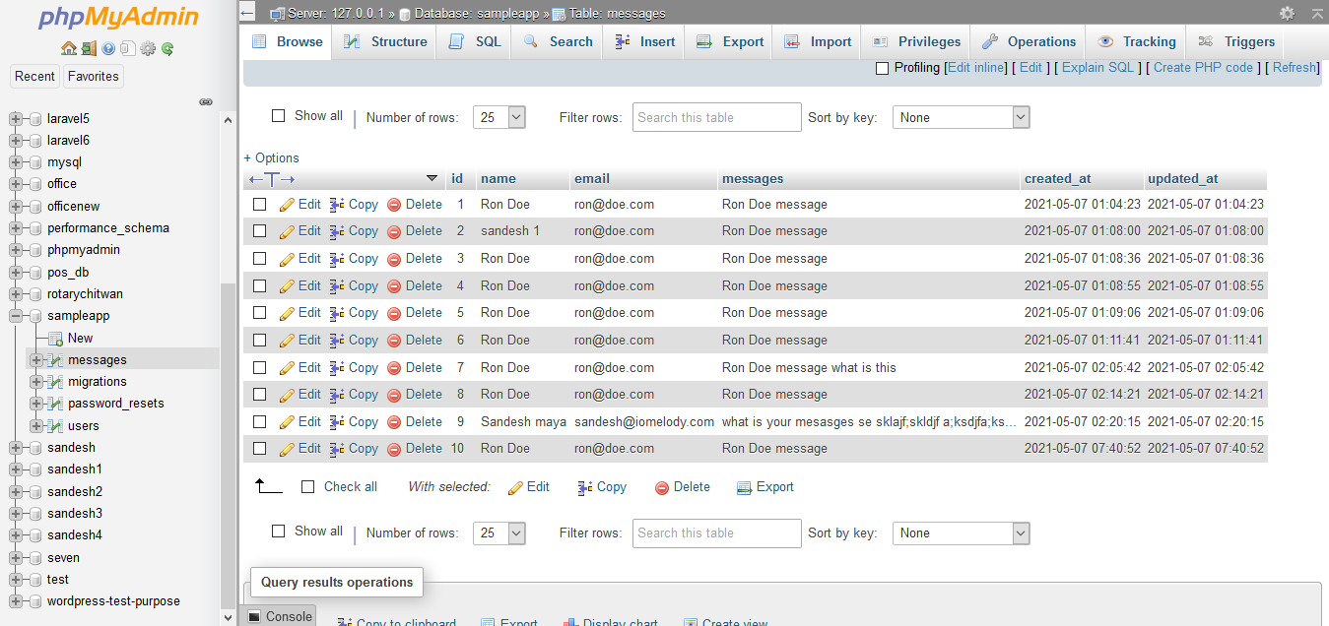

And there’s another thing also that we can view those messages from front end theres’ no user validation at this project but we can see from

localhost/messages

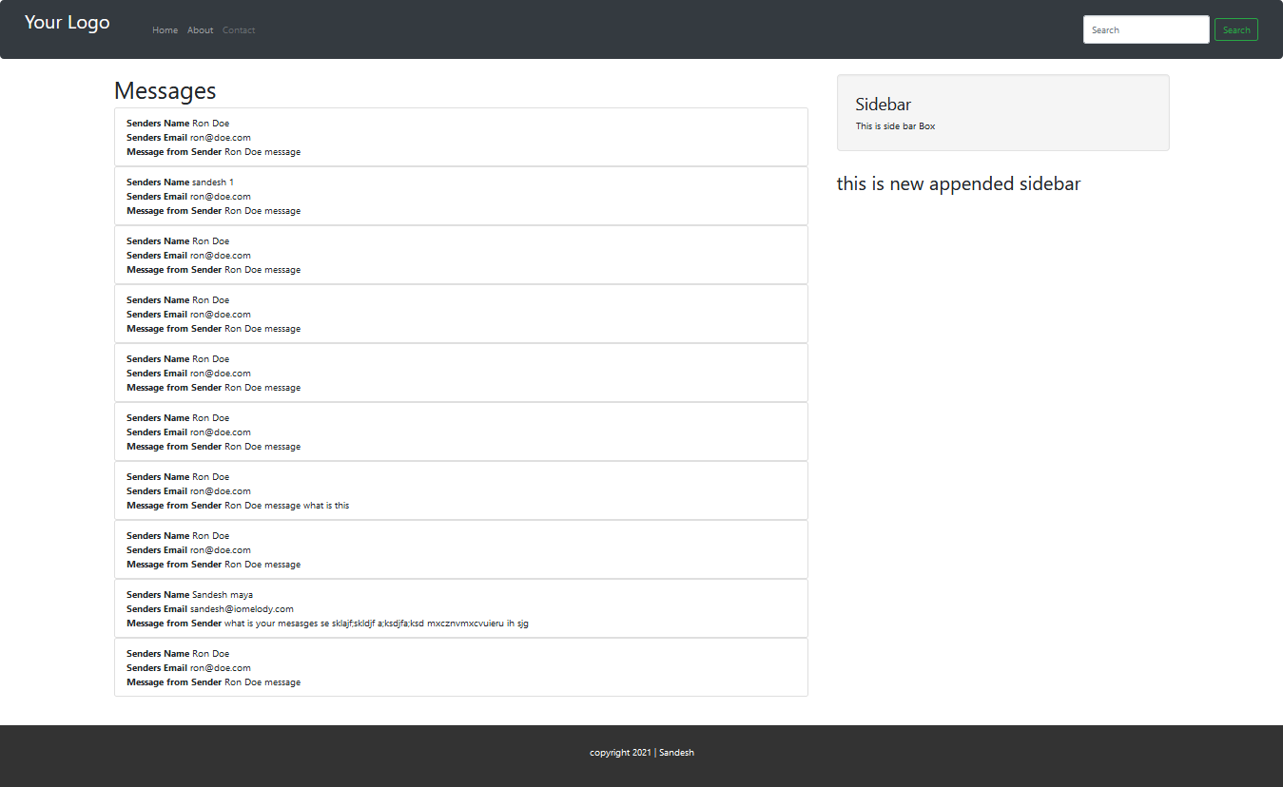

Like you can guess not much but a lot is going over this project for someone who is just starting the project you can learn a lot from this project. And I have not mentioned about my route file it’s well managed and there’s no any logics or function over there I have created separate pagesController to navigate through pages and all route is called to that controller.

[no logics should be written in route file.]

@csrf not to be forget in form fields] or in blade {‼ csrf_field()‼}

Note in this project I tried to create from using larael collective which is also a laravel package but may be some issues I was unable to perform so I did it using bootstrap. Current laravel version is 8.x and I am running this in laravel 5.4

That’s it. Thank you!