Multimodal Speech-to-Video Generation Framework for Object Learning in Specially Abled Education
Sandesh PY¹, Dr. Hamsaveni M²
¹Dept. of Computer Science & Engineering, Vidyavardhaka College of Engineering Mysuru, India
² Dept. of Computer Science & Engineering, Vidyavardhaka College of Engineering Mysuru, India
¹vvce24cse0583@vvce.ac.in ; ²hamsaveni.m@vvce.ac.in

ABSTRACT
Recent advancements in generative artificial intelligence have created new opportunities for developing interactive and accessible educational technologies. Specially abled learners, particularly individuals with hearing impairments and hyperactive conditions, often rely on visual learning methods to understand object vocabulary and real-world concepts. However, traditional educational tools such as flashcards and static images provide limited dynamic visual representation. This paper presents a multimodal Speech-to-Video Generation Framework aimed at helping specially abled learners by turning spoken or typed object names into short educational videos. This is done by making use of immersive video production that aligns with repetitive sound reinforcement to greatly enhance the object recognition and concentration process. This is done through the incorporation of speech recognition, multilingual support, prompt production, and artificial intelligence-driven video production to generate visual presentations that correspond to the input of the user. Rather than developing customized datasets, this system uses pretrained generative models in a GPU environment to develop several visual scenes for each object. These scenes are then combined together to form an ultimate educational video.
It can be seen from the prototype that it is possible to convert oral/written input into visual teaching materials through artificial intelligence-based techniques. The proposed approach focuses on the capacity of the multimedia generation technique based on artificial intelligence in promoting accessibility and engagement.
Keywords— Speech-to-Video Generation, Generative Artificial Intelligence, Diffusion Models, Multimodal Learning, Inclusive Education.

INTRODUCTION
Inclusive education refers to the creation of an environment where all learners receive equal opportunities for learning, regardless of whether or not they are specially abled. Learners with hearing impairments rely on visual learning techniques for the acquisition of object names and practical ideas. However, conventional instructional tools like textbooks and flashcards present restricted dynamism when illustrating objects and their actions. With the advent of artificial intelligence technology, the creation of computer-generated models that create visual elements from text has become possible. Models such as text-to-image and text-to-video generation enable the generation of real-life images using natural language inputs [5].
Generation of text-to-video is another research direction wherein text prompts are generated in form of video clips. Text-to-image synthesis through diffusion models has shown remarkable results in generating images corresponding to textual descriptions [2]. Such methods can be used to generate the educational videos for these objects. In order to achieve this goal, we propose our framework for Speech to Video Generation in multimodal format. As per our framework, educational videos corresponding to input object names are generated by utilizing speech recognition, prompt generation, and pre-trained generative models.

LITERATURE REVIEW & RESEARCH GAP
With recent developments in artificial intelligence and neural networks, machines have increasingly become proficient at creating visual media that is generated from text or verbal input. Generative models, most notably generative adversarial networks and diffusion models, have shown greater success in generating images and videos based on natural language [5]. Multilingual artificial intelligence frameworks have been developed to convert educational content into multiple languages while generating synchronized visual media. Such systems integrate translation models, speech synthesis techniques, and video generation algorithms to produce multimedia educational materials in regional languages [1]. These approaches help overcome language barriers and improve accessibility for learners who prefer studying in their native language.
Diffusion models have become a widely used technique for generative media synthesis. These models operate by gradually removing noise from random data to generate structured visual outputs. Diffusion-based text-to-video models can generate video frames aligned with textual descriptions while maintaining visual realism [2]. However, maintaining temporal consistency between frames remains a significant challenge in video generation. Artificial intelligence-driven accessibility systems have also been proposed to improve digital content accessibility for individuals with hearing impairments. These systems convert spoken language into visual elements such as images, emojis, or graphical cues using deep learning models and speech recognition algorithms [3]. Experimental results show that visual representations significantly improve comprehension and engagement among hearing-impaired users. Assistive learning platforms integrating speech-to-text, text-to-speech, and sign language translation technologies have been developed to support inclusive education [4].
In addition to generative models, cross-modal learning techniques have been used to improve the relationship between textual queries and video content [8]. Recent studies have also explored customized video generation techniques that combine textual prompts with structural guidance such as motion information or depth maps [9]. To address the high computational cost associated with video generation, grid diffusion models have been proposed to represent videos as structured image grids [10].
Research Gap: Nevertheless, studies dedicated to leveraging video generation technology to support specially abled learners have not been conducted extensively. As a result, combining speech recognition with multilingual processing and diffusion for video generation constitutes another research avenue that needs to be explored.

PROBLEM STATEMENT & OBJECTIVES
The basic issue lies in the fact that especially abled kids, particularly those with hearing problems and hyperactive disorders, presently do not have a means that could enable them to learn physical vocabulary through an interactive platform in their own regional language. Such children are generally made to depend upon conventional books or other online sources that can only provide information in English. This makes it impossible for them to learn because these methods fail to work effectively in such cases. By generating dynamic video outputs synchronized with repetitive auditory reinforcement—where the mapped input audio is rhythmically looped alongside the visual animation (for example, continuously repeating the spoken target word while the video plays)—the proposed system creates a highly stimulating, continuous multimodal feedback loop. This particular combination of video creation and audio repetition is particularly well-suited for capturing and maintaining the focus of the hyperactive learners, thus hastening their vocabulary development together with those who are hearing-impaired peers.
The main goals of the proposed system include::
- The development of a multimodal generation pipeline that can handle voice and textual inputs.
- The incorporation of a multilingual processing module that can manage regional languages such as Kannada, in addition to English.
- To automatically create concise and unequivocal educational videos regarding particular real-life objects alongside repetitive sounds.
- To operate the application via an easy-to-use web interface that performs intensive video production computations remotely behind the scenes.

METHODOLOGY

System Architecture
The proposed Speech-to-Video learning system follows a modular architecture that converts speech or textual input into short educational videos. The system integrates speech recognition, natural language processing, and artificial intelligence-based video generation models. The architecture consists of a User Input Module, Speech Recognition Module, Language Translation Module, Prompt Generation Module, Video Generation Module, Scene Composition Module, and Web Interface Module.

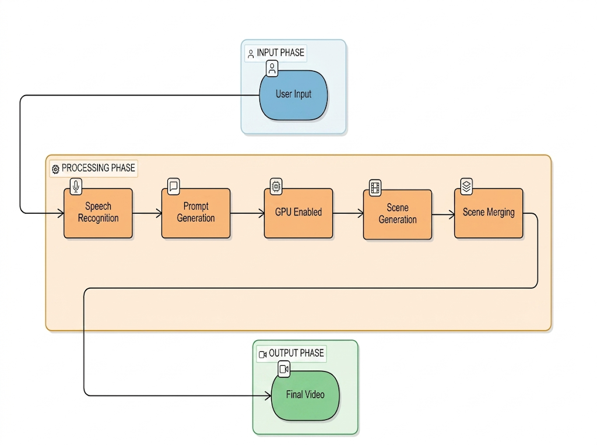
Implementation Workflow

Fig. 1 Proposed Speech-to-Video processing pipeline and system architecture
- User Input Module: The interface captures spoken input using a microphone or typed input through a web interface, acting as the primary interaction layer.
- Speech Recognition & Translation: If the input is provided in speech format, automatic speech recognition converts audio signals into textual data. To support multilingual users, inputs in regional scripts (like Kannada) are translated into English using neural machine translation models, as generative video models require English prompts.
- Prompt Generation: The recognized object name is converted into a structured prompt using a predefined template to ensure consistency (e.g., "A clear educational visual representation of a [INPUT] showing its appearance and movement").
- GPU-Based Video Generation and Audio Synchronization: As the generative model requires significant complexity, video generation occurs within a separate GPU system. It is responsible for producing a number of small scenes, each representing different parts of the object being analyzed. In parallel, the spoken word undergoes the processing stage resulting in an audio loop.
- Scene Composition: All the generated scenes are combined into a complete educational video. This looped audio file is added to the video itself to ensure the availability of constant feedback to promote hyperactivity. The video is returned to the user's browser.

RESULTS & DISCUSSIONS
The prototype system was tested with multiple object inputs to evaluate the feasibility of generating visual educational content from textual and speech prompts. The experiment focused on verifying whether the system could successfully convert isolated object names into dynamic visual demonstrations. Test cases included common vocabulary objects such as aeroplane, dog, lion, and tree. For each input object, the system generates multiple scenes which are then merged to produce a final video output.
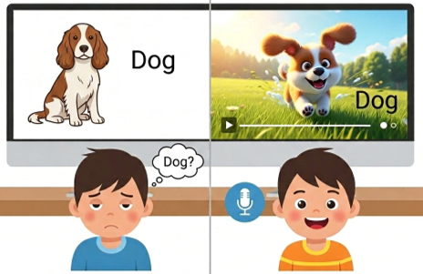
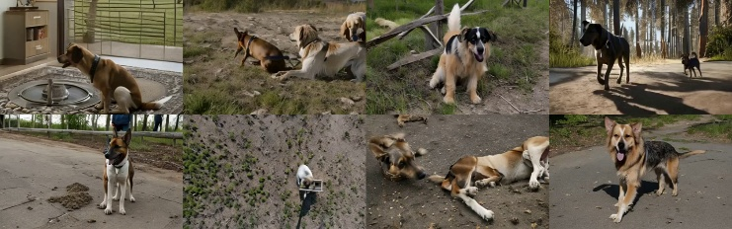
Fig. 3. Multi-scene generation process showing eight frames extracted from the generated video before scene merging.

Fig. 2 End-user application of speech-driven animation.
(Generated via Gemini AI)

TABLE I: SYSTEM OUTPUT EVALUATION FOR OBJECT INPUTS
Input Object | Generated Scenes | Final Output | Status
Aeroplane | 8 scenes | Educational video | Successful
Dog | 8 scenes | Educational video | Successful
Lion | 8 scenes | Educational video | Successful

As shown in the experimental evaluation, the proposed Speech-to-Video framework is effective in transforming object names into visual educational demonstrations. The video generated makes it easier for learners to learn about objects through visualization. Multiple scenes involved in the process of creating videos make more information available to the learner. It helps the learner become more interested in learning about the objects, as it is shown from various perspectives. Moreover, linking this information with rhythmical audio makes them more focused.
Video generation through generative artificial intelligence involves processes that demand powerful computing power. Since the system is currently prototyped using a relatively low-powered edge computing infrastructure, the whole process of generating the video is estimated to take between 20 to 30 minutes using just one object input. This takes between 4 to 8 minutes to generate each scene. Generation time will be considerably reduced if the process is conducted in an environment equipped with powerful GPUs, and it can prove ideal for use in educational scenarios. The use of pretrained generative models poses another challenge since the videos generated depend heavily on the performance of the model itself.
In comparison with current techniques which concentrate solely on producing long movies or even simply synchronizing the lips with faces, the new model has been specifically designed to visualize concepts. The output screen captures clearly show that the technique is able to circumvent all the extra baggage of creating a story, thus focusing only on demonstrating objects from multiple angles. This method ensures that computation is used exclusively in learning vocabularies, making it an efficient special educational tool.

CONCLUSION
In this study, a multi-modal Speech to Video generation model has been proposed which would assist the specially abled children including those who have hearing disabilities and hyperactivity in learning object names through visualization. The speech-to-video framework would make use of speech recognition, multilingual processing, prompt generation, and generative artificial intelligence techniques for the conversion of speech or text into an instructional video. In the proposed system, the input is taken from the user which is either in the form of speech or text. This input is then utilized in generating structured prompts which are subsequently utilized by pretrained generative models in a GPU-enabled environment to generate visual scenes. Subsequently, visual scenes are generated which along with repetitive auditory prompts are combined to create instructional videos which can be accessed by the user through a web-based portal. The proposed system has been developed as a proof-of-concept which demonstrates how object names can be turned into learning material in the form of visual content.

REFERENCES
[1] P. Subha, M. Nithya, R. Keerthana, and S. Harini, "AI-Based Multilingual Text-to-Video and Speech Generation System," Proceedings of the International Conference on Artificial Intelligence and Smart Systems, 2025.
[2] U. Sehgal, A. Gupta, and S. Sharma, "Text-to-Video Generation Using Latent Diffusion Models: Structural and Temporal Analysis," Proceedings of IEEE Madhya Pradesh Conference (MPCON), 2025.
[3] M. Hatami and M. Chegini, "Enhancing Digital Content Accessibility for the Hearing Impaired Through AI-Driven Visual Representations," Proceedings of the IEEE International Conference on Artificial Intelligence Applications, 2024.
[4] P. S. Kumari, M. S. Kumar, R. Karthikeyan, and V. Balamurugan, "Deep Learning-Based Multi-Model Assistive Learning System for Hearing and Visually Impaired Students," Proceedings of the IEEE International Conference on Intelligent Systems, 2023.
[5] A. Singh and R. Verma, "A Survey of AI Text-to-Image and AI Text-to-Video Generators," Proceedings of the IEEE International Conference on Artificial Intelligence and Data Science, 2023.
[6] G. Kaur and P. Sharma, "A Study of NLP and AI-Driven Online Text-to-Video Generation Platforms in Social Media," Proceedings of the IEEE International Conference on Smart Computing and Artificial Intelligence, 2024.
[7] I. Priya P., R. H. Kumar, and S. Manikandan, "Transforming Text to Video: Leveraging Advanced Generative AI Techniques," Proceedings of the IEEE International Conference on Emerging Technologies in Artificial Intelligence, 2024.
[8] J. Dong, Y. Wang, X. Chen, X. Qu, X. Li, Y. He, and X. Wang, "Reading-Strategy Inspired Visual Representation Learning for Text-to-Video Retrieval," IEEE Transactions on Circuits and
Systems for Video Technology, vol. 32, no. 8, pp. 5680–5694, 2022.
[9] J. Xing et al., "Make-Your-Video: Customized Video Generation Using Textual and Structural Guidance," IEEE Transactions on Visualization and Computer Graphics, 2025.
[10] T. Lee, S. Kwon, and T. Kim, "Grid Diffusion Models for Text-to-Video Generation," Proceedings of the IEEE/CVF Conference on Computer Vision and Pattern Recognition (CVPR), 2024.

AUTHORS PROFILE

Sandesh PY is currently pursuing his academic degree in the Department of Computer Science & Engineering at Vidyavardhaka College of Engineering, Mysuru, India. The primary research interests lie in advanced computing, multimodal machine learning, and assistive technologies aimed at enhancing digital accessibility for specially abled individuals.

Dr. Hamsaveni M is an Associate Professor in the Department of Computer Science & Engineering at Vidyavardhaka College of Engineering, Mysuru, India. With over 14 years of experience in academia and research, her work predominantly focuses on computer networks, cloud computing, Internet of Things (IoT), and the application of machine learning.

