#include <stdio.h>
#include <stdlib.h>

struct node
{
int info;
struct node *prev;
struct node *next;
};

struct node *start = NULL;

void create(int value)
{
struct node *newnode = malloc(sizeof(struct node));
newnode->info = value;
newnode->prev = NULL;
newnode->next = NULL;

if (start == NULL)
{
start = newnode;
}
else
{
struct node *temp = start;
while (temp->next != NULL)
temp = temp->next;
temp->next = newnode;
newnode->prev = temp;
}
}

void insert_left(int value, int key)
{
struct node *temp = start;

while (temp != NULL && temp->info != key)
temp = temp->next;

if (temp == NULL)
{
printf("Element not found\n");
return;
}

struct node *newnode = malloc(sizeof(struct node));
newnode->info = value;
newnode->next = temp;
newnode->prev = temp->prev;

if (temp->prev != NULL)
temp->prev->next = newnode;
else
start = newnode;

temp->prev = newnode;
printf("Inserted to the left\n");
}

void delete_value(int key)
{
struct node *temp = start;

while (temp != NULL && temp->info != key)
temp = temp->next;

if (temp == NULL)
{
printf("Element not found\n");
return;
}

if (temp->prev != NULL)
temp->prev->next = temp->next;
else
start = temp->next;

if (temp->next != NULL)
temp->next->prev = temp->prev;

free(temp);
printf("Node deleted\n");
}

void display()
{
struct node *temp = start;

if (temp == NULL)
{
printf("List is empty\n");
return;
}

printf("List: ");
while (temp != NULL)
{
printf("%d ", temp->info);
temp = temp->next;
}
printf("\n");
}

int main()
{
int n, value, i;
int choice, key;

printf("Enter number of nodes: ");
scanf("%d", &n);

for (i = 0; i < n; i++)
{
scanf("%d", &value);
create(value);
}

printf("\n1.Insert Left\n2.Delete\n3.Display\n4.Exit\n");
while (1)
{
printf("Enter choice: ");
scanf("%d", &choice);

switch (choice)
{
case 1:
printf("Enter new value: ");
scanf("%d", &value);
printf("Enter key value: ");
scanf("%d", &key);
insert_left(value, key);
break;

case 2:
printf("Enter value to delete: ");
scanf("%d", &key);
delete_value(key);
break;

case 3:
display();
break;

case 4:
return 0;
}

printf("\n");
}
}

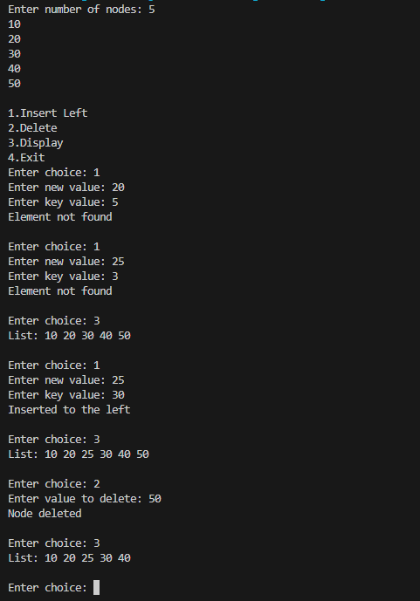
OUTPUT;

