## What Is DevOps?

DevOps is a methodology that integrates software development (Dev) with IT operations (Ops). It focuses on automating the software delivery process and maintaining continuous improvement throughout the software development lifecycle (SDLC).

## Technical Overview and History

* **Traditional Model:** In traditional software engineering, developers write code and then “hand it off” to operations. This separation often led to delays and errors.
* **DevOps Emergence:** Around 2007–2008, engineers identified that merging these functions—through practices such as continuous integration (CI) and continuous delivery (CD)—could greatly reduce release times and errors. This integration led to the DevOps movement.

## The DevOps Lifecycle

The DevOps lifecycle is a continuous process composed of several technical stages:

1. **Plan:** Define requirements and project scope using tools like Jira.
2. **Code & Build:** Write code in version control systems (e.g., Git) and compile or build the application.
3. **Test:** Use automated testing frameworks to run unit tests, integration tests, and regression tests.
4. **Release & Deploy:** Implement CI/CD pipelines to automatically deploy code to staging and production environments.
5. **Operate & Monitor:** Use monitoring tools (e.g., Splunk, Datadog) to track system performance, uptime, and security.
6. **Learn:** Analyze feedback and conduct blameless postmortems to refine processes and improve code quality.

Each stage relies on technical tools and automation to ensure rapid, reliable software releases.

## DevOps Culture and Its Technical Impact

A robust DevOps culture emphasizes:

* **Collaboration:** Cross-functional teams work together, breaking down silos between developers, operations, and QA.
* **Automation:** Automating processes such as builds, tests, deployments, and monitoring reduces human error and speeds up delivery.
* **Continuous Feedback:** Real-time monitoring and automated alert systems provide immediate technical feedback to developers.
* **Shared Responsibility:** Developers take part in operations (often encapsulated by the “you build it, you run it” principle), leading to better code quality and faster issue resolution.

This technical culture contrasts with traditional IT, where rigid separation and manual processes often lead to slower deployments and higher risk of errors.

## Technical Case Study: Knight Capital Group

In 2012, Knight Capital Group experienced a severe failure due to a manual deployment error:

* **Deployment Issue:** Out of eight servers, one did not receive the updated code because the deployment process was manual.
* **Legacy Code Activation:** An old flag triggered outdated functionality (“Power Peg”) on the missed server.
* **Consequences:** This resulted in erroneous trades and a loss of approximately $460 million in 45 minutes.
* **Technical Lessons:** Automated deployments, version control consistency, and real-time monitoring would have likely prevented this failure.

[dougseven.com](https://dougseven.com/2014/04/17/knightmare-a-devops-cautionary-tale/)

## Key DevOps Principles for Preventing Failures

For a company like NexusCorp, adhering to these technical principles could prevent early issues:

* **Automated CI/CD Pipelines:** Ensure code is built, tested, and deployed uniformly.
* **Integrated Monitoring Tools:** Set up continuous monitoring to quickly detect and alert on failures.
* **Cross-Functional Teams:** Enable collaboration between development, operations, and QA to share technical responsibility.
* **Blameless Postmortems:** Conduct technical reviews after incidents to identify improvements without assigning blame.
* **Version Control and Configuration Management:** Maintain a single source of truth for code and configuration to avoid discrepancies.

**CASE STUDY ON NEXUSCorp:**

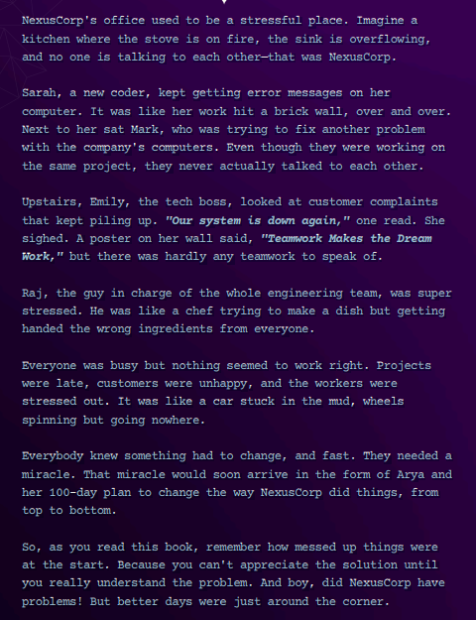

**1. What was the most shocking aspect of NexusCorp's initial state to you?**

The most shocking aspect was the complete breakdown of collaboration and communication. Despite working on the same projects, the teams operated in isolated silos with no shared version control or unified deployment processes. This led to inconsistent configurations, repeated errors, and an inability to detect and correct issues promptly—much like a system with misconfigured environments causing cascading failures.

**2. Why do you think DevOps could be a solution to NexusCorp's problems?**

DevOps could solve these issues because it integrates development and operations through automated CI/CD pipelines, continuous testing, and real-time monitoring. By breaking down silos, it enables seamless communication and shared responsibility. This integration reduces manual errors and inconsistencies, ensures that every change is tested and deployed uniformly, and creates rapid feedback loops to quickly resolve issues.

**3. How can DevOps be customized to fit different organizational needs?**

DevOps is inherently flexible; it can be tailored by selecting tools and practices that align with the organization's structure and goals. For example:

* **Tool Selection:** Choose CI/CD, configuration management, and monitoring tools that fit the team’s workflow.
* **Process Adaptation:** Adjust deployment strategies (e.g., blue-green deployments, canary releases) to suit scale and risk tolerance.
* **Cultural Integration:** Implement agile practices that encourage iterative improvements and cross-functional teamwork, adapting the pace and level of automation based on organizational maturity.

This customization ensures that DevOps practices enhance efficiency without imposing a rigid, one-size-fits-all model.

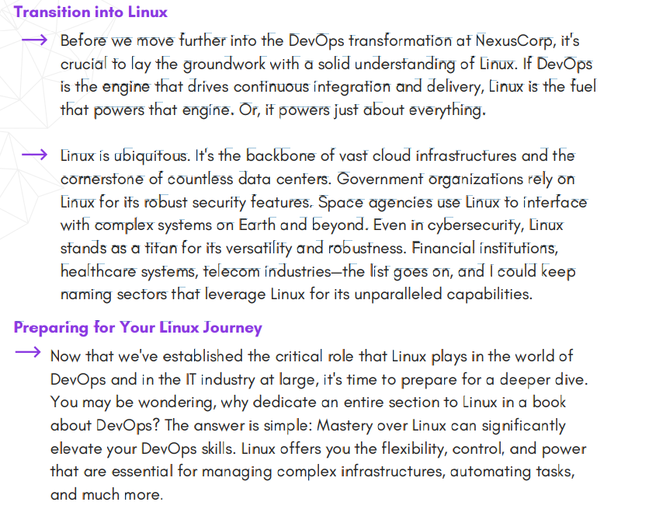

**Netflix DevOps Case Study Summary**

Netflix’s journey to becoming a DevOps leader began after a major outage in 2008 prompted a full-scale migration to the cloud. Instead of merely shifting legacy systems, Netflix re-architected its entire application from a monolithic Java application to a cloud-native, microservices-based system on AWS. This migration enabled Netflix to build horizontally scalable and resilient systems, fundamentally changing its operational model.

Key technical initiatives included:

* **Cloud Migration & Microservices:**  
  Netflix rewrote its application to use a microservices architecture with NoSQL databases, enabling loosely coupled services. This allowed independent teams to build, test, and deploy changes rapidly, significantly accelerating the release cycle.
* **Chaos Engineering:**  
  To ensure system resilience, Netflix developed **Chaos Monkey**—a tool that randomly terminates instances in production. This practice, along with the broader **Simian Army** (including tools like Latency Monkey, Conformity Monkey, and Chaos Gorilla), allowed Netflix to continuously test failure scenarios and build robust recovery mechanisms.
* **Containerization with Titus:**  
  Netflix adopted container technology and built its own container management platform, **Titus**. This solution standardized container deployments, improved resource utilization, and reduced deployment times from tens of minutes to just one or two minutes.
* **Operate What You Build Culture:**  
  By shifting from siloed roles to a model where development teams are also responsible for operating their code (“you build it, you run it”), Netflix minimized communication gaps, shortened feedback loops, and enhanced overall system reliability.

**Lessons Learned:**  
Netflix’s approach shows that a successful DevOps transformation isn’t just about tools—it’s about culture. Key takeaways include empowering teams with full control over the SDLC, automating failure testing to build fault tolerance, and continuously innovating to meet customer demands.