* Reading data from external source file is called parameterization.
* Apache poi configuration
* How to do apache poi configuration?

1. Step download apache poi from below site

<https://www.apache.org/dyn/closer.lua/poi/release/bin/poi-bin-5.2.1-20220224.zip>

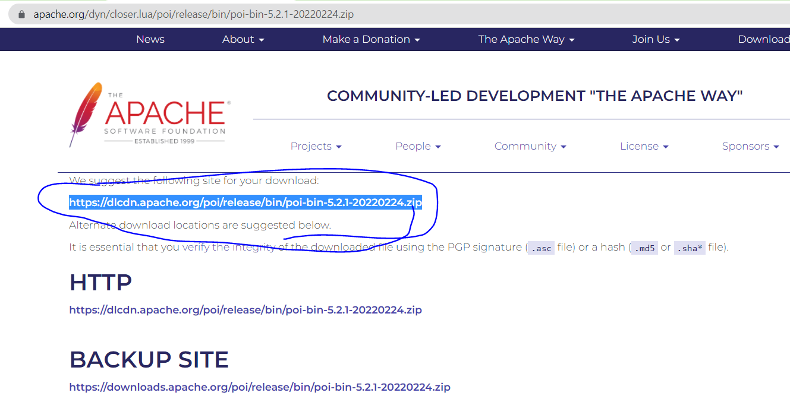

Step 2: unzip downloaded zip to folder

Step 3:Cofigure downloaded files into project

Step 4: goto build path and add external jars

8 jars+ auxiliary + lib + ooxml-lib

**package** parametrization;

**import** java.io.FileInputStream;

**import** java.io.IOException;

**import** org.apache.poi.EncryptedDocumentException;

**import** org.apache.poi.ss.usermodel.WorkbookFactory;

**import** org.openqa.selenium.By;

**import** org.openqa.selenium.WebDriver;

**import** org.openqa.selenium.chrome.ChromeDriver;

**import** config.Configuration;

**public** **class** TC01 {

**public** **static** **void** main(String[] args) **throws** EncryptedDocumentException, IOException {

//Read excel sheet data

FileInputStream path = **new** FileInputStream("C:\\Users\\balaji\\Desktop\\Java Automation\\1-Jan\\Automation\\paramterization\\TestData.xlsx");

String username = WorkbookFactory.*create*(path).getSheet("Sheet1").getRow(2).getCell(1).getStringCellValue();

System.***out***.println(username);

//Browser launch

System.*setProperty*("webdriver.chrome.driver", Configuration.*driverPath*);

WebDriver driver = **new** ChromeDriver();

driver.get(Configuration.*appUrl*);

driver.manage().window().maximize();

driver.findElement(By.*xpath*("//input[@id='email']")).sendKeys(username);

}

}

Ex:

**package** parametrization;

**import** java.io.FileInputStream;

**import** java.io.FileNotFoundException;

**import** java.io.IOException;

**import** org.apache.poi.EncryptedDocumentException;

**import** org.apache.poi.ss.usermodel.WorkbookFactory;

**public** **class** Demo {

**public** **static** **void** main(String[] args) **throws** EncryptedDocumentException, IOException {

FileInputStream path = **new** FileInputStream("C:\\Users\\balaji\\Desktop\\Java Automation\\1-Jan\\Automation\\paramterization\\TestData.xlsx");

String readData = WorkbookFactory.*create*(path).getSheet("Sheet1").getRow(1).getCell(2).getStringCellValue();

System.***out***.println(readData);

}

}

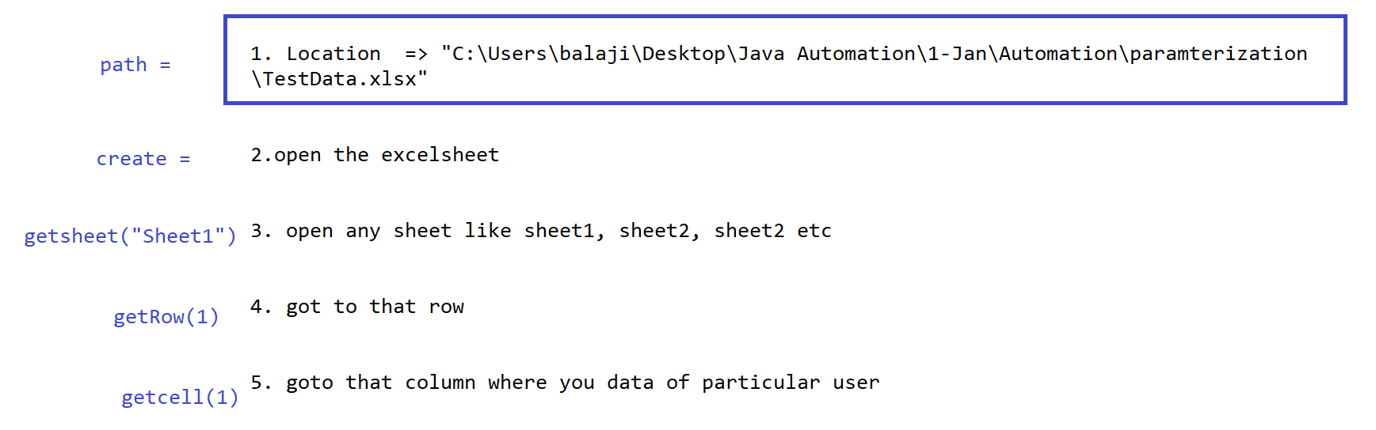

Parameterization:

* Reading data from externl source file is known as parametrization.
* External source file can be excel sheet, csv file , testNg data provider.

To read excel we to perform following configuration in project

Step1: to read excel sheet we have to add apche poi in project.

Step2: create one excel sheet and some data into that sheet.

Step3: To specify location and name of excel sheet create object of FileInptStream class and pass location as argument.

FileInputStream path = **new** FileInputStream("Excel sheet path");

Step4: call the static method create() and pass object of FileInputStream class as argument. Create method is part of workbookfactory.

Ex: WorkbookFactory.create(path)

This method will open excel sheeet

Step 5: to open praticaular sheet call method getSheet() method and pass sheet name as argument.

WorkbookFactory.create(path).getSheet("Sheet1")

Step6: to get data from particular row and column call the method getRow() and getCell()

Step7: TO read string type of information call method getStringCellValue() which retruns string as data type

Step8: if we want to read numeric value call method getNeumericCellValue().

**import** org.apache.poi.EncryptedDocumentException;

**import** org.apache.poi.ss.usermodel.WorkbookFactory;

**public** **class** Test {

**public** **static** **void** main(String[] args) **throws** EncryptedDocumentException, IOException {

**for** (**int** i = 1; i <= 4; i++) {

FileInputStream path = **new** FileInputStream(

"C:\\Users\\balaji\\Desktop\\Java Automation\\1-Jan\\Automation\\paramterization\\TestData.xlsx");

String readData = WorkbookFactory.*create*(path).getSheet("Sheet1").getRow(i).getCell(2).getStringCellValue();

System.***out***.println(readData);

}

}

}

**package** parametrization;

**import** java.io.FileInputStream;

**import** java.io.FileNotFoundException;

**import** java.io.IOException;

**import** org.apache.poi.EncryptedDocumentException;

**import** org.apache.poi.ss.usermodel.WorkbookFactory;

**public** **class** Test1 {

**public** **static** **void** main(String[] args) **throws** EncryptedDocumentException, IOException {

FileInputStream path = **new** FileInputStream(

"C:\\Users\\balaji\\Desktop\\Java Automation\\1-Jan\\Automation\\paramterization\\TestData.xlsx");

**int** value = WorkbookFactory.*create*(path).getSheet("Sheet1").getLastRowNum();

System.***out***.println(value);

}

}

**package** parametrization;

**import** java.io.FileInputStream;

**import** java.io.FileNotFoundException;

**import** java.io.IOException;

**import** org.apache.poi.EncryptedDocumentException;

**import** org.apache.poi.ss.usermodel.Cell;

**import** org.apache.poi.ss.usermodel.Sheet;

**import** org.apache.poi.ss.usermodel.WorkbookFactory;

**public** **class** Test2 {

**public** **static** **void** main(String[] args) **throws** EncryptedDocumentException, IOException {

FileInputStream path = **new** FileInputStream(

"C:\\Users\\balaji\\Desktop\\Java Automation\\1-Jan\\Automation\\paramterization\\TestData.xlsx");

Sheet sht = WorkbookFactory.*create*(path).getSheet("Sheet1");

**for** (**int** i = 0; i <= 4; i++) {

String data = sht.getRow(i).getCell(1).getStringCellValue();

System.***out***.println(data);

}

}

}

Ex:

**package** parametrization;

**import** java.io.FileInputStream;

**import** java.io.FileNotFoundException;

**import** java.io.IOException;

**import** org.apache.poi.EncryptedDocumentException;

**import** org.apache.poi.ss.usermodel.Cell;

**import** org.apache.poi.ss.usermodel.Sheet;

**import** org.apache.poi.ss.usermodel.WorkbookFactory;

**public** **class** Test2 {

**public** **static** **void** main(String[] args) **throws** EncryptedDocumentException, IOException {

FileInputStream path = **new** FileInputStream(

"C:\\Users\\balaji\\Desktop\\Java Automation\\1-Jan\\Automation\\paramterization\\TestData.xlsx");

Sheet sht = WorkbookFactory.*create*(path).getSheet("Sheet1");

**for** (**int** i = 0; i <= 4; i++) {

**for** (**int** j = 0; j <= 3; j++) {

String data = sht.getRow(i).getCell(j).getStringCellValue();

System.***out***.println(data);

}

}

}

}