α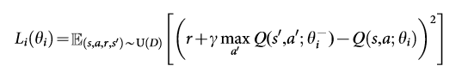

Figure 1

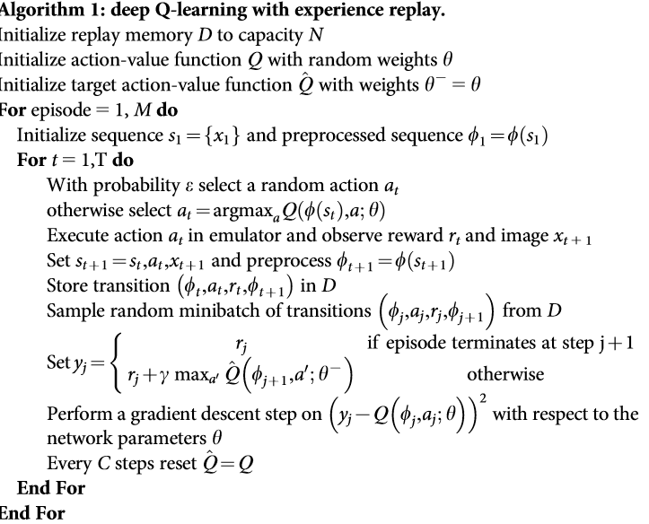

*at* = *argmax*a *Q*(Φ(*st*), *a; θ*)

Ε