<link rel="stylesheet" href="jquery-ui/jquery-ui.css" />

<link rel="stylesheet" href="jquery-ui/jquery-ui.structure.css" />

<link rel="stylesheet" href="jquery-ui/jquery-ui.theme.css" />

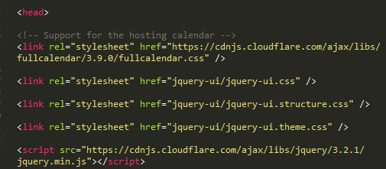

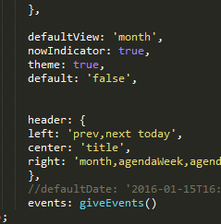

Theme: true,

Default: ‘false’