

Customer Retention

Submitted by:

SANDES P

**ACKNOWLEDGMENT**

I used different online sources and research papers to understand the domain. Some of them are given below. I used informative tutorials to follow some steps in the task from websites like geeksforgeeks, stackoverflow, etc.

**INTRODUCTION**

* Business Problem Framing

E-retail factors for customer activation and retention: A case study from Indian e-commerce customers

Customer satisfaction has emerged as one of the most important factors that guarantee the success of the online store; it has been posited as a key stimulant of purchase, repurchase intentions and customer loyalty. A comprehensive review of the literature, theories and models have been carried out to propose the models for customer activation and customer retention. Five major factors that contributed to the success of an e-commerce store have been identified as: service quality, system quality, information quality, trust and net benefit. The research furthermore investigated the factors that influence the online customers repeat purchase intention. The combination of both utilitarian value and hedonistic values are needed to affect the repeat purchase intention (loyalty) positively. The data is collected from the Indian online shoppers. Results indicate the e-retail success factors, which are very much critical for customer satisfaction. Be careful: There are two sheets (one is detailed) and second is encoded in the excel file. You may use any of them by extracting in separate excel sheet. The number of column(s) is more than 47. Read the column header carefully. Note : Data Scientists have to apply their analytical skills to give findings and conclusions in detailed data analysis written in jupyter notebook . Only data analysis is required.

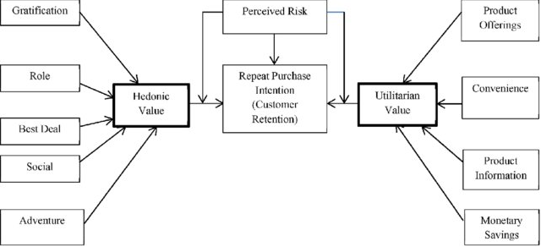

* Conceptual Background of the Domain Problem

This domain is related to the different online shopping websites in India. We have collected different data from people who use different online shopping websites like Amazon, Flipkart, etc. Our aim is to analyze the data and find anything related to customer retention.

* Review of Literature

Here we are trying to analyze the data in terms of customer retention. But the problem with the data is, it is scattered on different websites. So Finding the people who tend to retain is difficult. According to some researches, some factors depend on the performance of the website, secure transactions, different offers, etc. The trustworthiness and return policies also matter.

**Analysis**

* Data Sources and their formats

The data source is output from surveys done on e-commerce users in India. The form of the dataset is in xlsx format. The dataset has 71 columns and 269 rows.

1Gender of respondent,

2 How old are you? ,

3 Which city do you shop online from?,

4 What is the Pin Code of where you shop online from?,

5 Since How Long You are Shopping Online ?,

6 How many times you have made an online purchase in the past 1 year?,

7 How do you access the internet while shopping on-line?,

8 Which device do you use to access the online shopping?,

9 What is the screen size of your mobile device?

10 What is the operating system (OS) of your device?

11 What browser do you run on your device to access the website?

12 Which channel did you follow to arrive at your favorite online store for the first time? ,

13 After first visit, how do you reach the online retail store? 14 How much time do you explore the e- retail store before making a purchase decision? ,

15 What is your preferred payment Option? ,

16 How frequently do you abandon (selecting an items and leaving without making payment) your shopping cart? ,

17 Why did you abandon the “Bag”, “Shopping Cart”? ,

18 The content on the website must be easy to read and understand,

19 Information on similar product to the one highlighted is important for product comparison,

20 Complete information on listed seller and product being offered is important for purchase decision.,

21 All relevant information on listed products must be stated clearly,

22 Ease of navigation in website, 23 Loading and processing speed,

24 User friendly Interface of the website,

25 Convenient Payment methods,

26 Trust that the online retail store will fulfill its part of the transaction at the stipulated time,

27 Empathy (readiness to assist with queries) towards the customers,

28 Being able to guarantee the privacy of the customer,

29 Responsiveness, availability of several communication channels (email, online rep, twitter, phone etc.),

30 Online shopping gives monetary benefit and discounts,

31 Enjoyment is derived from shopping online,

32 Shopping online is convenient and flexible,

33 Return and replacement policy of the e-tailer is important for purchase decision,

34 Gaining access to loyalty programs is a benefit of shopping online,

35 Displaying quality Information on the website improves satisfaction of customers,

36 User derive satisfaction while shopping on a good quality website or application,

37 Net Benefit derived from shopping online can lead to users satisfaction,

38 User satisfaction cannot exist without trust,

39 Offering a wide variety of listed product in several category,

40 Provision of complete and relevant product information,

41 Monetary savings,

42 The Convenience of patronizing the online retailer,

43 Shopping on the website gives you the sense of adventure,

44 Shopping on your preferred e-tailer enhances your social status,

45 You feel gratification shopping on your favorite e-tailer,

46 Shopping on the website helps you fulfill certain roles,

47 Getting value for money spent,

From the following, tick any (or all) of the online retailers you have shopped from; ,

Easy to use website or application,

Visual appealing web-page layout, Wild variety of product on offer,

Complete, relevant description information of products,

Fast loading website speed of website and application,

Reliability of the website or application,

Quickness to complete purchase,

Availability of several payment options, Speedy order delivery ,

Privacy of customers information,

Security of customer financial information,

Perceived Trustworthiness,

Presence of online assistance through multi-channel,

Longer time to get logged in (promotion, sales period),

Longer time in displaying graphics and photos (promotion, sales period),

Late declaration of price (promotion, sales period),

Longer page loading time (promotion, sales period),

Limited mode of payment on most products (promotion, sales period),

Longer delivery period, Change in website/Application design,

Frequent disruption when moving from one page to another,

Website is as efficient as before,

Which of the Indian online retailer would you recommend to a friend?

* Findings from data

* Male respondents are lesser than female respondents

* Most of the respondents belongs to the age group 30-40

* In all age slabs, female respondents are higher

* The largest number of respondents have more experienced

* Female users purchase more than men

* Most of the users mobile internet to purchase online

* Since most of the users use mobile internet to purchase, the smartphone will be their device

* More people using windows OS for purchasing online

* There are no respondents from Mac(Desktop) users

* Most of the respondents from smartphones are Android users

* Laptop users are more than desktop users

* Respondents who use apple laptops are very less

* In Google Chrome users, most of them are using Windows OS

* There are very few are using Mozilla Firefox and Opera browser

* Around half of the IOS users use chrome for online shopping

* Most of the users reached the shopping website by the search engine for the first time

* Only less than 20% of the customers visit the shopping website through content marketing and advertisements

* No customers reached through content marketing from Windows OS

* NO customers reached through adverts from IOS

* After the first use people who use application directly increases

* After the first use, people browse URL directly also increases

* Customers which earned through content marketing was through lesser screen size devices

* Most of the people spend more than 15 minutes to make a decision to purchase

* People who have age between 20 and 30 take more time to make a purchase decision

* People between 30 and 40 make purchase decisions very quickly

* Most of the people use card transactions for the purchase

* People aged between 20 and 30 mainly uses a card(credit/debit) for purchase

* People aged above 50, not at all using e-wallets for purchasing

* Most of the people abandon the cart because of the better alternative offer

* People ages between 20 and forty are looking for alternative offers aggressively

* Most of the users agree that their online store website is easily readable

* most of the people agree that product comparison is good on their online shopping website

* Most of the people agree that relevant info is shared clearly on their shopping website

* People aged between 20 and 40 are satisfied with the relevant information about the product on the shopping website

* Most of the websites have an easy navigation system

* Respondents rated as overall good as website performance like design, loading, info, etc

* Most of the customers are satisfied with the payment options given on the shopping website

* Most of the people trust the transaction system

* People in 30s trust the transaction fulfillment most people in 40s have less trust

* Majority of people agree that shopping website has empathy

* Most of the users are thinking the website gives good privacy to them

* above 50% people agree that their shopping website has good communication

* Most of the people think that they are saving when they shop online

* Very few people think that there is no benefit in purchasing online

* Online shopping is convenient for most the people

* It is obvious that return policy is a matter for most of the people

* Female users consider loyalty point is important than males

* Trust and satisfaction are correlated

* All people used Amazon.in for online purchase

* Most of the people used Flipkart for online purchase

* Myntra has a lesser number of customers as per the response

* Flipkart and Amazon are the most easily usable platforms

* Paytm is the lease easy usable

* Amazon is the most visually appealing website

* Snapdeal is the least visually appealing website

* Amazon and Flipkart are leading in a variety of products

* Snapdeal and Paytm have fewer variety products

* Amazon gives a high description

Lowest for Snapdeal and Paytm

* Amazon has the highest loading speed

Myntra has the least loading speed

* Amazon has highest reliability

Snapdeal has the least reliability

* Customers who use Amazon have an opinion that they can purchase quickly from the website

* For different payment options, Amazon and Flipkart are almost the same

Paytm has the least no. of payment method

* Amazon has the greatest delivery speed

No respondents choose Paytm

* Hardware and Software Requirements and Tools Used

The model building is done on a computer with specifications as follows

* 8GB RAM
* i5 7th gen processor

Softer requirements

* Python
* Jupyter notebook

Libraries

* Numpy
* Pandas
* Matplotlib
* Seaborn
* Visualizations

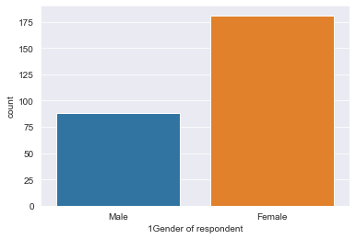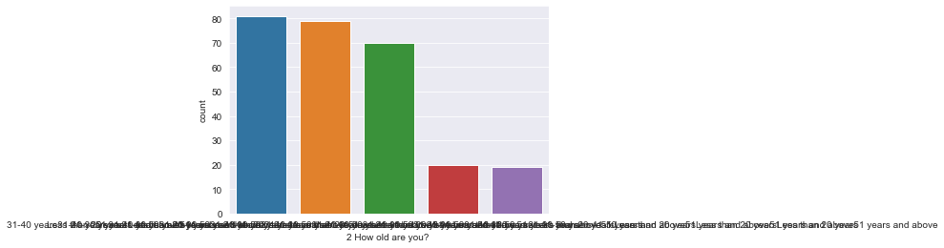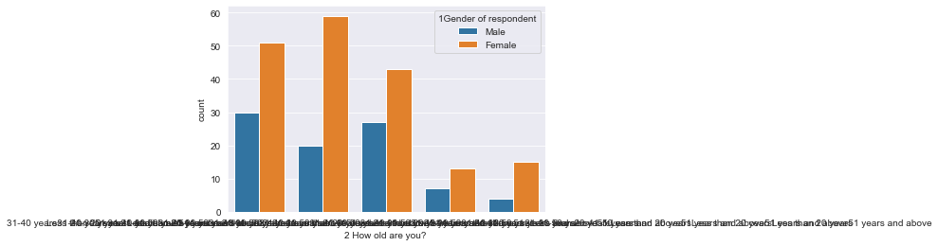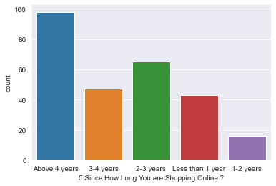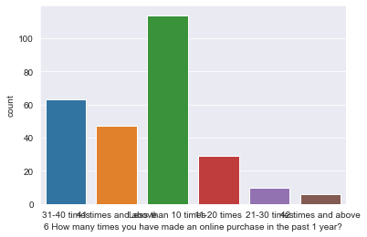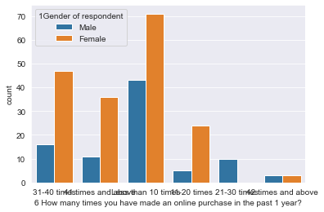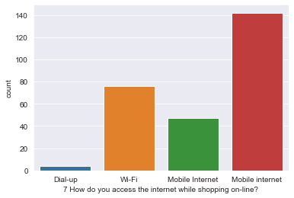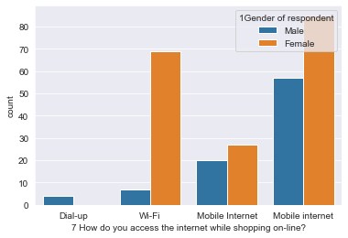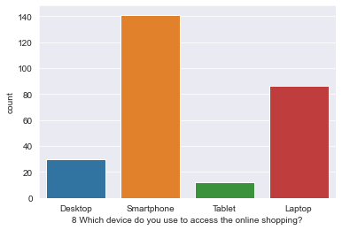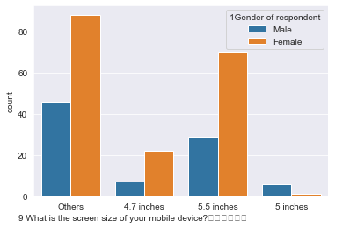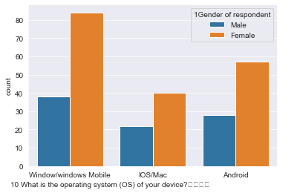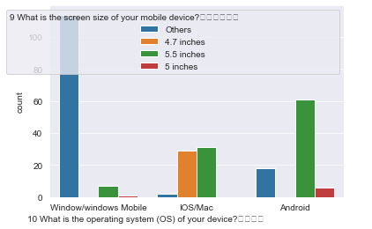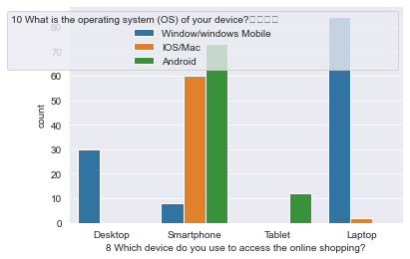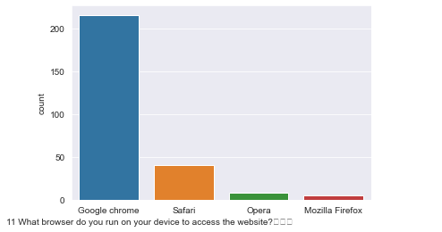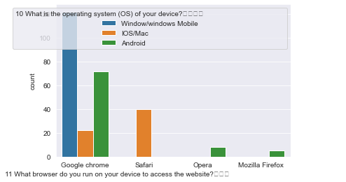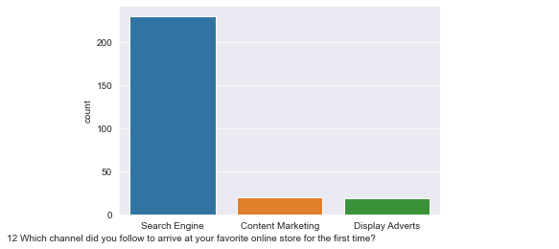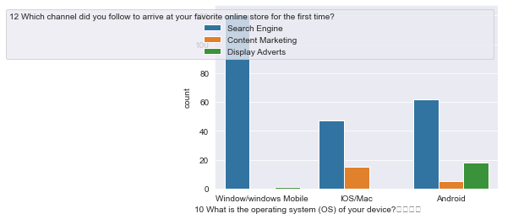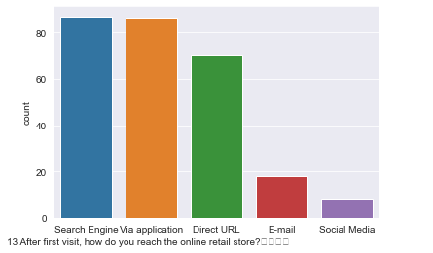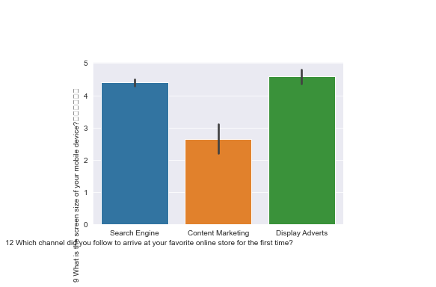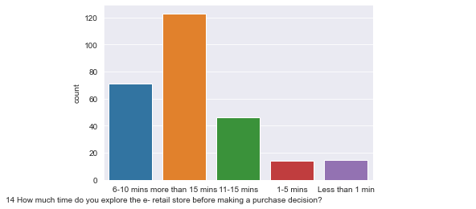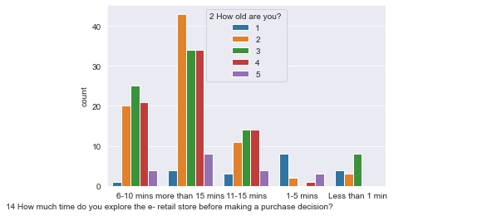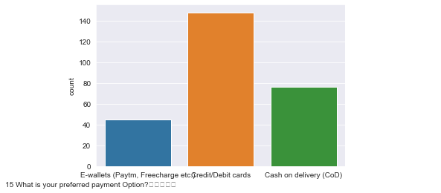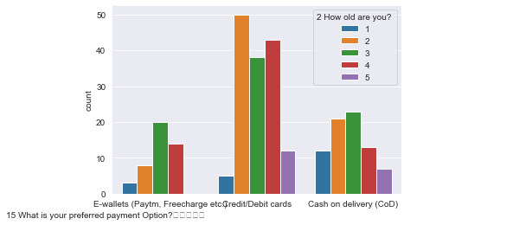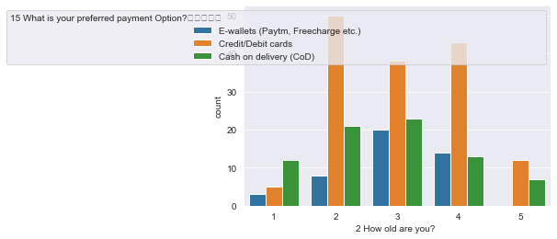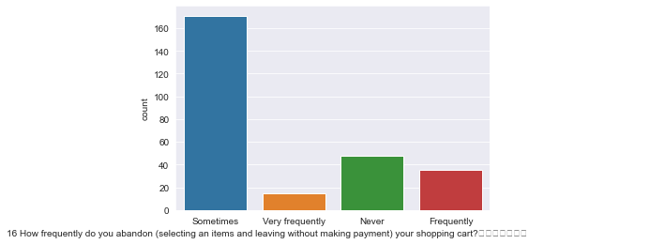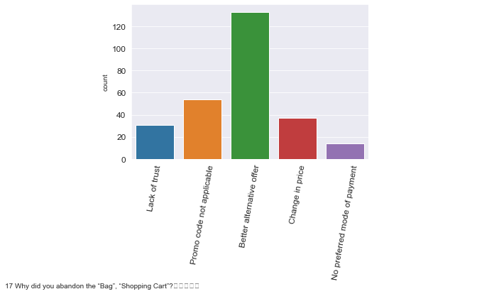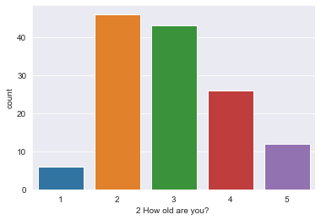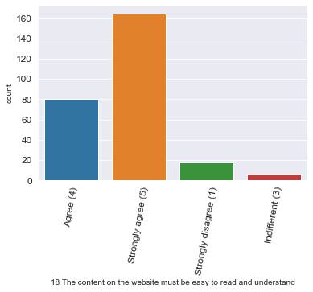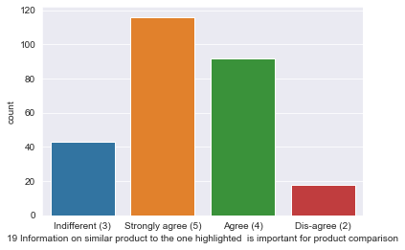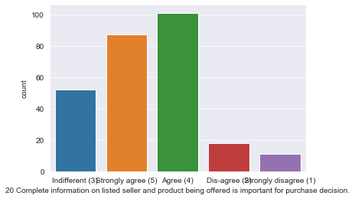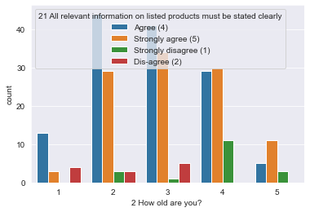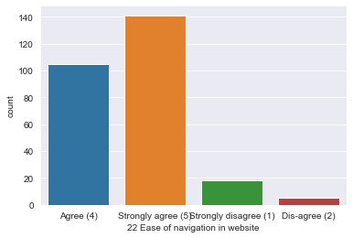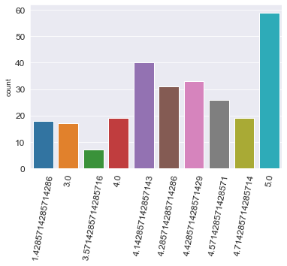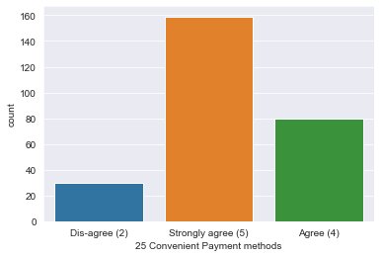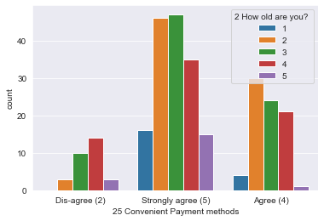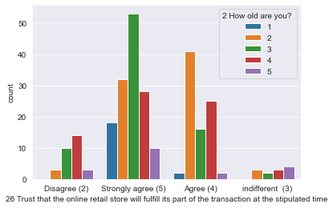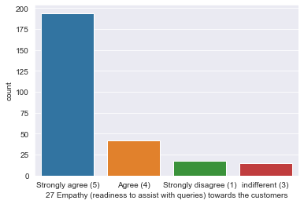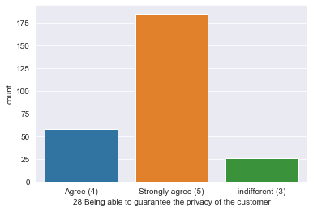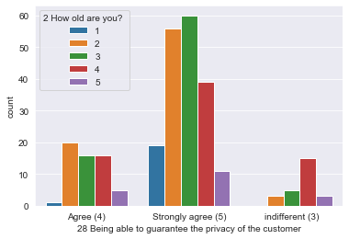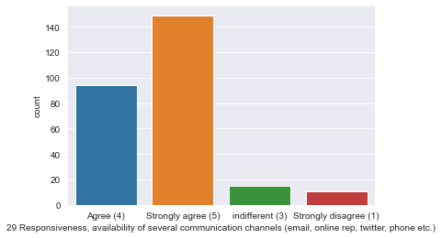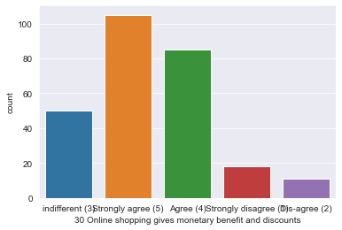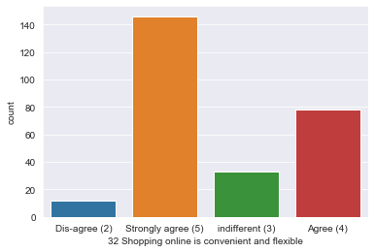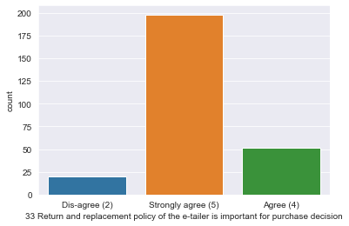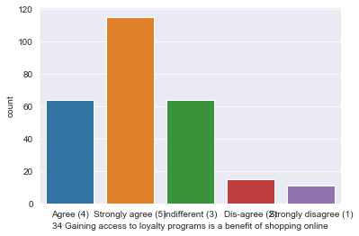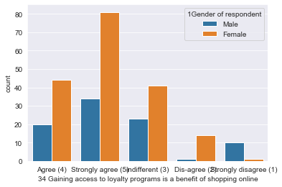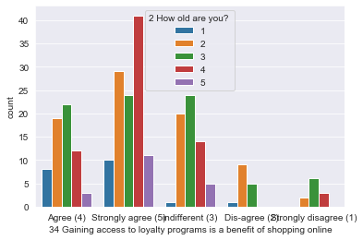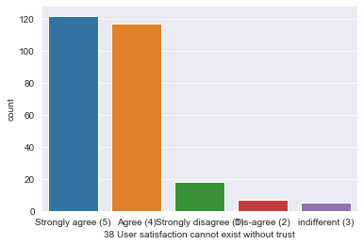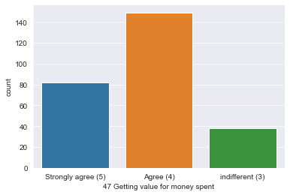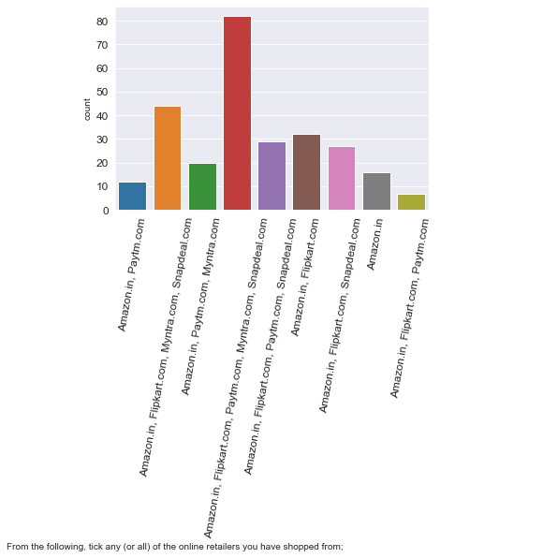

**CONCLUSION**

* Key Findings and Conclusions of the Study

By using above customer data, we can say that Amazon scores the highest score in terms of website quality and service related to the products

The second best score is for Flipkart

More than 80% of people recommend amazon to their friends or family

* Limitations of this work and Scope for Future Work

This data does not give an idea of a particular store. The data is scattered