# Db2

Database models

fms- datasets file management system

hierarchical -ims(information management system)

Network -idms(set) intigratedata management system

Relational - db2 v1r1 1 st version released by 1983 flexibility model

With respect to object relationship

fms - every object is independent objects it means object relation is declaration not possible

hirechical dbms root (parent) child or parent child every object must be relationship parent child

d

a

emps

empd

emppd

first level should be always parent object next level should be child middle level should be either parent or child based on dependency

network

emppd emps

empd in network every object acts as parent and child every object relation parent and child

RDBMS

In this object relationship is optional based on the relationship acting as fms and heretical and network.

RDBMS model

The rdbms model organize data in logical mathematical set in tabular from.

Here each data fields is considered as column and each record considered as row.

Structure of data as bytes

Db2 an abbreviation for ibm database 2 is ibms rdbms for mvs operating system as well as os/400 ,unix ,win etc,

Db2 is a sub system any os (mvs) that allows user to build, access and maintain relational databases, using the well –known relational language sql.

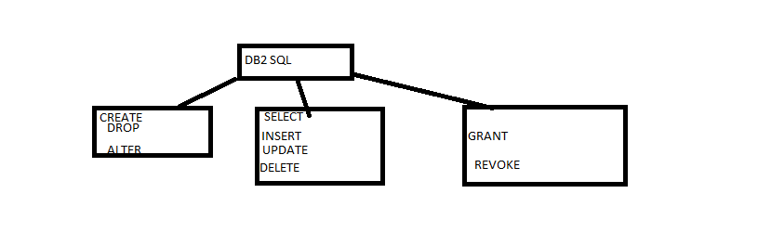

DDL DML DCL DDL

RELATE TO OBJECT LEVEL

ITS used to create table and drop table and remove the objects alter means change the existing objects

DML

DML operation is with respect to record level

Insert adding record, selecting records, updating records, deleting records

DCL

Dcl operation with respect to resource level the resource can be either user or object or record or component etc.

Grant to used permission to other user, revoke is used to remove the access to resource from user.

Commit and roll back means undo ,commit it will excute permanently

Begin transaction

Commit or rollback

** code

Save point

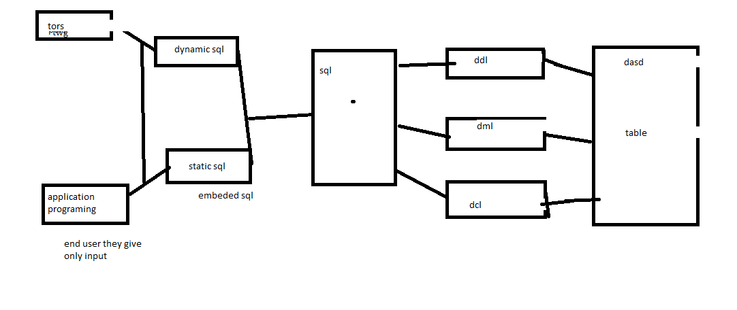

Db2 inbuilt spufi (sql processing using file input) or else third party query manangement facility(qmf),caf,

The programing either dynamic or static (emebeded sql) application programing.

Db2 catlog

Db2 directory

Db2 log

Etc

User db types

1. Sysadm system admin
2. Dbadm, database admin
3. Db ctrc database controller
4. Db maint database maintaince
5. Sysopr system operator

Sysadmin

Dbadm sysopr

Dbctrc

Db main

Components of DB2

FROM high-level point of view db2 has four major components

1. System services

2. Locking services

3. Database services

4. Distributed services

Each above divided into sub components

System services

Handles all system –wide tasks.

Support system operation, operator communication, logging and similar functions

Control connections to other mvs subsystem (cics,ims/dc,ims/db,and tso)

Handles system start up, shut down and operator communication.

Manages the system log (both active and archive logs).

Locking services

Provides necessary control for managing concurrent access the data, using irlm.

IRLM: IMS resource lock manager

Database services

Supports the definition, retrieval and update of db2 data (user and system data), using a series of six sub components.

1. Pre-compiler

2. Bind

3. run time supervise.

4. Database manager

5. Buffer manager

6. Utilities.

Distributed data facility(ddf)

Provides db2’s distributed database support

Note: of the above four components only the database services component is directly relevant to the user

Db2 objects are:

1. Storage groups

2. Database

3. Tables space

4. Table

5. Index

6. Synonym.

7. View

8. Buffer poll

9. Db2 catalog

Storage groups: its uniquely named collections of dasd volumes all of same device type that is issued by db2 to allocate space for system.

Within each storage group spaces and partitions are stored using vsam LDS.

Database: is named collection of logically related tables their associated indexes, view, synonym and the various spaces that contain those tables.

Is the unit of start and stop a database can be made available or unavailable for processing by the operator.

Table space: is the physical space is used to hold one or more tables

Is the unit for recovery and reorganization.

Type:

1. Simple

2. Partioned

3. Segmented

Simple table space:

Can hold or more tables

Only one table per table space is recommended,

Partitioned table space:

The entire table space is divided into partitions and each partition is stored in vsam file (lds)

Holds only one table, the entire table contained across multiple partitions.

Partitions can be can be recovered or reorganized individually

Segmented table space.

The pages of a table space are organized into segments and each segment contain one table.

Event it can have more than one table.

Each segment consists of the same number of pages

­­­page:

Is a block of physical storage (unit of I/O transaction between the secondary and primary storage in a physical I/O operation.)

Available page sizes are 4k, 8k, 16k, 32k, 64k, default is 4k.

Table:

Is a collection of rows that have a set of columns with data present as values at the intersection of a row and columns

One table for each entity.

One column for each element of the data needed.

One row for every occurrence of the entity.

Every table and every column with to be named.

Table name unique for owner

INDEX

Is used to locate the rows that contain a given value.

Gain efficient and faster direct access to data.

Is based on one or more columns of a table.

Has an entry for every value in the columns, with a RID FOR EACH ROW that holds that value.

Multiple indexes can be defined on a table.

Index space:

Required for storing an index.

Each index exactly contains one index.

The index space is automatically created by the system. When the index is created.

Consists of addresses of each record stored in the table.

View:

A predefined selection of data in base tables.

The view definition is stored in the db2 CatLog, and is called whenever the view is referred to.

Is a virtual table that does not physically exist. But is processed as a table.

Data represented by a view is actually stored in the underlying base tables.

It can be created from one or more base tables or other views or combinations of view and tables.

Synonym:

Is an alternate name for table or view.

Can be used only by the user who created it.

Alias: is similar to synonym, but can be used even by other users.

DB2CATALOG:

IS A DB2 DATABASE PRE-DEFINED TABLE.

Is also called as system catalog.

Contains information about every db2 object that is maintained by it.

Contains a set of 30db2 tables stored in the dsndb06 database.

Whenever any db2 object is created, altered, or deleted, an entry is made in the db2 CataLog.

A user can retrieve information from a catalog.

However user cannot update catalog tables

Some tables in catalog:

Systables –contain information about the table’s views available.

Systablespace- contains one row of information for each table space available.

Sysviews –one row of information each view available.

Syscolumns- information about each columns of table and views including those of the catalog.

Every catalog table qualify by the owner name owner name is sysibm ex-sysibm.systables

DATA types

1. Numeric data types. – Small Integer, Integer, bigint, decimal (p,q),float(p)

2 .character data types. Char (2), varchar (n)

3. Graphic data types. Graphic (n), vargraphic (n), (needed for certain language whose character sets exceed256 characters/symbols.

4 .data/time data type. Date, time timestamp.

Small integer:

Data stored in binary format in half word

Two byte binary integer, 15 bits for data and 1 bit for sign range -32768 to +32768

Fractional values if inserted are truncated

Useful for columns that will always be whole number and used in arithmetic operations.

Integer:

Small integer:

Data stored in binary format in full word

Two byte binary integer, 31 bits for data and 1 bit for sign range -2147483648 to 2147483648

Fractional values if inserted are truncated

Useful for columns that will always be whole number and used in arithmetic operations

Bigint :

Data stored in binary format in two word

Either byte integer, with a precision of 19 digits

Decimal

Data stored in packed format.

P the total #of digits before and after the decimal point excluding the decimal point and the sign

Q the #of digits after the decimal points

Id there are no digits after the decimal point, q would be equal to zero

Float :

Data stored in floating point format ,p integer

P<22--------------------------- pb/w 22&53 both inclusive

Single precision stored in full word double precision stored in two words (8 bytes)

(4 bytes)

Used exclusively for scientific applaications where extreme precision is required.