Q1

Q2



Q3

Q4

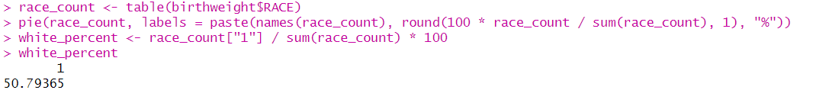

Q5

Q6)

Q7)

On the stem 30 and leaf 7 structure.

Q8)

The distribution of AGE appears somewhat right-skewed, with most mothers clustered between 20-30 years of age.

Q9)

The distribution is unimodal and right-skewed.

Q10)

The stem-and-leaf plot shows actual data points, allowing to see individual values, which are lost in the binning of a histogram.

Q11)

While the histogram provides a clearer picture of the distribution’s overall shape, the stem-and-leaf plot retains more granular detail about specific data values.

Q12)

Q13)

The mean of LWT is 129.82 and the median is 130. These values suggest a roughly symmetric distribution.

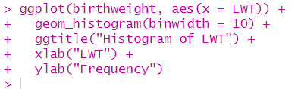

Q14)

The variable LWT is centered around a mean of 129.82 pounds, with a median close to the mean, indicating a relatively symmetric distribution. The spread, represented by the standard deviation, shows moderate variability, and the histogram supports the visual observation of symmetry with no major outliers.