Exercise 1

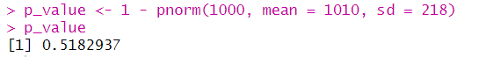

P(X>1000) = 0.5182937

Exercise 2

Q1 = 862.9612

Median = 1010

Exercise 3



